Status of petrale sole (*Eopsetta jordani* )

along the U.S. west coast in 2019

Chantel R. Wetzel1

1Northwest Fisheries Science Center, U.S. Department of Commerce, National Oceanic and Atmospheric Administration, National Marine Fisheries Service, 2725 Montlake Boulevard East, Seattle, Washington 98112

August 2019

DRAFT SAFE

Disclaimer: This information is distributed solely for the purpose of pre-dissemination peer review under applicable information quality guidelines. It has not been formally disseminated by NOAA Fisheries. It does not represent and should not be construed to represent any agency determination or policy.

This report may be cited as:

Wetzel, C.R. 2019. Status of petrale sole (*Eopsetta jordani* ) along the U.S. west coast in 2019. Pacific Fishery Management Council, 7700 Ambassador Place NE, Suite 200, Portland, OR 97220.

Status of petrale sole (*Eopsetta jordani* )

along the U.S. west coast in 2019

**Contents**

**Executive Summary** **i**

Stock . . . . . . . . . . . . . . . . . . . . . . . . . . . . . . . . . . . . . . . . . . . i

Landings . . . . . . . . . . . . . . . . . . . . . . . . . . . . . . . . . . . . . . . . . i

Data and Assessment iii

Updated Data iii

Stock Biomass iv

Recruitment vii

Exploitation Status ix

Ecosystem Considerations xii

Reference Points xii

Management Performance xiii

Unresolved Problems and Major Uncertainties xiv

Decision Table xv

Research and Data Needs xvii

1. Introduction 1

1.1 Basic Information . . . . . . . . . . . . . . . . . . . . . . . . . . . . . . . . . 1

1.2 Life History . . . . . . . . . . . . . . . . . . . . . . . . . . . . . . . . . . . . 2

* 1. Historical and Current Fishery Information . . . . . . . . . . . . . . . . . . . 2
  2. Summary of Management History and Performance . . . . . . . . . . . . . . 3
  3. Fisheries off Canada and Alaska . . . . . . . . . . . . . . . . . . . . . . . . . 5

1. Data 5

2.1 Fishery-Independent Data . . . . . . . . . . . . . . . . . . . . . . . . . . . . 6

* + 1. NWFSC West Coast Groundfish Bottom Trawl Survey . . . . . . . . 6
    2. AFSC/NWFSC West Coast Triennial Shelf Survey . . . . . . . . . . 7

2.2 Fishery-Dependent Data . . . . . . . . . . . . . . . . . . . . . . . . . . . . . 9

2.2.1 Commercial Fishery Landings . . . . . . . . . . . . . . . . . . . . . . 9 2.2.2 Discards 10

* + 1. Foreign Landings 11
    2. Historical Commercial Catch-Per-Unit Effort/Logbooks 11
    3. Fishery Length and Age Data 11
  1. Biological Data 12
     1. Natural Mortality 12
     2. Maturation and Fecundity 13
     3. Sex Ratio 14
     4. Length-Weight Relationship 14
     5. Growth (Length-at-Age) 14
     6. Ageing Precision and Bias 15
     7. Environmental and Ecosystem Data 15

1. Assessment Model 15
   1. History of Modeling Approaches Used for This Stock 15
   2. General Model Specifications and Assumptions 16
      1. Changes Between the 2013, the 2015 Update, and the Current Update Assessment Model 16
      2. Summary of Fleets and Areas 17
      3. Priors 17
      4. Data Weighting 18
      5. Estimated and Fixed Parameters 18
      6. Key Assumptions and Structural Choices 18
      7. Bridging Analysis 19
      8. Convergence 19
   3. Base Model Results 19
      1. Parameter Estimates 19
      2. Fits to the Data 21
      3. Population Trajectory 22
      4. Sensitivity Analyses 23
      5. Retrospective Analysis 24
      6. Added Data Analysis 24
      7. Historical Analysis 25
      8. Likelihood Profiles 25
      9. Reference Points 26

|  |  |  |
| --- | --- | --- |
| **4** | **Harvest Projections and Decision Tables** | **26** |
| **5** | **Regional Management Considerations** | **27** |
| **6** | **Research Needs** | **27** |
| **7** | **Acknowledgments** | **27** |
| **8** | **References** | **29** |
| **9** | **Tables** | **34** |
| **10** | **Figures** | **69** |
| **11** | **Appendix A. Detailed Fit to Length Composition Data** | **186** |
| **12** | **Appendix B. Detailed Fit to Age Composition Data** | **208** |
| **13** | **Appendix C. List of Auxiliary Files Available** | **224** |

**Executive Summary**

**Stock**

This assessment reports the status of the petrale sole (*Eopsetta jordani* ) off the U.S. coast of California, Oregon, and Washington using data through 2018. While petrale sole are modeled as a single stock, the spatial aspects of the coast-wide population are addressed through geographic separation of data sources/fleets where possible. There is currently no genetic evidence suggesting distinct biological stocks of petrale sole off the U.S. coast. The limited tagging data available to describe adult movement suggests that petrale sole may have some homing ability for deep water spawning sites but also have the ability to move long distances between spawning sites, inter-spawning season, as well as seasonally.

**Landings**

While records do not exist, the earliest catches of petrale sole are reported in 1876 in California and 1884 in Oregon. In this assessment, fishery removals have been divided among 4 fleets: 1) Winter North trawl, 2) Summer North trawl, 3) Winter South trawl, and 4) Summer South trawl. Landings for the North fleet are defined as fish landed in Washington and Oregon ports. Landings for the South fleet are defined as fish landed in California ports. Recent annual catches between 1981-2018 range between 755 and 3008 mt per year and the most recent year landings are shown in Table a. The landings are summarized into winter and summer fleets where winter is defined as November to February and summer running from March to October. Petrale sole are caught nearly exclusively by trawl fleets; non-trawl gears contribute only a small fraction of the catches across all years.

From the inception of the fishery through the war years, the vast majority of catches occurred between March and October (the summer fishery), when the stock is dispersed over the continental shelf. The post-World War II period witnessed a steady decline in the amount and proportion of annual catches occurring during the summer months (March-October). Conversely, petrale sole catch during the winter season (November-February), when the fishery targets spawning aggregations, has exhibited a steadily increasing trend since the 1940s. From the mid-1980s through the early 2000s, catches during the winter months were roughly equivalent to or exceeded catches throughout the remainder of the year, whereas during the past 10 years, the relative catches during the winter and summer have been more variable across years (Table a). Petrale sole are a desirable market species and discarding has historically been low.

Table a: Landings (mt) and total dead for the past 10 years for petrale sole by source.

|  |  |  |  |  |  |  |
| --- | --- | --- | --- | --- | --- | --- |
| Year | Winter | Summer | Winter | Summer | Total | Total |
|  | (N) | (N) | (S) | (S) | Landings | Dead |
| 2009 | 847 | 642 | 470 | 250 | 2209 | 2334 |
| 2010 | 264 | 292 | 78 | 121 | 755 | 869 |
| 2011 | 224 | 427 | 40 | 78 | 768 | 785 |
| 2012 | 410 | 494 | 124 | 108 | 1135 | 1153 |
| 2013 | 513 | 1045 | 130 | 280 | 1967 | 1995 |
| 2014 | 853 | 861 | 273 | 386 | 2373 | 2392 |
| 2015 | 1040 | 1077 | 215 | 354 | 2686 | 2704 |
| 2016 | 865 | 1168 | 237 | 235 | 2506 | 2523 |
| 2017 | 1142 | 1271 | 201 | 393 | 3008 | 3026 |
| 2018 | 957 | 1262 | 218 | 402 | 2840 | 2857 |

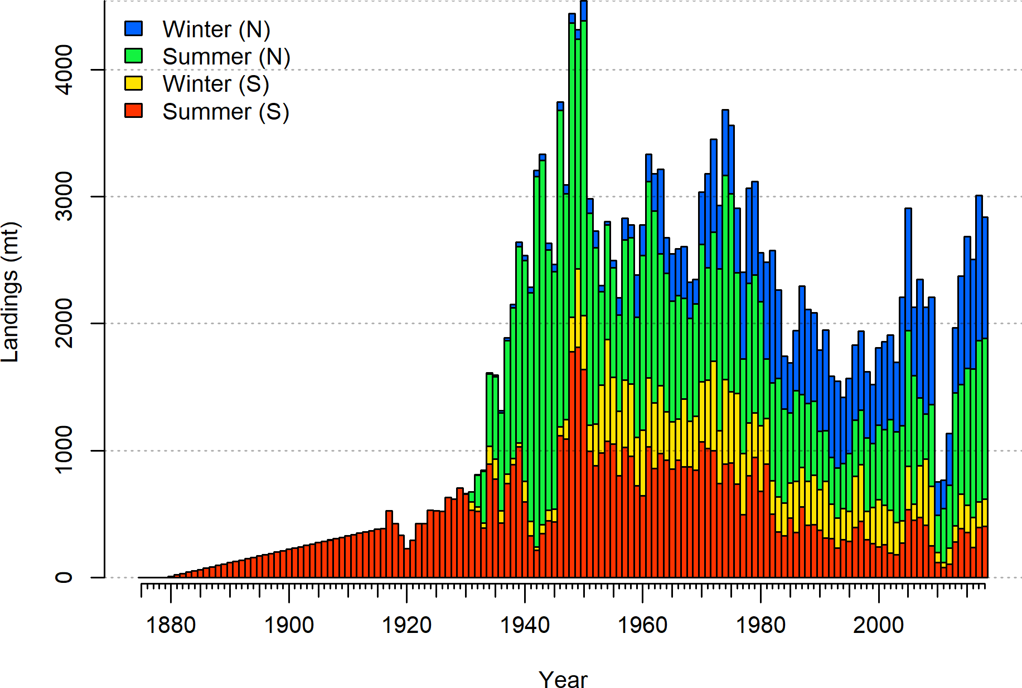

Figure a: ’Landings of by the Northern and Southern winter and summer fleets off the U.S. west coast.

## Data and Assessment

This an update assessment for petrale sole, which was last assessed in 2013 and updated in 2015. This update assessment was conducted using the length- and age-structured modeling software Stock Synthesis (version 3.30.13). The coastwide population was modeled allowing separate growth and mortality parameters for each sex (a two-sex model) with the fishing year beginning on November 1 and ending on October 31. The fisheries are structured seasonally based on winter (November to February) and summer (March to October) fishing seasons due to the development and growth of the wintertime fishery, which began in the 1950s. In recent decades, wintertime catches have often exceed summertime catches. The fisheries are modeled as the Winter North and Summer North fleets, where the North includes both Washington and Oregon, and Southern Winter and Southern Summer encompasses California fisheries.

The model includes fishery data in the form of catches, discard rates and average weights, length- and age-frequency data, as well as standardized winter fishery catch-per-unit-effort (CPUE). Biological data are derived from both port and on-board observer sampling programs. The National Marine Fisheries Service (NMFS) AFSC/NWFSC West Coast Triennial Shelf Survey early (1980, 1983, 1986, 1989, 1992) and late period (1995, 1998, 2001, and 2004) and the NWFSC West Coast Groundfish Bottom Trawl Survey (2003-2018) relative biomass indices and biological sampling provide fishery independent information on relative trend and demographics of the petrale sole stock.

## Updated Data

The base assessment model structure is consistent with the 2013 assessment and the 2015 update, except as noted here. Modifications from the previous assessment model include:

1. Commercial catches (2015-2018 added);
2. Commercial length and age data (all years reprocessed, 2015-2018 added);
3. Observed discard rates, average weights, and lengths (2002-2017 reprocessed, 2014-2017 added);
4. AFSC/NWFSC West Coast Triennial Shelf Survey early and late indices of abundance and length composition data (1980-2004 reprocessed);
5. NWFSC West Coast Groundfish Bottom Trawl Survey index of abundance, length and age composition data (2003-2018 reprocessed, 2015-2018 added);
6. Model tuning to re-weight data using the McAllister and Iannelli approach (same approach applied in the 2013 assessment);
7. Length-weight relationship parameters estimated outside of the stock assessment model from the NWFSC West Coast Groundfish Bottom Trawl Survey data up to 2018 and input as fixed values;
8. The natural mortality prior for female and male fish was updated; and,
9. Model fitting using latest version of Stock Synthesis (SS v.3.30.13).

## Stock Biomass

Petrale sole were lightly exploited during the early 1900s, but by the 1950s, the fishery was well developed with the stock showing declines in biomass and catches (Figures a and b). The rate of decline in spawning biomass accelerated through the 1970s reaching minimums generally around or below 10% of the unexploited levels during the 1980s through the early 2000s (Figure c). The petrale sole spawning stock biomass is estimated to have increased in recent years due to reduced catches during rebuilding and in response to above average recruitment in 2006, 2007, and 2008. The 2019 estimated spawning biomass relative to

unfished equilibrium spawning biomass is above the target of 25% of unfished spawning biomass, at 39.1% (∼ 95% asymptotic interval: ± 28.2%-50.1%) (Table b).

Table b: Recent trend in estimated spawning biomass (mt) and estimated relative spawning biomass.

|  |  |  |  |  |
| --- | --- | --- | --- | --- |
| Year | Spawning Biomass  (mt) | ˜ 95%  Confidence Interval | Estimated  Relative Spawning Biomass | ˜ 95%  Confidence Interval |
| 2010 | 4227 | 3452 - 5002 | 0.127 | 0.087 - 0.166 |
| 2011 | 5378 | 4414 - 6342 | 0.161 | 0.111 - 0.211 |
| 2012 | 7205 | 5958 - 8452 | 0.216 | 0.150 - 0.281 |
| 2013 | 9488 | 7888 - 11087 | 0.284 | 0.199 - 0.369 |
| 2014 | 11433 | 9524 - 13341 | 0.342 | 0.241 - 0.443 |
| 2015 | 12691 | 10603 - 14778 | 0.380 | 0.270 - 0.490 |
| 2016 | 13206 | 11039 - 15374 | 0.395 | 0.283 - 0.508 |
| 2017 | 13519 | 11293 - 15745 | 0.405 | 0.292 - 0.518 |
| 2018 | 13365 | 11077 - 15653 | 0.400 | 0.289 - 0.511 |
| 2019 | 13078 | 10689 - 15467 | 0.391 | 0.282 - 0.501 |

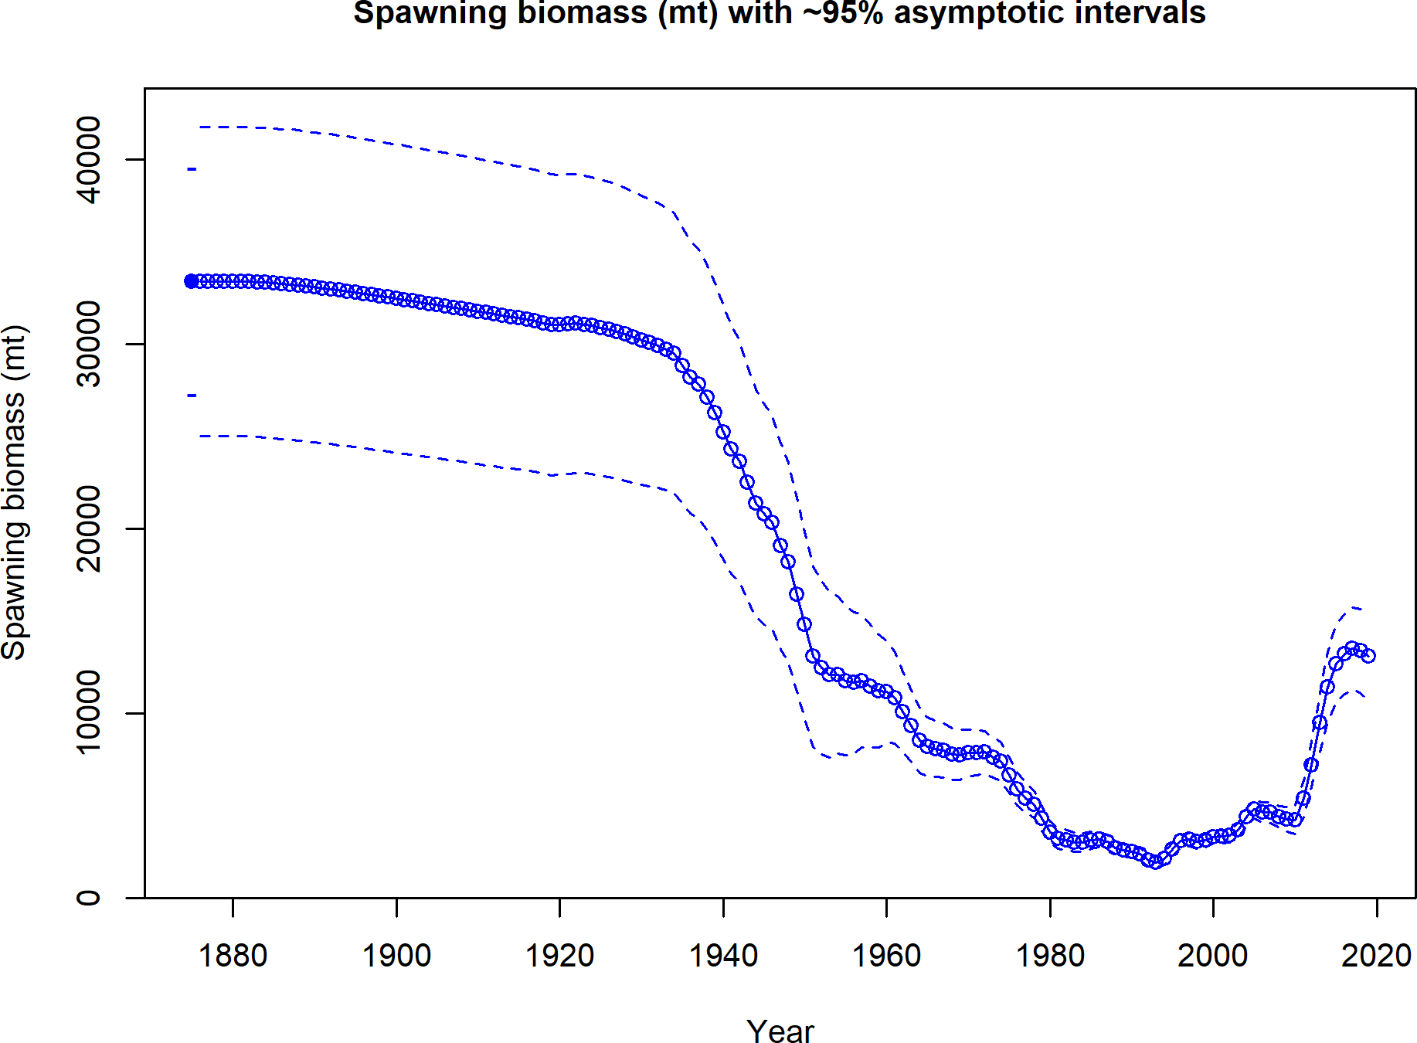

Figure b: Estimated time-series of spawning biomass trajectory (circles and line: median; light broken lines: 95% credibility intervals) for the base assessment model.

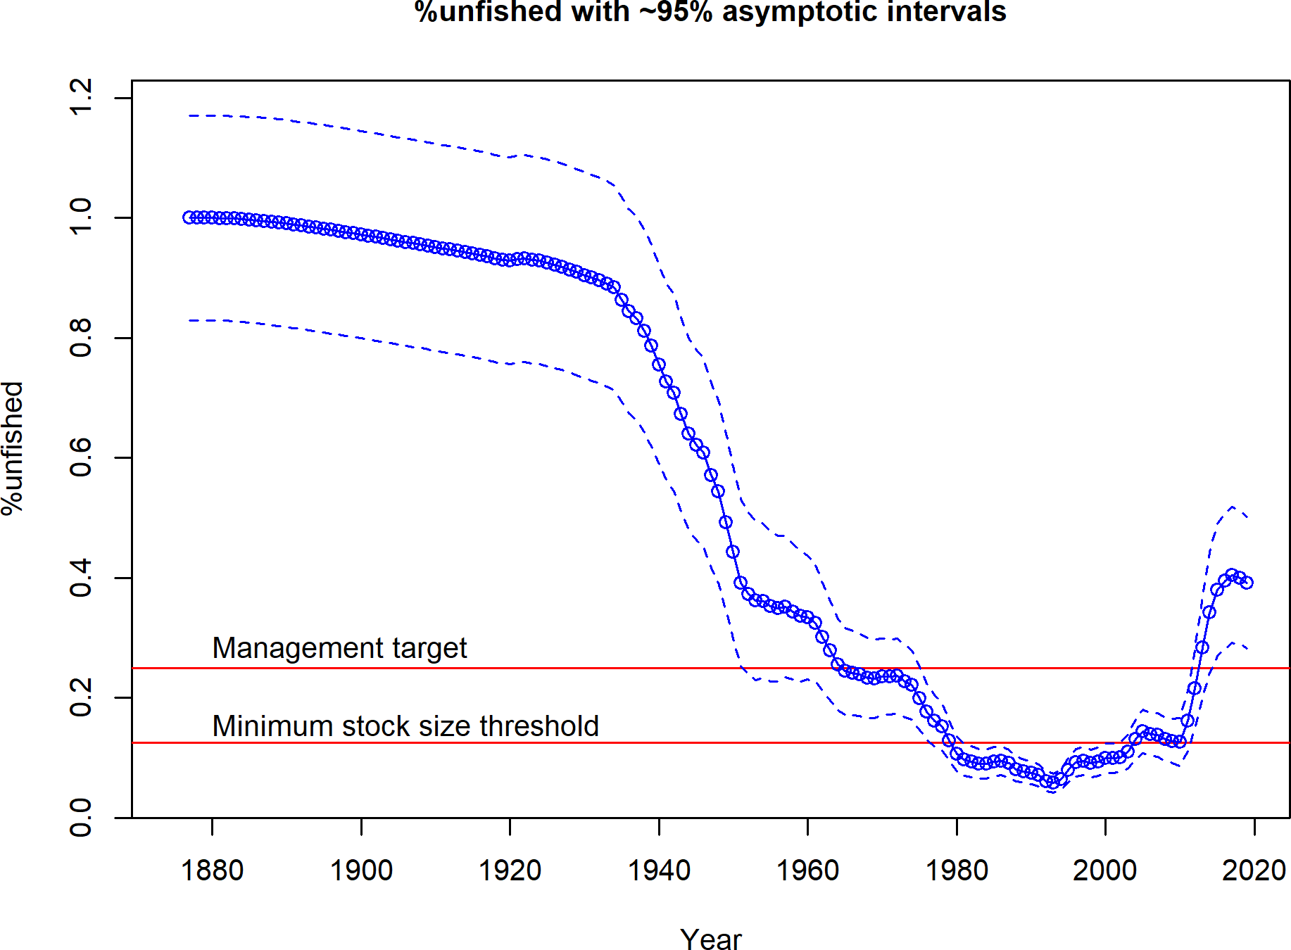

Figure c: Estimated time-series of relative spawning biomass (depletion) (circles and line: median; light broken lines: 95% credibility intervals) for the base assessment model.

## Recruitment

Annual recruitment was treated as stochastic, and estimated as annual deviations from log-mean recruitment where mean recruitment is the fitted Beverton-Holt stock recruitment curve. The time-series of estimated recruitments shows a relationship with the decline in spawning biomass, punctuated by larger recruitments in 2006, 2007, and 2008 (Figure d). However, recruitment in recent years (2013 - 2017) is estimated to be less than the expected mean recruitment indicating an absence of strong incoming recruitment (Table c).

The five largest estimated recruitments estimated within the model (in ascending order) occurred in 2006, 1998, 1966, 2007, and 2008. The four lowest recruitments estimated within

the model (in ascending order) occurred in 1986, 1992, 1987, and 2003.

Table c: Recent estimated trend in recruitment and estimated recruitment deviations deter- mined from the base model. The recruitment deviations for 2018 and 2019 were fixed at zero within the model.

|  |  |  |  |  |
| --- | --- | --- | --- | --- |
| Year | Estimated  Recruitment | ˜ 95% Confidence  Interval | Estimated  Recruitment Devs. | ˜ 95% Confidence  Interval |
| 2010 | 12637 | 8002 - 19956 | -0.134 | -0.446 - 0.177 |
| 2011 | 15344 | 9888 - 23810 | -0.002 | -0.288 - 0.283 |
| 2012 | 22946 | 15296 - 34420 | 0.339 | 0.097 - 0.581 |
| 2013 | 13483 | 8315 - 21863 | -0.239 | -0.610 - 0.132 |
| 2014 | 13529 | 8178 - 22379 | -0.261 | -0.660 - 0.138 |
| 2015 | 12792 | 7177 - 22801 | -0.330 | -0.817 - 0.158 |
| 2016 | 16460 | 8550 - 31688 | -0.102 | -0.674 - 0.469 |
| 2017 | 16517 | 7577 - 36006 | -0.122 | -0.853 - 0.610 |
| 2018 | 19018 | 8362 - 43254 | 0.000 | -0.784 - 0.784 |
| 2019 | 18972 | 8346 - 43127 | 0.000 | -0.784 - 0.784 |

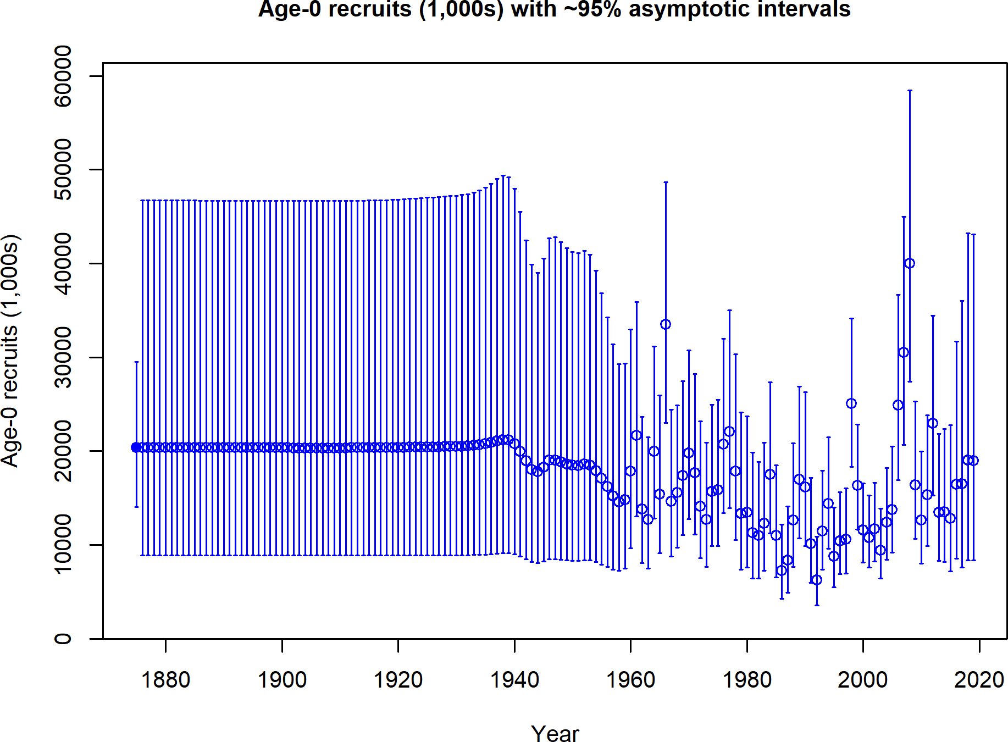

Figure d: Time-series of estimated petrale sole recruitments for the base model with 95% confidence or credibility intervals.

## Exploitation Status

The relative spawning biomass of petrale sole was estimated to have dropped below the management target (25%) for the first time in 1965. The stock continued to decline and first fell below the minimum stock size threshold level of 12.5% in 1980 (although, at the time the management target and thresholds were not set at the current values of 25% and 12.5%). The relative spawning biomass remained around the threshold stock size until approximately 2010, with the stock reaching its lowest relative spawning biomass level in 1993 at 5.8%. In 2009 petrale sole was formally declared overfished. Fishing mortality rates sharply declined during the rebuilding period, relative to previous year rates, which exceeded the target (Figure e). After reduced harvests, the 2015 update stock assessment estimated the stock to have rebuilt to the management target (25%) in 2014. This update estimates that the relative spawning biomass exceeded 25% in 2013 with harvest rates in the most recent years remaining under of the target rate (Table d and Figures e and f).

Table d: Recent trend in spawning potential ratio 1-SPR and summary exploitation rate for age 3+ biomass for petrale sole.

|  |  |  |  |  |
| --- | --- | --- | --- | --- |
| Year | 1-SPR | ˜ 95%  Confidence Interval | Exploitation  Rate | ˜ 95%  Confidence Interval |
| 2009 | 0.793 | 0.724 - 0.861 | 0.232 | 0.190 - 0.273 |
| 2010 | 0.570 | 0.469 - 0.670 | 0.075 | 0.060 - 0.091 |
| 2011 | 0.498 | 0.399 - 0.597 | 0.051 | 0.041 - 0.061 |
| 2012 | 0.515 | 0.419 - 0.612 | 0.061 | 0.049 - 0.072 |
| 2013 | 0.584 | 0.491 - 0.677 | 0.092 | 0.076 - 0.108 |
| 2014 | 0.578 | 0.485 - 0.670 | 0.103 | 0.085 - 0.120 |
| 2015 | 0.580 | 0.489 - 0.672 | 0.110 | 0.092 - 0.129 |
| 2016 | 0.549 | 0.458 - 0.640 | 0.102 | 0.085 - 0.119 |
| 2017 | 0.584 | 0.495 - 0.673 | 0.122 | 0.102 - 0.143 |
| 2018 | 0.573 | 0.484 - 0.662 | 0.119 | 0.098 - 0.140 |

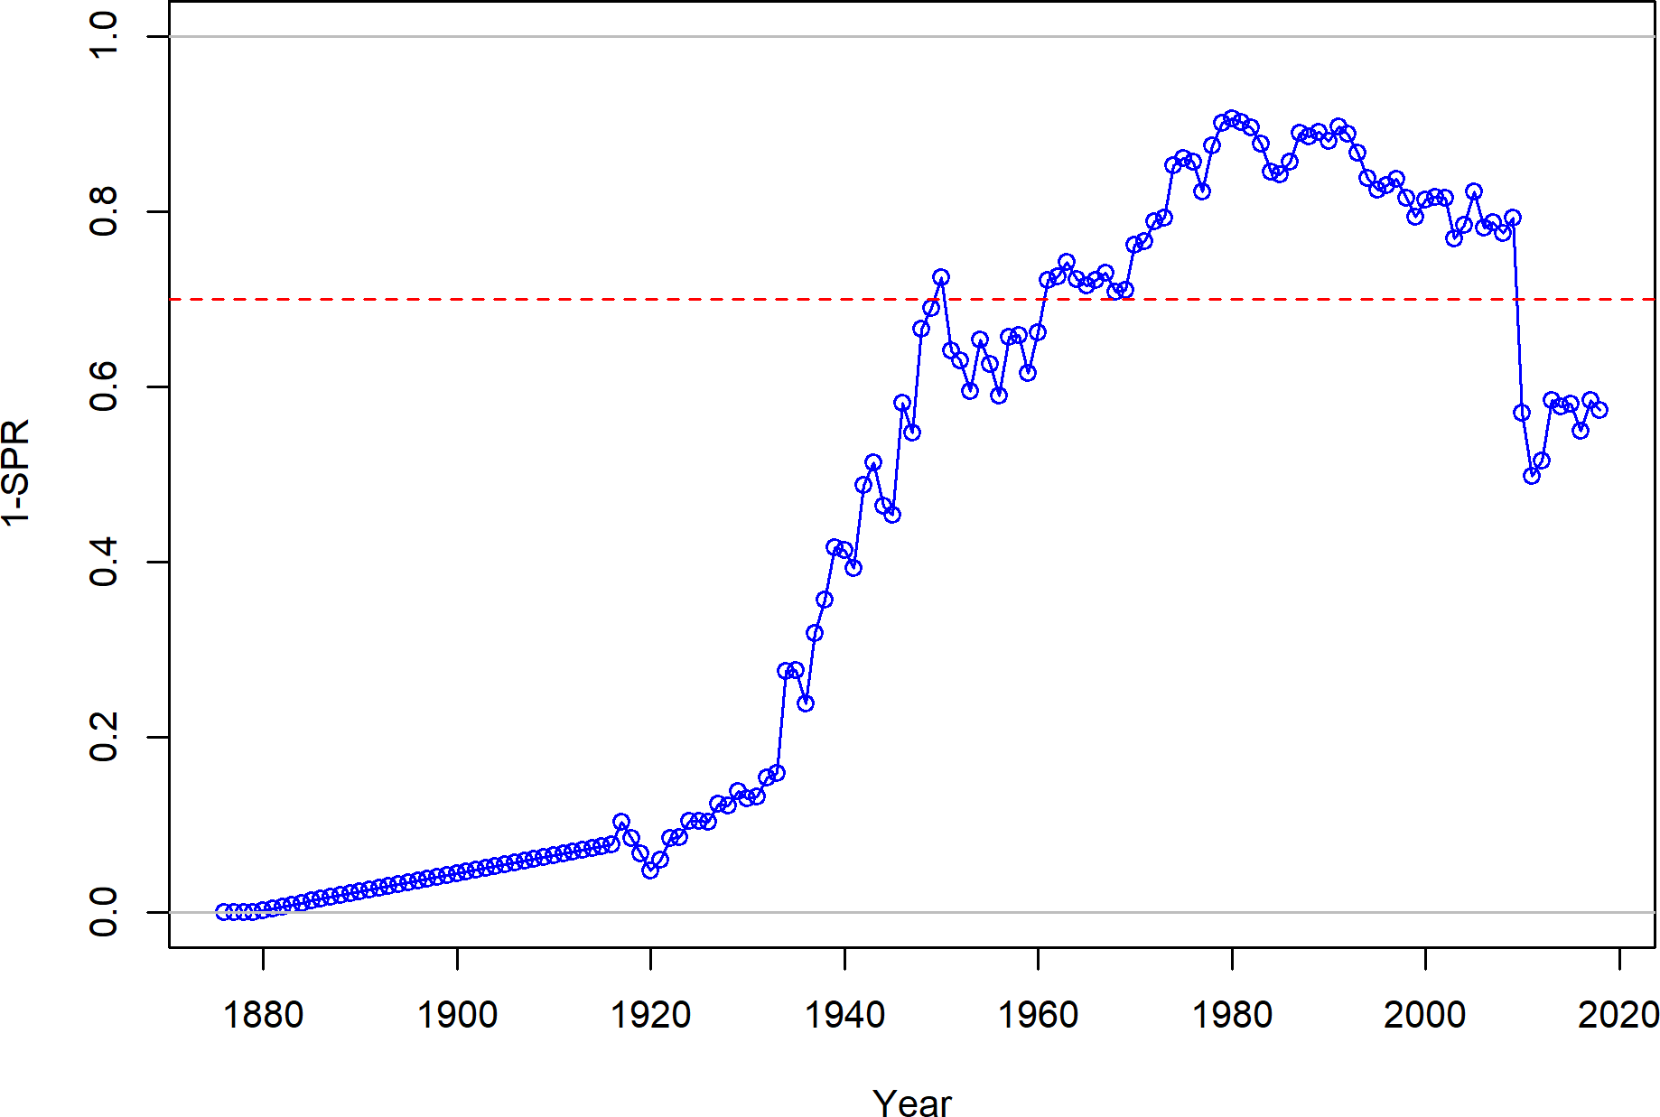

Figure e: Estimated relative spawning potential ratio 1-SPR for the base model. One minus SPR is plotted so that higher exploitation rates occur on the upper portion of the y-axis. The management target is plotted as a red horizontal line and values above this reflect harvests in excess of the overfishing proxy based on the SPR30% harvest rate. The last year in the time-series is 2018.

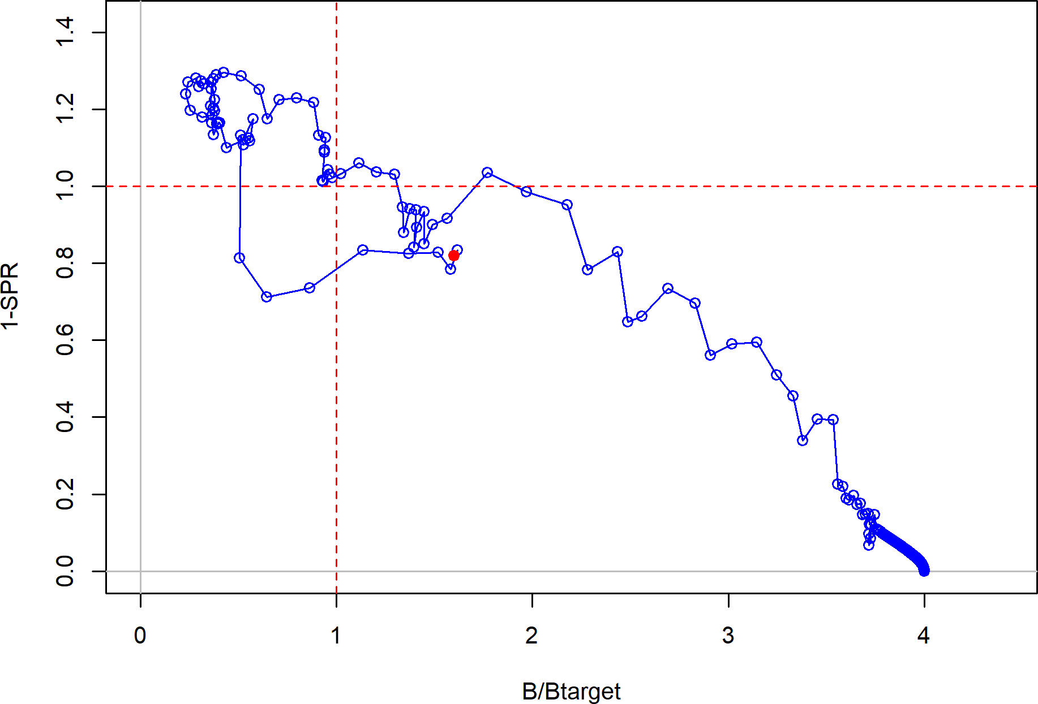

Figure f: Phase plot of estimated 1-SPR(%) vs. relative spawning biomass (B/Btarget) for the base case model. The red circle indicates 2018 estimated status and exploitation for petrale sole.

## Ecosystem Considerations

Ecosystem factors have not been explicitly modeled in this assessment, but there are several aspects of the California current ecosystem that may impact petrale sole population dynamics and warrant further research. Castillo (1992) and Castillo et al. (1995) suggest that density- independent survival of early life stages is low and show that offshore Ekman transportation of eggs and larvae may be an important source of variation in year-class strength in the Columbia INPFC area. The effects of the Pacific Decadal Oscillation on California current temperature and productivity (Mantua et al. 1997) may also contribute to non-stationary recruitment dynamics for petrale sole. The prevalence of a strong late 1990s year-class for many West Coast groundfish species suggests that environmentally driven recruitment variation may be correlated among species with relatively diverse life history strategies. Although current research efforts along these lines are limited, a more explicit exploration of ecosystem processes may be possible in future petrale sole stock assessments if resources are available for such investigations.

## Reference Points

This update stock assessment estimates that the spawning biomass of petrale sole is above the management target. Due to reduced landings and a series of above average recruitments (2006, 2007, and 2008), an increasing trend in spawning biomass was estimated in the base model with a decline in the start of the year spawning biomass estimate in 2019. The estimated relative spawning biomass in 2019 is 39.1% ( 95% asymptotic interval: 28.2%-50.1%), corresponding to an spawning biomass of 13,078 mt ( 95% asymptotic interval: 10,689-15,467 mt) (Table e). Unfished age 3+ biomass was estimated to be 54,086.6 mt in the base model.

∼

∼ ±

The target spawning biomass based on the biomass target (*𝑆𝐵*25%) is 8,351.5 mt, with an equilibrium catch of 3,148.5 mt (Table e). Equilibrium yield at the proxy *𝐹𝑀𝑆𝑌* harvest rate corresponding to *𝑆𝑃 𝑅*30% is 3,135.2 mt. Estimated MSY catch is at a 3,156.7 spawning biomass of 7,563.3 mt (22.6% relative spawning biomass).

Table e: Summary of reference points and management quantities for the base case.

**Quantity Estimate 2.5%**

∼

**Confi- dence Interval**

**97.5%**

**Confi- dence Interval**

∼

|  |  |  |  |
| --- | --- | --- | --- |
| Unfished spawning biomass (mt) | 33405.9 | 27188.1 | 39623.7 |
| Unfished age 3+ biomass (mt) | 54086.6 | 45524.9 | 62648.3 |
| Unfished recruitment (R0, thousands) | 20361.1 | 12720.2 | 28002 |
| Spawning biomass(2019 mt) | 13077.7 | 10688.8 | 15466.6 |
| Relative spawning biomass (depletion) (2019) | 0.391 | 0.282 | 0.501 |
| **Reference points based on SB25**%  Proxy spawning biomass (*𝐵*25%) | 8351.5 | 6797 | 9905.9 |
| SPR resulting in *𝐵*25% (*𝑆𝑃 𝑅𝐵*25%) | 0.285 | 0.26 | 0.31 |
| Exploitation rate resulting in *𝐵*25% | 0.182 | 0.163 | 0.2 |
| Yield with *𝑆𝑃 𝑅𝐵*25% at *𝐵*25% (mt)  ***Reference points based on SPR proxy for MSY*** | 3148.5 | 2887.6 | 3409.4 |
| Spawning biomass | 8866.2 | 6954.6 | 10777.7 |
| *𝑆𝑃 𝑅*30%  Exploitation rate corresponding to *𝑆𝑃 𝑅*30% | 0.173 | 0.147 | 0.198 |
| Yield with *𝑆𝑃 𝑅*30% at *𝑆𝐵𝑆𝑃𝑅* (mt)  ***Reference points based on estimated MSY values*** | 3135.2 | 2849.4 | 3420.9 |
| Spawning biomass at *𝑀𝑆𝑌* (*𝑆𝐵𝑀𝑆𝑌* ) | 7563.3 | 5677.6 | 9448.9 |
| *𝑆𝑃 𝑅𝑀𝑆𝑌* | 0.263 | 0.202 | 0.323 |
| Exploitation rate at *𝑀𝑆𝑌* | 0.196 | 0.166 | 0.227 |
| *𝑀𝑆𝑌* (mt) | 3156.7 | 2909.6 | 3403.8 |

## Management Performance

The 2009 stock assessment estimated petrale sole to be at 11.6% of unfished spawning stock biomass. Based on the 2009 stock assessment, the 2010 coast-wide ACL was reduced to 1,200 mt to reflect the overfished status of the stock and the 2011 coast-wide overfishing limit (OFL) and ACL were set at 1,021 mt and 976 mt, respectively (Table f).

Recent coast-wide annual landings have not exceeded the ACL. The 2009, 2011, and 2013 full assessments estimated that petrale sole have been below the management target since the 1960s and below the overfished threshold between the early 1980s and 2009 with fishing mortality rates in excess of the current F-target for flatfish of *𝑆𝑃 𝑅*30%. The 2015 update assessment estimated that the stock had recovered with the relative spawning biomass exceeding the management target.

Table f: Recent trend in total catch and landings (mt) relative to the management guidelines. Estimated total catch reflect the landings plus the model estimated discarded biomass based on discard rate data.

|  |  |  |  |  |
| --- | --- | --- | --- | --- |
| Year | OFL (mt; ABC  prior to 2011) | ACL (mt; OY  prior to 2011) | Total Landings  (mt) | Estimated  Total Catch |
|  |  |  |  | (mt) |
| 2009 | 2811 | 2433 | 2209 | 2334 |
| 2010 | 2751 | 1200 | 755 | 869 |
| 2011 | 1021 | 976 | 768 | 785 |
| 2012 | 1275 | 1160 | 1135 | 1153 |
| 2013 | 2711 | 2592 | 1967 | 1995 |
| 2014 | 2774 | 2652 | 2373 | 2392 |
| 2015 | 3073 | 2816 | 2686 | 2704 |
| 2016 | 3208 | 2910 | 2506 | 2523 |
| 2017 | 3208 | 3136 | 3008 | 3026 |
| 2018 | 3152 | 3013 | 2840 | 2857 |

## Unresolved Problems and Major Uncertainties

Parameter uncertainty is explicitly captured in the asymptotic confidence intervals reported throughout this assessment for key parameters and management quantities. These intervals reflect the uncertainty in the model fit to the data sources included in the assessment, but do not include uncertainty associated with alternative model configurations, weighting of data sources (a combination of input sample sizes and relative weighting of likelihood components), or fixed parameters.

There are a number of major uncertainties regarding model parameters that have been explored via sensitivity analysis. The most notable explorations involved the sensitivity of model estimates to:

1. The value of natural mortality by sex.
2. The current sex ratio between female and males in the population of petrale sole.
3. Fecundity estimates based upon new research for petrale sole and measured differences in fecundity between northern and southern fish.
4. Changes in the model estimates based on alternative data weighting approaches.

Additionally, a reconstructed historical Washington catch history has not been included in the petrale sole stock assessment. Washington state is currently undergoing efforts to determine historical catches for petrale sole and the next stock assessment is likely to incorporate these new historical catch estimates.

## Decision Table

The forecast of stock abundance and yield was developed using the base model. The total catches in 2019 and 2020 are set at values provided by the Groundfish Management Team (GMT) of the PFMC at 2908 and 2845 mt, respectively. The management adopted ACL values for these years are 2921 and 2857 mt. The exploitation rate for 2021 and beyond is based upon an SPR of 30% and the 25:5 harvest control rule. The average exploitation rates, across recent years, by fleet as provided by the GMT were used to distribute catches during the forecast period.

Uncertainty in the forecasts is based upon the three states of nature based on the likelihood profile of female natural mortality (*𝑀* ). The low and high values for natural mortality were chosen using a change of 1.2 negative log-likelihood units (75% interval) from the minimum value to correspond midpoints of the lower 25% probability and upper 25% probability regions from the base model. Based on the profile the range of uncertainty around natural mortality were selected at a low value of 0.130 yr-1 and high of 0.185 yr-1.

Catches during the projection period under the current harvest control rule are projected to start at 4115 mt and decline over the projection period to 3093 mt, in the base model, as the stock declines towards that target spawning biomass (Table g). Across the low and high states of nature the under the current harvest control rule, the relative biomass (depletion) range between 0.24 - 0.34 by the end of the 12-year projection period (Table h).

Table g: Projections of potential OFL (mt) and ABC (mt) and the estimated spawning biomass and relative spawning biomass based on ABC removals. The 2019 and 2020 ABC and OFL values shown are based on current harvest specifications, rather than the updated model estimates.

|  |  |  |  |  |
| --- | --- | --- | --- | --- |
| Year | OFL | ABC | Spawning Biomass  (mt) | Relative  Biomass |
| 2019 | 3042 | 2908 | 13078 | 0.391 |
| 2020 | 2976 | 2845 | 12558 | 0.376 |
| 2021 | 4402 | 4115 | 12019 | 0.360 |
| 2022 | 3936 | 3660 | 10799 | 0.323 |
| 2023 | 3634 | 3365 | 10038 | 0.300 |
| 2024 | 3470 | 3199 | 9655 | 0.289 |
| 2025 | 3402 | 3120 | 9523 | 0.285 |
| 2026 | 3392 | 3097 | 9527 | 0.285 |
| 2027 | 3406 | 3096 | 9580 | 0.287 |
| 2028 | 3425 | 3097 | 9635 | 0.288 |
| 2029 | 3442 | 3098 | 9677 | 0.290 |
| 2030 | 3452 | 3093 | 9701 | 0.290 |

Table h: Decision table summary of 10-year projections beginning in 2021 for alternate states of nature based on an axis of uncertainty about female natural mortality for the base model. The removals in 2019 and 2020 were set at the defined management specification of 2908 and 2845 mt, respectively, assuming full attainment. Columns range over low, mid, and high states of nature, and rows range over different assumptions of catch levels. The ABC catch stream is based on the equilibrium yield applying the SPR30 harvest rate.

**States of nature**

M = 0.13 M = 0.159 M = 0.185

|  |  |  |  |  |  |  |  |  |
| --- | --- | --- | --- | --- | --- | --- | --- | --- |
|  | Year | Catch | Spawning  Biomass | Depletion | Spawning  Biomass | Depletion | Spawning  Biomass | Depletion |
|  | 2021 | 4115 | 11517 | 0.308 | 12019 | 0.360 | 12572 | 0.414 |
|  | 2022 | 3660 | 10361 | 0.277 | 10798 | 0.323 | 11279 | 0.371 |
|  | 2023 | 3365 | 9603 | 0.257 | 10039 | 0.301 | 10502 | 0.346 |
| ABC | 2024 | 3199 | 9179 | 0.246 | 9659 | 0.289 | 10140 | 0.334 |
|  | 2025 | 3120 | 8985 | 0.241 | 9533 | 0.285 | 10046 | 0.331 |
|  | 2026 | 3097 | 8923 | 0.239 | 9545 | 0.286 | 10088 | 0.332 |
|  | 2027 | 3096 | 8918 | 0.239 | 9606 | 0.288 | 10173 | 0.335 |
|  | 2028 | 3097 | 8929 | 0.239 | 9671 | 0.289 | 10249 | 0.337 |
|  | 2029 | 3098 | 8938 | 0.239 | 9720 | 0.291 | 10301 | 0.339 |
|  | 2030 | 3093 | 8939 | 0.239 | 9752 | 0.292 | 10328 | 0.340 |
|  | 2021 | 3451 | 11517 | 0.308 | 12019 | 0.360 | 12572 | 0.414 |
|  | 2022 | 3188 | 10764 | 0.288 | 11193 | 0.335 | 11668 | 0.384 |
|  | 2023 | 3017 | 10286 | 0.275 | 10697 | 0.320 | 11140 | 0.367 |
| SPR | 2024 | 2927 | 10052 | 0.269 | 10486 | 0.314 | 10928 | 0.360 |
| target = | 2025 | 2891 | 9991 | 0.268 | 10470 | 0.313 | 10926 | 0.360 |
| 0.34 | 2026 | 2893 | 10028 | 0.269 | 10556 | 0.316 | 11025 | 0.363 |
|  | 2027 | 2909 | 10103 | 0.271 | 10675 | 0.320 | 11150 | 0.367 |
|  | 2028 | 2924 | 10184 | 0.273 | 10790 | 0.323 | 11260 | 0.371 |
|  | 2029 | 2937 | 10257 | 0.275 | 10886 | 0.326 | 11344 | 0.373 |
|  | 2030 | 2944 | 10318 | 0.276 | 10961 | 0.328 | 11401 | 0.375 |
|  | 2021 | 2690 | 11517 | 0.308 | 12019 | 0.360 | 12572 | 0.414 |
|  | 2022 | 2592 | 11228 | 0.301 | 11648 | 0.349 | 12115 | 0.399 |
|  | 2023 | 2537 | 11105 | 0.297 | 11486 | 0.344 | 11906 | 0.392 |
| SPR | 2024 | 2522 | 11140 | 0.298 | 11519 | 0.345 | 11916 | 0.392 |
| target = | 2025 | 2534 | 11287 | 0.302 | 11680 | 0.350 | 12066 | 0.397 |
| 0.4 | 2026 | 2567 | 11489 | 0.308 | 11900 | 0.356 | 12274 | 0.404 |
|  | 2027 | 2604 | 11702 | 0.313 | 12127 | 0.363 | 12482 | 0.411 |
|  | 2028 | 2636 | 11905 | 0.319 | 12334 | 0.369 | 12663 | 0.417 |
|  | 2029 | 2664 | 12088 | 0.324 | 12513 | 0.375 | 12810 | 0.422 |
|  | 2030 | 2686 | 12248 | 0.328 | 12664 | 0.379 | 12925 | 0.425 |

## Research and Data Needs

Progress on a number of research topics and data issues would substantially improve the ability of this assessment to reliably and precisely model petrale sole population dynamics in the future:

1. In the past many assessments have derived historical catches independently. The states of California and Oregon have completed comprehensive historical catch reconstructions. At the time of this assessment, a comprehensive historical catch reconstruction is not available for Washington. Completion of a Washington catch reconstruction would provide the best possible estimated catch series that accounts for all the catch and better resolves historical catch uncertainty for flatfish as a group.
2. Due to limited data, new studies on the maturity at length or age for petrale sole would be beneficial.
3. Where possible, historical otolith samples aged using a combination of surface and break-and-burn methods should be re-aged using the break-and-burn method. Early surface read otoliths should also be re-aged using the break-and-burn method. Historical otoliths aged with a standard method will allow the further evaluation of the potential impacts of consistent under ageing using surface methods, changes in selectivity during early periods of time without any composition information, and potential changes in growth.
4. Studies on stock structure and movement of petrale sole, particularly with regard to the winter-summer spawning migration of petrale sole and the likely trans-boundary movement of petrale sole between U.S. and Canadian waters seasonally.
5. The extent of spatial variability on productivity processes such as growth, recruitment, and maturity is currently unknown and would benefit from further research.

xviii

Table i: Base model results summary.

|  |  |  |  |  |  |  |  |  |  |  |
| --- | --- | --- | --- | --- | --- | --- | --- | --- | --- | --- |
| Quantity | 2010 | 2011 | 2012 | 2013 | 2014 | 2015 | 2016 | 2017 | 2018 | 2019 |
| OFL (mt) | 2751 | 1021 | 1275 | 2711 | 2774 | 3073 | 3208 | 3208 | 3152 | 3042 |
| ACL (mt) | 1200 | 976 | 1160 | 2592 | 2652 | 2816 | 2910 | 3136 | 3013 | 2921 |
| Landings (mt) | 755 | 768 | 1135 | 1967 | 2373 | 2686 | 2506 | 3008 | 2840 |  |
| Total Est. Catch (mt) | 869 | 785 | 1153 | 1995 | 2392 | 2704 | 2523 | 3026 | 2857 |  |
| 1-*𝑆𝑃 𝑅* | 0.570 | 0.498 | 0.515 | 0.584 | 0.578 | 0.580 | 0.549 | 0.584 | 0.573 |  |
| Exploitation rate | 0.075 | 0.051 | 0.061 | 0.092 | 0.103 | 0.110 | 0.102 | 0.122 | 0.119 |  |
| Age 3+ biomass (mt) | 11515.0 | 15463.3 | 18960.3 | 21683.2 | 23276.7 | 24487.5 | 24741.5 | 24774.1 | 23996.7 | 23350.8 |
| Spawning Biomass | 4227 | 5378 | 7205 | 9488 | 11433 | 12691 | 13206 | 13519 | 13365 | 13078 |
| 95% CI | 3452 - 5002 | 4414 - 6342 | 5958 - 8452 | 7888 - 11087 | 9524 - 13341 | 10603 - 14778 | 11039 - 15374 | 11293 - 15745 | 11077 - 15653 | 10689 - 15467 |
| Relative Depletion | 0.127 | 0.161 | 0.216 | 0.284 | 0.342 | 0.380 | 0.395 | 0.405 | 0.400 | 0.391 |
| 95% CI | 0.087 - 0.166 | 0.111 - 0.211 | 0.150 - 0.281 | 0.199 - 0.369 | 0.241 - 0.443 | 0.270 - 0.490 | 0.283 - 0.508 | 0.292 - 0.518 | 0.289 - 0.511 | 0.282 - 0.501 |
| Recruits | 12637 | 15344 | 22946 | 13483 | 13529 | 12792 | 16460 | 16517 | 19018 | 18972 |
| 95% CI | 8002 - 19956 | 9888 - 23810 | 15296 - 34420 | 8315 - 21863 | 8178 - 22379 | 7177 - 22801 | 8550 - 31688 | 7577 - 36006 | 8362 - 43254 | 8346 - 43127 |

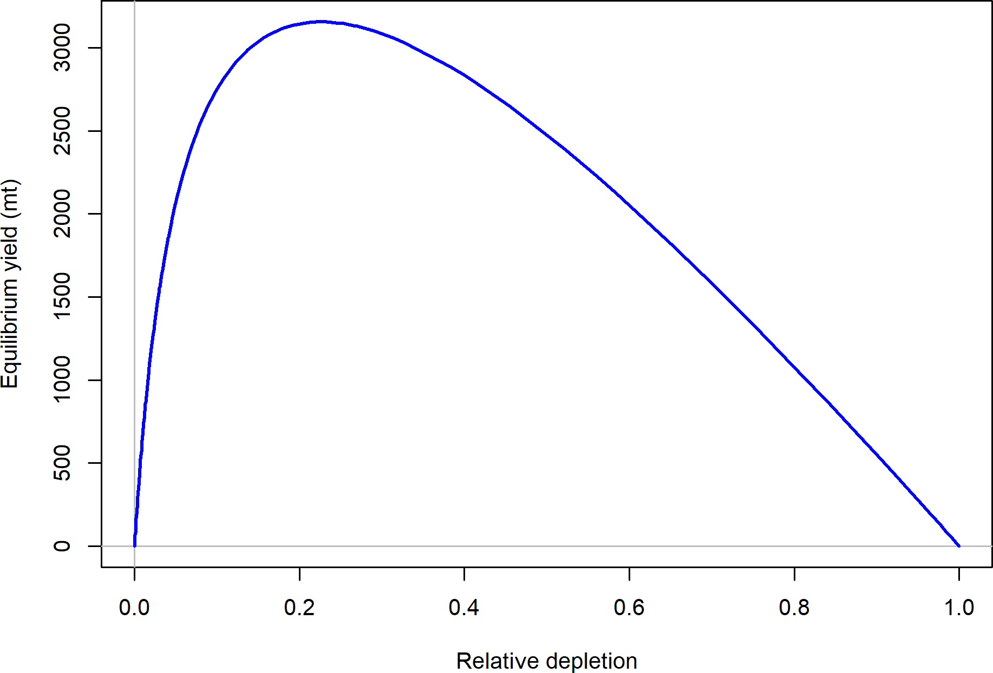

Figure g: Equilibrium yield curve for the base case model. Values are based on the 2018 fishery selectivity and with steepness estimated at 0.84.

# Introduction

## Basic Information

Petrale sole (*Eopsetta jordani* ) is a right-eyed flounder in the family Pleuronectidae ranging from the western Gulf of Alaska to the Coronado Islands, northern Baja California (Kramer et al. 1995, Love et al. 2005) with a preference for soft substrates at depths ranging from 0-550 m (Love et al. 2005). Common names include brill, California sole, Jordan’s flounder, cape sole, round nose sole, English sole, soglia, petorau, nameta, and tsubame garei (Smith 1937, Gates and Frey 1974, Eschmeyer and Herald 1983, Love 1996). In northern and central California petrale sole are dominant on the middle and outer continental shelf. PacFIN fishery logbook data show that adults are caught in depths from 18 to 1,280 m off the U.S. West Coast with a majority of the catches of petrale sole being taken between 70-220 m during March through October, and between 290-440 m during November through February.

Past assessments completed by Demory (1984,), Turnock et al. (1993), and Sampson and Lee (1999) considered petrale sole in the Columbia and U.S.-Vancouver INPFC areas a single stock. Sampson and Lee (1999) assumed that petrale sole in the Eureka and Monterey INPFC areas represented two additional distinct socks. The 2005 petrale sole assessment assumed two stocks, northern (U.S.-Vancouver and Columbia INPFC areas) and southern (Eureka, Monterey and Conception INPFC areas), to maintain continuity with previous assessments. Three stocks (West Coast Vancouver Island, Queen Charlotte Sound, and Heceta Strait) are considered for petrale sole in the waters off British Columbia, Canada (Starr and Fargo 2004). The 2009, 2011, 2013, and 2015 assessments integrate the previously separate north-south assessments to provide a coast-wide status evaluation. The decision to conduct a single-area assessment is based on strong evidence of a mixed stock from tagging studies, a lack of genetic studies on stock structure, and a lack of evidence for differences in growth between the 2005 northern and southern assessment areas and from examination of the fishery size-at-age data, as well as confounding differences in data collection between Washington, Oregon, and California. This 2019 update assessment provides a coast-wide status evaluation for petrale sole using data through 2018.

Fishing fleets are separated both geographically and seasonally to account for spatial and seasonal patterns in catch given the coast-wide assessment area. The petrale sole fisheries possess a distinct seasonality, with catches peaking during the winter months, so the fisheries are divided into winter (November-February) and summer (March-October) fisheries. Note that the “fishing year” for this assessment (November 1 to October 31) differs from the standard calendar year. The U.S.-Canadian border is the northern boundary for the assessed stock, although the basis for this choice is due to political and current management needs rather than the population dynamics. Given the lack of clear information regarding the status of distinct biological populations, this assessment treats the U.S. petrale sole resource from the Mexican border to the Canadian border as a single coast-wide stock.

## Life History

Petrale sole spawn during the winter at several discrete deep water sites (270-460 m) off the

U.S. West Coast, from November to April, with peak spawning taking place from December to February (Harry 1959, Best 1960, Gregory and Jow 1976, Castillo et al. 1993, Reilly et al. 1994, Love 1996). Females spawn once each year and fecundity varies with fish size, with one large female laying as many as 1.5 million eggs (Porter 1964). Petrale sole eggs are planktonic, ranging in size from 1.2 to 1.3 mm, and are found in deep water habitats at

water temperatures of 4-10 ∘C and salinities of 25-30 ppt (Best 1960, Ketchen and Forrester

1966, Alderdice and Forrest 1971, Gregory and Jow 1976). The duration of the egg stage

can range from approximately 6 to 14 days (Alderdice and Forrest 1971, Love 1996). The most favorable conditions for egg incubation and larval growth are 6-7 ∘C and 27.5-29.5 ppt (Ketchen and Forrester 1966, Alderdice and Forrest 1971, Castillo 1995).

Adult petrale sole achieve a maximum size of around 50 cm and 63 cm for males and females, respectively (Best 1963, Pedersen 1975). The maximum length reported for petrale sole is 70 cm (Eschmeyer and Herald 1983, Love et al. 2005) while the maximum observed break-and-burn age is 34 years (observed in 2003 by the NWFSC West Coast Groundfish Bottom Trawl Survey survey).

## Historical and Current Fishery Information

Petrale sole have been caught in the flatfish fishery off the U.S. Pacific coast since the late 19th century. The fishery first developed off of California where, prior to 1876, fishing in San Francisco Bay was by hand or set lines and beach seining (Scofield 1948). By 1880 two San Francisco based trawler companies were running a total of six boats, extending the fishing grounds beyond the Golden Gate Bridge northward to Point Reyes (Scofield 1948). Steam trawlers entered the fishery during 1888 and 1889, and four steam tugs based out of San Francisco were sufficient to flood market with flatfish (Scofield 1948). By 1915 San Francisco and Santa Cruz trawlers were operating at depths of about 45-100 m with catches averaging 10,000 lbs per tow or 3,000 lbs per hour (Scofield 1948). Flatfish comprised approximately 90% of the catch with 20-25% being discarded as unmarketable (Scofield 1948). During 1915 laws were enacted that prohibited dragging in California waters and making it illegal to possess a trawl net from Santa Barbara County southward (Scofield 1948). By 1934 twenty 56-72 foot diesel engine trawlers operated out of San Francisco fishing between about 55 and 185 m (Scofield 1948). From 1944-1947 the number of California trawlers fluctuated between 16 and 46 boats (Scofield 1948). Although the flatfish fishery in California was well developed by the 1950s and 1960s, catch statistics were not reported until 1970 (Heimann and Carlisle 1970). In this early California report petrale sole landings during 1916 to 1930 were not separated from the total flatfish landings.

The earliest trawl fishing off Oregon began during 1884-1885, and the fishery was solidly established by 1937, with the fishery increasing rapidly during WWII (Harry and Morgan,

1961). Initially trawlers stayed close to the fishing grounds adjacent to Newport and Astoria, operating at about 35-90 m between Stonewall Bank and Depoe Bay. Fishing operations gradually extended into deep water. For example, Newport-based trawlers were commonly fishing at about 185 m in 1949, at about 185-365 m by 1952, and at about 550 m by 1953.

Alverson and Chatwin (1957) describe the history of the petrale sole fishery off of Washington and British Columbia with fishing grounds ranging from Cape Flattery to Destruction Island. Petrale sole catches off of Washington were small until the late 1930s with the fishery extending to about 365 m following the development of deep water rockfish fisheries during the 1950s.

By the 1950s the petrale sole fishery was showing signs of depletion with reports suggesting that petrale sole abundance had declined by at least 50% from 1942 to 1947 (Harry 1956). Sampson and Lee (1999) reported that three fishery regulations were implemented during 1957-67: 1) a winter closure off Oregon, Washington and British Columbia, 2) a 3,000 lb per trip limit, and 3) no more than two trips per month during 1957. With the 1977 enactment of the Magnuson Fishery Conservation and Management Act (MFCMA) the large foreign- dominated fishery that had developed since the late 1960s was replaced by the domestic fishery that continues today. Petrale sole are harvested almost exclusively by bottom trawls in the U.S. West Coast groundfish fishery. Recent petrale sole catches exhibit marked seasonal variation, with substantial portions of the annual harvest taken from the spawning grounds during December and January. Evidence suggests that the winter fishery on the deep water spawning grounds developed sporadically during the 1950s and 1960s as fishers discovered new locations (e.g., Alverson and Chatwin (1957); Ketchen and Forrester (1966)). Both historical and current petrale sole fisheries have primarily relied upon trawl fleets. Fishery removals were divided among 4 fleets: 1) winter North trawl, 2) summer North trawl, 3) winter South trawl, and 4) summer South trawl. Landings for the North fleet are defined as fish landed in Washington and Oregon ports. Landings for the South fleet are defined as fish landed in California ports.

Historical landings reconstructions show peak catches from the summer fishery occurred during the 1940s and 1950s and subsequently declined, during which time the fleet moved to fishing in deeper waters during the winter. After the period of peak landings during the 1940s and 1950s, total landings were somewhat stable until about the late 1970s, and then generally declined until the mid-2000s. (Table 1 and Figure 1). During 2009 the fishery was declared overfished and during 2010 management restrictions limited the catch to 755 mt (Table 1 and Figure 1). Recent years overfishing limit (OFL), annual catch limit (ACL), landings, and estimated total dead are shown in Table 2.

## Summary of Management History and Performance

Beginning in 1983 the Pacific Fishery Management Council (PFMC) established coast-wide annual catch limits (ACLs) for the annual harvests of petrale sole in the waters off the U.S. West Coast. The first assessment of West Coast petrale sole occurred in 1984 (Demory 1984).

Based on the 1999 assessment a coast-wide ACL of 2,762 mt was specified and remained unchanged between 2001 and 2006.

The 2005 assessment of petrale sole stock assessment split the stock into two areas, the northern area that included U.S.-Vancouver and Columbia INPFC areas and the southern area that included the Eureka, Monterey and Conception INPFC areas (Lai et al. 2005). While petrale sole stock structure is not well understood, CPUE and geographical differences between states were used to support the use of two separate assessment areas. In 2005 petrale sole were estimated to be at 34 and 29% of unfished spawning stock biomass in the northern and southern areas, respectively. In spite of different models and data, the biomass trends were qualitatively similar in both areas, providing support for a coast-wide stock. This assessment estimated that petrale sole had historically been below the Pacific Council’s minimum stock size threshold of 25% of unfished biomass from the mid-1970s until just prior to the completion of the assessment, with estimated harvest rates in excess of the target fishing mortality rate implemented for petrale sole at that time (F40%). However, the 2005 stock assessment determined that the stock was in the precautionary zone and was not overfished (i.e., the spawning stock biomass was not below 25% of the unfished spawning stock biomass). Based on the 2005 stock assessment results, ACLs were set at 3,025 mt and 2,919 mt for 2007 and 2008, respectively, with an ACT of 2,499 mt for both years.

In comparison to the 1999 assessment of petrale sole, the 2005 assessment represented a significant change in the perception of petrale sole stock status. The stock assessment conducted in 1999 (Washington-Oregon only) estimated the spawning stock biomass in 1998 at 39% of unfished stock biomass. Although the estimates of 1998 spawning-stock biomass were little changed between the 1999 and 2005 (Northern area) assessments, the estimated depletion in the 2005 assessment was much lower. The change in status between the 1999 and 2005 analyses was due to the introduction of a reconstructed catch history in 2005, which spanned the entire period of removals. The 1999 stock assessment used a catch history that started in 1977, after the bulk of the removals from the fishery had already taken place. Thus the 1999 stock assessment produced a more optimistic view of the petrale stock’s level of depletion. The stock’s estimated decline in status between the 2005 and 2009 assessments was driven primarily by a significant decline in the trawl-survey index over that period. The 2011 assessment concluded that the stock status continued to be below the target of 25% of unfished biomass.

The 2009 coast-wide stock assessment estimated that the petrale sole stock had declined from its 2005 high to 11.6% of the unfished spawning stock biomass (Haltuch and Hicks 2009). The petrale sole was declared overfished based on newly adopted management targets (e.g., target spawning biomass for flatfish stocks defined as 25% and overfished threshold of 12.5% of unfished spawning stock biomass) resulting in a rebuilding plan and catch restrictions for petrale sole. The stock was declared rebuilt based on the results of the 2015 update stock assessment which estimated the coastwide biomass at 30.7% of unfished spawning stock output with ACLs of 3,136 and 3,013 in 2017 and 2018 respectively (Stawitz et al. 2015).

For additional information on changes in the petrale sole fishery please see the 2013 stock

assessment (Haltuch et al. 2013b).

## Fisheries off Canada and Alaska

The Canadian fishery developed rapidly during the late 1940s to mid-1950s following the discovery of petrale sole spawning aggregations off the West Coast of Vancouver Island (Anon 2001). Annual landings of petrale sole in British Columbia peaked at 4,800 mt in 1948 but declined significantly after the mid-1960s (Anon 2001). By the 1970s, analysis conducted by Pederson (1975) suggested that petrale sole abundance was low and abundance remained low into the 1990s. In the early 1990s vessel trip quotas were established to try to halt the decline in petrale sole abundance (Anon 2001). Winter quarter landings of petrale sole were limited to 44,000 lb per trip during 1985-91; to 10,000 lb per trip during 1991-95; and to 2,000 lb per trip in 1996. Biological data collected during 1980-1996 showed a prolonged decline in the proportion of young fish entering the population (Anon 2001). Therefore, no directed fishing for petrale sole has been permitted in Canada since 1996 due to a continuing decline in long term abundance (Fargo 1997, Anon 2001). As of 2005 petrale sole off of British Columbia were treated as three “stocks” and were still considered to be at low levels. The recent assessments for the Canadian stocks have been based on catch histories and limited biological data.

In Alaska petrale sole are not targeted in the Bering Sea/Aleutian Island fisheries and are managed as a minor species in the “Other Flatfish” stock complex.

# Data

Data used in the petrale sole assessment are summarized in Figure 2. The data that were added or reprocessed for this assessment are:

1. Commercial catches (2015-2018 added);
2. Commercial length and age data (all years reprocessed, 2015-2018 added);
3. Observed discard rates, average weights, and lengths (2002-2017 reprocessed, 2014-2017 added);
4. AFSC/NWFSC West Coast Triennial Shelf Survey early and late indices of abundance and length composition data (1980-2004 reprocessed); and
5. NWFSC West Coast Groundfish Bottom Trawl Survey index of abundance, length and age composition data (2003-2018 reprocessed, 2015-2018 added).

A description of each data source is provided below.

## Fishery-Independent Data

### NWFSC West Coast Groundfish Bottom Trawl Survey

Three sources of information are produced by this survey: an index of relative abundance, length-frequency distributions, and age-frequency distributions. Only years in which the NWFSC West Coast Groundfish Bottom Trawl Survey included the continental shelf (55-183

m) are considered (2003-2018), since the highest percent of positive survey tows with petrale sole are found on the continental shelf.

The NWFSC West Coast Groundfish Bottom Trawl Survey is based on a random-grid design; covering the coastal waters from a depth of 55 m to 1,280 m (Bradburn et al. 2011). This design generally uses four industry chartered vessels per year, assigned to a roughly equal number of randomly selected grid cells and divided into two ‘passes’ of the coast that are executed from north to south. Two vessels fish during each pass, which are conducted from late May to early October each year. This design therefore incorporates both vessel-to-vessel differences in catchability as well as variance associated with selecting a relatively small number (˜700) of possible cells from a very large set of possible cells spread from the Mexican to the Canadian border.

The NWFSC West Coast Groundfish Bottom Trawl Survey commonly encounters petrale sole along the U.S West Coast, except south of Point Conception (Figure 3). The catch-

per-unit-effort estimated from the survey is roughly constant north of 38∘ (Figure 4). The survey does fish shallower than 54 m and the encounter rate of petrale sole declines at waters

deeper than 400 m. Figure 5 shows that the positive tows catch rate by depth peaks between 100-200 meters and declines as depth increases. The observed lengths captured across depths by the survey are shown in Figure 6.

The data from the NWFSC West Coast Groundfish Bottom Trawl Survey was analyzed using a spatio-temporal delta model implemented as an R package, VAST (Thorson and Barnett 2017, Thorson 2019), which is publicly available online (<https://github.com/James-Thorson/VAST>). Spatial and spatio-temporal variation is specifically included in both encounter probability and positive catch rates, a logit-link for encounter probability and a log-link for positive catch rates. Vessel-year effects were included for each unique combination of vessel and year in the data to account for the random selection of commercial vessels used during sampling (Helser et al. 2004, Thorson and Ward 2013). Spatial variation was approximated using 250 knots, and the model used the bias-correction algorithm (Thorson and Kristensen 2016) in Template Model Builder (Kristensen et al. 2016). Further details regarding model structure are available in the user manual (<https://github.com/James-Thorson/VAST/blob/> master/examples/VAST user manual.pdf).

The gamma distribution with random strata-year and vessel effects was chosen as the final model. The Q-Q plot does not show any departures from the assumed distribution (Figure 7). The Pearson residuals for the encounter and catch rates for gamma distribution model are shown in Figures 8 and 9.

The estimated index of abundance is given in Table 3. For comparison, the 2015 model estimated, the 2019 design based, and the 2019 VAST indices are shown in Figure 10. The spatial density by year estimated by VAST is shown in Figure 11. The index for the NWFSC West Coast Groundfish Bottom Trawl Survey shows an increase in the population between 2009 and 2014 and roughly stable through 2017, and decrease in the index in the most recent year, 2018.

Length bins from 12 to 62 cm in 2 cm increments were used to summarize the length frequency of the survey catches in each year. The first length bin includes all observations less than 14 cm and the last bin includes all fish larger than 62 cm. Table 5 shows the number of lengths taken by the survey. The length frequency distributions for the NWFSC West Coast Groundfish Bottom Trawl Survey from 2003-2018 generally show an increased frequency in observations of smaller fish between 2007 and 2011 (Figure 12). The stratification for length data expansion based on the design-based estimates is provided in Table 4.

Age distributions included bins from age 1 to age 17, with the last bin including all fish of greater age. Table 6 shows the number of ages taken by the survey. The marginal NWFSC West Coast Groundfish Bottom Trawl Survey age-compositions, which allow for easier viewing of strong cohorts, show the strong 1998 cohort ageing from 2003 to 2007, with younger fish appearing between 2008-2011 (Figure 13). The exception to this is the female composition in 2005, where only one female fish estimated to be age 3 was aged from the tow with the largest catch rate.

The input sample sizes for length and marginal age-composition data for all fishery- independent surveys were calculated based on the approach used in the 2013 full and 2015 update assessment as:

Input N = (0*.*138 * ( *𝑁* fish*�/ 𝑁* tows*�*) + 1) * *𝑁* tows*�*

∑︀ ∑︀ ∑︀

where fish is the number of petrale sole by year *�* and *𝑁* the total number of tows by year. The input sample size of conditional-age-at-length data was set at the number of fish at each length by sex and by year. The conditional-age-at-length data were not expanded and were binned according to length, age, sex, and year.

### AFSC/NWFSC West Coast Triennial Shelf Survey

The AFSC/NWFSC West Coast Triennial Shelf Survey (referred to as the Triennial Survey for short) was first conducted by the AFSC in 1977 and spanned the time-frame from 1977-2004. The survey’s design and sampling methods are most recently described in Weinberg et al. (2002). Its basic design was a series of equally-spaced transects from which searches for tows in a specific depth range were initiated. The survey design has changed slightly over time. In general, all of the surveys were conducted in the mid-summer through early fall: the 1977 survey was conducted from early July through late September; the surveys from 1980

through 1989 ran from mid-July to late September; the 1992 survey spanned from mid-July through early October; the 1995 survey was conducted from early June to late August; the 1998 survey ran from early June through early August; and the 2001 and 2004 surveys were conducted in May-July.

Haul depths ranged from 91-457 m during the 1977 survey with no hauls shallower than 91 m. The surveys in 1980, 1983, and 1986 covered the West Coast south to 36*.*8∘ N latitude and a depth range of 55-366 m. The surveys in 1989 and 1992 covered the same depth range but extended the southern range to 34*.*5∘ N (near Point Conception). From 1995 through 2004, the surveys covered the depth range 55-500 m and surveyed south to 34*.*5∘ N. In the final

year of the Triennial Survey series, 2004, the NWFSC’s Fishery Resource and Monitoring

division (FRAM) conducted the survey and followed very similar protocols as the Alaska Fisheries Science Center (AFSC). Due to haul performance issues and differences in sampling depths, the 1977 are omitted from analysis.

Due to changes in survey timing, the Triennial Survey data have been split into independent early (1980-1992) and late (1995-2004) survey time series. The splitting of this time series was investigated during the 2009 STAR panel due to the changes in survey timing and the expected change in petrale sole catchability because of the stock’s seasonal onshore-offshore migrations (Cook et al. 2009). For these reasons, as well as because the split improved fits to the split time series and made small changes to the estimation of the selectivity curves, the 2009 STAR panel supported the split.

The Triennial Survey commonly encounters petrale sole along the U.S West Coast (Figure 14). The catch-per-unit-effort estimated from the survey is roughly constant across the surveyed latitudes (Figure 15). Additionally, petrale sole were captured across the survey depths between 55-500 m (Figure 16). The observed lengths captured across depths by each survey period are shown in Figure 17.

The data from the petrale sole was analyzed using a spatio-temporal delta model implemented as an R package, VAST (Thorson and Barnett 2017, Thorson 2019), described above in Section 2.1.1. Spatial variation was approximated using 250 knots, and the model used the bias-correction algorithm (Thorson and Kristensen 2016) in Template Model Builder (Kristensen et al. 2016). The index of abundance was estimated using VAST seperately for the early and late periods of the survey.

The gamma distribution with random strata-year and vessel effects was chosen as the final model for both the early and late time periods. The Q-Q plots do not show any departures from the assumed distribution (Figures 18 and 19). The Pearson residuals for the encounter and catch rates for the early and late periods are shown in Figures 20, 21, 22, and 23.

The estimated index of abundance is given in Table 3. For comparison, the 2013 model estimated, the 2019 design based, and the 2019 VAST indices are shown in Figure 24. The estimated density of petrale sole is show in Figures 25 and 26. The index for the Triennial Survey across the early and late period shows an slight increase in the population between 1980 and 2001 with a spike in the final year of 2004.

Length bins from 12 to 62 cm in 2 cm increments were used to summarize the length frequency of the survey catches in each year. Table 7 shows the number of lengths taken by the survey. The length frequency distributions for the Triennial Survey from 1980-2004 are shown in Figures 27 and 28. The stratifications for length data expansions are provided in Tables 8 and 9.

There are no petrale sole age data from the Triennial Survey.

The input sample sizes for length data were calculated using the same approach for the NWFSC West Coast Groundfish Bottom Trawl Survey data described in Section 2.1.1.

## Fishery-Dependent Data

* + 1. **Commercial Fishery Landings**

All landings for this update assessment were summarized by port of landing, where available, as well as for a northern fleet consisting of Washington and Oregon and a southern fleet consisting of California. Landings for Washington and Oregon are summed into a single northern fleet due to the fact that vessels commonly fish and land in each other’s waters and ports.

The PacFIN database (1981-2018 for California and Washington; 1987-2018 for Oregon) extracted June 26, 2019. Historical catches were not updated from the previous assessment in 2013. The 2013 assessment historical Washington catches were obtained from WDFW landings reconstruction for 1935, 1939 and 1949- 1969 (pers. comm. T. Tsou and G. Lippert) and the Pacific Marine Fisheries Commission (PMFC) Data Series for 1956-1980 (PFMC 1979). The 2013 assessment historical Oregon landings were obtained from reconstruction for 1932 to 1986 (Karnowski et al. 2014). The 2013 assessment historical California landings used catch reconstruction data extending from 1931-1980 (Ralston et al. 2010) and California Department of Fish and Game (CDFG) Fish Bulletins for 1916-1930 landings (Heimann and Carlisle 1970) as reconstructed by Lai et al. (2005). The California fishery began in 1876 but no landings data are available from 1876-1915. Therefore a linear interpolation between landings of 1 ton in 1876 and the landings recorded for 1916 are used to filling this period.

Landings for the fishing year, beginning on 1 November, are summarized by fleet in Table 1 and Figure 1. The landings of petrale sole by gear types other than groundfish-trawl have been inconsequential, averaging less than 2.5% of the coast-wide landings. The non-trawl landings, that consist of only a small fraction of the total landings, are included in the trawl landings.

* + 1. **Discards**

Data on discards of petrale sole are available from two different data sources. The earliest source is referred to as the Pikitch data and comes from a study organized by Ellen Pikitch that collected trawl discards from 1985-1987 (Pikitch et al. 1988). The northern and southern

boundaries of the study were 48∘42′ N latitude and 42∘60′ N latitude respectively, which is primarily within the Columbia INPFC area (Pikitch et al. 1988, Rogers and Pikitch 1992).

Participation in the study was voluntary and included vessels using bottom, midwater, and shrimp trawl gears. Observers of normal fishing operations on commercial vessels collected the data, estimated the total weight of the catch by tow, and recorded the weight of species retained and discarded in the sample. Results of the Pikitch data were obtained from John Wallace (personal communication, NWFSC, NOAA) for the 2013 assessment in the form of ratios of discard weight to retained weight of petrale sole and sex-specific length frequencies. The Pikitch discard estimates were applied to both the summer and winter northern fisheries and are shown in Table 10. These data have not been modified in this update assessment.

The second source is from the West Coast Groundfish Observer Program (WCGOP). This program is part of the NWFSC and has been recording discard observations since 2003. Table 10 shows the discard ratios (discarded/(discarded + retained)) of petrale sole from WCGOP based on observer observations. Since 2011, when the trawl rationalization program was implemented, observer coverage rates increased to nearly 100% for all the limited entry trawl vessels in the program and discard rates declined compared to pre-2011 rates. However, discarding rate of petrale sole within this data-set has always been relatively low. Discard rates were obtained for both the catch-share and the non-catch share sector for petrale sole. A single discard rate was calculated by weighting discard rates based on the commercial landings by each sector. Coefficient of variations were calculated for the non-catch shares sector and pre-catch share years by bootstrapping vessels within ports because the observer program randomly chooses vessels within ports to be observed. The coefficient of variation of discarding in the catch share fleet, given nearly 100% observer coverage, was considered low and a value of 0.01 was assumed. The discard rates from WCGOP are shown in Table 10.

Starting in 2015, a small number of vessels switched to electronic monitoring discards at sea rather than a human observer (4, 7, and 8 vessels in 2015, 2016, and 2017 respectively). Discarding rates at sea of petrale sole by these vessels were very low, near zero. This update assessment did not evaluate these data to estimate an electronic monitoring specific discard rate, but rather applied the discard ratio from the observed vessels in the WCGOP database. Future assessments should evaluate this assumption in greater detail.

Discard mean body weight data were obtained from the WCGOP data and used in this update assessment for each of the four fishing fleets. The mean body weight of discarded fish from each fleet are shown in Figures 31 - 34. The summer fisheries, both north and south, had relatively large sample numbers which is reflected in a lower coefficient of variation by year relative to the winter fisheries.

Discard length composition data available from the Pikitch study and WCGOP data were

used in this update assessment to estimate retention curves for each of the four fishing fleets. The discard length data from each fleet are shown in Figures 35 and 36.

### Foreign Landings

The impact of landings of petrale sole by foreign fishing fleets prior to the institution of the exclusive economic zone (EEZ) of the U.S. West Coast is currently not quantified and remains an area for research.

### Historical Commercial Catch-Per-Unit Effort/Logbooks

Commercial logbook data for petrale sole was first used to construct CPUE indices of abundance in the 1999 assessment for Oregon fleets from 1987-1997 (Sampson and Lee 1999). Since the first inclusion in 1999, the commercial CPUE indices were extended and or updated based on management changes and new statistical methods through 2009. For additional information on the use of CPUE indices in the assessment of petrale sole please see the 2013 assessment (Haltuch et al. 2013b).

CPUE calculations for the Winter fishery on aggregations of petrale sole described in the 2013 assessment were retained for this assessment (Haltuch et al. 2013b) (Figures 29 and 30). Two CPUE indices from 1987-2009 with catchability modeled as a power function are used in this update assessment, one for the north and south winter fisheries. These data have not been re-evaluated for this update assessment.

### Fishery Length and Age Data

The PacFIN BDS database contains data from Oregon Department of Fish and Wildlife (ODFW; 1966-present) and Washington Department of Fish and Wildlife (WDFW; 1955- present), but only 1986-present data from California Department of Fish and Game (CDFG). The CDFG data set for the years 1948-1992 was extracted and provided from CalCOM by Brenda Erwin (CDFG) in 2011.

The historical Oregon data for petrale sole has change substantially since 2015. The state has identified that all samples collected prior to 1987 were not collected according to the state’s standardized sampling protocol that were included in PacFIN as random samples in error (pers. comm. Ali Whitman). These samples likely represent samples that were collected for special projects. Oregon has removed some of these samples for petrale sole from PacFIN, but not all, as of June 2019. To remove the remaining non-standard samples, Oregon PacFIN data were filtered to remove all samples prior to 1987. Although these samples were removed from the length and age composition data for this update assessment, future assessments

should evaluate these data to determine if they can be included within the assessment through alternative means (e.g., external estimates of length-at-age or as conditional-age-at-length data).

Commercial length-frequency distributions based on the fishing year were developed for each state for which observations were available. For each fleet, the raw observations (compiled from the PacFIN and CalCOM data-bases) were expanded to the sample level, to allow for any fish that were not measured, then to the trip level to account for the relative size of the landing from which the sample was obtained. The expanded length observations were then expanded by the landings in each state for the combined Washington and Oregon fleet. Age frequencies were computed in the same manner, except that age observations for Washington and Oregon were not combined due to ageing error considerations.

Length and age data collected from commercial landings for each fleet are summarized by the number of trips and fish sampled by year (Tables 11 and 12). Figures 35, 36, and 37 show plots of the commercial length and age composition data across time for each fishery fleet.

The calculation for input sample sizes for the commercial length and age data was done to be consistent with the 2013 assessment. The input sample size for commercial lengths and ages were set equal to the number of trips by year for each fleet.

## 2.3 Biological Data

### 2.3.1 Natural Mortality

The instantaneous rate of natural mortality for a wild fish population is notoriously difficult to estimate. One accepted method is to examine the age distribution of an unexploited or lightly exploited stock. This method cannot readily be applied to petrale sole given the long history of exploitation off the U.S. West Coast. Ketchen and Forrester (1966) estimated that the natural mortality coefficients were 0.18-0.26 yr-1 for males and 0.19-0.21 yr-1 for females based on a catch curve analysis of 1943-1945 Washington trawl data from Swiftsure Bank, off the southwest corner of Vancouver Island. However, petrale sole catches were relatively high during mid-1940s through the 1950s. Starr and Fargo (2004) estimated the instantaneous rate of natural mortality (*𝑀* ) using Hoenig’s method (Hoenig 1983) estimating *𝑀* values of

0.22 and 0.15 yr-1 were estimated given maximum ages of 20 and 30 years, respectively.

An archived set of commercial samples, collected from Northern California between the late 1950s and early 1980s, recently found that multiple samples were aged between 20-31 years old, suggesting a similar range of *𝑀* values for U.S. West Coast petrale sole. U.S. stock assessments prior to 2009 and current British Columbia stock assessments assumed a value of

*𝑀* = 0.2 yr-1 for both sexes. The 2013 stock assessment used a meta-analysis value produced the following normal prior distributions for females (mean = 0.151, sd = 0.16) and males

(0.206, sd = 0.218) based on early research by Owen Hamel (pers. comm.) with maximum age for females and males of 32 and 29 years, respectively.

Hamel (2015) refined and published a method for combining meta-analytic approaches relating the *𝑀* rate to other life-history parameters such as longevity, size, growth rate, and reproductive effort to provide a prior on *𝑀*. In that same issue of *ICES Journal of Marine Science*, Then et al. (2015) provided an updated data set of estimates of *𝑀* and related life history parameters across a large number of fish species from which to develop an *𝑀* estimator for fish species in general. They concluded by recommending *𝑀* estimates be based on maximum age alone, based on an updated Hoenig non-linear least squares

estimator *𝑀* = 4*.*899*𝐴*−0*.*916. The approach of basing *𝑀* priors on maximum age alone was

*�𝑎�*

one that was already being used for West Coast rockfish assessments. However, in fitting the

alternative model forms relating *𝑀* to *𝐴*max, Then et al. (2015) did not consistently apply their transformation. In particular, in real space, one would expect substantial heteroscedasticity in both the observation and process error associated with the observed relationship of *𝑀* to

*𝐴*max. Therefore, it would be reasonable to fit all models under a log transformation. This was not done. Re-evaluating the data used in Then et al. (2015) by fitting the one-parameter

*𝐴*max model under a log-log transformation (such that the slope is forced to be -1 in the transformed space (Hamel 2015)), the point estimate for *𝑀* is:

*𝑀* = 5*.*4

*𝐴*

max

The above is also the median of the prior. The prior is defined as a lognormal distribution with mean *��*(5*.*4*/𝐴*max) and SE = 0.438.

The natural mortality prior was updated for this update assessment using the above approach (Figure 38). Maximum age was assumed to be 32 and 29 years for females and males, respectively, the same assumption applied in the 2013 assessment. Using the Hamel et al. approach above, the prior value for females in regular space is 0.169 and for males is 0.186.

### Maturation and Fecundity

Petrale sole maturity-at-length information is generally sparse in space and time, has not been collected in a systematic fashion across time, is of varying quality, and does not always agree between studies. It is possible that maturity may have changed over time. However, it is not possible to assess this quantitatively owing to differences in when historical samples on which maturity ogives could be based were taken, and how maturity stage (visual vs. histological) was determined. The 2005 petrale sole assessment used the most recent study for the West Coast of the U.S. that was based on observations collected during 2002 from Oregon and Washington (Hannah et al. 2002). The 50% size-at-maturity was estimated at 33.1 cm with maturity asymptoting to 1.0 for larger fish (Figure 39).

At the time of the last assessment, there had been limited information regarding fecundity at age or length of petrale sole. The 2013 stock assessment assumed that fecundity of female

petrale sole was equal to biomass (Figure 40). However, new research has been done examining the fecundity of petrale sole (Lefebvre et al. n.d.) which is in press at Fisheries Research. The study concluded a difference in fecundity between California and Washington petrale sole where a 40 cm fish in California is more fecund compared to northern fish of the same size (Figure 41). However, northern fish of the largest size were more fecund relative to fish in California. The current petrale sole model is a single area coastwide model, which assumes fish along the U.S. have the same biology (e.g. natural mortality, growth, fecundity). The estimates of fecundity for petrale sole were considered new data and based on the guidelines for update stock assessments, these data were not included in the base model. However, a sensitivity to including these data was provided. The next full assessment should explore and include the new data about fecundity-at-length.

### Sex Ratio

Past assessments of petrale sole have assumed a 50% sex ratio between females and males off the U.S West Coast. Similarly, Canadian data from the 2004 published stock assessment also suggests sex ratios of petrale sole in British Columbia are generally 50% males and 50% females (Starr and Fargo 2004). To be consistent with the full assessment this update assessment retains the equal sex ratio assumption. However, examining the NWFSC West Coast Groundfish Bottom Trawl Survey data the proportion of females in the population across the mid-range lengths is approximately 0.40 - 0.45 with the proportion increasing to 1 at the largest lengths due to dimorphic growth (Figure 42). The next full assessment should evaluate the sex ratio across time and space for petrale sole.

### Length-Weight Relationship

The length-weight relationship for petrale sole was estimated outside the model using all biological data available from the NWFSC West Coast Groundfish Bottom Trawl Survey data consistent with method applied by the 2013 assessment. The female weight-at-length in grams was estimated at 1.986e-06*𝐿*3.48 and males at 2.983e-06*𝐿*3.36 where *𝐿* is length in cm (Figures 43). The length-weight relationship estimates from the NWFSC West Coast Groundfish Bottom Trawl Survey data were consistent with the biological observations available from the fishery data.

### Growth (Length-at-Age)

The length-at-age was estimated for male and female petrale sole. Figure 44 shows the lengths and ages as well as predicted von Bertalanffy fits to the data from the fishery and the NWFSC West Coast Groundfish Bottom Trawl Survey data. Females grow larger than males and sex-specific growth parameters were estimated at the following values for females

*𝐿*∞ = 54 cm; *�* = 0.16 yr−1, and males *𝐿*∞ = 41 cm; *�* = 0.25 yr−1. These values were used as starting parameter values within the base model prior to estimating each parameter for male and female petrale sole.

### Ageing Precision and Bias

Historically, petrale sole otoliths have been read by multiple ageing labs using surface and break and burn methods. In order to conduct a comprehensive estimation of ageing bias and imprecision, the 2009 assessment compiled and analyzed all of the available double-read data from the Cooperative Aging Project (CAP) and the Washington Department of Fish and Wildlife (WDFW), as well information from a bomb radiocarbon age validation study for petrale sole off the U.S. West Coast (Haltuch and Hicks 2009, Haltuch et al. (2013a)).

The 2013 stock assessment applied read method and lab specific ageing error vectors (Haltuch et al. 2013b). This update assessment did not re-evaluate ageing error and applied the same approach as the 2013 stock assessment. The ageing error vectors are shown in Tables 13 and

14. For a detailed description please see the 2013 stock assessment (Haltuch et al. 2013b).

### Environmental and Ecosystem Data

This update assessment did not evaluate potential ecosystem data and methodologies for petrale sole.

# Assessment Model

## History of Modeling Approaches Used for This Stock

Early stock assessments only assessed petrale sole in the combined U.S.-Vancouver and Columbia INPFC areas, i.e. petrale sole in these areas were treated as a unit stock, using time series of data that began during the 1970s (Demory 1984, Turnock et al. 1993). The first assessment used stock reduction analysis and the second assessment used the length-based Stock Synthesis model. The third petrale sole assessment utilized the hybrid length-and-age- based Stock Synthesis 1 model, using data from 1977-1998 (Sampson and Lee 1999). During the 1999 stock assessment an attempt was made to include separate area assessments for the Eureka and Monterey INPFC areas but acceptable models could not be configured due to a lack of data (Sampson and Lee 1999).

The 2005 petrale sole assessment was conducted as two separate stocks, the northern stock encompassing the U.S. Vancouver and Columbia INPFC areas and the southern stock including

the Eureka, Monterey and Conception INPFC areas, using Stock Synthesis 2, a length-age structured model. Both the northern- and southern-area models specified the fishing year as beginning on November 1 and continuing through October 31 of the following year, with a November-February winter fishery and a March-October summer fishery. Landings prior to 1957 were assumed to have been taken during the summer season in years where monthly data were not available to split the catches seasonally. The complete catch history was reconstructed for petrale sole for the 2005 stock assessment, with the northern area model starting in 1910 and the southern area model in 1876. In 2005, the STAR panel noted that the petrale sole stock trends were similar in both northern and southern areas, in spite of the different modeling choices made for each area, and that a single coast-wide assessment should be considered.

The 2009 and 2011 assessments treated petrale sole as a single coast-wide stock, with the fleets and landings structured by state (WA, OR, CA) area of catch. During the 2011 STAR panel concerns were raised regarding the difficulty of discriminating landings from Washington and Oregon waters, particularly in light of the Oregon historical landings reconstruction that includes a summary of data by port of landing but not by catch area, due to the fact that the Oregon and Washington vessels commonly fish in each other’s waters and land in each other’s ports. The availability of the historical comprehensive landings reconstruction for Oregon by port of landing lead the STAR panel to recommend combining the Washington and Oregon fleets within the coast-wide stock assessment using port of landing rather than catch area.

Starting with the 2013 stock assessment, the coast-wide stock assessment now summarizes petrale sole landings by the port of landing and combines Washington and Oregon into a single fleet (Haltuch et al. 2013b). This update assessment assumes the same approach as the 2013 stock assessment.

## General Model Specifications and Assumptions

Stock Synthesis version 3.30.03.13 was used to estimate the parameters in the model (Methot and Wetzel 2013). r4ss, version 1.35.1, along with R version 3.4.3 were used to investigate and plot model fits. A summary of the data sources used in the model (details discussed above) is shown in Figure 2.

### Changes Between the 2013, the 2015 Update, and the Current Update Assessment Model

This update assessment model retains all parameterization assumed in the 2013 assessment. The only changes between the 2013 and this update assessment were extending and repro- cessing data sources. This section linking the two models is intended to clearly identify where substantive changes were made. These changes include:

* + - 1. Fitting using SS v.3.30.13.
      2. Added commercial fishery catch data (2015-2018).
      3. Added composition data from the commercial fishery (length and age data 2015-2018) and reprocessed all data and expanded based upon the current methods.
      4. Added recent discard data (2014-2017) and reprocessed all discard rate, average weight, and length composition data.
      5. Added 2015-2018 NWFSC West Coast Groundfish Bottom Trawl Survey data and calculated the index of abundance using VAST.
      6. Added NWFSC West Coast Groundfish Bottom Trawl Survey length and age data 2015-2018.
      7. Triennial Survey early and late indices of abundance were calculated using VAST.
      8. Model tuning to re-weight data.
      9. Length-weight relationship parameters estimated outside of the stock assessment model from the NWFSC West Coast Groundfish Bottom Trawl Survey data up to 2018 and input as fixed values.
      10. Update the natural mortality prior for female and male fish.

The general model set-up is described in Table 15.

### Summary of Fleets and Areas

Fishery removals were divided among 4 fleets: 1) Winter North trawl, 2) Summer North trawl, 3) Winter South trawl, and 4) Summer South trawl. Landings for the North fleet are defined as fish landed in Washington and Oregon ports. Landings for the South fleet are defined as fish landed in California ports. Removals by other gears are very small and are included in the trawl fishery removals. The data available for each fleet are described in Figure 2.

### Priors

Priors were applied only to parameters for steepness (*ℎ*) and natural mortality (*𝑀*). The steepness prior is based on the Myers (1999) meta-analysis of flatfish steepness and the natural mortality prior is based on a meta-analysis completed by Hamel (2015). The prior for steepness assumed a beta distribution with a mean equal to 0.80 (Figure 45).

The natural mortality prior was updated for this update assessment using the Hamel meta- analysis approach. Maximum age was assumed to be 32 and 29 years for females and male, respectively (Figure 38). The same maximum age assumption was applied in the 2013 assessment.

### Data Weighting

Length and conditional-age-at-length compositions from the NWFSC West Coast Groundfish Bottom Trawl Survey were fit along with length and marginal age compositions from the fishery fleets and the Triennial Survey. Length data started with a input sample size determined from the equation listed in Sections 2.1.1 (survey data) and 2.2.5 (fishery data). It was assumed for conditional-age-at-length data that each age was a random sample within the length bin and the model started with a sample size equal to the number of fish in that length bin.

The update assessment model was weighted using the McAllister and Ianelli (1997) method (Harmonic Mean weighting), consistent with the 2013 full and 2015 update assessments. The McAllister and Ianelli data weight approach looks at the difference between individual observations and predictions. A sensitivity was performed examining the difference between alternative weighting approaches. The weights applied to each length and age data set for the base model are shown in Table 16.

### Estimated and Fixed Parameters

There were 304 estimated parameters in the base model. These included parameters for

*𝑅*0, natural mortality by sex, steepness, growth, selectivity, retention, time blocking of the fleets and the surveys, commercial CPUE catchability, recruitment deviations, and forecast recruitment deviations (Table 17).

Fixed parameters in the model were as follows. The standard deviation of recruitment deviates was fixed at 0.40. Maturity-at-length and fecundity was fixed as described above in Section 2.3.2. Length-weight parameters were fixed at estimates using all length-weight observations (Figure 43).

### Key Assumptions and Structural Choices

All structural choices for stock assessment models are likely to be important under some circumstances. In this update assessment update these choices are generally made to be consistent with the previous assessment (Haltuch et al. 2013b). Major choices in the structuring of this stock assessment model include a coast-wide model with seasonal fleet

structure for two regions, north and south, splitting the Triennial Survey into an early and late time period, and estimates of selectivity and retention curves for each fleet.

### Bridging Analysis

The exploration of models began by bridging from the 2015 update assessment to Stock Synthesis version 3.30.03.13, which produced no discernible difference (Figure 46).

### Convergence

Proper convergence was determined by starting the minimization process from dispersed values of the maximum likelihood estimates to determine if the model found a better minimum. Starting parameters were jittered by 5% and 10%. This was repeated 50 times and a better minimum was not found (Table 18). Jittering showed the model to be sensitive to starting values and there were a number of times where the model resulted in similar likelihood values (*<* 1 unit difference) to the maximum likelihood estimate.

Through the jittering done as explained above and likelihood profiles, we are confident that the base model as presented represents the best fit to the data given the assumptions made. There were no difficulties in inverting the Hessian to obtain estimates of variability, although much of the early model investigation was done without attempting to estimate a Hessian.

## Base Model Results

The base model parameter estimates along with approximate asymptotic standard errors are shown in Table 17 and the likelihood components are shown in Table 19. Estimates of derived reference points and approximate 95% asymptotic confidence intervals are shown in Table 20. Estimates of stock size over time are shown in Table 21.

### Parameter Estimates

Natural mortality be sex was estimated directly within the model. Natural mortality was estimated to be 0.159 for female fish and 0.164 for male fish. In comparison the estimates from the 2015 assessment were 0.145 and 0.154 for female and male fish, respectively.

Steepness was also estimated within the model, consistent with the approach applied in the 2013 full and 2015 update assessment. The estimate of steepness from the Beverton-Holt

stock recruitment curve was estimated at 0.84. The previous update assessment estimated a steepness of 0.89.

The estimates of maximum length and the von Bertanlaffy growth coefficient, *�*, were less than the external estimates for males and female but were well within the 95% confidence interval given the estimated uncertainty (Table 17). The estimated *�* for female and male fish were greater than the values estimated in the 2015 update assessment (0.142 versus 0.134 for females and 0.238 versus 0.203 for males). The majority of growth for female and male petrale sole growth occurs at younger ages, reaching near maximum length by age 10-15, depending upon sex, with female petrale sole reaching larger maximum lengths (Figure 47). The spawning output estimated was equal to the spawning weight of female fish (Figure 48).

Selectivity curves were estimated for the fishery and survey fleets. The estimated selectivities for the fishery fleets are shown in Figure 49. All fishery selectivities were estimated to be asymptotic, reaching maximum selectivity for fish between 35 and 40 cm. Shifts in selectivities for were estimated for each fleet fishery were estimated based on time blocks assumed in the 2013 assessment (Figure 49). The estimated retention curves for each fleet based on the historical time blocks and discarded length composition data are shown in Figure 50. Sex specific survey selectivities were assumed to be asymptotic and are shown in Figure 51.

The catchability for each of the winter CPUE time series were estimated as power functions. The Winter North base catchability value was estimated at 0.001 with the exponent parameter at -0.121. The Winter South base catchability value was estimated at 0.26 with the exponent parameter at -0.853.

The catchability for both surveys, Triennial Survey and NWFSC West Coast Groundfish Bottom Trawl Survey, were analytically solved comparing observed to expected vulnerable biomass across all years. The Triennial Survey had catchability values of 0.423 and 0.65 for the early and late periods, respectively. The NWFSC West Coast Groundfish Bottom Trawl Survey catchability value 2.851.

Additional survey variability, process error added directly to each year’s input variability for the Triennial Survey, both early and late, was estimated within the model. The model estimated an added variance of 0.218 for the early time period of and 0.313 for the late period. No additional variance was estimated for the NWFSC West Coast Groundfish Bottom Trawl Survey.

The time-series of estimated recruitments shows a relationship with the decline in spawning output, punctuated by larger recruitments in recent years (2006, 2007, and 2008) (Figures 52 and 53). There is little information regarding recruitment prior to 1960 and the uncertainty in those estimates is expressed in the model. The five largest estimated recruitment estimated with the model (in ascending order) occurred in 2006, 1998, 1966, 2007, and 2008. The four lowest recruitments estimated within the model (in ascending order) occurred in 1986, 1992, 1987, and 2003. However, recruitment in recent years (2013 - 2017) is estimated to be less than the expected mean recruitment indicating an absence of strong incoming recruitment. The recruitment bias adjustment applied within the model across years is shown in Figure 54.

### Fits to the Data

There are numerous types of data for which the fits are discussed: fishery CPUE, survey abundance indices, discard data (rates, mean body weights, and length compositions), length- composition data for the fisheries and surveys, marginal age compositions for the fisheries, and conditional age-at-length observations for the NWFSC West Coast Groundfish Bottom Trawl Survey.

The fit to the CPUE for the winter fisheries is show in Figures 55, 56, 57, and 58. The model fits both of the CPUE time-series relatively well. The fits to the survey indices are shown in Figures 59, 60, and 61. In order to fit the early and the late periods of the Triennial Survey extra standard error was required. The trend in the early time-series of the Triennial Survey was generally not consistent with other data within the model. The final year, 2004, in the late period of the Triennial Survey was under fit by the model. The petrale sole survey index from the NWFSC West Coast Groundfish Bottom Trawl Survey was generally fit well. However, the most recent year, 2018 data point which was lower than previous year’s indices, was not fit by the model.

The observed WCGOP discard rates (Figures 62 - 65) were fit by each fishery using time blocks. The time blocks on the discard data was based on those define in the 2013 assessment (Haltuch et al. 2013a) with the final block starting in 2011 being extended through the final model year, 2018. The discard rates for the northern fleets from the Pikitch data collected in 1985-1987 fit the mean of the estimates for the winter fishery (Figure 62) but estimated higher discard rates for the summer fleet (Figure 63). The lack of fit to the summer fleet is consistent to the estimates from the 2015 update assessment. Fits to the WCGOP observed mean body weights are shown in Figures 66 - 69. The fits to the discard mean body weights to the summer fleets were generally better than the data from the winter fisheries which had more variable observations and lower number of observations (hence larger annual uncertainties).

Fits to the length data are shown based on the proportions of lengths observed by year and the Pearson residuals-at-length for all fleets. Detailed fits to the length data by year and fleet are provided in Appendix A, Section 11. Aggregate fits by fleet are shown in Figure 70. There are a few things that stand out when examining the aggregated length composition data. First, the sexed discard lengths from the Pikitch study appear to be poorly fit by the model but this is related to small sample sizes. However, the unsexed discard lengths from the WCGOP data for each fleet were fit well by the model.

Discard lengths from WCGOP were fit well by the model and show no obvious pattern in the residuals (Figures 71 - 74). The residuals to the fishery lengths clearly showed the growth differential between males and females where the majority of positive residuals at larger sizes were from female fish (Figures 75 - 78). Notably, the Summer North fishery has a large positive residual pattern for male fish between 1966-1980. A similar pattern in the Pearson residuals was observed in the 2013 full and the 2015 update assessment (Haltuch et al. 2013b, Stawitz et al. 2015). The residuals for each of the surveys are shown in Figures 79, 80, and 81. The Pearson residuals from the NWFSC West Coast Groundfish Bottom Trawl Survey shows

indications of the 2008 cohort moving through the population. Length data were weighted according to the McAllister Ianelli Harmonic approach and the data weights are shown in Table 16.

Age data were fitted to as marginal age compositions for the fishery fleets.The NWFSC West Coast Groundfish Bottom Trawl Survey ages were treated as conditional age-at-length data to facilitate the estimation of growth within the model. The aggregated fits to the marginal age data are shown in Figure 82. The aggregated age data were fit generally well for the fishery fleets, however, the peaks of the age data were often under fit by the model which was also observed in the 2013 assessment (Haltuch et al. 2013b). Detailed fits to the age data by year and fleet are provided in Appendix B, Section 12. The Pearson residuals for the fishery fleets are shown in Figures 83 - 86. The age data were weighted using the McAllister Ianelli approach and the data weights are shown in Table 16.

The observed and expected conditional age-at-length fits for NWFSC West Coast Groundfish Bottom Trawl Survey are shown in Figures 87 - 91. The fits generally match the observations. The Pearson residuals are shown in Figure 93 and 94. The age data were also weighted according to the McAllister Ianelli Harmonic mean weights (Table 16).

### Population Trajectory

The predicted spawning biomass is given in Table 21 and plotted in Figure 95. The predicted spawning biomass time series shows a strong decline from the late-1930s through the mid- 1960s, followed by a small recovery through the mid-1970s, and another decline to its lowest point during the early 1990s. This general pattern of stock decline is coincident with increasing catches and the movement of the fishery from the south to the north, and from summer fishing in shallow waters to winter fishing on spawning aggregations in deeper waters. From the mid-1990s through 2005 the stock increased slightly, then declined through 2010 (Figure 95). The stock has increased strongly since 2010 in response to reduced catches and above average recruitment in 2006, 2007, and 2008. The estimated total biomass follows the same general trend as observed in the spawning biomass (Figure 96). The 2019 estimated spawning biomass relative to unfished equilibrium spawning biomass is above the target of 25% of unfished spawning biomass at 39.1% (Figure 97). Approximate confidence intervals based on the asymptotic variance estimates show that the uncertainty in the estimated spawning biomass is generally low. The standard deviation of the log of the spawning output in 2019 is 0.09.

Recruitment deviations were estimated for the entire time-series that was modeled (Figure 52 and discussed in Section 3.3.1) and provide a realistic portrayal of uncertainty. The time series of estimated recruitments shows a relationship with the decline in spawning output, punctuated by larger recruitments in 2006, 2007, and 2008. The five largest estimated recruitment estimated with the model (in ascending order) occurred in 2006, 1998, 1966, 2007, and 2008. The four lowest recruitments estimated within the model (in ascending order)

occurred in 1986, 1992, 1987, and 2003. However, in recent years, 2013 - 2016, based on the data the incoming recruitment has been estimated to be lower than average with negative recruitment deviations (ranging between -0.10 and -0.33) indicating an absence of strong incoming recruitment.

The stock-recruit curve resulting from a value of estimated steepness, 0.84, is shown in Figure 98 with estimated recruitments also shown.

### Sensitivity Analyses

A number of sensitivity analyses were conducted. Each of the sensitivities conducted was a single exploration from the base model assumptions and/or data, and were not performed in a cumulative fashion.

* + - 1. Fix natural mortality value for female fish at a lower value of 0.125.
      2. Fix natural mortality value for female fish at a higher value of 0.180.
      3. Use the natural mortality prior for female and male fish used in the 2015 update assessment, natural mortality estimated for both sexes.
      4. Use the coastwide fecundity relationship for petrale sole estimated by Lefebvre et al. in press.
      5. Estimate the sex ratio between female and male fish within the model. Single parameter estimated for the modeled years. Future explorations may want to explore blocking of this parameter for pre- and post-development of the spawning ground Winter fishery with the assumption that this may disproportionately impact the numbers of female petrale sole.
      6. Estimate the sex ratio between female and male fish within the model and assume the coastwide fecundity relationship for petrale sole based on Lefebvre et al. in press. Single parameter for the sex ratio estimated across all modeled years.
      7. Data weighting according to the Francis method using the weighting values shown in Table 22.
      8. Data weighting according to the Dirichlet method where the estimated parameters are shown in Table 23.

Likelihood values and estimates of key parameters from each sensitivity are available in Table

24. Plots of the estimated time-series of spawning biomass and relative spawning biomass are shown in Figures 99 and 100.

The two sensitivities exploring higher and lower natural mortality for female petrale sole were the two sensitivities that differed the most from the base model. The estimated spawning biomasses and relative stock statuses were higher or lower compared to the base model for each of these runs (Table 24, Figures 99 and 100).

Two sensitivities exploring alternative data weighting approaches were compared to the base model which was weighted using the McAllister-Ianelli data weighting approach. Both data weighting approaches resulted in similar estimates to the base model (Table 22 and Figures 99 and 99). However, the Dirichlet data weighting approach which estimates a parameter for each data source (e.g., length by fleet and ages by fleet), the estimated parameters hit the upper bounds for each data source (Table 23). Converted to real space, this data weighting approach resulted in full weight (approximately 1) for each data set. The Dirichlet method is restricted to data weights less than one, but both the Francis and McAllister and Ianelli approaches estimated data weights greater than one for some data sets. The estimated data weights are linked to the calculation of the input sample sizes which in this model were calculated based on the number of trips for the commercial data and a combination on number of tows and fish samples for the surveys. Future work should be done to better understand the performance of data weighting approaches dependent upon the calculation of input sample sizes.

The final sensitivities that had potentially meaningful differences from the base model were the three runs that explored a skewed sex ratio, potential changes in the fecundity relationship for female petrale sole, and both of these items combined. Each of these sensitivities resulted in slightly more pessimistic estimates of the relative spawning biomass (Table 24). It would be expected that the next full assessment would explore both of these parameter changes.

### Retrospective Analysis

A five-year retrospective analysis was conducted by running the model using data only through 2013, 2014, 2015, 2016, 2017 and 2018 (Figures 101, 102, and 103). The initial scale of the spawning biomass trended upward relative to the base model. Overall, no alarming patterns were present in the retrospective analysis.

### Added Data Analysis

The changes from the 2015 update assessment based on the addition and reprocessing of data was explored. Each data source was added starting with catches and ending with ages for all fleets within the model where each model run contains the earlier updated data (e.g.,

+ Lengths has data through 2019 for the catches, indices, discard rates and weights, and lengths for all fleets with only the age data through 2014). The estimates of the spawning biomass, relative spawning biomass, and the annual recruitment deviations from each model are shown in Figures 104, 105, and 106.

The time-series when data was added was relatively similar to the estimates from the 2015 update assessment. The one notable difference is the estimates of spawning biomass between the 1950s and 1970s. This update assessment estimates marginally larger spawning biomasses during this period relative to the 2015 estimate. The source of this change was due to two changes; 1) the removal of non-random samples from Oregon from the commercial biological data contained in PacFIN (see Section 2.2.5 for additional information), and 2) improvements in the processing and expansion of PacFIN data.

### Historical Analysis

The estimated summary biomass from previous assessments since 2005 are shown in Figure

107. The current assessment estimated a slight increase in initial spawning biomass compared to previous assessments.

### Likelihood Profiles

Likelihood profiles were conducted for *𝑅*0, steepness, and female natural mortality values separately. These likelihood profiles were conducted by fixing the parameter at specific values and estimated the remaining parameters based on the fixed parameter value.

For steepness, the negative log-likelihood supported values between 0.70 - 0.95 (Figure 108). Likelihood components by data source show that the age data (primarily the Northern fleets) support a higher steepness value while the length data from the NWFSC West Coast Groundfish Bottom Trawl Survey support lower values. The surveys generally provide very little information concerning steepness. The relative spawning biomass for petrale sole diverges most during the middle of the time series based on the assumed values of steepness with the final status being above the management target biomass (Figures 109 and 110).

The negative log-likelihood was minimized at a female natural mortality value of 0.159, but the 95% confidence interval extends over values ranging from 0.12 - 0.18. Male natural mortality was estimated in the likelihood profile. The age and length data likelihood contribution was minimized at female natural morality values ranging from 0.15-0.16 (Figure 111). The relative spawning biomass for petrale sole widely varied across alternative values of natural mortality (Figures 112 and 113).

In regards to values of *𝑅*0, the negative log-likelihood was minimized at approximately log(*𝑅*0) of 9.92 (Figure 114). The data source with the largest information regarding *𝑅*0 was the NWFSC West Coast Groundfish Bottom Trawl Survey.

### Reference Points

Reference points were calculated using the estimated selectivities and catch distributions among fleets in the most recent year of the model (2018). Sustainable total yields (landings plus discards) were 3,135.2 mt when using an *𝑆𝑃 𝑅*30% reference harvest rate and with a 95% confidence interval of 2,849.4 mt based on estimates of uncertainty. The spawning biomass equivalent to 25% of the unfished spawning output (*𝑆𝐵*25%) was 8,351.5.

The predicted spawning biomass from the base model generally showed a decline beginning during the 1950s and reaching a low in spawning biomass in 1993 with the stock declining to 5.8% relative stock size (Figures 95 and 97). Since 2010, the spawning biomass has been increasing due to small catches and above average recruitment. The 2019 spawning biomass relative to unfished equilibrium spawning biomass is above the target of 25% of unfished (Figure 97). The fishing intensity, 1-SPR, exceeded the current harvest rate limit (*𝑆𝑃 𝑅*30%) throughout the late 1970s until approximately 2010 as seen in Figure 115. Recent exploitation rates on petrale sole were estimated to be less than target levels.

Table 20 shows the full suite of estimated reference points for the base model and Figure 116 shows the equilibrium curve based on a steepness value estimated at 0.84.

# Harvest Projections and Decision Tables

The forecast of stock abundance and yield was developed using the base model. The total catches in 2019 and 2020 are set at values provided by the Groundfish Management Team (GMT) of the PFMC at 2908 and 2845 mt, respectively. The management adopted ACL values for these years are 2921 and 2857 mt. The exploitation rate for 2021 and beyond is based upon an SPR of 30% and the 25:5 harvest control rule. The average exploitation rates, across recent years, by fleet as provided by the GMT were used to distribute catches during the forecast period.

Uncertainty in the forecasts is based upon the three states of nature based on the likelihood profile of female natural mortality (*𝑀* ). The low and high values for natural mortality were chosen using a change of 1.2 negative log-likelihood units (75% interval) from the minimum value to correspond midpoints of the lower 25% probability and upper 25% probability regions from the base model. Based on the profile the range of uncertainty around natural mortality were selected at a low value of 0.130 yr-1 and high of 0.185 yr-1.

Catches during the projection period under the current harvest control rule are projected to start at 4115 mt and decline over the projection period to 3093 mt, in the base model, as the stock declines towards that target spawning biomass (Table 25). Across the low and high states of nature the under the current harvest control rule, the relative biomass (depletion) ranged between 0.24 - 0.34 by the end of the 12-year projection period (Table 26).

1. **Regional Management Considerations**

Currently petrale sole are managed using a coast-wide harvest; therefore this assessment does not provide a recommended method for allocating harvests regionally. The resource is modeled as a single stock. There is currently no genetic evidence that there are distinct biological stocks of petrale sole off the U.S. coast and the limited tagging data that describes adult movement suggests that movement may be significant across depth and latitude.

1. **Research Needs**

There are many areas of research that could be improved to benefit the understanding and assessment of petrale sole. Below, are issues that are considered of importance.

1. Due to limited data, new studies on maturity for petrale sole would be beneficial.
2. Studies on stock structure and movement of petrale sole, particularly with regard to the winter-summer spawning migration of petrale sole and the likely trans-boundary movement of petrale sole between U.S. and Canadian waters seasonally.
3. The extent of spatial variability on productivity processes such as growth, recruitment, and maturity is currently unknown and would benefit from further research.
4. **Acknowledgments**

Many people were instrumental in the successful completion of this assessment and their contribution is greatly appreciated. This assessment draws heavily on the text and analyses from previous petrale sole assessments and has benefited greatly from the efforts of all authors contributing to those analyses.

Alison Whitman (ODFW), Patrick Mirrick (ODFW), and Ted Calavan (ODFW) provided Oregon composition data, historical catches, corrected PacFIN catches, and quickly uploaded age data that were critical to this assessment. Melissa Mandrup (CDFW) and Brenda Erwin (CDFW) provided timely answers and resolutions regarding California data. John Wallace provided multiple last minute PacFIN extractions and analyzed historical discard rates for use in the assessment.

I am very grateful to Patrick McDonald and the team of agers at CAP for their hard work reading numerous otoliths and availability to answer questions when needed. Additionally, I am appreciative of agers at WDFW who went above and beyond helping read the backlog

of survey otoliths in time for this assessment. The work by Todd Hay and Beth Horness to streamline data access made data extraction and exploration easy. They were always eager to help and answered numerous questions. Jason Jannot, Kate Richardson, and Kayleigh Sommers assisted with data from the WCGOP and entertained my many questions. Also, I would like to acknowledge our survey team and their dedication to improving the assessments we do. The data they collect is essential to assessment of West Coast stocks.

The assessment was greatly improved through the streamlining of data processing tools (Kelli Johnson, Ian Taylor, Andi Stephens) and the many discussions within the Population Ecology team in the FRAM division at the NWFSC.

John Devore was an indispensable resource of the past, current, and future management as well as a great organizer and representative of the Pacific Fishery Management Council.

1. **References**

Alderdice, D., and Forrest, C. 1971. Effects of salinity and temperature on embryonic development of the petrale sole(*Eopsetta jordani* ). Journal of Fisheries Research Board Canada **28**: 727–744.

Alverson, D., and Chatwin, B. 1957. Results from tagging experiments on a spawning stock of petrale sole, *Eopsetta jordani* (Lockington). Journal of Fisheries Research Board Canada **14**: 953–974.

Anon. 2001. Fish stocks of the Pacific coast. Fisheries; Oceans Canada.

Best, E. 1960. Petrale Sole. In: California ocean fishereies resources to the year 1960. California Department of Fish; Game.

Best, E. 1963. Movements of petrale sole, *Eopsetta jordani*, tagged off of California. Pacific Marine Fisheries Commission Bulletin **6**: 24–38.

Bradburn, M., Keller, A., and Horness, B. 2011. The 2003 to 2008 US West Coast bottom trawl surveys of groundfish resources off Washington, Oregon, and California: Estimates of distribution, abundance, length, and age composition. US Department of Commerce, National Oceanic; Atmospheric Administration, National Marine Fisheries Service.

Castillo, G. 1992. Fluctuations of year-class strength of petrale sole (*Eopsetta jordani* ) and their relation to environmental factors. Master’s thesis, Oregon State University.

Castillo, G. 1995. Latitudinal patterns in reproductive life history traits of northeast Pacific flatfish. *In* Proceedings of the International Symposium on North Pacific Flatfish. Alaska Sea Grant, University of Alaska Fairbanks. pp. 51–72.

Castillo, G., Li, H., and Golden, J. 1993. Environmental induced recruitment variation in petrale sole, *Eopsetta jordani*. Fisheries Bulletin **92**: 481–493.

Cook, R., He, X., Maguire, J., and Tsou, T. 2009. Petrale sole STAR panel report. Pacific Fishery Management Council, 7700 Ambassador Place NE, Suite 200, Portland, OR 97220.

Demory, R. 1984. Progress report on the status of petrale sole in the INPFC Columbia- Vancouver areas in 1984. Pacific Fishery Management Council, 7700 Ambassador Place NE, Suite 200, Portland, OR 97220.

Eschmeyer, W., and Herald, E. 1983. A field guide of Pacific coaast fishes North America. Houghton Mifflin CO, Boston, MA.

Fargo, J. 1997. Flatfish stock assessments for the West Coast of Canada for 1997 and

recommended yield options for 1998. Can. Stock Assess. Sec. Res. Doc.

Gates, D., and Frey, H. 1974. Designated common names of certain marine organisms of California. Fish Buletin **161**: 55–90.

Gregory, P., and Jow, T. 1976. The validity of otoliths as indicators of age of petrale sole from California. California Department of Fish and Game **62**(2): 132–140.

Haltuch, M.A., and Hicks, A.C. 2009. Status of the U.S. petrale sole resource ien 2008. Pacific Fishery Management Council, 7700 Ambassador Place NE, Suite 200, Portland, OR 97220.

Haltuch, M.A., Hamel, O.S., Piner, K.R., McDonald, P., Kastelle, C.R., and Field, J.C. 2013a. A California Current bomb radiocarbon reference chronology and petrale sole ( *Eopsetta jordani* ) age validation. Canadian Journal of Fisheries and Aquatic Sciences **70**(1): 22–31. doi: [10.1139/cjfas-2011-0504](https://doi.org/10.1139/cjfas-2011-0504).

Haltuch, M.A., Ono, K., and Valero, J.L. 2013b. Status of the U.S. petrale sole resource in 2012. Pacific Fishery Management Council, 7700 Ambassador Place NE, Suite 200, Portland, OR 97220.

Hamel, O.S. 2015. A method for calculating a meta-analytical prior for the natural mortality rate using multiple life history correlates. ICES Journal of Marine Science: Journal du Conseil **72**(1): 62–69. doi: [10.1093/icesjms/fsu131](https://doi.org/10.1093/icesjms/fsu131).

Hannah, R., Parker, S., and Fruth, E. 2002. Length and age at maturity of female petrale sole (*Eopsetta jordani* ) determined from samples collected prior to spawning aggregation.

U.S. Fish Bulletin **100**: 711–719.

Harry, G. 1956. Analysis and history of the Oregon otter-trawl fishery. PhD Thesis, University of Washington, Seattle, WA.

Harry, G. 1959. Time of spawning, length at maturity, and fecundity of the English, petrale, and dover soles (*Parophrys vetulus*, *Eopsetta jordani*, and *Microstomus pacificus*, respectively). Fisheries Commission of Oregon, Research Briefs **7**(1): 5–13.

Heimann, R., and Carlisle, J. 1970. Pacific Fishes of Canada. California Department of Fish and Game Fish Bulletin **149**.

Helser, T., Punt, A.E., and Methot, R.D. 2004. A generalized linear mixed model analysis of a multi-vessel fishery resource survey. **70**: 251–264.

Hoenig, J.M. 1983. Empirical use of longevity data to estimate mortality rates. Fishery Bulletin **82**: 898–903.

Karnowski, M., Gertseva, V., and Stephens, A. 2014. Historical Reconstruction of Oregon’s

Commercial Fisheries Landings. Oregon Department of Fish; Wildlife, Salem, OR.

Ketchen, K., and Forrester, C. 1966. Population dynamics of the petrale sole, *Eopsetta* *jordani*, in waters off western Canada. Fish. Res. Bd. Canada Bull.

Kramer, D., Barss, W., Paust, B., and Bracken, B. 1995. Guide to northeast Pacific flatfishes: Families Bothidae, Cynoglossidae, and Pleuronectidae. Alaska Sea Grant, University of Alaska Fairbanks.

Kristensen, K., Nielsen, A., Berg, C.W., Skaug, H.J., and Bell, B. 2016. TMB: Automatic Differentiation and Laplace Approximation. Journal of Statistical Software **70**: 1–21.

Lai, H., Haltuch, M.A., Punt, A.E., and Cope, J. 2005. Stock assessment of petrale sole: 2004. Pacific Fishery Management Council, 7700 Ambassador Place NE, Suite 200, Portland, OR 97220.

Lefebvre, L.S., Friedlander, C., and Field, J.C. (n.d.). Reproductive ecology and size- dependent fecundity in the petrale sole, *Eopsetta jordani*, in California, Oregon, and Wash- ington waters. Fishery Bulletin.

Love, M. 1996. Probably more than you want to know about the fishes of the Pacific Coast. Really Big Press, Santa Barbara, California.

Love, M., Mecklenburg, C., Mecklenburg, T., and Thorsteinson, L. 2005. Resource inventory of marine and estuarine fishes of the West Coast and Alaska: A checklist of north Pacific and arctic ocean species from Baja California to the Alsaka-Yukon border. USGS, Seattle, WA.

Mantua, N.J., Hare, S.R., Zhang, Y., Wallace, J.R., and Francis, R.C. 1997. A Pacific interdecadal climate oscillation with impacts on salmon production. Bull. Am. Meteorol Soc. **78**: 1069–1080.

McAllister, M.K., and Ianelli, J.N. 1997. Bayesian stock assessment using catch-age data and the sampling - importance resampling algorithm. Canadian Journal of Fisheries and Aquatic Sciences **54**: 284–300.

Methot, R.D., and Wetzel, C.R. 2013. Stock synthesis: A biological and statistical framework for fish stock assessment and fishery management. Fisheries Research **142**: 86–99. doi: [10.1016/j.fishres.2012.10.012](https://doi.org/10.1016/j.fishres.2012.10.012).

Myers, R.A., Bowen, K.G., and Barrowman, N. 1999. Maximum reproductive rate of fish at low population sizes. Canadian Journal of Fisheries and Aquatic Sciences **56**: 2404– 2419. Available from <http://www.nrcresearchpress.com/doi/pdf/10.1139/f99-201>[accessed 4

October 2016].

Pedersen, M. 1975. Movements and growth of petrale sole (*Eopsetta jordani* ) tagged off

Washington and southwest Vancouver Island. Fishery Research Board of Canada Progress Report.

PFMC. 1979. Data series, groundfish section. Pacific Fishery Management Council, 7700 Ambassador Place NE, Suite 200, Portland, OR 97220.

Pikitch, E.K., Erikson, D., and Wallace, J.R. 1988. An evaluation of the effectiveness of trip limits as a management tool. NOAA, NMFSC.

Porter, P. 1964. Notes on fecundity, spawning, and early life history of petrale sole (*Eopsetta jordani* ) with descriptions of flatfish larvae collected in the Pacific Ocean off Humboldt Bay, California. Master’s thesis, Humboldt State College.

Ralston, S., Pearson, D.E., Field, J.C., and Key, M. 2010. Documentation of the California catch reconstruction project. US Department of Commerce, National Oceanic; Atmospheric Adminstration, National Marine.

Reilly, P., Wilson-Vandenberg, D., Lea, R., Wilson, C., and Sullivan, M. 1994. Recreational angler’s guide to the common nearshore fishes of Northern and Central California. California Department of Fish; Game.

Rogers, J.B., and Pikitch, E.K. 1992. Numerical definition of groundfish assemblages caught off the coasts of Oregon and Washington using commercial fishing strategies. Canadian Journal of Fisheries and Aquatic Sciences **49**(12): 2648–2656.

Sampson, D., and Lee, Y. 1999. An assessment of the stocks of petrale sole off Washing- ton, Oregon, and Northern California in 1998. Pacific Fishery Management Council, 7700 Ambassador Place NE, Suite 200, Portland, OR 97220.

Scofield, W. 1948. Trawling gear in California. California Fish and Game Fish Bulletin **72**: 1–60.

Smith, R. 1937. Report on the Puget Sound otter trawl investigations. Master’s thesis, University of Washington.

Starr, P.J., and Fargo, J. 2004. Petrale sole stock assessment for 2003 and recommendations for management in 2004. CSAS Res. Doc 2004/036.

Stawitz, C.C., Hurtado-Ferro, F., Kuriyama, P.T., Trochta, J., Johnson, K.F., Haltuch, M.A., and Hamel, O.S. 2015. Stock assessment update: Status of the U.S. petrale sole resource in 2014. Pacific Fishery Management Council, 7700 Ambassador Place NE, Suite 200, Portland, OR 97220.

Then, A.Y., Hoenig, J.M., Hall, N.G., and Hewitt, D.A. 2015. Evaluating the predictive performance of empirical estimators of natural mortality rate using information on over 200

fish species. ICES Journal of Marine Science **72**(1): 82–92. doi: [10.1093/icesjms/fsu136](https://doi.org/10.1093/icesjms/fsu136).

Thorson, J.T. 2019. Guidance for decisions using the Vector Autoregressive Spatio-Temporal (VAST) package in stock, ecosystem, habitat and climate assessments. Fisheries Research **210**: 143–161. doi: [10.1016/j.fishres.2018.10.013](https://doi.org/10.1016/j.fishres.2018.10.013).

Thorson, J.T., and Barnett, L.A.K. 2017. Comparing estimates of abundance trends and distri- bution shifts using single- and multispecies models of fishes and biogenic habitat. ICES Journal of Marine Science: Journal du Conseil **74**(5): 1311–1321. doi: [10.1093/icesjms/fsw193](https://doi.org/10.1093/icesjms/fsw193).

Thorson, J.T., and Kristensen, K. 2016. Implementing a generic method for bias correction in statistical models using random effects, with spatial and population dynamics examples. Fisheries Research **175**: 66–74. doi: [10.1016/j.fishres.2015.11.016](https://doi.org/10.1016/j.fishres.2015.11.016).

Thorson, J.T., and Ward, E.J. 2013. Accounting for space–time interactions in index standardization models. Fisheries Research **147**: 426–433. doi: [10.1016/j.fishres.2013.03.012](https://doi.org/10.1016/j.fishres.2013.03.012).

Turnock, J., Wilkins, M., Saelens, M., and Wood, C. 1993. Status of West Coast petrale sole in 1993. Pacific Fishery Management Council, 7700 Ambassador Place NE, Suite 200, Portland, OR 97220.

Weinberg, K., Wilkins, M., Shaw, F., and Zimmermann, M. 2002. The 2001 Pacific West Coast bottom trawl survey of groundifsh resources: Estimates of distribution, abundance and length and age composition. NOAA Technical Memorandum, U.S. Department of Commerce.

1. **Tables**

Table 1: Landings (mt) for each fleet for the modeled years.

|  |  |  |  |  |
| --- | --- | --- | --- | --- |
| Year | Winter North | Summer North | Winter South | Summer South |
| 1875 | 0 | 0 | 0 | 0 |
| 1876 | 0 | 0 | 0 | 1 |
| 1877 | 0 | 0 | 0 | 1 |
| 1878 | 0 | 0 | 0 | 1 |
| 1879 | 0 | 0 | 0 | 1 |
| 1880 | 0 | 0 | 0 | 12 |
| 1881 | 0 | 0 | 0 | 22 |
| 1882 | 0 | 0 | 0 | 33 |
| 1883 | 0 | 0 | 0 | 43 |
| 1884 | 0 | 0 | 0 | 54 |
| 1885 | 0 | 0 | 0 | 64 |
| 1886 | 0 | 0 | 0 | 75 |
| 1887 | 0 | 0 | 0 | 85 |
| 1888 | 0 | 0 | 0 | 96 |
| 1889 | 0 | 0 | 0 | 106 |
| 1890 | 0 | 0 | 0 | 117 |
| 1891 | 0 | 0 | 0 | 128 |
| 1892 | 0 | 0 | 0 | 138 |
| 1893 | 0 | 0 | 0 | 149 |
| 1894 | 0 | 0 | 0 | 159 |
| 1895 | 0 | 0 | 0 | 170 |
| 1896 | 0 | 0 | 0 | 180 |
| 1897 | 0 | 0 | 0 | 191 |
| 1898 | 0 | 0 | 0 | 201 |
| 1899 | 0 | 0 | 0 | 212 |
| 1900 | 0 | 0 | 0 | 223 |
| 1901 | 0 | 0 | 0 | 233 |
| 1902 | 0 | 0 | 0 | 244 |
| 1903 | 0 | 0 | 0 | 254 |
| 1904 | 0 | 0 | 0 | 265 |
| 1905 | 0 | 0 | 0 | 275 |
| 1906 | 0 | 0 | 0 | 286 |
| 1907 | 0 | 0 | 0 | 296 |
| 1908 | 0 | 0 | 0 | 307 |
| 1909 | 0 | 0 | 0 | 318 |
| 1910 | 0 | 0 | 0 | 328 |
| 1911 | 0 | 0 | 0 | 339 |
| 1912 | 0 | 0 | 0 | 349 |

Continued on next page

Table 1: Landings (mt) for each fleet for the modeled years.

|  |  |  |  |  |
| --- | --- | --- | --- | --- |
| Year | Winter North | Summer North | Winter South | Summer South |
| 1913 | 0 | 0 | 0 | 360 |
| 1914 | 0 | 0 | 0 | 370 |
| 1915 | 0 | 0 | 0 | 381 |
| 1916 | 0 | 0 | 0 | 386 |
| 1917 | 0 | 0 | 0 | 526 |
| 1918 | 0 | 0 | 0 | 424 |
| 1919 | 0 | 0 | 0 | 333 |
| 1920 | 0 | 0 | 0 | 230 |
| 1921 | 0 | 0 | 0 | 294 |
| 1922 | 0 | 0 | 0 | 425 |
| 1923 | 0 | 0 | 0 | 427 |
| 1924 | 0 | 0 | 0 | 533 |
| 1925 | 0 | 0 | 0 | 528 |
| 1926 | 0 | 0 | 0 | 522 |
| 1927 | 0 | 0 | 0 | 632 |
| 1928 | 0 | 0 | 0 | 620 |
| 1929 | 0 | 2 | 0 | 706 |
| 1930 | 0 | 1 | 0 | 659 |
| 1931 | 0 | 81 | 63 | 531 |
| 1932 | 2 | 251 | 36 | 520 |
| 1933 | 6 | 408 | 39 | 392 |
| 1934 | 10 | 568 | 139 | 896 |
| 1935 | 14 | 650 | 155 | 777 |
| 1936 | 16 | 770 | 95 | 432 |
| 1937 | 20 | 1051 | 75 | 741 |
| 1938 | 27 | 1187 | 48 | 890 |
| 1939 | 35 | 1545 | 31 | 1029 |
| 1940 | 39 | 1737 | 162 | 597 |
| 1941 | 41 | 1803 | 111 | 331 |
| 1942 | 46 | 2919 | 24 | 216 |
| 1943 | 51 | 2867 | 72 | 345 |
| 1944 | 55 | 2047 | 86 | 447 |
| 1945 | 60 | 1866 | 102 | 439 |
| 1946 | 64 | 2492 | 72 | 1116 |
| 1947 | 69 | 1778 | 154 | 1093 |
| 1948 | 74 | 2315 | 273 | 1778 |
| 1949 | 76 | 1809 | 617 | 1812 |
| 1950 | 156 | 2322 | 424 | 1638 |
| 1951 | 118 | 1666 | 208 | 993 |
| 1952 | 131 | 1390 | 326 | 882 |

Table 1: Landings (mt) for each fleet for the modeled years.

|  |  |  |  |  |
| --- | --- | --- | --- | --- |
| Year | Winter North | Summer North | Winter South | Summer South |
| 1953 | 46 | 737 | 533 | 981 |
| 1954 | 27 | 903 | 801 | 1073 |
| 1955 | 57 | 863 | 526 | 1052 |
| 1956 | 137 | 759 | 508 | 801 |
| 1957 | 171 | 1103 | 527 | 1027 |
| 1958 | 99 | 1152 | 568 | 957 |
| 1959 | 332 | 947 | 379 | 723 |
| 1960 | 241 | 1374 | 520 | 644 |
| 1961 | 217 | 1547 | 542 | 1029 |
| 1962 | 295 | 1512 | 515 | 859 |
| 1963 | 663 | 1038 | 534 | 978 |
| 1964 | 282 | 1090 | 378 | 927 |
| 1965 | 370 | 950 | 374 | 853 |
| 1966 | 366 | 972 | 325 | 925 |
| 1967 | 409 | 793 | 532 | 874 |
| 1968 | 284 | 811 | 361 | 871 |
| 1969 | 190 | 887 | 421 | 848 |
| 1970 | 412 | 1081 | 472 | 1071 |
| 1971 | 743 | 883 | 540 | 1016 |
| 1972 | 730 | 1017 | 703 | 1000 |
| 1973 | 497 | 1272 | 417 | 742 |
| 1974 | 517 | 1611 | 665 | 893 |
| 1975 | 539 | 1559 | 561 | 901 |
| 1976 | 506 | 951 | 713 | 737 |
| 1977 | 682 | 743 | 484 | 495 |
| 1978 | 746 | 1098 | 419 | 801 |
| 1979 | 734 | 1086 | 353 | 945 |
| 1980 | 382 | 976 | 518 | 680 |
| 1981 | 761 | 468 | 360 | 895 |
| 1982 | 1041 | 771 | 262 | 502 |
| 1983 | 696 | 935 | 273 | 361 |
| 1984 | 416 | 739 | 260 | 329 |
| 1985 | 392 | 553 | 273 | 471 |
| 1986 | 474 | 714 | 403 | 355 |
| 1987 | 855 | 573 | 311 | 556 |
| 1988 | 743 | 610 | 349 | 411 |
| 1989 | 696 | 583 | 393 | 415 |
| 1990 | 641 | 460 | 319 | 373 |
| 1991 | 793 | 397 | 448 | 310 |
| 1992 | 640 | 366 | 272 | 307 |

Table 1: Landings (mt) for each fleet for the modeled years.

|  |  |  |  |  |
| --- | --- | --- | --- | --- |
| Year | Winter North | Summer North | Winter South | Summer South |
| 1993 | 685 | 392 | 237 | 234 |
| 1994 | 518 | 355 | 246 | 299 |
| 1995 | 591 | 454 | 236 | 287 |
| 1996 | 591 | 440 | 406 | 394 |
| 1997 | 621 | 430 | 448 | 442 |
| 1998 | 522 | 577 | 221 | 300 |
| 1999 | 463 | 504 | 287 | 267 |
| 2000 | 610 | 586 | 372 | 241 |
| 2001 | 691 | 597 | 308 | 260 |
| 2002 | 667 | 714 | 335 | 195 |
| 2003 | 544 | 713 | 256 | 180 |
| 2004 | 1010 | 750 | 177 | 271 |
| 2005 | 964 | 1069 | 343 | 533 |
| 2006 | 537 | 1012 | 125 | 454 |
| 2007 | 931 | 536 | 404 | 475 |
| 2008 | 842 | 354 | 519 | 414 |
| 2009 | 847 | 642 | 470 | 250 |
| 2010 | 264 | 292 | 78 | 121 |
| 2011 | 224 | 427 | 40 | 78 |
| 2012 | 410 | 494 | 124 | 108 |
| 2013 | 513 | 1045 | 130 | 280 |
| 2014 | 853 | 861 | 273 | 386 |
| 2015 | 1040 | 1077 | 215 | 354 |
| 2016 | 865 | 1168 | 237 | 235 |
| 2017 | 1142 | 1271 | 201 | 393 |
| 2018 | 957 | 1262 | 218 | 402 |

Table 2: Recent trend in estimated total catch relative to management guidelines. The estimated total catch includes the total landings plus the model estimated discard mortality based upon discard rate data.

|  |  |  |  |  |
| --- | --- | --- | --- | --- |
| Year | OFL (mt; ABC  prior to 2011) | ACL (mt; OY  prior to 2011) | Total landings  (mt) | Estimated total  catch (mt) |
| 2009 | 2811 | 2433 | 2209 | 2334 |
| 2010 | 2751 | 1200 | 755 | 869 |
| 2011 | 1021 | 976 | 768 | 785 |
| 2012 | 1275 | 1160 | 1135 | 1153 |
| 2013 | 2711 | 2592 | 1967 | 1995 |
| 2014 | 2774 | 2652 | 2373 | 2392 |
| 2015 | 3073 | 2816 | 2686 | 2704 |
| 2016 | 3208 | 2910 | 2506 | 2523 |
| 2017 | 3208 | 3136 | 3008 | 3026 |
| 2018 | 3152 | 3013 | 2840 | 2857 |

Table 3: Summary of the fishery-independent biomass/abundance time-series used in the stock assessment. The standard error includes the input annual standard error and model estimated added variance.

Winter N. Winter S. Triennial Early Triennial Late NWFSC

|  |  |  |  |  |  |  |  |  |  |  |
| --- | --- | --- | --- | --- | --- | --- | --- | --- | --- | --- |
| Year | Obs | SE | Obs | SE | Obs | SE | Obs | SE | Obs | SE |
| 1980 | - | - | - | - | 1416 | 0.45 | - | - | - | - |
| 1983 | - | - | - | - | 2019 | 0.40 | - | - | - | - |
| 1986 | - | - | - | - | 2094 | 0.41 | - | - | - | - |
| 1987 | 1.09 | 0.28 | 1.08 | 0.56 | - | - | - | - | - | - |
| 1988 | 1.16 | 0.27 | 0.91 | 0.33 | - | - | - | - | - | - |
| 1989 | 0.92 | 0.27 | 0.53 | 0.43 | 3512 | 0.38 | - | - | - | - |
| 1990 | 0.76 | 0.28 | 0.96 | 0.46 | - | - | - | - | - | - |
| 1991 | 0.86 | 0.27 | 0.90 | 0.36 | - | - | - | - | - | - |
| 1992 | 0.56 | 0.28 | 0.59 | 0.68 | 2024 | 0.39 | - | - | - | - |
| 1993 | 0.56 | 0.27 | 0.86 | 0.35 | - | - | - | - | - | - |
| 1994 | 0.50 | 0.28 | 0.71 | 0.30 | - | - | - | - | - | - |
| 1995 | 0.66 | 0.28 | 0.90 | 0.30 | - | - | 2218 | 0.39 | - | - |
| 1996 | 0.77 | 0.29 | 1.25 | 0.30 | - | - | - | - | - | - |
| 1997 | 0.85 | 0.28 | 0.82 | 0.28 | - | - | - | - | - | - |
| 1998 | 1.01 | 0.29 | 0.93 | 0.31 | - | - | 3492 | 0.38 | - | - |
| 1999 | 0.71 | 0.29 | 0.83 | 0.29 | - | - | - | - | - | - |
| 2000 | 0.67 | 0.28 | 0.62 | 0.29 | - | - | - | - | - | - |
| 2001 | 0.83 | 0.27 | 0.66 | 0.29 | - | - | 3879 | 0.39 | - | - |
| 2002 | 0.93 | 0.28 | 0.80 | 0.29 | - | - | - | - | - | - |
| 2003 | 1.02 | 0.28 | 0.85 | 0.29 | - | - | - | - | 17126 | 0.11 |
| 2004 | 1.63 | 0.28 | 1.71 | 0.31 | - | - | 10521 | 0.39 | 22842 | 0.11 |
| 2005 | 1.85 | 0.28 | 1.93 | 0.29 | - | - | - | - | 23292 | 0.10 |
| 2006 | 2.01 | 0.28 | 1.58 | 0.29 | - | - | - | - | 20149 | 0.10 |
| 2007 | 2.04 | 0.28 | 2.07 | 0.28 | - | - | - | - | 17102 | 0.10 |
| 2008 | 1.96 | 0.27 | 1.62 | 0.28 | - | - | - | - | 14663 | 0.10 |
| 2009 | 2.12 | 0.27 | 1.76 | 0.28 | - | - | - | - | 18787 | 0.10 |
| 2010 | - | - | - | - | - | - | - | - | 24506 | 0.09 |
| 2011 | - | - | - | - | - | - | - | - | 30070 | 0.09 |
| 2012 | - | - | - | - | - | - | - | - | 36156 | 0.10 |
| 2013 | - | - | - | - | - | - | - | - | 52602 | 0.11 |
| 2014 | - | - | - | - | - | - | - | - | 66738 | 0.09 |
| 2015 | - | - | - | - | - | - | - | - | 52192 | 0.09 |
| 2016 | - | - | - | - | - | - | - | - | 61236 | 0.09 |
| 2017 | - | - | - | - | - | - | - | - | 70052 | 0.09 |
| 2018 | - | - | - | - | - | - | - | - | 45575 | 0.09 |

Table 4: Description of the strata used to create the indices for the NWFSC West Coast Groundfish Bottom Trawl Survey.

|  |  |  |  |  |
| --- | --- | --- | --- | --- |
| Strata | Depth Lower  Bound (m) | Depth Upper  Bound (m) | Latitude  South | Latitude  North |
| Shallow Vancouver | 55 | 100 | 47.5 | 49.0 |
| Shallow Columbia | 55 | 100 | 43.0 | 47.5 |
| Shallow Eureka | 55 | 100 | 40.5 | 43.0 |
| Shallow Monterey | 55 | 100 | 36.0 | 40.5 |
| Shallow Conception | 55 | 100 | 34.5 | 36.0 |
| Mid Vancouver | 100 | 183 | 47.5 | 49.0 |
| Mid Columbia | 100 | 183 | 43.0 | 47.5 |
| Mid Eureka | 100 | 183 | 40.5 | 43.0 |
| Mid Monterey | 100 | 183 | 36.0 | 40.5 |
| Mid Conception | 100 | 183 | 34.5 | 36.0 |
| Deep Van/Col/Eur | 183 | 549 | 40.5 | 49.0 |
| Deep Montery | 183 | 549 | 36.0 | 40.5 |
| Deep Conception | 183 | 549 | 32.0 | 36.0 |

Table 5: Summary of the number of NWFSC West Coast Groundfish Bottom Trawl Survey length samples used in the stock assessment.

|  |  |  |  |
| --- | --- | --- | --- |
| Year | Tows | Fish | Sample Size |
| 2003 | 197 | 2837 | 589 |
| 2004 | 212 | 3346 | 674 |
| 2005 | 278 | 4555 | 907 |
| 2006 | 247 | 3668 | 753 |
| 2007 | 257 | 3409 | 727 |
| 2008 | 257 | 3047 | 677 |
| 2009 | 277 | 3387 | 744 |
| 2010 | 325 | 6052 | 1160 |
| 2011 | 320 | 6176 | 1172 |
| 2012 | 295 | 5372 | 1036 |
| 2013 | 218 | 3445 | 693 |
| 2014 | 332 | 4822 | 997 |
| 2015 | 312 | 4236 | 897 |
| 2016 | 309 | 4385 | 914 |
| 2017 | 314 | 4261 | 902 |
| 2018 | 291 | 3783 | 813 |

Table 6: Summary of the number of NWFSC West Coast Groundfish Bottom Trawl Survey age samples used in the stock assessment.

|  |  |  |  |
| --- | --- | --- | --- |
| Year | Tows | Fish | Sample Size |
| 2003 | 173 | 765 | 279 |
| 2004 | 167 | 723 | 267 |
| 2005 | 237 | 752 | 341 |
| 2006 | 236 | 774 | 343 |
| 2007 | 196 | 690 | 291 |
| 2008 | 225 | 746 | 328 |
| 2009 | 258 | 777 | 365 |
| 2010 | 297 | 801 | 408 |
| 2011 | 289 | 799 | 399 |
| 2012 | 269 | 777 | 376 |
| 2013 | 217 | 843 | 333 |
| 2014 | 318 | 766 | 424 |
| 2015 | 291 | 751 | 395 |
| 2016 | 307 | 893 | 430 |
| 2017 | 313 | 884 | 435 |
| 2018 | 291 | 810 | 403 |

Table 7: Summary of the number of AFSC/NWFSC West Coast Triennial Shelf Survey length samples used in the stock assessment.

|  |  |  |  |
| --- | --- | --- | --- |
| Year | Tows | Fish | Sample Size |
| 1980 | 1 | 16 | 3 |
| 1983 | 2 | 30 | 6 |
| 1986 | 36 | 540 | 111 |
| 1989 | 141 | 1419 | 337 |
| 1992 | 116 | 1015 | 256 |
| 1995 | 145 | 1369 | 334 |
| 1998 | 236 | 2624 | 598 |
| 2001 | 254 | 3016 | 670 |
| 2004 | 239 | 4676 | 884 |

Table 8: Description of the strata used to create the indices for the AFSC/NWFSC West Coast Triennial Shelf Survey Early (1980 - 1992) survey.

|  |  |  |  |  |
| --- | --- | --- | --- | --- |
| Strata | Depth Lower  Bound (m) | Depth Upper  Bound (m) | Latitude  South | Latitude  North |
| Shallow Van/Col | 55 | 100 | 43.0 | 49.0 |
| Shallow Eureka | 55 | 100 | 40.5 | 43.0 |
| Shallow Mon/Con | 55 | 100 | 32.0 | 40.5 |
| Deep Van/Col/Eur | 100 | 400 | 40.5 | 49.0 |
| Deep Mon/Con | 100 | 400 | 32.0 | 40.5 |

Table 9: Description of the strata used to create the indices for the AFSC/NWFSC West Coast Triennial Shelf Survey Late (1995-2004) survey.

|  |  |  |  |  |
| --- | --- | --- | --- | --- |
| Strata | Depth Lower  Bound (m) | Depth Upper  Bound (m) | Latitude  South | Latitude  North |
| Shallow Van/Col | 55 | 100 | 43.0 | 49.0 |
| Shallow Eureka | 55 | 100 | 40.5 | 43.0 |
| Shallow Mon/Con | 55 | 100 | 32.0 | 40.5 |
| Deep Van/Col | 100 | 500 | 43.0 | 49.0 |
| Deep Eureka | 100 | 500 | 40.5 | 43.0 |
| Deep Mon/Con | 100 | 500 | 36.0 | 40.5 |
| Deep Con | 100 | 500 | 32.0 | 36.0 |

Table 10: Summary of discard rates used in the model by each data source.

|  |  |  |  |  |
| --- | --- | --- | --- | --- |
| Year | Fleet | Discard Rate | Standard Error | Data Source |
| 1985 | WinterN | 0.022 | 0.110 | Pikitch |
| 1986 | WinterN | 0.021 | 0.116 | Pikitch |
| 1987 | WinterN | 0.027 | 0.119 | Pikitch |
| 2002 | WinterN | 0.008 | 0.001 | WCGOP |
| 2003 | WinterN | 0.004 | 0.002 | WCGOP |
| 2004 | WinterN | 0.003 | 0.002 | WCGOP |
| 2005 | WinterN | 0.002 | 0.001 | WCGOP |
| 2006 | WinterN | 0.006 | 0.003 | WCGOP |
| 2007 | WinterN | 0.012 | 0.005 | WCGOP |
| 2008 | WinterN | 0.022 | 0.012 | WCGOP |
| 2009 | WinterN | 0.027 | 0.014 | WCGOP |
| 2010 | WinterN | 0.119 | 0.023 | WCGOP |
| 2011 | WinterN | 0.002 | 0.015 | WCGOP |
| 2012 | WinterN | 0.001 | 0.015 | WCGOP |
| 2013 | WinterN | 0.001 | 0.015 | WCGOP |
| 2014 | WinterN | 0.003 | 0.015 | WCGOP |
| 2015 | WinterN | 0.001 | 0.015 | WCGOP |
| 2016 | WinterN | 0.001 | 0.015 | WCGOP |
| 2017 | WinterN | 0.003 | 0.015 | WCGOP |
| 2018 | WinterN | 0.001 | 0.015 | WCGOP |
| 1985 | SummerN | 0.035 | 0.042 | Pikitch |
| 1986 | SummerN | 0.034 | 0.043 | Pikitch |
| 1987 | SummerN | 0.032 | 0.045 | Pikitch |
| 2002 | SummerN | 0.186 | 0.023 | WCGOP |
| 2003 | SummerN | 0.105 | 0.022 | WCGOP |
| 2004 | SummerN | 0.083 | 0.023 | WCGOP |
| 2005 | SummerN | 0.042 | 0.008 | WCGOP |
| 2006 | SummerN | 0.078 | 0.015 | WCGOP |
| 2007 | SummerN | 0.116 | 0.021 | WCGOP |
| 2008 | SummerN | 0.051 | 0.016 | WCGOP |
| 2009 | SummerN | 0.206 | 0.067 | WCGOP |
| 2010 | SummerN | 0.099 | 0.029 | WCGOP |
| 2011 | SummerN | 0.037 | 0.015 | WCGOP |
| 2012 | SummerN | 0.022 | 0.015 | WCGOP |
| 2013 | SummerN | 0.017 | 0.015 | WCGOP |
| 2014 | SummerN | 0.026 | 0.015 | WCGOP |
| 2015 | SummerN | 0.006 | 0.015 | WCGOP |
| 2016 | SummerN | 0.017 | 0.015 | WCGOP |
| 2017 | SummerN | 0.007 | 0.015 | WCGOP |
| 2002 | WinterS | 0.035 | 0.016 | WCGOP |

Continued on next page

Table 10: Summary of discard rates used in the model by each data source.

|  |  |  |  |  |
| --- | --- | --- | --- | --- |
| Year | Fleet | Discard Rate | Standard Error | Data Source |
| 2003 | WinterS | 0.012 | 0.001 | WCGOP |
| 2004 | WinterS | 0.013 | 0.033 | WCGOP |
| 2005 | WinterS | 0.033 | 0.004 | WCGOP |
| 2006 | WinterS | 0.071 | 0.035 | WCGOP |
| 2007 | WinterS | 0.012 | 0.003 | WCGOP |
| 2008 | WinterS | 0.013 | 0.010 | WCGOP |
| 2009 | WinterS | 0.024 | 0.009 | WCGOP |
| 2010 | WinterS | 0.052 | 0.031 | WCGOP |
| 2011 | WinterS | 0.001 | 0.015 | WCGOP |
| 2012 | WinterS | 0.001 | 0.015 | WCGOP |
| 2013 | WinterS | 0.003 | 0.015 | WCGOP |
| 2014 | WinterS | 0.001 | 0.015 | WCGOP |
| 2015 | WinterS | 0.001 | 0.015 | WCGOP |
| 2016 | WinterS | 0.003 | 0.015 | WCGOP |
| 2017 | WinterS | 0.006 | 0.015 | WCGOP |
| 2018 | WinterS | 0.001 | 0.015 | WCGOP |
| 2002 | SummerS | 0.058 | 0.016 | WCGOP |
| 2003 | SummerS | 0.033 | 0.011 | WCGOP |
| 2004 | SummerS | 0.033 | 0.014 | WCGOP |
| 2005 | SummerS | 0.012 | 0.003 | WCGOP |
| 2006 | SummerS | 0.038 | 0.014 | WCGOP |
| 2007 | SummerS | 0.065 | 0.023 | WCGOP |
| 2008 | SummerS | 0.026 | 0.014 | WCGOP |
| 2009 | SummerS | 0.023 | 0.006 | WCGOP |
| 2010 | SummerS | 0.056 | 0.007 | WCGOP |
| 2011 | SummerS | 0.041 | 0.015 | WCGOP |
| 2012 | SummerS | 0.013 | 0.015 | WCGOP |
| 2013 | SummerS | 0.004 | 0.015 | WCGOP |
| 2014 | SummerS | 0.004 | 0.015 | WCGOP |
| 2015 | SummerS | 0.010 | 0.015 | WCGOP |
| 2016 | SummerS | 0.004 | 0.015 | WCGOP |
| 2017 | SummerS | 0.008 | 0.015 | WCGOP |

Table 11: Summary of the number of fishery length samples used in the stock assessment (continued on the next page).

Winter N. Summer N. Winter S. Summer S.

|  |  |  |  |  |  |  |  |  |
| --- | --- | --- | --- | --- | --- | --- | --- | --- |
| Year | Trips | Fish | Trips | Fish | Trips | Fish | Trips | Fish |
| 1948 | 0 | 0 | 0 | 0 | 4 | 202 | 4 | 203 |
| 1949 | 0 | 0 | 0 | 0 | 6 | 275 | 4 | 183 |
| 1955 | 1 | 507 | 0 | 0 | 0 | 0 | 0 | 0 |
| 1956 | 0 | 0 | 1 | 534 | 0 | 0 | 0 | 0 |
| 1960 | 0 | 0 | 1 | 644 | 0 | 0 | 0 | 0 |
| 1962 | 0 | 0 | 0 | 0 | 0 | 0 | 3 | 150 |
| 1964 | 0 | 0 | 0 | 0 | 2 | 73 | 22 | 897 |
| 1965 | 0 | 0 | 0 | 0 | 1 | 25 | 14 | 583 |
| 1966 | 0 | 0 | 2 | 463 | 20 | 852 | 33 | 1396 |
| 1967 | 0 | 0 | 3 | 485 | 12 | 481 | 44 | 1815 |
| 1968 | 0 | 0 | 7 | 1842 | 13 | 499 | 87 | 3414 |
| 1969 | 1 | 328 | 4 | 992 | 19 | 705 | 49 | 1907 |
| 1970 | 1 | 237 | 5 | 1309 | 6 | 226 | 29 | 920 |
| 1971 | 3 | 721 | 6 | 1481 | 12 | 519 | 37 | 1180 |
| 1972 | 2 | 516 | 14 | 3255 | 21 | 747 | 39 | 1435 |
| 1973 | 2 | 440 | 4 | 829 | 18 | 752 | 40 | 1460 |
| 1974 | 3 | 768 | 25 | 7196 | 28 | 974 | 35 | 1133 |
| 1975 | 9 | 1978 | 12 | 3509 | 8 | 325 | 19 | 873 |
| 1976 | 1 | 379 | 4 | 1054 | 10 | 475 | 26 | 1255 |
| 1977 | 1 | 220 | 2 | 529 | 16 | 739 | 38 | 1816 |
| 1978 | 3 | 678 | 2 | 570 | 9 | 448 | 33 | 1649 |
| 1979 | 2 | 219 | 4 | 400 | 5 | 247 | 13 | 601 |
| 1980 | 4 | 573 | 22 | 2287 | 20 | 999 | 81 | 4042 |
| 1981 | 4 | 400 | 0 | 0 | 31 | 1522 | 65 | 3134 |
| 1982 | 0 | 0 | 0 | 0 | 30 | 1496 | 34 | 1434 |
| 1983 | 0 | 0 | 0 | 0 | 17 | 851 | 33 | 1600 |
| 1984 | 0 | 0 | 0 | 0 | 13 | 627 | 19 | 943 |
| 1985 | 0 | 0 | 0 | 0 | 8 | 400 | 17 | 825 |
| 1986 | 0 | 0 | 0 | 0 | 22 | 1100 | 32 | 1602 |
| 1987 | 6 | 300 | 16 | 805 | 12 | 600 | 29 | 1450 |
| 1988 | 10 | 499 | 8 | 401 | 10 | 500 | 12 | 532 |
| 1989 | 3 | 151 | 13 | 652 | 16 | 783 | 18 | 900 |
| 1990 | 5 | 251 | 11 | 552 | 10 | 428 | 2 | 76 |
| 1991 | 10 | 356 | 7 | 277 | 22 | 754 | 2 | 82 |
| 1992 | 8 | 313 | 11 | 428 | 6 | 176 | 0 | 0 |
| 1993 | 8 | 236 | 8 | 296 | 0 | 0 | 0 | 0 |
| 1994 | 6 | 258 | 9 | 371 | 1 | 1 | 0 | 0 |
| 1995 | 6 | 230 | 2 | 66 | 0 | 0 | 0 | 0 |
| 1996 | 2 | 67 | 4 | 168 | 0 | 0 | 0 | 0 |

|  |  |  |  |  |  |  |  |  |
| --- | --- | --- | --- | --- | --- | --- | --- | --- |
| 1997 | 8 | 284 | 11 | 417 | 0 | 0 | 0 | 0 |
| 1998 | 5 | 201 | 22 | 1004 | 0 | 0 | 0 | 0 |
| 1999 | 11 | 413 | 15 | 703 | 0 | 0 | 0 | 0 |
| 2000 | 17 | 638 | 24 | 1012 | 0 | 0 | 0 | 0 |
| 2001 | 12 | 468 | 18 | 786 | 10 | 305 | 9 | 289 |
| 2002 | 13 | 551 | 31 | 1259 | 7 | 209 | 10 | 252 |
| 2003 | 28 | 872 | 35 | 1370 | 10 | 254 | 30 | 475 |
| 2004 | 22 | 720 | 30 | 1328 | 10 | 228 | 15 | 431 |
| 2005 | 18 | 628 | 35 | 1493 | 9 | 169 | 36 | 966 |
| 2006 | 26 | 1106 | 51 | 2639 | 37 | 1040 | 47 | 1059 |
| 2007 | 42 | 1680 | 46 | 2402 | 58 | 1656 | 103 | 2971 |
| 2008 | 65 | 2059 | 36 | 2127 | 66 | 2023 | 97 | 2442 |
| 2009 | 32 | 1220 | 66 | 2860 | 34 | 749 | 62 | 1597 |
| 2010 | 49 | 1614 | 59 | 1795 | 29 | 655 | 52 | 1356 |
| 2011 | 26 | 855 | 47 | 2019 | 33 | 1170 | 23 | 400 |
| 2012 | 32 | 1059 | 44 | 1954 | 28 | 1099 | 40 | 1125 |
| 2013 | 55 | 2145 | 52 | 2300 | 40 | 1753 | 43 | 1930 |
| 2014 | 59 | 2158 | 64 | 2421 | 35 | 1292 | 49 | 1672 |
| 2015 | 61 | 1929 | 60 | 2386 | 34 | 1062 | 62 | 2026 |
| 2016 | 31 | 1045 | 39 | 1071 | 34 | 1311 | 70 | 2306 |
| 2017 | 57 | 1816 | 74 | 2790 | 33 | 1289 | 85 | 2489 |
| 2018 | 50 | 1386 | 93 | 2654 | 19 | 823 | 77 | 2663 |

Table 12: Summary of fishery age samples used in the stock assessment (continued on the next page).

Winter N. Summer N. Winter S. Summer S.

|  |  |  |  |  |  |  |  |  |
| --- | --- | --- | --- | --- | --- | --- | --- | --- |
| Year | Trips | Fish | Trips | Fish | Trips | Fish | Trips | Fish |
| 1960 | 0 | 0 | 1 | 168 | 0 | 0 | 0 | 0 |
| 1966 | 0 | 0 | 2 | 340 | 19 | 441 | 27 | 649 |
| 1967 | 0 | 0 | 3 | 482 | 2 | 50 | 11 | 273 |
| 1968 | 0 | 0 | 3 | 663 | 4 | 64 | 56 | 1340 |
| 1969 | 1 | 100 | 2 | 192 | 12 | 293 | 31 | 765 |
| 1970 | 1 | 116 | 4 | 499 | 5 | 126 | 29 | 709 |
| 1971 | 2 | 318 | 5 | 785 | 12 | 294 | 37 | 930 |
| 1972 | 2 | 349 | 13 | 1984 | 21 | 512 | 38 | 962 |
| 1973 | 2 | 393 | 4 | 684 | 16 | 425 | 37 | 951 |
| 1974 | 3 | 295 | 20 | 2033 | 27 | 643 | 34 | 837 |
| 1975 | 8 | 766 | 10 | 1012 | 7 | 175 | 18 | 473 |
| 1976 | 1 | 99 | 4 | 400 | 10 | 250 | 23 | 575 |
| 1977 | 1 | 98 | 1 | 100 | 10 | 241 | 33 | 822 |
| 1978 | 3 | 308 | 2 | 387 | 6 | 150 | 32 | 800 |
| 1979 | 0 | 0 | 3 | 295 | 4 | 100 | 11 | 270 |
| 1980 | 2 | 177 | 16 | 1569 | 12 | 300 | 50 | 1244 |
| 1981 | 2 | 195 | 0 | 0 | 10 | 250 | 27 | 677 |
| 1982 | 0 | 0 | 0 | 0 | 7 | 175 | 18 | 352 |
| 1983 | 0 | 0 | 0 | 0 | 9 | 276 | 8 | 191 |
| 1984 | 0 | 0 | 0 | 0 | 2 | 49 | 3 | 74 |
| 1985 | 0 | 0 | 0 | 0 | 2 | 50 | 4 | 100 |
| 1986 | 0 | 0 | 0 | 0 | 11 | 265 | 16 | 396 |
| 1987 | 6 | 173 | 16 | 573 | 5 | 125 | 12 | 299 |
| 1988 | 10 | 379 | 8 | 256 | 5 | 123 | 6 | 149 |
| 1989 | 3 | 144 | 12 | 507 | 0 | 0 | 0 | 0 |
| 1990 | 5 | 159 | 11 | 272 | 10 | 294 | 1 | 38 |
| 1991 | 10 | 202 | 7 | 151 | 8 | 245 | 0 | 0 |
| 1992 | 8 | 313 | 11 | 424 | 0 | 0 | 0 | 0 |
| 1993 | 8 | 234 | 8 | 296 | 0 | 0 | 0 | 0 |
| 1994 | 6 | 256 | 9 | 371 | 0 | 0 | 0 | 0 |
| 1995 | 6 | 228 | 2 | 66 | 0 | 0 | 0 | 0 |
| 1996 | 2 | 67 | 4 | 165 | 0 | 0 | 0 | 0 |
| 1997 | 8 | 283 | 10 | 375 | 0 | 0 | 0 | 0 |
| 1998 | 5 | 201 | 22 | 999 | 0 | 0 | 0 | 0 |
| 1999 | 6 | 256 | 14 | 649 | 0 | 0 | 0 | 0 |
| 2000 | 6 | 258 | 12 | 560 | 0 | 0 | 0 | 0 |
| 2001 | 5 | 250 | 11 | 498 | 0 | 0 | 0 | 0 |
| 2002 | 8 | 346 | 20 | 834 | 0 | 0 | 0 | 0 |
| 2003 | 20 | 665 | 26 | 1071 | 2 | 41 | 5 | 55 |

|  |  |  |  |  |  |  |  |  |
| --- | --- | --- | --- | --- | --- | --- | --- | --- |
| 2004 | 7 | 313 | 24 | 1059 | 2 | 57 | 4 | 96 |
| 2005 | 6 | 294 | 18 | 874 | 3 | 55 | 10 | 217 |
| 2006 | 4 | 197 | 14 | 697 | 2 | 51 | 7 | 154 |
| 2007 | 14 | 536 | 24 | 1018 | 4 | 78 | 5 | 97 |
| 2008 | 11 | 336 | 26 | 1079 | 7 | 97 | 18 | 300 |
| 2009 | 28 | 400 | 39 | 684 | 0 | 0 | 3 | 78 |
| 2010 | 19 | 353 | 34 | 542 | 0 | 0 | 0 | 0 |
| 2011 | 24 | 327 | 42 | 845 | 8 | 185 | 8 | 26 |
| 2012 | 31 | 385 | 40 | 835 | 4 | 118 | 1 | 34 |
| 2013 | 48 | 723 | 46 | 831 | 1 | 39 | 3 | 100 |
| 2014 | 29 | 678 | 24 | 616 | 0 | 0 | 0 | 0 |
| 2015 | 56 | 584 | 48 | 811 | 0 | 0 | 0 | 0 |
| 2016 | 28 | 318 | 36 | 302 | 0 | 0 | 0 | 0 |
| 2017 | 49 | 567 | 61 | 779 | 0 | 0 | 0 | 0 |
| 2018 | 38 | 534 | 78 | 961 | 0 | 0 | 0 | 0 |

Table 13: Estimated ageing error vectors applied to ages read by the Cooperative Aging Project lab used in the assessment model.

Break and Burn Surface Combo Surface Pre-1990

|  |  |  |  |  |  |  |  |  |
| --- | --- | --- | --- | --- | --- | --- | --- | --- |
| True Age | Mean | SD | Mean | SD | Mean | SD | Mean | SD |
| 0.5 | 0.26 | 0.17 | 0.16 | 0.12 | 0.47 | 0.13 | 0.00 | 0.00 |
| 1.5 | 1.35 | 0.17 | 1.27 | 0.12 | 1.42 | 0.13 | 0.71 | 0.00 |
| 2.5 | 2.41 | 0.23 | 2.35 | 0.18 | 2.37 | 0.25 | 2.02 | 0.08 |
| 3.5 | 3.44 | 0.29 | 3.41 | 0.25 | 3.32 | 0.38 | 3.24 | 0.17 |
| 4.5 | 4.45 | 0.36 | 4.43 | 0.32 | 4.27 | 0.51 | 4.38 | 0.26 |
| 5.5 | 5.44 | 0.44 | 5.42 | 0.40 | 5.22 | 0.64 | 5.44 | 0.35 |
| 6.5 | 6.41 | 0.52 | 6.39 | 0.49 | 6.17 | 0.76 | 6.44 | 0.46 |
| 7.5 | 7.35 | 0.61 | 7.33 | 0.59 | 7.12 | 0.89 | 7.36 | 0.56 |
| 8.5 | 8.28 | 0.71 | 8.25 | 0.70 | 8.07 | 1.02 | 8.22 | 0.67 |
| 9.5 | 9.18 | 0.81 | 9.14 | 0.82 | 9.02 | 1.14 | 9.03 | 0.79 |
| 10.5 | 10.06 | 0.92 | 10.01 | 0.96 | 9.97 | 1.27 | 9.78 | 0.92 |
| 11.5 | 10.92 | 1.04 | 10.85 | 1.11 | 10.92 | 1.40 | 10.48 | 1.05 |
| 12.5 | 11.76 | 1.18 | 11.67 | 1.27 | 11.87 | 1.53 | 11.14 | 1.19 |
| 13.5 | 12.58 | 1.32 | 12.47 | 1.45 | 12.82 | 1.65 | 11.75 | 1.34 |
| 14.5 | 13.38 | 1.48 | 13.24 | 1.66 | 13.77 | 1.78 | 12.32 | 1.49 |
| 15.5 | 14.17 | 1.64 | 14.00 | 1.88 | 14.72 | 1.91 | 12.85 | 1.66 |
| 16.5 | 14.94 | 1.82 | 14.73 | 2.12 | 15.67 | 2.03 | 13.35 | 1.83 |
| 17.5 | 15.68 | 2.02 | 15.45 | 2.39 | 16.62 | 2.16 | 13.81 | 2.01 |

Table 14: Estimated ageing error vectors applied to ages read by Washington Department of Fish and Wildlife used in the assessment model.

Combo Surface Break and Burn

|  |  |  |  |  |  |  |
| --- | --- | --- | --- | --- | --- | --- |
| True Age | Mean | SD | Mean | SD | Mean | SD |
| 0.5 | 0.49 | 0.13 | 0.13 | 0.10 | 0.50 | 0.15 |
| 1.5 | 1.46 | 0.13 | 1.32 | 0.10 | 1.51 | 0.15 |
| 2.5 | 2.44 | 0.27 | 2.47 | 0.21 | 2.52 | 0.30 |
| 3.5 | 3.42 | 0.40 | 3.58 | 0.31 | 3.52 | 0.45 |
| 4.5 | 4.39 | 0.53 | 4.64 | 0.41 | 4.53 | 0.60 |
| 5.5 | 5.37 | 0.67 | 5.67 | 0.52 | 5.53 | 0.75 |
| 6.5 | 6.35 | 0.80 | 6.66 | 0.62 | 6.54 | 0.90 |
| 7.5 | 7.32 | 0.93 | 7.62 | 0.72 | 7.55 | 1.05 |
| 8.5 | 8.30 | 1.07 | 8.54 | 0.83 | 8.55 | 1.20 |
| 9.5 | 9.28 | 1.20 | 9.43 | 0.93 | 9.56 | 1.35 |
| 10.5 | 10.25 | 1.33 | 10.28 | 1.03 | 10.57 | 1.51 |
| 11.5 | 11.23 | 1.47 | 11.11 | 1.13 | 11.57 | 1.66 |
| 12.5 | 12.21 | 1.60 | 11.90 | 1.24 | 12.58 | 1.81 |
| 13.5 | 13.18 | 1.74 | 12.67 | 1.34 | 13.59 | 1.96 |
| 14.5 | 14.16 | 1.87 | 13.41 | 1.44 | 14.59 | 2.11 |
| 15.5 | 15.14 | 2.00 | 14.12 | 1.55 | 15.60 | 2.26 |
| 16.5 | 16.11 | 2.14 | 14.81 | 1.65 | 16.60 | 2.41 |
| 17.5 | 17.09 | 2.27 | 15.47 | 1.75 | 17.61 | 2.56 |

Table 15: Specifications of the model for petrale sole.

Model Specification Base Model

Starting year 1876

Population characteristics

Maximum age 40

Gender 2

Population lengths 4-78 cm by 2 cm bins

Summary biomass (mt) Age 3+

Data characteristics

Data lengths 12-62 cm by 2 cm bins

Data ages 1-17 ages

Minimum age for growth calculations 2

Maximum age for growth calculations 17

First mature age 3

Fishery characteristics

Fishing mortality method Hybrid

Maximum F 3

Catchability - Fishery Power

Catchability - Survey Analytical estimate

Winter North selectivity Double Normal

Summer North selectivity Double Normal

Winter South selectivity Double Normal

Summer South selectivity Double Normal

AFSC/NWFSC West Coast Triennial Shelf Survey - early

AFSC/NWFSC West Coast Triennial Shelf Survey - late

NWFSC West Coast Groundfish Bottom Trawl Survey

Double Normal Double Normal Double Normal

Fishery time blocks

Fishery selectivity 1876-1972,1973-1982, 1983-1992, 1993-2002, 2003-2010,

2011-2018

Winter retention 1876-2002, 2003-2009, 2010, 2011-2018

Summer retention 1876-2002, 2003-2008, 2009-2010, 2011-2018

Table 16: Data weights applied when using McAllister Ianelli Harmonic Mean data weighting.

|  |  |  |
| --- | --- | --- |
| Fleet | Lengths | Ages |
| Winter North | 1.366 | 2.926 |
| Summer North | 1.039 | 2.45 |
| Winter South | 1.017 | 1.756 |
| Summer South | 1.169 | 1.601 |
| Triennial Early Survey | 1.807 | - |
| Triennial Late Survey | 1.285 | - |
| NWFSC WCGBT Survey | 0.579 | 0.215 |

54

Table 17: List of parameters used in the base model, including estimated values and standard deviations (SD), bounds (minimum and maximum), estimation phase (negative values indicate not estimated), status (indicates if parameters are near bounds, and prior type information (mean, SD).

Parameter Value Phase Bounds Status SD Prior (Exp.Val, SD)

NatM p 1 Fem GP 1 0.158704 2 (0.005, 0.5) OK 0.02 Log Norm (-1.7793, 0.438)

L at Amin Fem GP 1 15.6515 3 (10, 45) OK 0.42 None

L at Amax Fem GP 1 53.1167 3 (35, 80) OK 0.42 None

VonBert K Fem GP 1 0.141731 3 (0.04, 0.5) OK 0.01 None

SD young Fem GP 1 0.186051 3 (0.01, 1) OK 0.01 None

SD old Fem GP 1 0.0351949 4 (0.01, 1) OK 0.01 None

Wtlen 1 Fem GP 1 0.000001986 -3 (-3, 3) Normal (0.00000199, 0.8)

Wtlen 2 Fem GP 1 3.484 -3 (1, 5) Normal (3.478, 0.8)

Mat50% Fem GP 1 33.1 -3 (10, 50) Normal (33.1, 0.8)

Mat slope Fem GP 1 -0.743 -3 (-3, 3) Normal (-0.743, 0.8)

Eggs/kg inter Fem GP 1 1 -3 (-3, 3) Normal (1, 1)

Eggs/kg slope wt Fem GP 1 0 -3 (-3, 3) Normal (0, 1)

NatM p 1 Mal GP 1 0.164428 2 (0.005, 0.6) OK 0.02 Log Norm (-1.6809, 0.438)

L at Amin Mal GP 1 16.1562 3 (10, 45) OK 0.35 None

L at Amax Mal GP 1 40.8281 3 (35, 80) OK 0.34 None

VonBert K Mal GP 1 0.238 3 (0.04, 0.5) OK 0.01 None

SD young Mal GP 1 0.136371 3 (0.01, 1) OK 0.01 None

SD old Mal GP 1 0.06 4 (0.01, 1) OK 0.00 None

Wtlen 1 Mal GP 1 0.000002983 -3 (-3, 3) Normal (0.00000298, 0.8)

Wtlen 2 Mal GP 1 3.363 -3 (-3, 5) Normal (3.363, 0.8)

CohortGrowDev 1 -4 (0, 1) None

FracFemale GP 1 0.5 -99 (0.01, 0.99) None

SR LN(R0) 9.92138 1 (5, 20) OK 0.19 None

SR BH steep 0.841493 5 (0.2, 1) OK 0.05 Normal (0.8, 0.09)

SR sigmaR 0.4 -99 (0, 2) Normal (0.9, 5)

SR regime 0 -2 (-5, 5) Normal (0, 0.2)

SR autocorr 0 -99 (0, 0) None

Early InitAge 31 0.000000194064 3 (-4, 4) act 0.40 dev (NA, NA)

Early InitAge 30 0.00000022766 3 (-4, 4) act 0.40 dev (NA, NA)

Early InitAge 29 0.00000026352 3 (-4, 4) act 0.40 dev (NA, NA)

Early InitAge 28 0.000000311448 3 (-4, 4) act 0.40 dev (NA, NA)

Early InitAge 27 0.000000363083 3 (-4, 4) act 0.40 dev (NA, NA)

Early InitAge 26 0.000000420272 3 (-4, 4) act 0.40 dev (NA, NA)

Early InitAge 25 0.000000495381 3 (-4, 4) act 0.40 dev (NA, NA)

Early InitAge 24 0.000000576002 3 (-4, 4) act 0.40 dev (NA, NA)

Early InitAge 23 0.000000673192 3 (-4, 4) act 0.40 dev (NA, NA)

Early InitAge 22 0.000000787185 3 (-4, 4) act 0.40 dev (NA, NA)

Early InitAge 21 0.000000919947 3 (-4, 4) act 0.40 dev (NA, NA)

Early InitAge 20 0.00000107607 3 (-4, 4) act 0.40 dev (NA, NA)

55

Table 17: List of parameters used in the base model, including estimated values and standard deviations (SD), bounds (minimum and maximum), estimation phase (negative values indicate not estimated), status (indicates if parameters are near bounds, and prior type information (mean, SD).

Parameter Value Phase Bounds Status SD Prior (Exp.Val, SD)

Early InitAge 19 0.00000125601 3 (-4, 4) act 0.40 dev (NA, NA)

Early InitAge 18 0.00000146407 3 (-4, 4) act 0.40 dev (NA, NA)

Early InitAge 17 0.00000170636 3 (-4, 4) act 0.40 dev (NA, NA)

Early InitAge 16 0.00000198596 3 (-4, 4) act 0.40 dev (NA, NA)

Early InitAge 15 0.00000230604 3 (-4, 4) act 0.40 dev (NA, NA)

Early InitAge 14 0.00000268141 3 (-4, 4) act 0.40 dev (NA, NA)

Early InitAge 13 0.00000310519 3 (-4, 4) act 0.40 dev (NA, NA)

Early InitAge 12 0.00000359611 3 (-4, 4) act 0.40 dev (NA, NA)

Early InitAge 11 0.00000415824 3 (-4, 4) act 0.40 dev (NA, NA)

Early InitAge 10 0.0000047992 3 (-4, 4) act 0.40 dev (NA, NA)

Early InitAge 9 0.0000055294 3 (-4, 4) act 0.40 dev (NA, NA)

Early InitAge 8 0.00000635756 3 (-4, 4) act 0.40 dev (NA, NA)

Early InitAge 7 0.00000728903 3 (-4, 4) act 0.40 dev (NA, NA)

Early InitAge 6 0.00000833796 3 (-4, 4) act 0.40 dev (NA, NA)

Early InitAge 5 0.00000951955 3 (-4, 4) act 0.40 dev (NA, NA)

Early InitAge 4 0.0000108453 3 (-4, 4) act 0.40 dev (NA, NA)

Early InitAge 3 0.0000123508 3 (-4, 4) act 0.40 dev (NA, NA)

Early InitAge 2 0.0000140634 3 (-4, 4) act 0.40 dev (NA, NA)

Early InitAge 1 0.0000160097 3 (-4, 4) act 0.40 dev (NA, NA)

LnQ base WinterN(1) -7.01915 1 (-20, 5) OK 3.05 None

Q power WinterN(1) -0.120823 3 (-5, 5) OK 0.39 None

LnQ base WinterS(3) -1.3472 1 (-20, 5) OK 2.34 None

Q power WinterS(3) -0.852654 3 (-5, 5) OK 0.29 None

LnQ base TriEarly(5) -0.861191 -1 (-15, 15) None

Q extraSD TriEarly(5) 0.218021 5 (0.001, 2) OK 0.13 None

LnQ base TriLate(6) -0.430897 -1 (-15, 15) None

Q extraSD TriLate(6) 0.312559 4 (0.001, 2) OK 0.14 None

LnQ base NWFSC(7) 1.0476 -1 (-15, 15) None

LnQ base WinterN(1) BLK5add 2004 0.490021 3 (-0.99, 0.99) OK 0.20 Normal (0, 0.5)

LnQ base WinterS(3) BLK5add 2004 0.619915 3 (-0.99, 0.99) OK 0.23 Normal (0, 0.5)

Size DblN peak WinterN(1) 48.6805 2 (15, 75) OK 2.27 None

Size DblN top logit WinterN(1) 3 -3 (-5, 3) None

Size DblN ascend se WinterN(1) 4.30771 3 (-4, 12) OK 0.13 None

Size DblN descend se WinterN(1) 14 -3 (-2, 15) None

Size DblN start logit WinterN(1) -999 -4 (-15, 5) None

Size DblN end logit WinterN(1) -999 -4 (-5, 5) None

Retain L infl WinterN(1) 28.0301 2 (10, 40) OK 1.97 None

Retain L width WinterN(1) 1.8503 4 (0.1, 10) OK 0.52 None

Retain L asymptote logit WinterN(1) 8.3732 4 (-10, 10) OK 29.01 None

56

Table 17: List of parameters used in the base model, including estimated values and standard deviations (SD), bounds (minimum and maximum), estimation phase (negative values indicate not estimated), status (indicates if parameters are near bounds, and prior type information (mean, SD).

Parameter Value Phase Bounds Status SD Prior (Exp.Val, SD)

Retain L maleoffset WinterN(1) 0 -2 (-10, 10) None

SzSel Male Peak WinterN(1) -11.8861 4 (-15, 15) OK 0.85 None

SzSel Male Ascend WinterN(1) -1.45306 4 (-15, 15) OK 0.20 None

SzSel Male Descend WinterN(1) 0 -4 (-15, 15) None

SzSel Male Final WinterN(1) 0 -4 (-15, 15) None

SzSel Male Scale WinterN(1) 1 -4 (-15, 15) None

Size DblN peak SummerN(2) 48.4299 2 (15, 75) OK 1.88 None

Size DblN top logit SummerN(2) 3 -3 (-5, 3) None

Size DblN ascend se SummerN(2) 5.29851 3 (-4, 12) OK 0.11 None

Size DblN descend se SummerN(2) 14 -3 (-2, 15) None

Size DblN start logit SummerN(2) -999 -4 (-15, 5) None

Size DblN end logit SummerN(2) -999 -4 (-5, 5) None

Retain L infl SummerN(2) 30.6729 2 (10, 40) OK 0.40 None

Retain L width SummerN(2) 1.31436 4 (0.1, 10) OK 0.24 None

Retain L asymptote logit SummerN(2) 9.37198 4 (-10, 10) OK 15.63 None

Retain L maleoffset SummerN(2) 0 -2 (-10, 10) None

SzSel Male Peak SummerN(2) -12.7368 4 (-20, 15) OK 1.08 None

SzSel Male Ascend SummerN(2) -1.89766 4 (-15, 15) OK 0.24 None

SzSel Male Descend SummerN(2) 0 -4 (-15, 15) None

SzSel Male Final SummerN(2) 0 -4 (-15, 15) None

SzSel Male Scale SummerN(2) 1 -4 (-15, 15) None

Size DblN peak WinterS(3) 38.4882 2 (15, 75) OK 2.06 None

Size DblN top logit WinterS(3) 3 -3 (-5, 3) None

Size DblN ascend se WinterS(3) 4.41185 3 (-4, 12) OK 0.28 None

Size DblN descend se WinterS(3) 14 -3 (-2, 15) None

Size DblN start logit WinterS(3) -999 -4 (-15, 5) None

Size DblN end logit WinterS(3) -999 -4 (-5, 5) None

Retain L infl WinterS(3) 28.8815 2 (10, 40) OK 0.50 None

Retain L width WinterS(3) 1.35726 3 (0.1, 10) OK 0.27 None

Retain L asymptote logit WinterS(3) 3.97227 4 (-10, 10) OK 1.66 None

Retain L maleoffset WinterS(3) 0 -2 (-10, 10) None

SzSel Male Peak WinterS(3) -12.7221 4 (-15, 15) OK 1.87 None

SzSel Male Ascend WinterS(3) -1.86133 4 (-15, 15) OK 0.51 None

SzSel Male Descend WinterS(3) 0 -4 (-15, 15) None

SzSel Male Final WinterS(3) 0 -4 (-15, 15) None

SzSel Male Scale WinterS(3) 1 -4 (-15, 15) None

Size DblN peak SummerS(4) 40.6429 2 (15, 75) OK 1.61 None

Size DblN top logit SummerS(4) 3 -3 (-5, 3) None

Size DblN ascend se SummerS(4) 4.89772 3 (-4, 12) OK 0.17 None

57

Table 17: List of parameters used in the base model, including estimated values and standard deviations (SD), bounds (minimum and maximum), estimation phase (negative values indicate not estimated), status (indicates if parameters are near bounds, and prior type information (mean, SD).

Parameter Value Phase Bounds Status SD Prior (Exp.Val, SD)

Size DblN descend se SummerS(4) 14 -3 (-2, 15) None

Size DblN start logit SummerS(4) -999 -4 (-15, 5) None

Size DblN end logit SummerS(4) -999 -4 (-5, 5) None

Retain L infl SummerS(4) 28.8753 3 (10, 40) OK 0.27 None

Retain L width SummerS(4) 1.07128 3 (0.1, 10) OK 0.15 None

Retain L asymptote logit SummerS(4) 9.5208 4 (-10, 10) OK 12.51 None

Retain L maleoffset SummerS(4) 0 -2 (-10, 10) None

SzSel Male Peak SummerS(4) -12.548 4 (-15, 15) OK 1.34 None

SzSel Male Ascend SummerS(4) -1.89491 4 (-15, 15) OK 0.28 None

SzSel Male Descend SummerS(4) 0 -4 (-15, 15) None

SzSel Male Final SummerS(4) 0 -4 (-15, 15) None

SzSel Male Scale SummerS(4) 1 -4 (-15, 15) None

Size DblN peak TriEarly(5) 35.3503 2 (15, 61) OK 1.34 None

Size DblN top logit TriEarly(5) 3 -2 (-5, 3) None

Size DblN ascend se TriEarly(5) 4.21179 2 (-4, 12) OK 0.22 None

Size DblN descend se TriEarly(5) 14 -2 (-2, 15) None

Size DblN start logit TriEarly(5) -999 -4 (-15, 5) None

Size DblN end logit TriEarly(5) -999 -4 (-5, 5) None

SzSel Male Peak TriEarly(5) -3.88585 3 (-15, 15) OK 1.19 None

SzSel Male Ascend TriEarly(5) -0.561008 3 (-15, 15) OK 0.25 None

SzSel Male Descend TriEarly(5) 0 -3 (-15, 15) None

SzSel Male Final TriEarly(5) 0 -3 (-15, 15) None

SzSel Male Scale TriEarly(5) 1 -4 (-15, 15) None

Size DblN peak TriLate(6) 36.5056 2 (15, 61) OK 0.91 None

Size DblN top logit TriLate(6) 3 -2 (-5, 3) None

Size DblN ascend se TriLate(6) 4.64265 2 (-4, 12) OK 0.12 None

Size DblN descend se TriLate(6) 14 -2 (-2, 15) None

Size DblN start logit TriLate(6) -999 -4 (-15, 5) None

Size DblN end logit TriLate(6) -999 -4 (-5, 5) None

SzSel Male Peak TriLate(6) -2.23813 3 (-15, 15) OK 0.94 None

SzSel Male Ascend TriLate(6) -0.0352576 3 (-15, 15) OK 0.14 None

SzSel Male Descend TriLate(6) 0 -3 (-15, 15) None

SzSel Male Final TriLate(6) 0 -3 (-15, 15) None

SzSel Male Scale TriLate(6) 1 -4 (-15, 15) None

Size DblN peak NWFSC(7) 43.0085 2 (15, 61) OK 0.85 None

Size DblN top logit NWFSC(7) 3 -2 (-5, 3) None

Size DblN ascend se NWFSC(7) 5.14971 2 (-4, 12) OK 0.07 None

Size DblN descend se NWFSC(7) 14 -2 (-2, 15) None

Size DblN start logit NWFSC(7) -999 -4 (-15, 5) None

58

Table 17: List of parameters used in the base model, including estimated values and standard deviations (SD), bounds (minimum and maximum), estimation phase (negative values indicate not estimated), status (indicates if parameters are near bounds, and prior type information (mean, SD).

Parameter Value Phase Bounds Status SD Prior (Exp.Val, SD)

Size DblN end logit NWFSC(7) -999 -4 (-5, 5) None

SzSel Male Peak NWFSC(7) -5.0654 3 (-15, 15) OK 0.72 None

SzSel Male Ascend NWFSC(7) -0.410501 3 (-15, 15) OK 0.08 None

SzSel Male Descend NWFSC(7) 0 -3 (-15, 15) None

SzSel Male Final NWFSC(7) 0 -3 (-15, 15) None

SzSel Male Scale NWFSC(7) 1 -4 (-15, 15) None

Size DblN peak WinterN(1) BLK1add 1973 2.05549 5 (-31.6, 28.4) OK 2.40 Normal (0, 14.2)

Size DblN peak WinterN(1) BLK1add 1983 -1.98219 5 (-31.6, 28.4) OK 2.29 Normal (0, 14.2)

Size DblN peak WinterN(1) BLK1add 1993 -0.790166 5 (-31.6, 28.4) OK 2.18 Normal (0, 14.2)

Size DblN peak WinterN(1) BLK1add 2003 0.383774 5 (-31.6, 28.4) OK 2.14 Normal (0, 14.2)

Size DblN peak WinterN(1) BLK1add 2011 0.878534 5 (-31.6, 28.4) OK 2.14 Normal (0, 14.2)

Retain L infl WinterN(1) BLK2add 2003 -2.26483 5 (-16.19, 13.81) OK 3.11 Normal (0, 6.905)

Retain L infl WinterN(1) BLK2add 2010 1.76566 5 (-16.19, 13.81) OK 3.39 Normal (0, 6.905)

Retain L infl WinterN(1) BLK2add 2011 -3.23884 5 (-16.19, 13.81) OK 2.17 Normal (0, 6.905)

Retain L width WinterN(1) BLK2add 2003 0.12285 5 (-1.601, 8.299) OK 0.55 Normal (0, 0.8005)

Retain L width WinterN(1) BLK2add 2010 0.393503 5 (-1.601, 8.299) OK 0.76 Normal (0, 0.8005)

Retain L width WinterN(1) BLK2add 2011 -0.697801 5 (-1.601, 8.299) OK 0.52 Normal (0, 0.8005)

Retain L asymptote logit WinterN(1) BLK2repl 2003 6.63678 5 (-10, 10) OK 1.32 None

Retain L asymptote logit WinterN(1) BLK2repl 2010 2.11235 5 (-10, 10) OK 0.44 None

Retain L asymptote logit WinterN(1) BLK2repl 2011 9.9881 5 (-10, 10) HI 0.37 None

Size DblN peak SummerN(2) BLK1add 1973 1.9558 5 (-38.8, 21.2) OK 1.86 Normal (0, 10.6)

Size DblN peak SummerN(2) BLK1add 1983 -0.399466 5 (-38.8, 21.2) OK 1.85 Normal (0, 10.6)

Size DblN peak SummerN(2) BLK1add 1993 -2.38392 5 (-38.8, 21.2) OK 1.80 Normal (0, 10.6)

Size DblN peak SummerN(2) BLK1add 2003 -0.0936437 5 (-38.8, 21.2) OK 1.61 Normal (0, 10.6)

Size DblN peak SummerN(2) BLK1add 2011 3.26642 5 (-38.8, 21.2) OK 1.58 Normal (0, 10.6)

Retain L infl SummerN(2) BLK3add 2003 -0.419922 5 (-20.679, 9.321) OK 0.62 Normal (0, 4.6605)

Retain L infl SummerN(2) BLK3add 2009 1.29282 5 (-20.679, 9.321) OK 0.64 Normal (0, 4.6605)

Retain L infl SummerN(2) BLK3add 2011 -1.92562 5 (-20.679, 9.321) OK 0.67 Normal (0, 4.6605)

Retain L width SummerN(2) BLK3add 2003 0.161789 5 (-1.0278, 8.8722) OK 0.30 Normal (0, 0.5139)

Retain L width SummerN(2) BLK3add 2009 0.138985 5 (-1.0278, 8.8722) OK 0.30 Normal (0, 0.5139)

Retain L width SummerN(2) BLK3add 2011 0.21153 5 (-1.0278, 8.8722) OK 0.25 Normal (0, 0.5139)

Retain L asymptote logit SummerN(2) BLK3repl 2003 5.45846 5 (-10, 10) OK 1.10 None

Retain L asymptote logit SummerN(2) BLK3repl 2009 7.55883 5 (-10, 10) OK 13.67 None

Retain L asymptote logit SummerN(2) BLK3repl 2011 6.15877 5 (-10, 10) OK 0.42 None

Size DblN peak WinterS(3) BLK1add 1973 -15.0996 5 (-25.422, 34.578) OK 6.68 Normal (0, 12.711)

Size DblN peak WinterS(3) BLK1add 1983 5.08526 5 (-25.422, 34.578) OK 2.21 Normal (0, 12.711)

Size DblN peak WinterS(3) BLK1add 1993 9.18368 5 (-25.422, 34.578) OK 2.59 Normal (0, 12.711)

Size DblN peak WinterS(3) BLK1add 2003 6.98535 5 (-25.422, 34.578) OK 2.13 Normal (0, 12.711)

Size DblN peak WinterS(3) BLK1add 2011 8.30205 5 (-25.422, 34.578) OK 2.13 Normal (0, 12.711)

59

Table 17: List of parameters used in the base model, including estimated values and standard deviations (SD), bounds (minimum and maximum), estimation phase (negative values indicate not estimated), status (indicates if parameters are near bounds, and prior type information (mean, SD).

Parameter Value Phase Bounds Status SD Prior (Exp.Val, SD)

Retain L infl WinterS(3) BLK2add 2003 -2.0172 5 (-18.816, 11.184) OK 1.31 Normal (0, 5.592)

Retain L infl WinterS(3) BLK2add 2010 1.52688 5 (-18.816, 11.184) OK 1.64 Normal (0, 5.592)

Retain L infl WinterS(3) BLK2add 2011 -4.29967 5 (-18.816, 11.184) OK 2.30 Normal (0, 5.592)

Retain L width WinterS(3) BLK2add 2003 0.366784 5 (-1.0443, 8.8557) OK 0.37 Normal (0, 0.52215)

Retain L width WinterS(3) BLK2add 2010 0.13891 5 (-1.0443, 8.8557) OK 0.45 Normal (0, 0.52215)

Retain L width WinterS(3) BLK2add 2011 -0.0497998 5 (-1.0443, 8.8557) OK 0.35 Normal (0, 0.52215)

Retain L asymptote logit WinterS(3) BLK2repl 2003 7.80958 5 (-10, 10) OK 5.65 None

Retain L asymptote logit WinterS(3) BLK2repl 2010 5.53053 5 (-10, 10) OK 7.47 None

Retain L asymptote logit WinterS(3) BLK2repl 2011 7.87413 5 (-10, 10) OK 1.52 None

Size DblN peak SummerS(4) BLK1add 1973 -5.16048 5 (-28.0793, 31.9207) OK 2.31 Normal (0, 14.0397)

Size DblN peak SummerS(4) BLK1add 1983 -6.38506 5 (-28.0793, 31.9207) OK 4.33 Normal (0, 14.0397)

Size DblN peak SummerS(4) BLK1add 1993 3.57295 5 (-28.0793, 31.9207) OK 2.06 Normal (0, 14.0397)

Size DblN peak SummerS(4) BLK1add 2003 6.2503 5 (-28.0793, 31.9207) OK 1.72 Normal (0, 14.0397)

Size DblN peak SummerS(4) BLK1add 2011 6.03167 5 (-28.0793, 31.9207) OK 1.70 Normal (0, 14.0397)

Retain L infl SummerS(4) BLK3add 2003 -1.40609 5 (-19.055, 10.945) OK 0.88 Normal (0, 5.4725)

Retain L infl SummerS(4) BLK3add 2009 -1.68655 5 (-19.055, 10.945) OK 1.29 Normal (0, 5.4725)

Retain L infl SummerS(4) BLK3add 2011 -2.0893 5 (-19.055, 10.945) OK 1.06 Normal (0, 5.4725)

Retain L width SummerS(4) BLK3add 2003 0.604487 5 (-0.876, 9.024) OK 0.23 Normal (0, 0.438)

Retain L width SummerS(4) BLK3add 2009 0.47059 5 (-0.876, 9.024) OK 0.25 Normal (0, 0.438)

Retain L width SummerS(4) BLK3add 2011 0.581508 5 (-0.876, 9.024) OK 0.20 Normal (0, 0.438)

Retain L asymptote logit SummerS(4) BLK3repl 2003 7.55833 5 (-10, 10) OK 3.64 None

Retain L asymptote logit SummerS(4) BLK3repl 2009 8.89461 5 (-10, 10) OK 15.05 None

Retain L asymptote logit SummerS(4) BLK3repl 2011 7.68067 5 (-10, 10) OK 1.30 None

Table 18: Results from 50 jitters from the base model.

|  |  |  |
| --- | --- | --- |
| Status | Jitter = 0.05 | Jitter = 0.10 |
| Returned to base case | 2 | 2 |
| Found local minimum | 48 | 48 |
| Likelihood Diff. *<* 0.5 | 9 | 5 |
| Found better solution | 0 | 0 |
| Gradient *>* 1 | 42 | 45 |
| Total | 50 | 50 |

Table 19: Likelihood components from the base model

|  |  |
| --- | --- |
| Likelihood Component | Value |
| Total | 1383.6 |
| Survey | -74.63 |
| Discard | -228.76 |
| Mean-body weight data | -161.16 |
| Length-frequency data | 769.45 |
| Age-frequency data | 1093.47 |
| Recruitment | -22.45 |
| Forecast Recruitment | 0.05 |
| Parameter Priors | 7.59 |
| Parameter Softbounds | 0.04 |

Table 20: Summary of reference points and management quantities for the base model.

**Quantity Estimate 2.5%**

∼

**Confi- dence Interval**

**97.5%**

**Confi- dence Interval**

∼

|  |  |  |  |
| --- | --- | --- | --- |
| Unfished spawning biomass (mt) | 33405.9 | 27188.1 | 39623.7 |
| Unfished age 3+ biomass (mt) | 54086.6 | 45524.9 | 62648.3 |
| Unfished recruitment (R0, thousands) | 20361.1 | 14037.4 | 29533.5 |
| Spawning biomass(2019 mt) | 13077.7 | 10688.8 | 15466.6 |
| Depletion (2019) | 0.391 | 0.282 | 0.501 |
| **Reference points based on SB40**%  Proxy spawning biomass (*𝐵*25%) | 8351.5 | 6797 | 9905.9 |
| SPR resulting in *𝐵*25% (*𝑆𝑃 𝑅𝐵*25%) | 0.285 | 0.26 | 0.31 |
| Exploitation rate resulting in *𝐵*25% | 0.182 | 0.163 | 0.2 |
| Yield with *𝑆𝑃 𝑅𝐵*25% at *𝐵*25% (mt)  ***Reference points based on SPR proxy for MSY*** | 3148.5 | 2887.6 | 3409.4 |
| Spawning biomass | 8866.2 | 6954.6 | 10777.7 |
| *𝑆𝑃 𝑅�����*  Exploitation rate corresponding to *𝑆𝑃 𝑅�����* | 0.173 | 0.147 | 0.198 |
| Yield with *𝑆𝑃 𝑅�����* at *𝑆𝐵𝑆𝑃𝑅* (mt)  ***Reference points based on estimated MSY values*** | 3135.2 | 2849.4 | 3420.9 |
| Spawning bioamss at *𝑀𝑆𝑌* (*𝑆𝐵𝑀𝑆𝑌* ) | 7563.3 | 5677.6 | 9448.9 |
| *𝑆𝑃 𝑅𝑀𝑆𝑌* | 0.263 | 0.202 | 0.323 |
| Exploitation rate at *𝑀𝑆𝑌* | 0.196 | 0.166 | 0.227 |
| *𝑀𝑆𝑌* (mt) | 3156.7 | 2909.6 | 3403.8 |

Table 21: Time-series of population estimates from the base model.

|  |  |  |  |  |  |  |  |  |
| --- | --- | --- | --- | --- | --- | --- | --- | --- |
| Year | Total biomass (mt) | Spawning biomass (million  eggs) | Summary biomass 3+ (mt) | Relative biomass | Age-0 recruits | Estimated total catch  (mt) | 1-SPR | Exploit. rate |
| 1876 | 54,744 | 33,406 | 54,087 | 1.00 | 20,362 | 1 | 0 | 0 |
| 1877 | 54,742 | 33,405 | 54,086 | 1.00 | 20,362 | 1 | 0 | 0 |
| 1878 | 54,742 | 33,405 | 54,085 | 1.00 | 20,362 | 1 | 0 | 0 |
| 1879 | 54,741 | 33,404 | 54,084 | 1.00 | 20,362 | 1 | 0 | 0 |
| 1880 | 54,740 | 33,404 | 54,083 | 1.00 | 20,362 | 12 | 0 | 0 |
| 1881 | 54,729 | 33,397 | 54,072 | 1.00 | 20,362 | 23 | 0 | 0 |
| 1882 | 54,708 | 33,383 | 54,051 | 1.00 | 20,361 | 34 | 0.003 | 0.001 |
| 1883 | 54,678 | 33,363 | 54,021 | 1.00 | 20,361 | 45 | 0.003 | 0.001 |
| 1884 | 54,640 | 33,337 | 53,983 | 1.00 | 20,360 | 56 | 0.003 | 0.001 |
| 1885 | 54,593 | 33,307 | 53,937 | 1.00 | 20,360 | 66 | 0.003 | 0.001 |
| 1886 | 54,540 | 33,271 | 53,884 | 1.00 | 20,359 | 77 | 0.003 | 0.001 |
| 1887 | 54,481 | 33,231 | 53,825 | 0.99 | 20,358 | 88 | 0.006 | 0.002 |
| 1888 | 54,416 | 33,188 | 53,760 | 0.99 | 20,357 | 99 | 0.006 | 0.002 |
| 1889 | 54,347 | 33,141 | 53,690 | 0.99 | 20,355 | 110 | 0.006 | 0.002 |
| 1890 | 54,273 | 33,091 | 53,616 | 0.99 | 20,354 | 121 | 0.006 | 0.002 |
| 1891 | 54,195 | 33,038 | 53,538 | 0.99 | 20,353 | 132 | 0.009 | 0.002 |
| 1892 | 54,114 | 32,982 | 53,457 | 0.99 | 20,352 | 143 | 0.009 | 0.003 |
| 1893 | 54,029 | 32,925 | 53,373 | 0.99 | 20,350 | 154 | 0.009 | 0.003 |
| 1894 | 53,942 | 32,865 | 53,286 | 0.98 | 20,349 | 165 | 0.009 | 0.003 |
| 1895 | 53,853 | 32,804 | 53,196 | 0.98 | 20,348 | 176 | 0.009 | 0.003 |
| 1896 | 53,761 | 32,741 | 53,105 | 0.98 | 20,347 | 187 | 0.012 | 0.004 |
| 1897 | 53,668 | 32,677 | 53,012 | 0.98 | 20,345 | 198 | 0.012 | 0.004 |
| 1898 | 53,573 | 32,612 | 52,917 | 0.98 | 20,344 | 208 | 0.012 | 0.004 |
| 1899 | 53,477 | 32,546 | 52,820 | 0.97 | 20,343 | 219 | 0.012 | 0.004 |
| 1900 | 53,379 | 32,479 | 52,723 | 0.97 | 20,342 | 230 | 0.012 | 0.004 |
| 1901 | 53,280 | 32,411 | 52,625 | 0.97 | 20,341 | 241 | 0.015 | 0.005 |
| 1902 | 53,181 | 32,342 | 52,525 | 0.97 | 20,340 | 252 | 0.015 | 0.005 |
| 1903 | 53,081 | 32,273 | 52,425 | 0.97 | 20,339 | 263 | 0.015 | 0.005 |
| 1904 | 52,980 | 32,204 | 52,324 | 0.96 | 20,338 | 274 | 0.015 | 0.005 |
| 1905 | 52,879 | 32,134 | 52,223 | 0.96 | 20,338 | 285 | 0.015 | 0.005 |
| 1906 | 52,777 | 32,063 | 52,121 | 0.96 | 20,338 | 296 | 0.018 | 0.006 |
| 1907 | 52,674 | 31,992 | 52,018 | 0.96 | 20,338 | 307 | 0.018 | 0.006 |
| 1908 | 52,572 | 31,921 | 51,916 | 0.96 | 20,338 | 318 | 0.018 | 0.006 |
| 1909 | 52,469 | 31,850 | 51,813 | 0.95 | 20,338 | 329 | 0.018 | 0.006 |
| 1910 | 52,366 | 31,779 | 51,710 | 0.95 | 20,339 | 340 | 0.018 | 0.007 |
| 1911 | 52,263 | 31,707 | 51,607 | 0.95 | 20,340 | 351 | 0.021 | 0.007 |
| 1912 | 52,160 | 31,635 | 51,504 | 0.95 | 20,342 | 361 | 0.021 | 0.007 |
| 1913 | 52,056 | 31,564 | 51,400 | 0.94 | 20,344 | 372 | 0.021 | 0.007 |
| 1914 | 51,954 | 31,492 | 51,298 | 0.94 | 20,347 | 383 | 0.021 | 0.007 |
| 1915 | 51,851 | 31,420 | 51,195 | 0.94 | 20,350 | 394 | 0.024 | 0.008 |
| 1916 | 51,748 | 31,349 | 51,092 | 0.94 | 20,354 | 400 | 0.024 | 0.008 |
| 1917 | 51,651 | 31,281 | 50,995 | 0.94 | 20,359 | 545 | 0.03 | 0.011 |
| 1918 | 51,425 | 31,129 | 50,769 | 0.93 | 20,361 | 439 | 0.024 | 0.009 |
| 1919 | 51,319 | 31,054 | 50,662 | 0.93 | 20,367 | 345 | 0.021 | 0.007 |
| 1920 | 51,316 | 31,044 | 50,659 | 0.93 | 20,376 | 239 | 0.015 | 0.005 |
| 1921 | 51,422 | 31,107 | 50,765 | 0.93 | 20,388 | 304 | 0.018 | 0.006 |
| 1922 | 51,465 | 31,132 | 50,808 | 0.93 | 20,400 | 440 | 0.024 | 0.009 |
| 1923 | 51,379 | 31,074 | 50,722 | 0.93 | 20,410 | 443 | 0.024 | 0.009 |
| 1924 | 51,298 | 31,017 | 50,640 | 0.93 | 20,421 | 552 | 0.03 | 0.011 |
| 1925 | 51,119 | 30,897 | 50,461 | 0.92 | 20,430 | 547 | 0.03 | 0.011 |
| 1926 | 50,958 | 30,787 | 50,300 | 0.92 | 20,441 | 540 | 0.03 | 0.011 |

Continued on next page

Table 21: Time-series of population estimates from the base model.

|  |  |  |  |  |  |  |  |  |
| --- | --- | --- | --- | --- | --- | --- | --- | --- |
| Year | Total biomass (mt) | Spawning biomass (million  eggs) | Summary biomass 3+ (mt) | Relative biomass | Age-0 recruits | Estimated total catch  (mt) | 1-SPR | Exploit. rate |
| 1927 | 50,819 | 30,690 | 50,160 | 0.92 | 20,454 | 655 | 0.036 | 0.013 |
| 1928 | 50,585 | 30,531 | 49,926 | 0.91 | 20,465 | 643 | 0.036 | 0.013 |
| 1929 | 50,383 | 30,392 | 49,723 | 0.91 | 20,478 | 733 | 0.042 | 0.015 |
| 1930 | 50,115 | 30,209 | 49,455 | 0.90 | 20,492 | 684 | 0.039 | 0.014 |
| 1931 | 49,919 | 30,071 | 49,258 | 0.90 | 20,513 | 701 | 0.039 | 0.014 |
| 1932 | 49,731 | 29,936 | 49,070 | 0.90 | 20,543 | 836 | 0.045 | 0.017 |
| 1933 | 49,441 | 29,732 | 48,780 | 0.89 | 20,589 | 871 | 0.048 | 0.018 |
| 1934 | 49,155 | 29,524 | 48,492 | 0.88 | 20,664 | 1669 | 0.084 | 0.034 |
| 1935 | 48,143 | 28,847 | 47,478 | 0.86 | 20,761 | 1651 | 0.084 | 0.035 |
| 1936 | 47,228 | 28,220 | 46,561 | 0.84 | 20,902 | 1354 | 0.072 | 0.029 |
| 1937 | 46,688 | 27,822 | 46,018 | 0.83 | 21,078 | 1946 | 0.096 | 0.042 |
| 1938 | 45,663 | 27,104 | 44,988 | 0.81 | 21,207 | 2221 | 0.108 | 0.049 |
| 1939 | 44,487 | 26,278 | 43,806 | 0.79 | 21,167 | 2724 | 0.126 | 0.062 |
| 1940 | 42,960 | 25,213 | 42,277 | 0.75 | 20,775 | 2618 | 0.123 | 0.062 |
| 1941 | 41,689 | 24,300 | 41,010 | 0.73 | 19,980 | 2359 | 0.117 | 0.058 |
| 1942 | 40,800 | 23,642 | 40,137 | 0.71 | 18,955 | 3300 | 0.147 | 0.082 |
| 1943 | 39,124 | 22,492 | 38,487 | 0.67 | 18,052 | 3442 | 0.153 | 0.089 |
| 1944 | 37,409 | 21,369 | 36,804 | 0.64 | 17,762 | 2727 | 0.138 | 0.074 |
| 1945 | 36,420 | 20,776 | 35,840 | 0.62 | 18,287 | 2555 | 0.135 | 0.071 |
| 1946 | 35,587 | 20,325 | 35,010 | 0.61 | 18,996 | 3882 | 0.174 | 0.111 |
| 1947 | 33,480 | 19,064 | 32,885 | 0.57 | 19,027 | 3215 | 0.165 | 0.098 |
| 1948 | 32,063 | 18,188 | 31,450 | 0.54 | 18,838 | 4627 | 0.201 | 0.147 |
| 1949 | 29,373 | 16,440 | 28,761 | 0.49 | 18,621 | 4532 | 0.207 | 0.158 |
| 1950 | 26,903 | 14,790 | 26,297 | 0.44 | 18,497 | 4772 | 0.216 | 0.181 |
| 1951 | 24,369 | 13,076 | 23,770 | 0.39 | 18,449 | 3144 | 0.192 | 0.132 |
| 1952 | 23,551 | 12,452 | 22,955 | 0.37 | 18,588 | 2890 | 0.189 | 0.126 |
| 1953 | 23,083 | 12,094 | 22,487 | 0.36 | 18,469 | 2461 | 0.18 | 0.109 |
| 1954 | 23,076 | 12,073 | 22,478 | 0.36 | 17,903 | 3010 | 0.195 | 0.134 |
| 1955 | 22,567 | 11,766 | 21,976 | 0.35 | 17,072 | 2671 | 0.189 | 0.122 |
| 1956 | 22,391 | 11,659 | 21,820 | 0.35 | 16,199 | 2356 | 0.177 | 0.108 |
| 1957 | 22,504 | 11,752 | 21,960 | 0.35 | 15,184 | 3013 | 0.198 | 0.137 |
| 1958 | 21,938 | 11,476 | 21,423 | 0.34 | 14,552 | 2961 | 0.198 | 0.138 |
| 1959 | 21,339 | 11,215 | 20,854 | 0.34 | 14,828 | 2518 | 0.186 | 0.121 |
| 1960 | 21,084 | 11,172 | 20,611 | 0.33 | 17,846 | 2939 | 0.198 | 0.143 |
| 1961 | 20,365 | 10,829 | 19,865 | 0.32 | 21,665 | 3530 | 0.216 | 0.178 |
| 1962 | 19,094 | 10,062 | 18,498 | 0.30 | 13,814 | 3368 | 0.219 | 0.182 |
| 1963 | 18,090 | 9,310 | 17,445 | 0.28 | 12,694 | 3414 | 0.222 | 0.196 |
| 1964 | 17,147 | 8,531 | 16,704 | 0.26 | 19,968 | 2882 | 0.216 | 0.173 |
| 1965 | 16,725 | 8,170 | 16,270 | 0.24 | 15,367 | 2742 | 0.213 | 0.169 |
| 1966 | 16,473 | 8,061 | 15,849 | 0.24 | 33,481 | 2769 | 0.216 | 0.175 |
| 1967 | 16,312 | 7,974 | 15,707 | 0.24 | 14,607 | 2807 | 0.219 | 0.179 |
| 1968 | 16,358 | 7,783 | 15,404 | 0.23 | 15,535 | 2517 | 0.213 | 0.163 |
| 1969 | 16,892 | 7,748 | 16,414 | 0.23 | 17,403 | 2586 | 0.213 | 0.158 |
| 1970 | 17,393 | 7,844 | 16,878 | 0.23 | 19,796 | 3332 | 0.228 | 0.197 |
| 1971 | 17,133 | 7,845 | 16,557 | 0.23 | 17,690 | 3434 | 0.231 | 0.207 |
| 1972 | 16,719 | 7,892 | 16,097 | 0.24 | 14,127 | 3716 | 0.237 | 0.231 |
| 1973 | 15,973 | 7,602 | 15,427 | 0.23 | 12,674 | 3230 | 0.237 | 0.209 |
| 1974 | 15,535 | 7,385 | 15,096 | 0.22 | 15,687 | 4095 | 0.255 | 0.271 |
| 1975 | 14,050 | 6,645 | 13,633 | 0.20 | 15,867 | 3926 | 0.258 | 0.288 |
| 1976 | 12,534 | 5,906 | 12,038 | 0.18 | 20,698 | 3258 | 0.258 | 0.271 |
| 1977 | 11,538 | 5,402 | 11,013 | 0.16 | 22,092 | 2668 | 0.246 | 0.242 |

Continued on next page

Table 21: Time-series of population estimates from the base model.

|  |  |  |  |  |  |  |  |  |
| --- | --- | --- | --- | --- | --- | --- | --- | --- |
| Year | Total  biomass (mt) | Spawning  biomass (million eggs) | Summary  biomass 3+ (mt) | Relative  biomass | Age-0  recruits | Estimated  total catch (mt) | 1-SPR | Exploit. rate |
| 1978 | 11,202 | 5,065 | 10,547 | 0.15 | 17,849 | 3436 | 0.264 | 0.326 |
| 1979 | 10,335 | 4,296 | 9,674 | 0.13 | 13,331 | 3600 | 0.27 | 0.372 |
| 1980 | 9,426 | 3,540 | 8,897 | 0.11 | 13,427 | 3100 | 0.273 | 0.348 |
| 1981 | 8,897 | 3,224 | 8,487 | 0.10 | 11,286 | 2959 | 0.27 | 0.349 |
| 1982 | 8,345 | 3,109 | 7,941 | 0.09 | 11,010 | 2891 | 0.27 | 0.364 |
| 1983 | 7,774 | 3,002 | 7,420 | 0.09 | 12,310 | 2524 | 0.264 | 0.34 |
| 1984 | 7,387 | 2,993 | 7,021 | 0.09 | 17,514 | 1949 | 0.255 | 0.278 |
| 1985 | 7,463 | 3,108 | 7,036 | 0.09 | 10,978 | 1906 | 0.252 | 0.271 |
| 1986 | 7,608 | 3,166 | 7,092 | 0.09 | 7,223 | 2174 | 0.258 | 0.307 |
| 1987 | 7,544 | 3,022 | 7,215 | 0.09 | 8,333 | 2605 | 0.267 | 0.361 |
| 1988 | 6,989 | 2,702 | 6,747 | 0.08 | 12,634 | 2387 | 0.267 | 0.354 |
| 1989 | 6,498 | 2,577 | 6,199 | 0.08 | 16,947 | 2329 | 0.267 | 0.376 |
| 1990 | 6,000 | 2,479 | 5,566 | 0.07 | 16,145 | 1989 | 0.264 | 0.357 |
| 1991 | 5,892 | 2,366 | 5,357 | 0.07 | 10,105 | 2175 | 0.27 | 0.406 |
| 1992 | 5,792 | 2,021 | 5,316 | 0.06 | 6,230 | 1848 | 0.267 | 0.348 |
| 1993 | 6,062 | 1,927 | 5,760 | 0.06 | 11,479 | 1721 | 0.261 | 0.299 |
| 1994 | 6,469 | 2,121 | 6,231 | 0.06 | 14,370 | 1572 | 0.252 | 0.252 |
| 1995 | 6,954 | 2,633 | 6,568 | 0.08 | 8,763 | 1702 | 0.246 | 0.259 |
| 1996 | 7,294 | 3,070 | 6,867 | 0.09 | 10,406 | 1950 | 0.249 | 0.284 |
| 1997 | 7,377 | 3,160 | 7,083 | 0.09 | 10,573 | 2071 | 0.252 | 0.292 |
| 1998 | 7,313 | 3,030 | 6,968 | 0.09 | 25,032 | 1763 | 0.246 | 0.253 |
| 1999 | 7,560 | 3,109 | 7,128 | 0.09 | 16,297 | 1641 | 0.237 | 0.23 |
| 2000 | 8,132 | 3,302 | 7,387 | 0.10 | 11,595 | 1941 | 0.243 | 0.263 |
| 2001 | 8,709 | 3,322 | 8,216 | 0.10 | 10,761 | 2013 | 0.246 | 0.245 |
| 2002 | 9,354 | 3,363 | 8,985 | 0.10 | 11,690 | 2116 | 0.246 | 0.235 |
| 2003 | 9,885 | 3,662 | 9,533 | 0.11 | 9,430 | 1797 | 0.231 | 0.188 |
| 2004 | 10,589 | 4,360 | 10,225 | 0.13 | 12,378 | 2299 | 0.234 | 0.225 |
| 2005 | 10,701 | 4,809 | 10,376 | 0.14 | 13,730 | 3019 | 0.246 | 0.291 |
| 2006 | 10,009 | 4,641 | 9,594 | 0.14 | 24,871 | 2218 | 0.234 | 0.231 |
| 2007 | 10,016 | 4,615 | 9,496 | 0.14 | 30,482 | 2408 | 0.237 | 0.254 |
| 2008 | 10,159 | 4,379 | 9,314 | 0.13 | 40,004 | 2183 | 0.234 | 0.234 |
| 2009 | 11,102 | 4,260 | 10,070 | 0.13 | 16,393 | 2334 | 0.237 | 0.232 |
| 2010 | 12,644 | 4,227 | 11,515 | 0.13 | 12,637 | 869 | 0.171 | 0.075 |
| 2011 | 15,968 | 5,378 | 15,463 | 0.16 | 15,344 | 785 | 0.15 | 0.051 |
| 2012 | 19,391 | 7,205 | 18,960 | 0.22 | 22,946 | 1153 | 0.156 | 0.061 |
| 2013 | 22,223 | 9,488 | 21,683 | 0.28 | 13,483 | 1995 | 0.174 | 0.092 |
| 2014 | 23,953 | 11,433 | 23,277 | 0.34 | 13,529 | 2392 | 0.174 | 0.103 |
| 2015 | 24,922 | 12,691 | 24,488 | 0.38 | 12,792 | 2704 | 0.174 | 0.11 |
| 2016 | 25,175 | 13,206 | 24,742 | 0.40 | 16,460 | 2523 | 0.165 | 0.102 |
| 2017 | 25,211 | 13,519 | 24,774 | 0.40 | 16,517 | 3026 | 0.174 | 0.122 |
| 2018 | 24,529 | 13,365 | 23,997 | 0.40 | 19,018 | 2857 | 0.171 | 0.119 |
| 2019 | 23,900 | 13,078 | 23,351 | 0.39 | 18,972 | - | - | - |

Table 22: Data weights applied when using Francis data weighting in the base model. The data weights were acquired after a single model weighting iteration.

|  |  |  |
| --- | --- | --- |
| Fleet | Lengths | Ages |
| Winter North | 1.132 | 2.937 |
| Summer North | 1.001 | 1.1684 |
| Winter South | 1.092 | 0.9932 |
| Summer South | 0.487 | 0.7214 |
| Triennial Early Survey | 0.230 | - |
| Triennial Late Survey | 0.960 | - |
| NWFSC WCGBT Survey | 0.258 | 0.0755 |

Table 23: Data weights applied when using Dirichlet data weighting. SS estimates these parameters in log-space. The estimated parameter values in log-space, converted to real-space, and the resulting theta values, the adjustment factor to the input sample sizes, are provided

|  |  |  |  |  |  |  |
| --- | --- | --- | --- | --- | --- | --- |
| Fleet | log(Lengths  Parm) | log(Ages  Parm) | Lengths | Ages | Lengths  Theta | Ages  Theta |
| Winter North | 6.999 | 6.99629 | 1095 | 1093 | 1 | 1 |
| Summer North | 6.999 | 6.99596 | 1095 | 1092 | 1 | 1 |
| Winter South | 9.998 | 6.99547 | 21993 | 1092 | 1 | 1 |
| Summer South | 6.998 | 6.99493 | 1095 | 1091 | 1 | 1 |
| Triennial Early Survey | 6.973 | - | 1068 | - | 1 | - |
| Triennial Late Survey | 6.970 | - | 1064 | - | 1 | - |
| NWFSC WCGBT Survey | 6.994 | 6.99985 | 1090 | 1096 | 1 | 1 |

66

Table 24: Sensitivity runs compared to the base model.

|  |  |  |  |  |  |  |  |  |  |
| --- | --- | --- | --- | --- | --- | --- | --- | --- | --- |
| Label | Base | Low M (female) | High M (female) | Old M Prior | Fecundity | Sex Ratio | Sex Ratio Fecundity | Francis | Dirichlet |
| Total Likelihood | 1383.600 | 1385.120 | 1384.920 | 1383.790 | 1394.590 | 1382.630 | 1393.630 | 627.466 | 1391.400 |
| Survey Likelihood | -74.627 | -74.198 | -74.594 | -74.631 | -74.682 | -74.746 | -74.758 | -75.430 | -74.644 |
| Discard Likelihood | -228.761 | -228.933 | -228.541 | -228.759 | -228.770 | -228.486 | -228.485 | -229.180 | -228.767 |
| Discard Mean Body Wt. | -161.155 | -161.242 | -161.074 | -161.153 | -161.168 | -161.120 | -161.125 | -162.310 | -161.173 |
| Length Likelihood | 769.450 | 771.862 | 767.793 | 769.378 | 770.135 | 769.764 | 769.737 | 480.251 | 772.946 |
| Age Likelihood | 1093.470 | 1092.010 | 1095.620 | 1093.550 | 1093.440 | 1092.350 | 1092.400 | 633.841 | 1098.340 |
| Recruitment Likelihood | -22.449 | -22.544 | -22.211 | -22.434 | -22.578 | -22.584 | -22.635 | -25.480 | -22.533 |
| Forecast Recruitment Likelihood | 0.046 | 0.043 | 0.046 | 0.046 | 0.046 | 0.045 | 0.045 | 0.020 | 0.000 |
| Parameter Priors Likelihood | 7.587 | 8.078 | 7.845 | 7.751 | 18.126 | 7.365 | 18.410 | 5.714 | 7.111 |
| log(R0) | 9.921 | 9.582 | 10.198 | 9.934 | 9.900 | 9.906 | 9.914 | 9.878 | 9.884 |
| SB Virgin | 33405.900 | 37338.500 | 30385.200 | 33273.400 | 34042.400 | 35308.900 | 36065.400 | 33437.300 | 33537.900 |
| SB 2019 | 13077.700 | 12304.400 | 13907.500 | 13117.900 | 11970.800 | 13114.900 | 12123.000 | 12483.700 | 13004.900 |
| Depletion 2019 | 0.391 | 0.330 | 0.458 | 0.394 | 0.352 | 0.371 | 0.336 | 0.373 | 0.388 |
| Total Yield - SPR 30 | 3135.150 | 2995.990 | 3215.000 | 3138.060 | 3043.360 | 3097.490 | 3029.910 | 3081.350 | 3097.050 |
| Steepness | 0.841 | 0.906 | 0.795 | 0.839 | 0.868 | 0.857 | 0.880 | 0.849 | 0.845 |
| Natural Mortality - Female | 0.159 | 0.130 | 0.185 | 0.160 | 0.158 | 0.147 | 0.148 | 0.157 | 0.156 |
| Length at Amin - Female | 15.652 | 15.730 | 15.532 | 15.649 | 15.654 | 15.681 | 15.676 | 15.690 | 15.661 |
| Length at Amax - Female | 53.117 | 52.972 | 53.234 | 53.122 | 53.113 | 52.956 | 52.956 | 53.490 | 53.094 |
| Von Bert. k - Female | 0.142 | 0.144 | 0.140 | 0.142 | 0.142 | 0.144 | 0.144 | 0.138 | 0.142 |
| CV young - Female | 0.186 | 0.185 | 0.188 | 0.186 | 0.186 | 0.185 | 0.185 | 0.184 | 0.186 |
| CV old - Female | 0.035 | 0.036 | 0.034 | 0.035 | 0.035 | 0.036 | 0.036 | 0.028 | 0.035 |
| Natural Mortality - Male | 0.164 | 0.133 | 0.193 | 0.166 | 0.163 | 0.175 | 0.176 | 0.162 | 0.161 |
| Length at Amin - Male | 16.156 | 16.174 | 16.132 | 16.154 | 16.155 | 16.155 | 16.155 | 16.429 | 16.154 |
| Length at Amax - Male | 40.828 | 40.727 | 40.907 | 40.832 | 40.815 | 40.962 | 40.963 | 41.346 | 40.806 |
| Von Bert. k - Male | 0.238 | 0.242 | 0.235 | 0.238 | 0.239 | 0.234 | 0.234 | 0.226 | 0.239 |
| CV young - Male | 0.136 | 0.136 | 0.137 | 0.136 | 0.136 | 0.137 | 0.137 | 0.127 | 0.136 |
| CV old - Male | 0.060 | 0.060 | 0.060 | 0.060 | 0.060 | 0.059 | 0.059 | 0.059 | 0.060 |

Table 25: Projections of potential OFL (mt) and ABC (mt) and the estimated spawning biomass and relative spawning biomass based on ABC removals. The 2019 and 2020 ABC and OFL values shown are based on current harvest specifications, rather than the updated model estimates.

|  |  |  |  |  |
| --- | --- | --- | --- | --- |
| Year | OFL | ABC | Spawning Biomass  (mt) | Relative  Biomass |
| 2019 | 3042 | 2908 | 13078 | 0.391 |
| 2020 | 2976 | 2845 | 12558 | 0.376 |
| 2021 | 4402 | 4115 | 12019 | 0.360 |
| 2022 | 3936 | 3660 | 10799 | 0.323 |
| 2023 | 3634 | 3365 | 10038 | 0.300 |
| 2024 | 3470 | 3199 | 9655 | 0.289 |
| 2025 | 3402 | 3120 | 9523 | 0.285 |
| 2026 | 3392 | 3097 | 9527 | 0.285 |
| 2027 | 3406 | 3096 | 9580 | 0.287 |
| 2028 | 3425 | 3097 | 9635 | 0.288 |
| 2029 | 3442 | 3098 | 9677 | 0.290 |
| 2030 | 3452 | 3093 | 9701 | 0.290 |

Table 26: Decision table summary of 10-year projections beginning in 2021 for alternate states of nature based on an axis of uncertainty about female natural mortality for the base model. The removals in 2019 and 2020 were set at the defined management specification of 2908 and 2845 mt, respectively, assuming full attainment. Columns range over low, mid, and high states of nature, and rows range over different assumptions of catch levels. The ABC catch stream is based on the equilibrium yield applying the SPR30 harvest rate.

**States of nature**

M = 0.130 M = 0.159 M = 0.180

|  |  |  |  |  |  |  |  |  |
| --- | --- | --- | --- | --- | --- | --- | --- | --- |
|  | Year | Catch | Spawning  Biomass | Depletion | Spawning  Biomass | Depletion | Spawning  Biomass | Depletion |
|  | 2021 | 4115 | 11517 | 0.308 | 12019 | 0.360 | 12572 | 0.414 |
|  | 2022 | 3660 | 10361 | 0.277 | 10798 | 0.323 | 11279 | 0.371 |
|  | 2023 | 3365 | 9603 | 0.257 | 10039 | 0.301 | 10502 | 0.346 |
| ABC | 2024 | 3199 | 9179 | 0.246 | 9659 | 0.289 | 10140 | 0.334 |
|  | 2025 | 3120 | 8985 | 0.241 | 9533 | 0.285 | 10046 | 0.331 |
|  | 2026 | 3097 | 8923 | 0.239 | 9545 | 0.286 | 10088 | 0.332 |
|  | 2027 | 3096 | 8918 | 0.239 | 9606 | 0.288 | 10173 | 0.335 |
|  | 2028 | 3097 | 8929 | 0.239 | 9671 | 0.289 | 10249 | 0.337 |
|  | 2029 | 3098 | 8938 | 0.239 | 9720 | 0.291 | 10301 | 0.339 |
|  | 2030 | 3093 | 8939 | 0.239 | 9752 | 0.292 | 10328 | 0.340 |
|  | 2021 | 3451 | 11517 | 0.308 | 12019 | 0.360 | 12572 | 0.414 |
|  | 2022 | 3188 | 10764 | 0.288 | 11193 | 0.335 | 11668 | 0.384 |
|  | 2023 | 3017 | 10286 | 0.275 | 10697 | 0.320 | 11140 | 0.367 |
| SPR | 2024 | 2927 | 10052 | 0.269 | 10486 | 0.314 | 10928 | 0.360 |
| target = | 2025 | 2891 | 9991 | 0.268 | 10470 | 0.313 | 10926 | 0.360 |
| 0.34 | 2026 | 2893 | 10028 | 0.269 | 10556 | 0.316 | 11025 | 0.363 |
|  | 2027 | 2909 | 10103 | 0.271 | 10675 | 0.320 | 11150 | 0.367 |
|  | 2028 | 2924 | 10184 | 0.273 | 10790 | 0.323 | 11260 | 0.371 |
|  | 2029 | 2937 | 10257 | 0.275 | 10886 | 0.326 | 11344 | 0.373 |
|  | 2030 | 2944 | 10318 | 0.276 | 10961 | 0.328 | 11401 | 0.375 |
|  | 2021 | 2690 | 11517 | 0.308 | 12019 | 0.360 | 12572 | 0.414 |
|  | 2022 | 2592 | 11228 | 0.301 | 11648 | 0.349 | 12115 | 0.399 |
|  | 2023 | 2537 | 11105 | 0.297 | 11486 | 0.344 | 11906 | 0.392 |
| SPR | 2024 | 2522 | 11140 | 0.298 | 11519 | 0.345 | 11916 | 0.392 |
| target = | 2025 | 2534 | 11287 | 0.302 | 11680 | 0.350 | 12066 | 0.397 |
| 0.4 | 2026 | 2567 | 11489 | 0.308 | 11900 | 0.356 | 12274 | 0.404 |
|  | 2027 | 2604 | 11702 | 0.313 | 12127 | 0.363 | 12482 | 0.411 |
|  | 2028 | 2636 | 11905 | 0.319 | 12334 | 0.369 | 12663 | 0.417 |
|  | 2029 | 2664 | 12088 | 0.324 | 12513 | 0.375 | 12810 | 0.422 |
|  | 2030 | 2686 | 12248 | 0.328 | 12664 | 0.379 | 12925 | 0.425 |

1. **Figures**



Figure 1: Total landings of petrale sole.

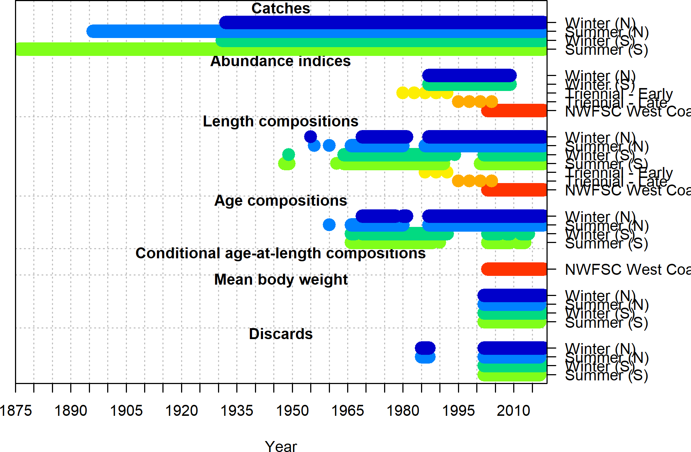

Figure 2: Summary of data sources used in the base model.

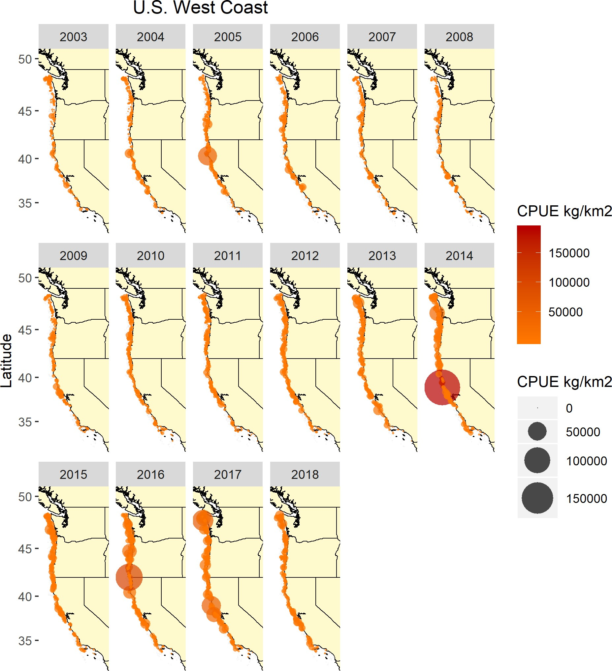

Figure 3: Map of the catch-per-unit-effort across by year for the NWFSC West Coast Groundfish Bottom Trawl Survey data.

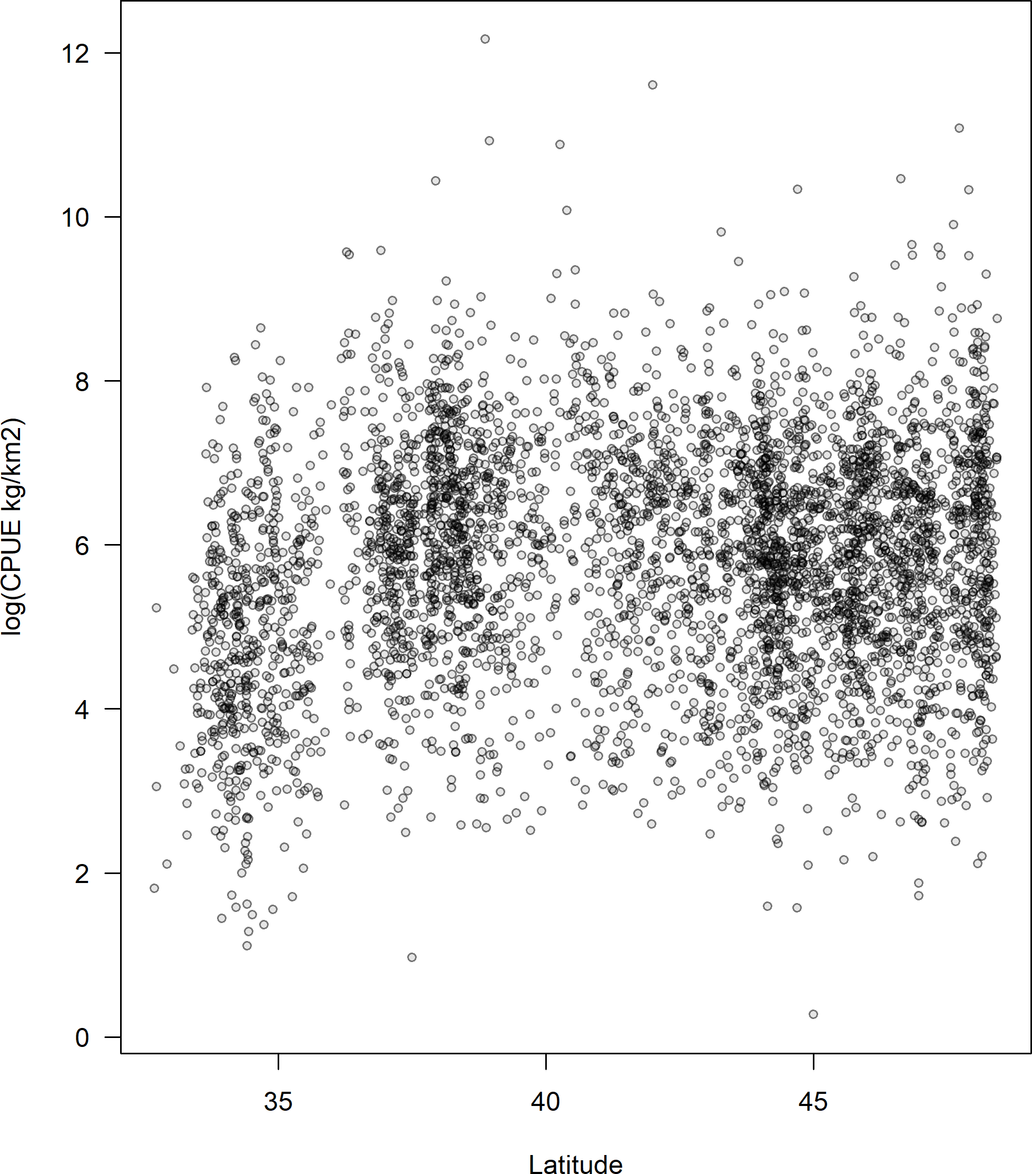

Figure 4: Catch-per-unit-effort (in log space) by latitude for the NWFSC West Coast Groundfish Bottom Trawl Survey data.

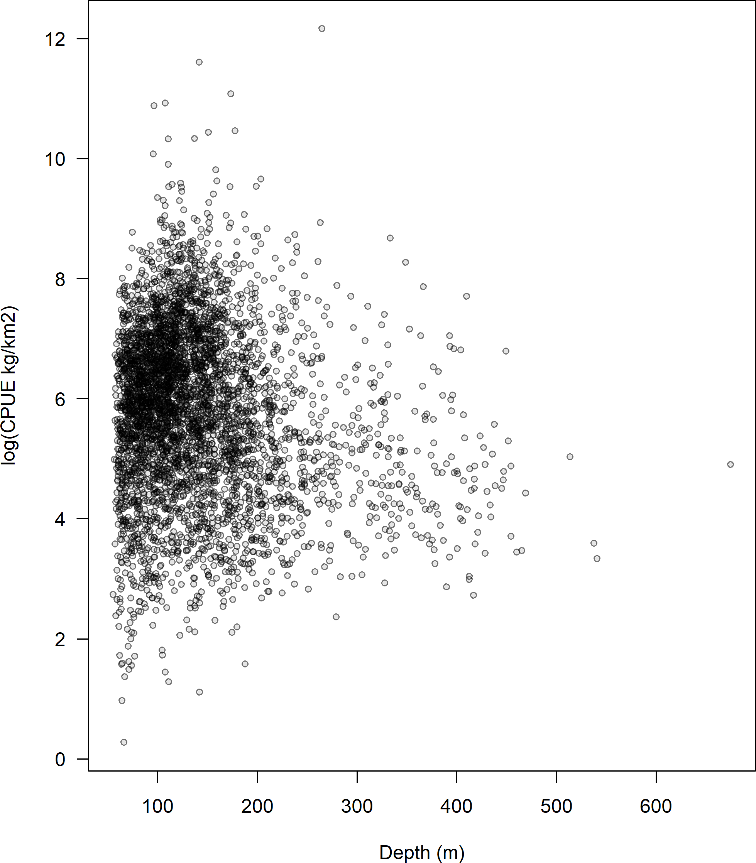

Figure 5: Catch-per-unit-effort (in log space) by depth for the NWFSC West Coast Groundfish Bottom Trawl Survey data.

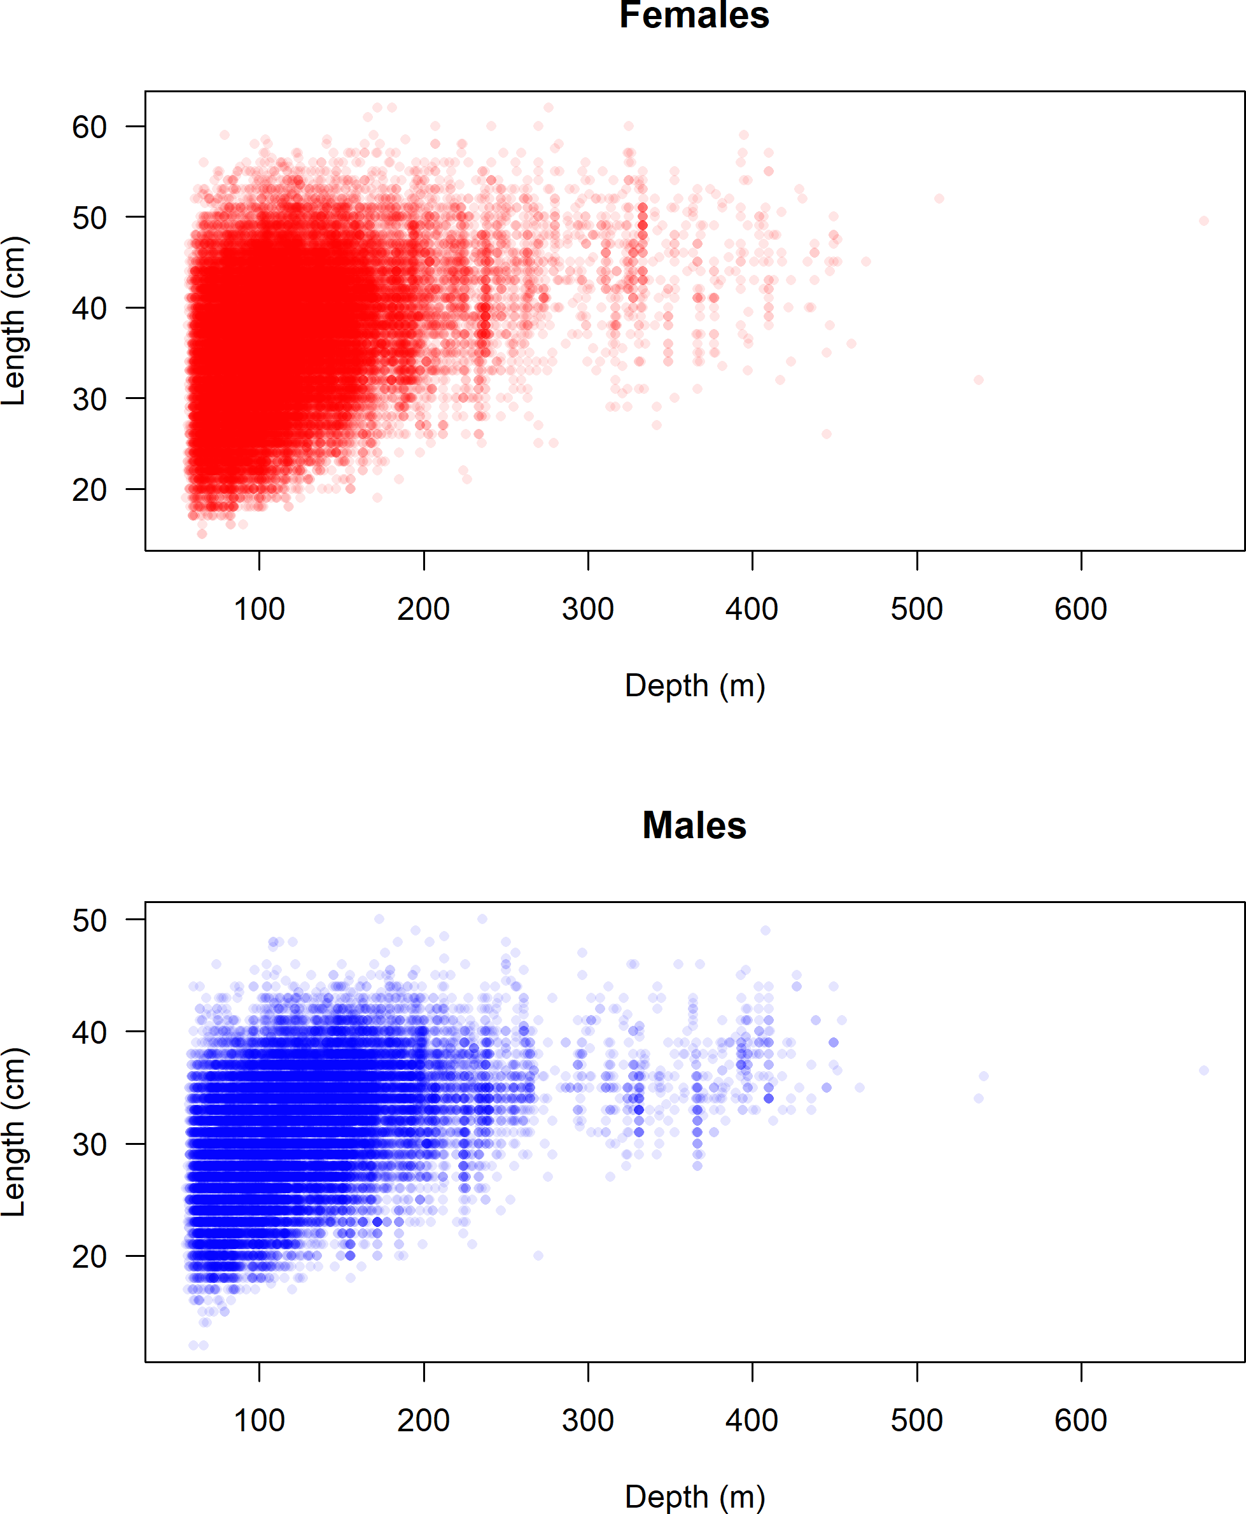

Figure 6: Length (cm) by depth (m) for the NWFSC West Coast Groundfish Bottom Trawl Survey data.

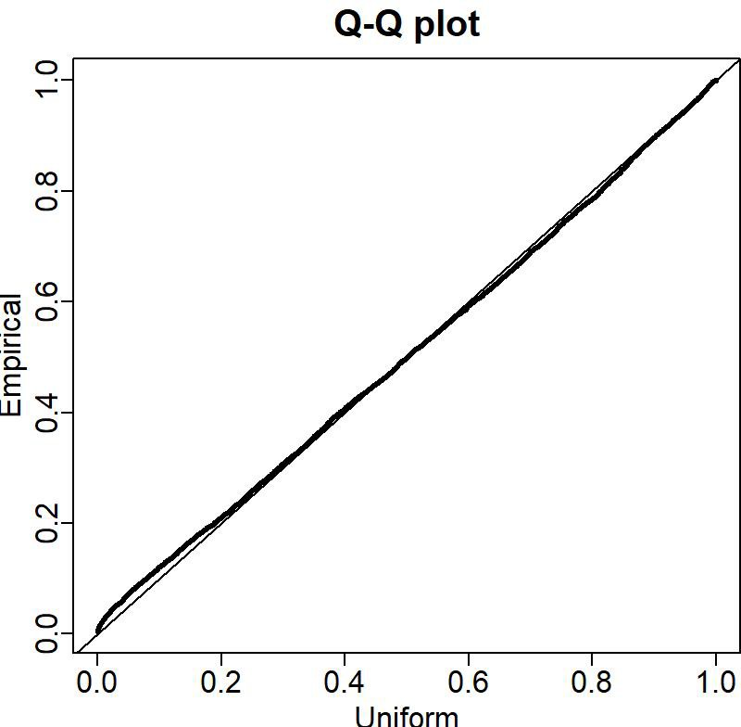

Figure 7: QQ plot for the NWFSC West Coast Groundfish Bottom Trawl Survey data.

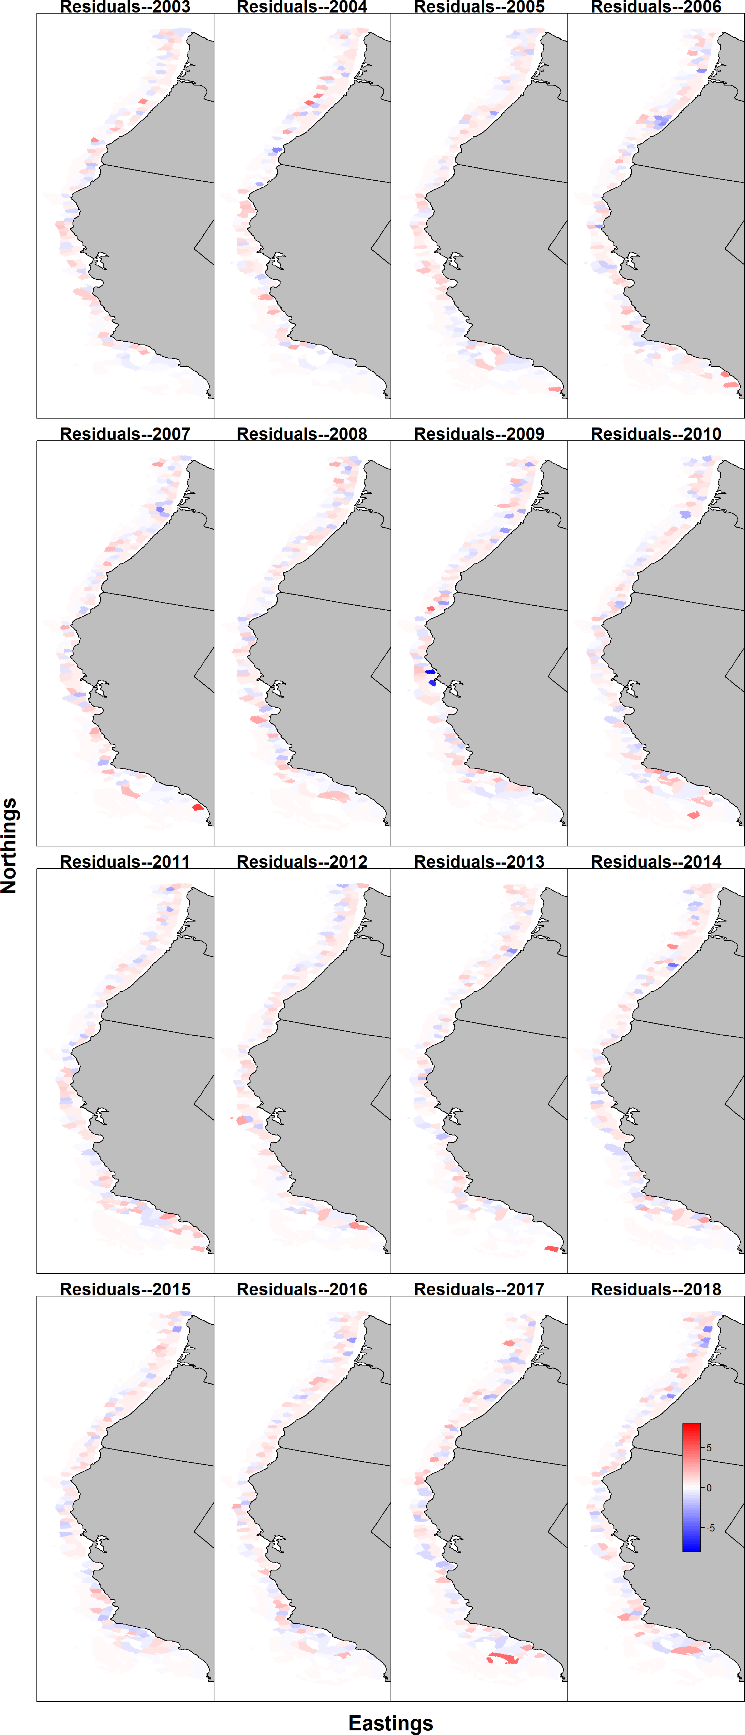

Figure 8: Pearson residuals for the encounter rate for the NWFSC West Coast Groundfish Bottom Trawl Survey by VAST. 77

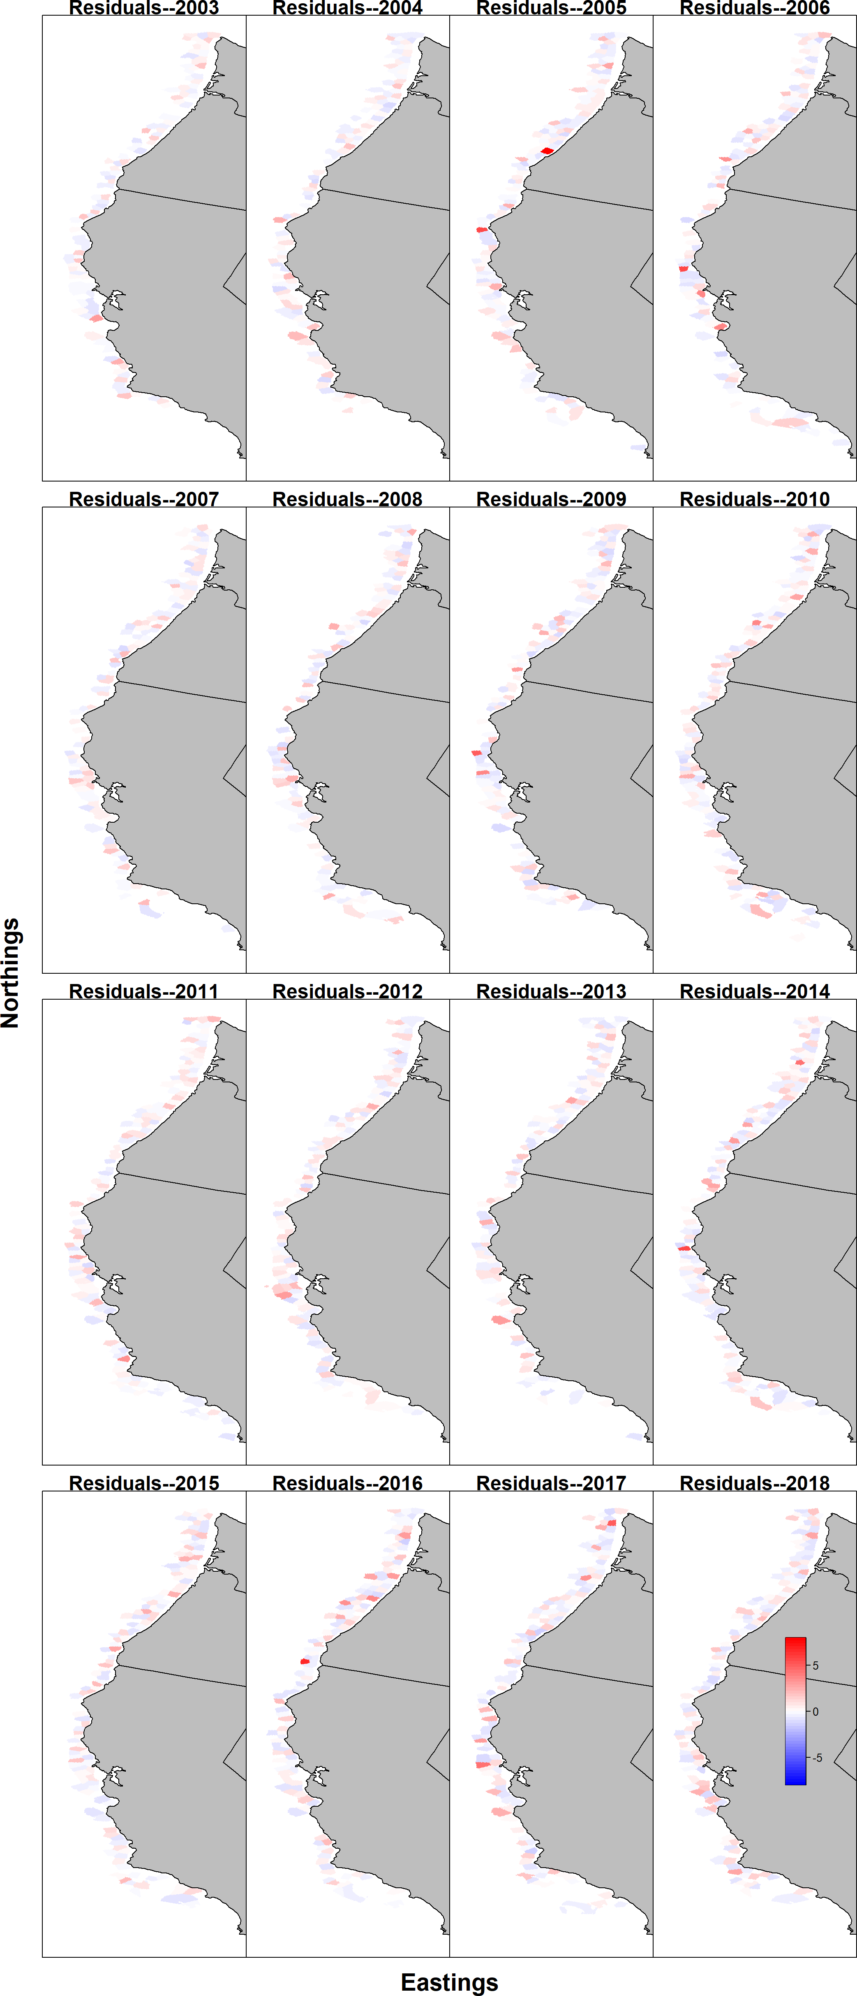

Figure 9: Pearson residuals for the estimated catch rate for the NWFSC West Coast Groundfish Bottom Trawl Survey by VAST. 78

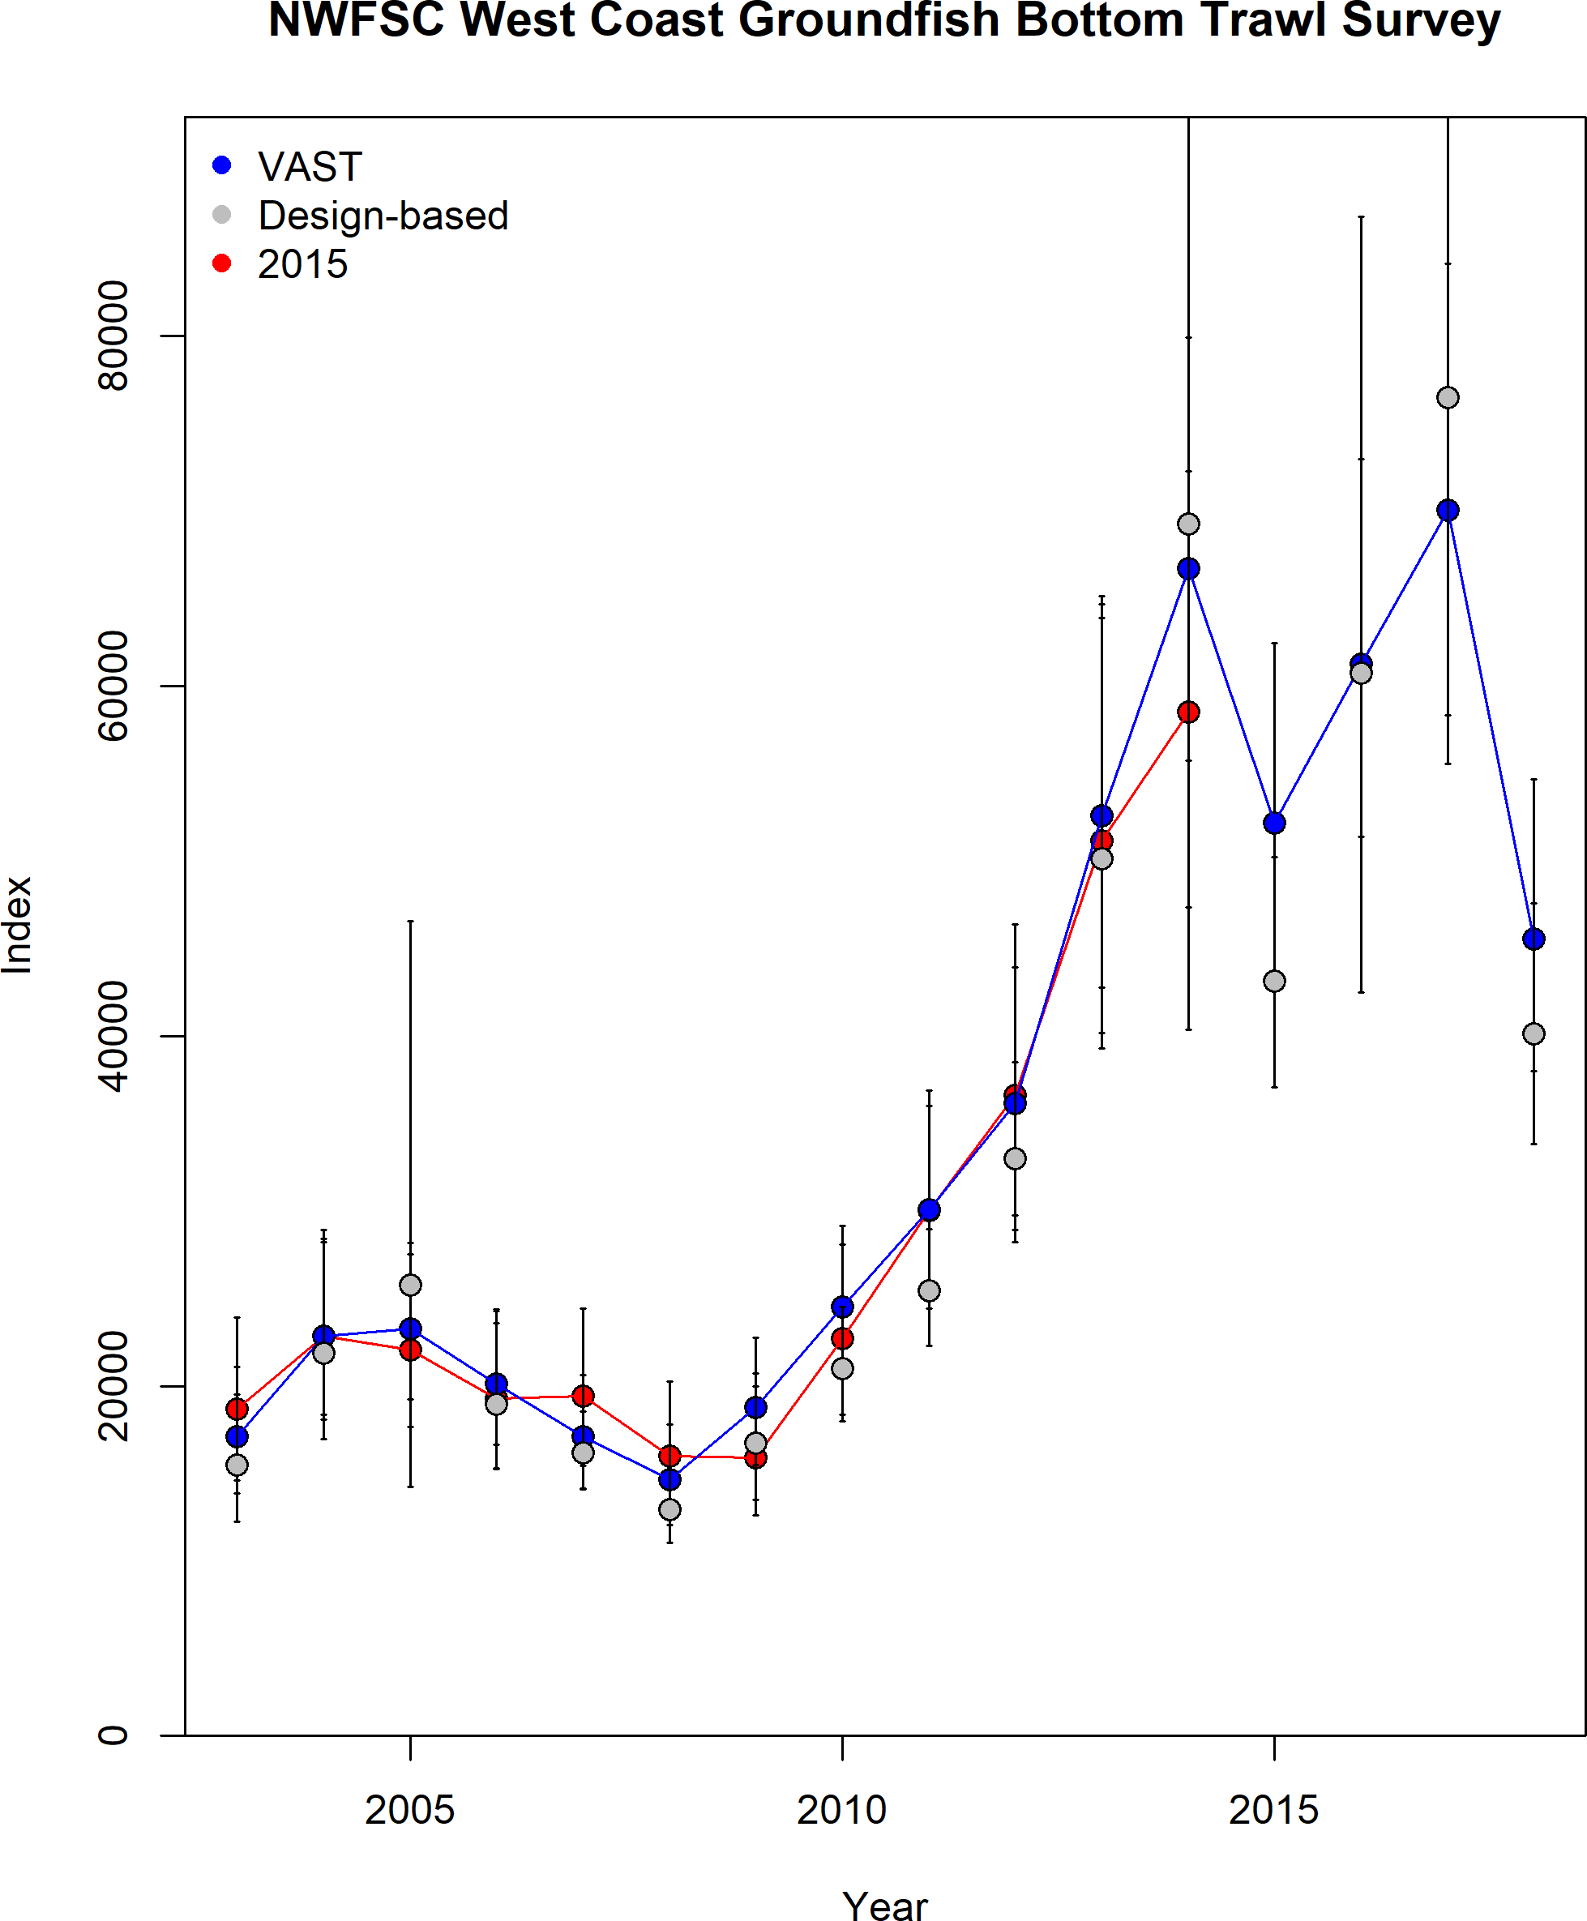

Figure 10: Estimated index of abundance from the NWFSC West Coast Groundfish Bottom Trawl Survey data compared to the design-based index and the index from the 2015 update assessment.

79

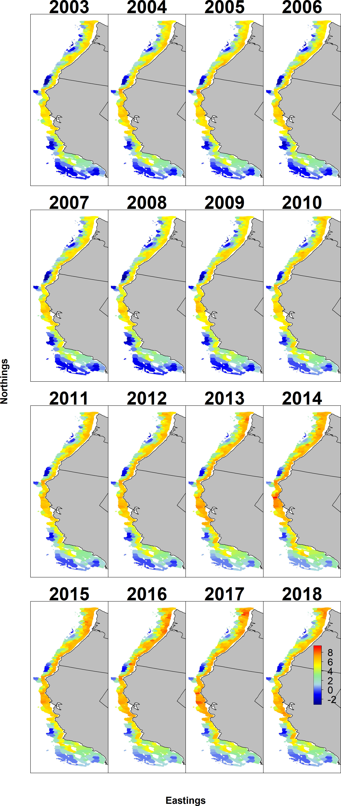

Figure 11: Estimated density of abundance from the NWFSC West Coast Groundfish Bottom Trawl Survey data by VAST. 80

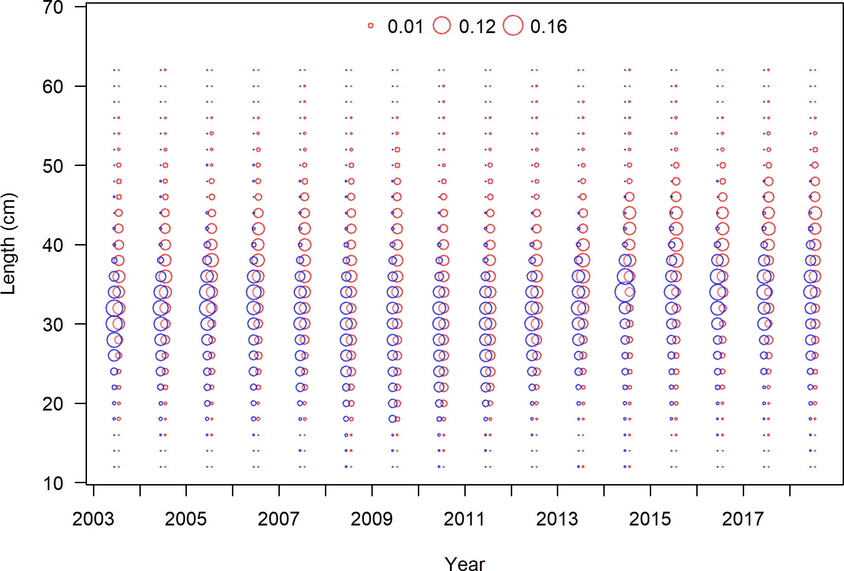

Figure 12: Length frequency by sex for the NWFSC West Coast Groundfish Bottom Trawl Survey data.

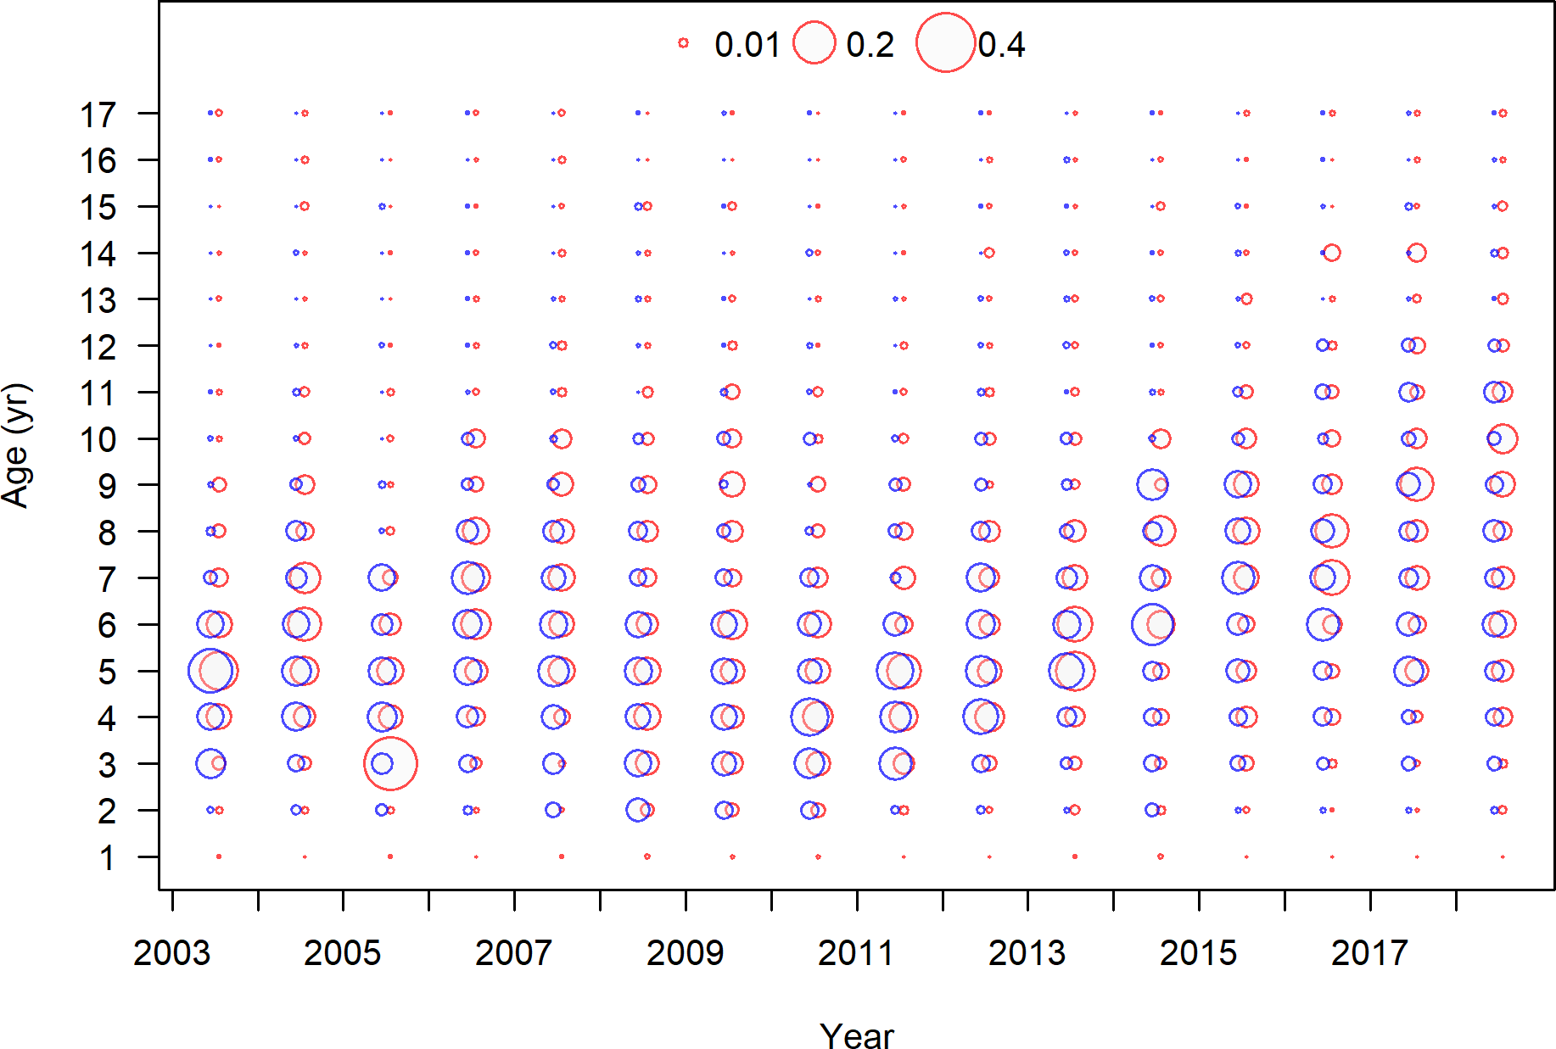

Figure 13: Age frequency by sex for the NWFSC West Coast Groundfish Bottom Trawl Survey data.

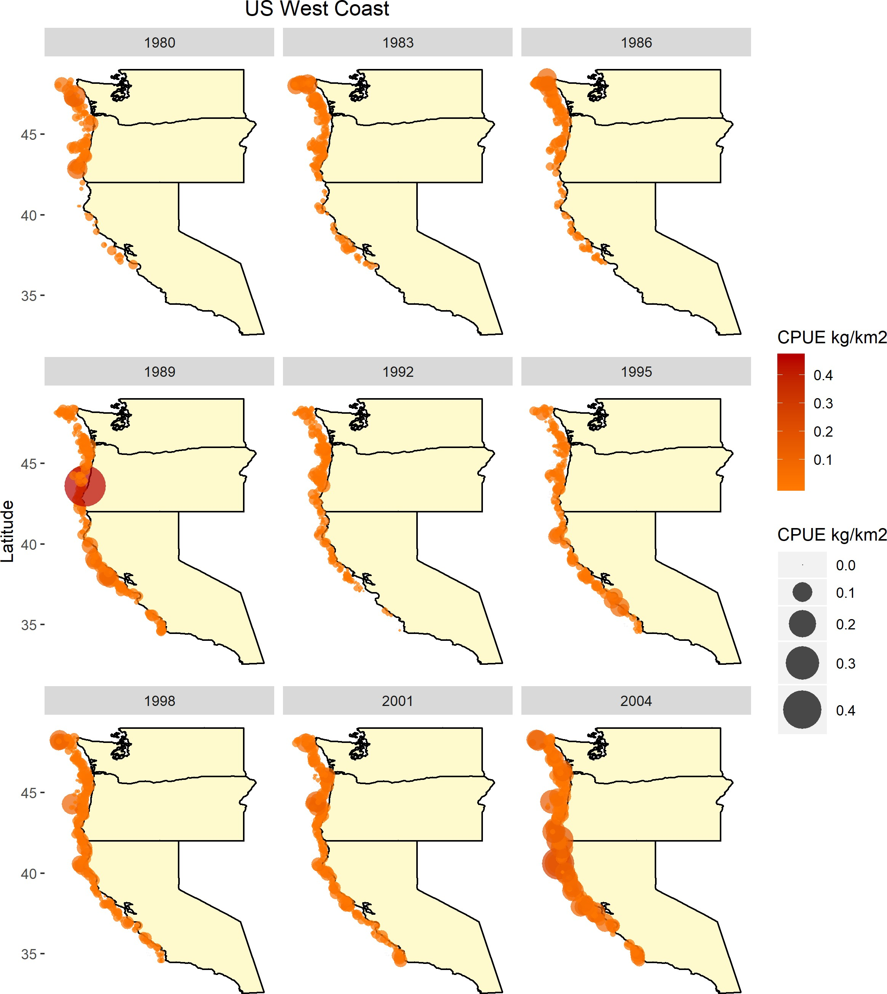

Figure 14: Map of the catch-per-unit-effort across by year for the Triennial Survey data.

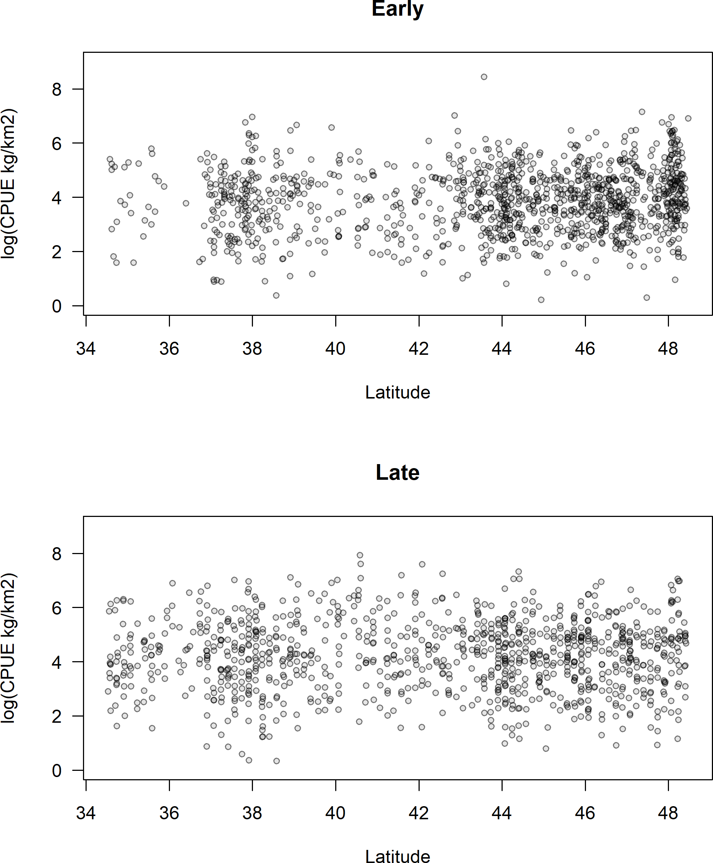

Figure 15: Catch-per-unit-effort (in log space) by latitude for the Triennial Survey data.

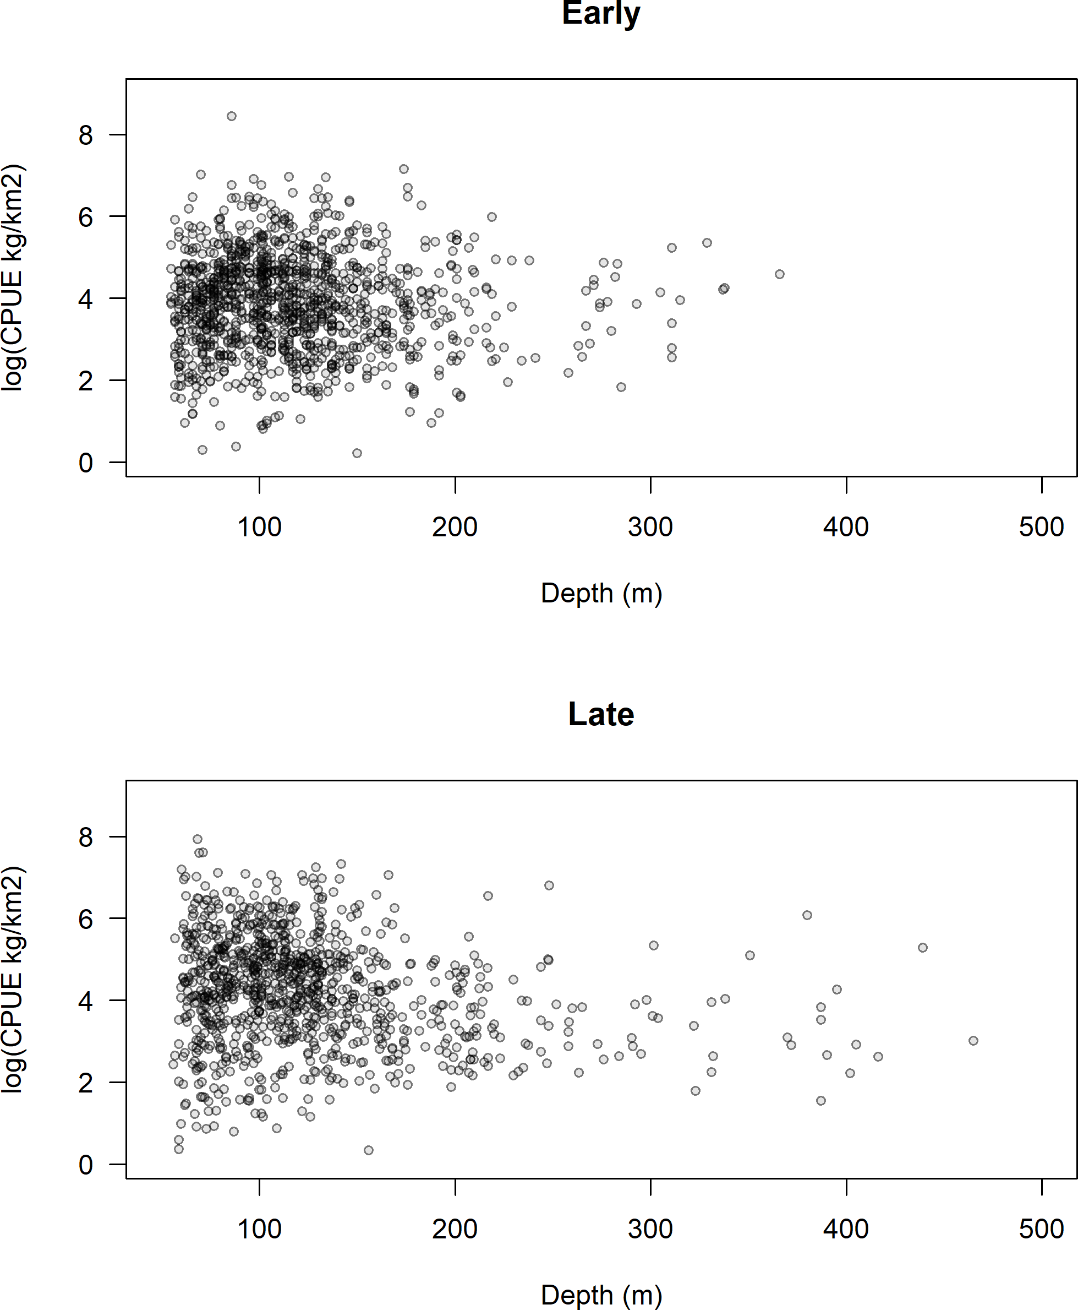

Figure 16: Catch-per-unit-effort (in log space) by depth (m) for the Triennial Survey data.

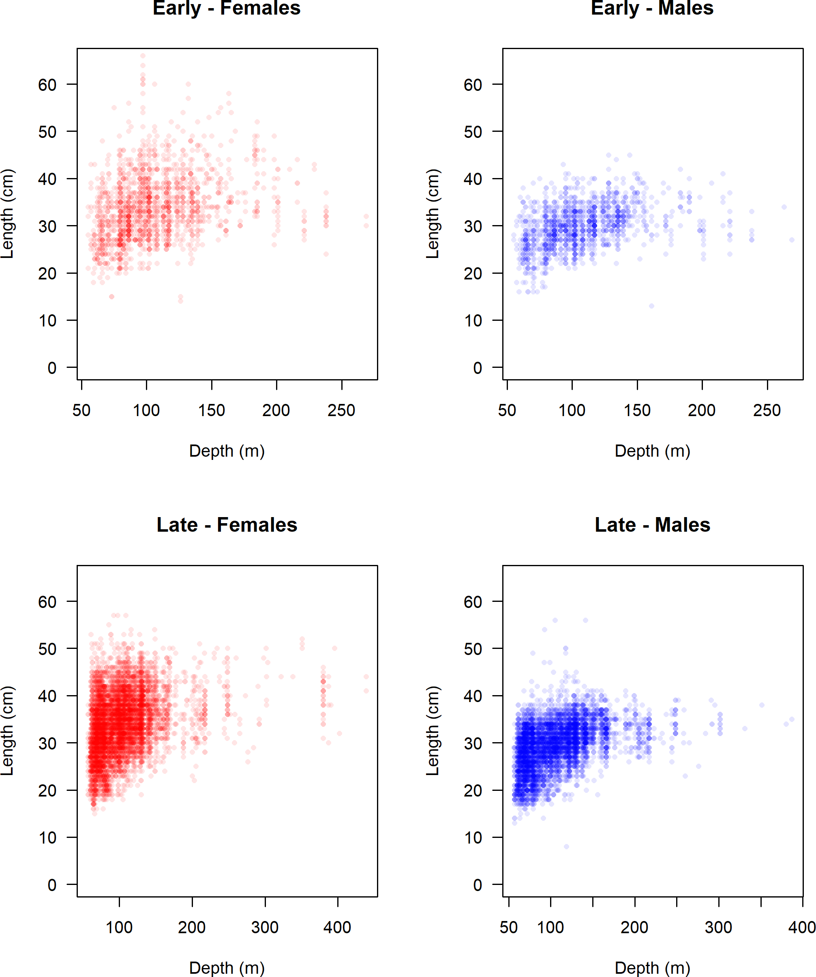

Figure 17: Length (cm) by depth (m) for the Triennial Survey data.

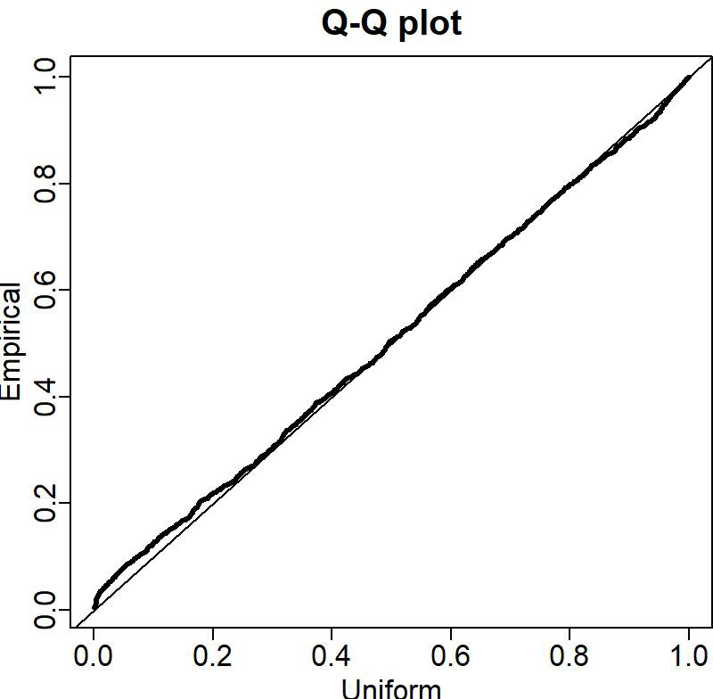

Figure 18: QQ plot for the Triennial Early Survey data.

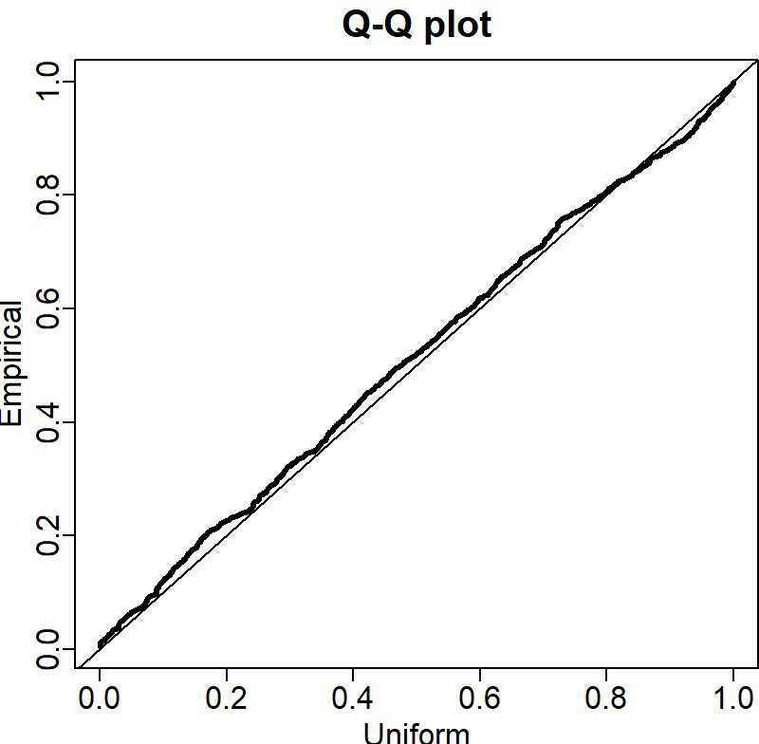

Figure 19: QQ plot for the Triennial Late Survey data.

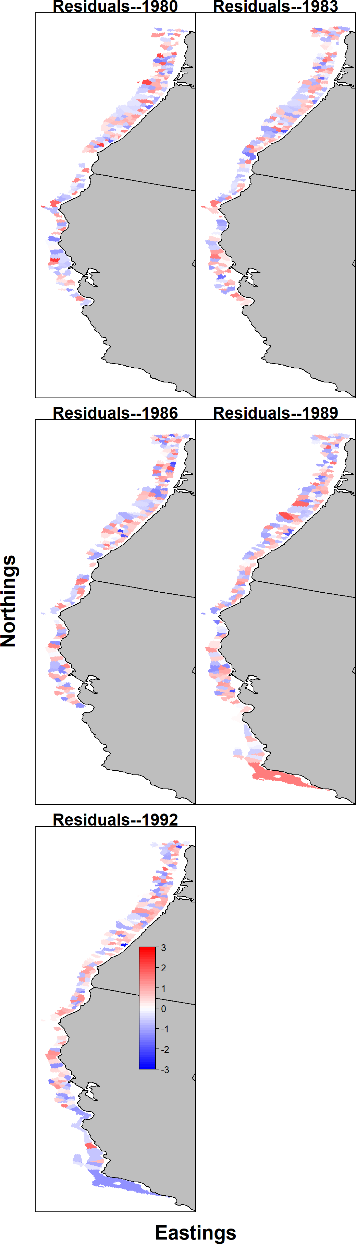

Figure 20: Pearson residuals for the encounter rate for the Triennial Early Survey by VAST.

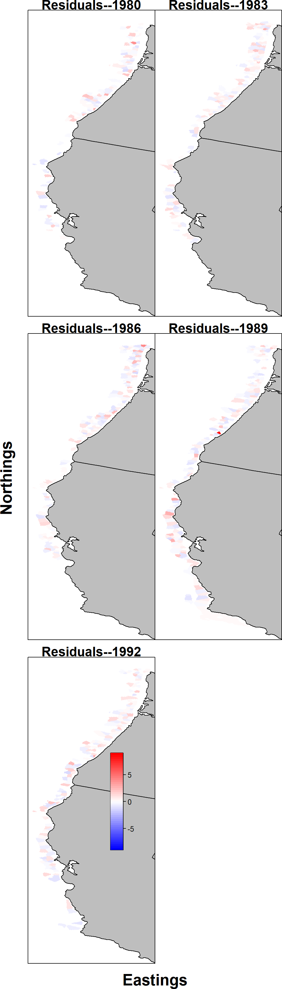

Figure 21: Pearson residuals for the estimated catch rate for the Triennial Early Survey by VAST. 90

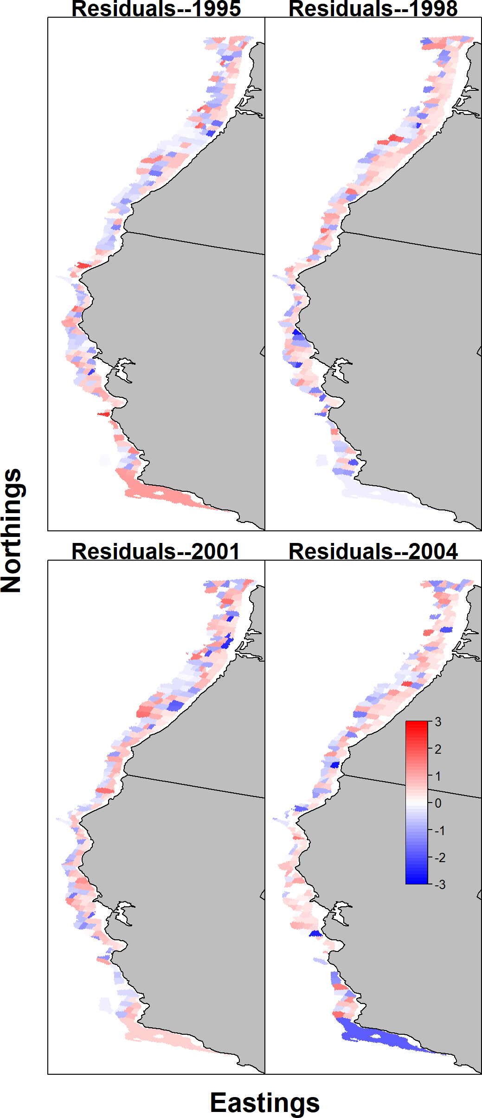

Figure 22: Pearson residuals for the encounter rate for the Triennial Late Survey by VAST.

91

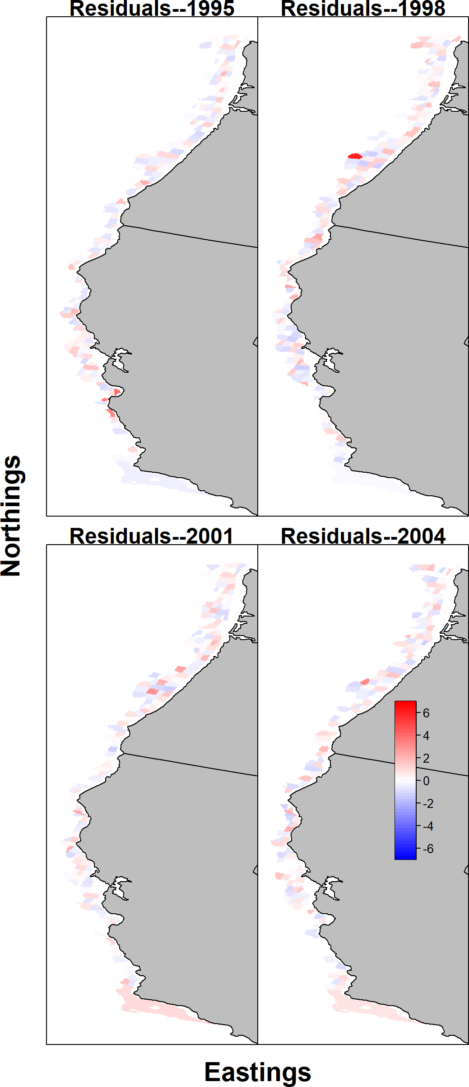

Figure 23: Pearson residuals for the estimated catch rate for the Triennial Late Survey by VAST. 92

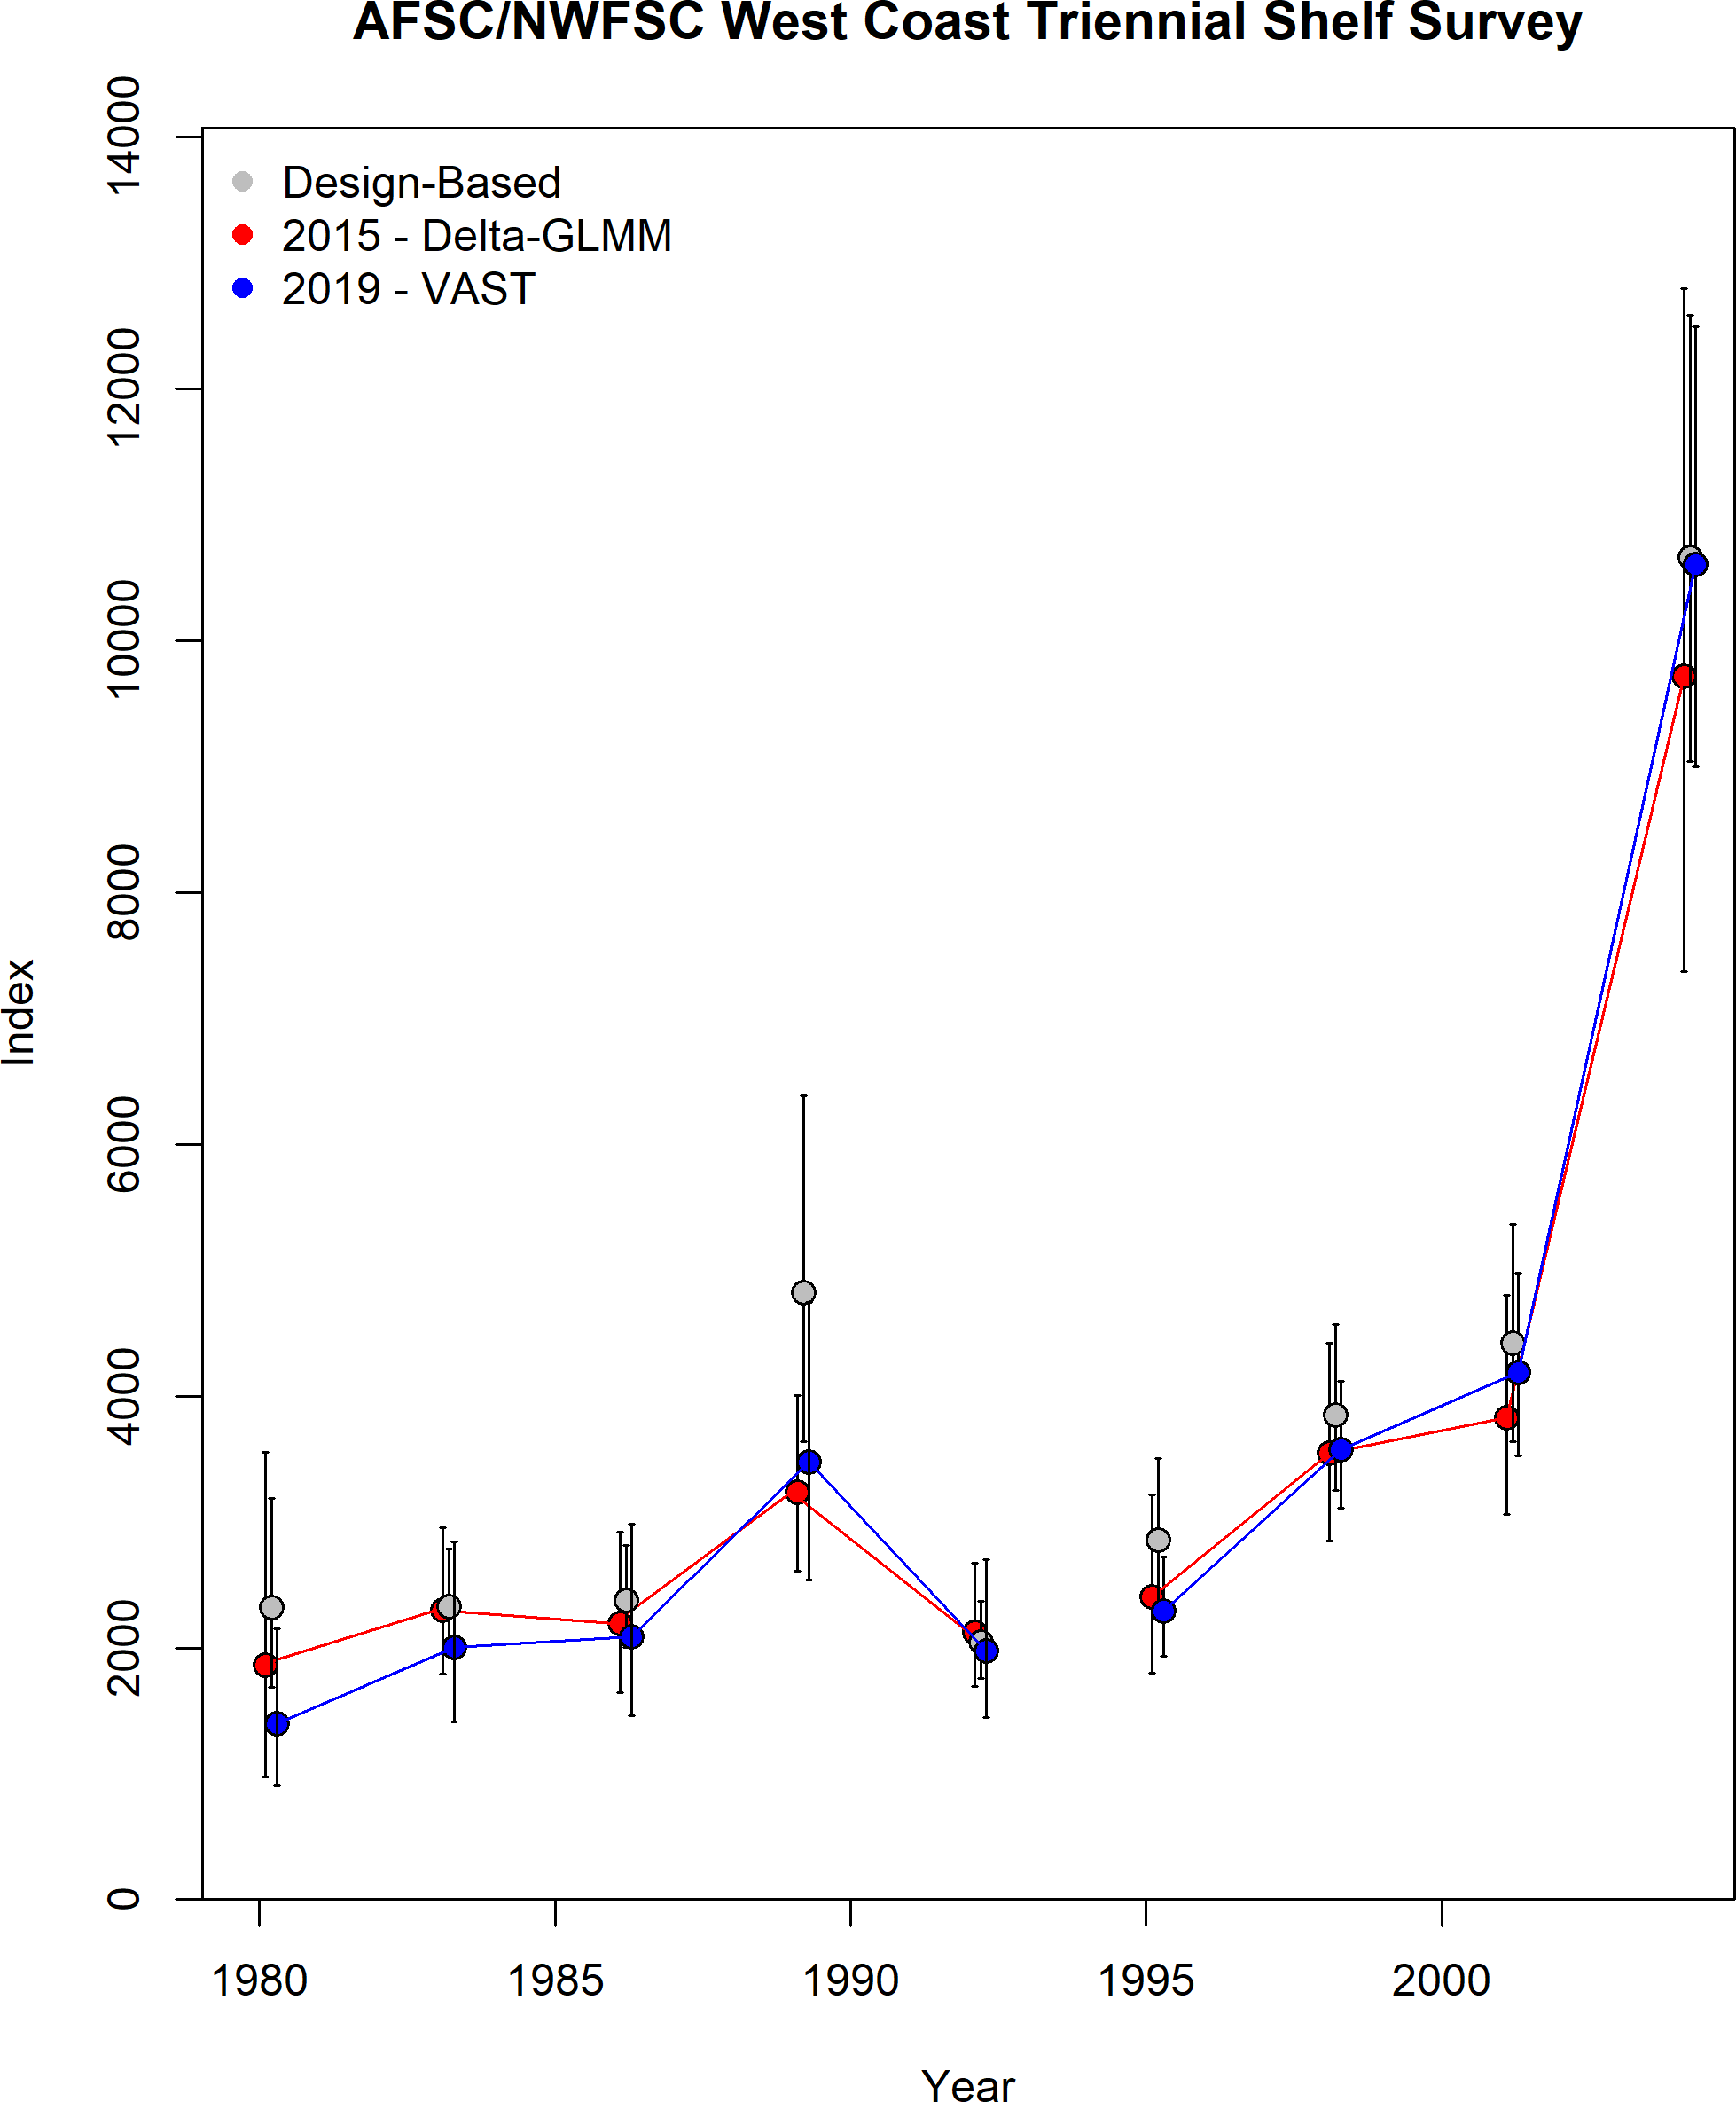

Figure 24: Estimated index of abundance from the Triennial Survey data compared to the design-based index and the index from the 2015 update assessment.

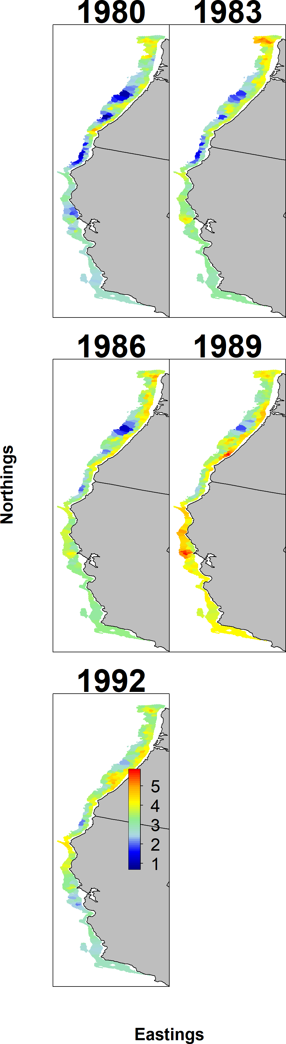

Figure 25: Estimated density of abundance from the Triennial Early Survey data by VAST.

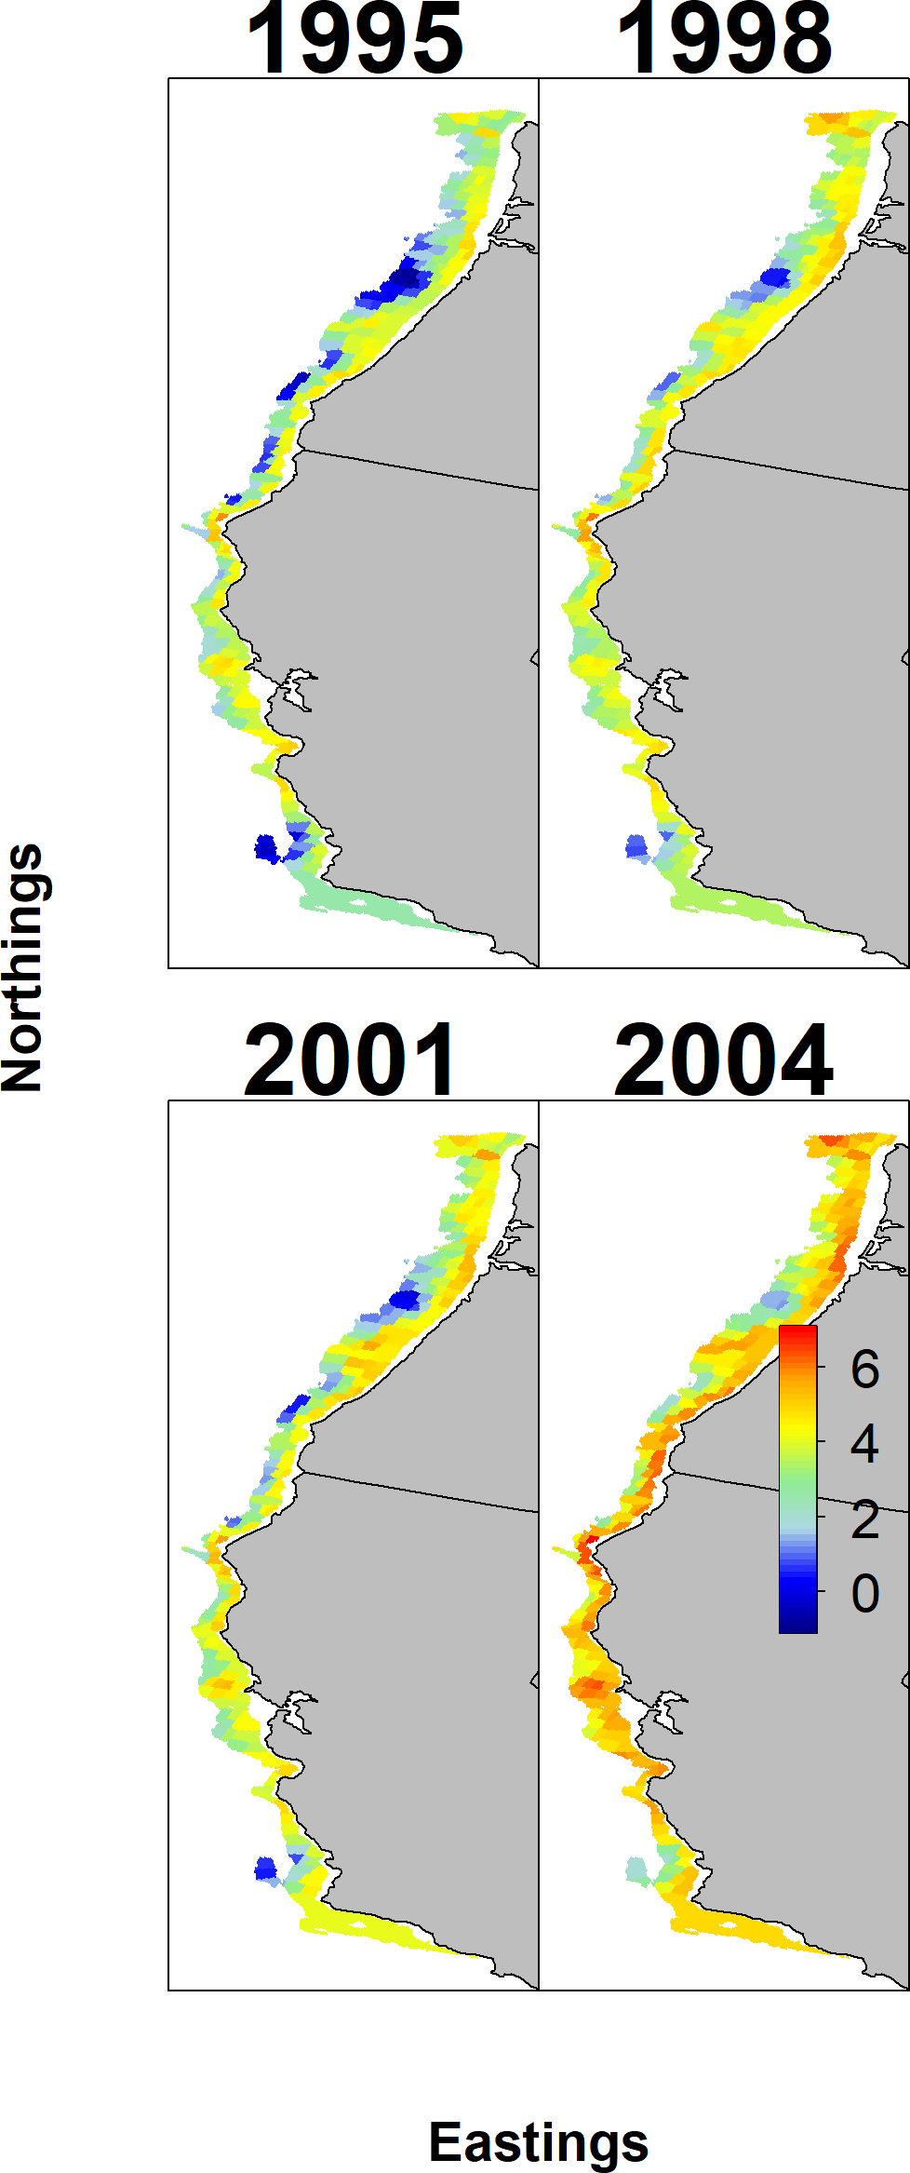

Figure 26: Estimated density of abundance from the Triennial Late Survey data by VAST.

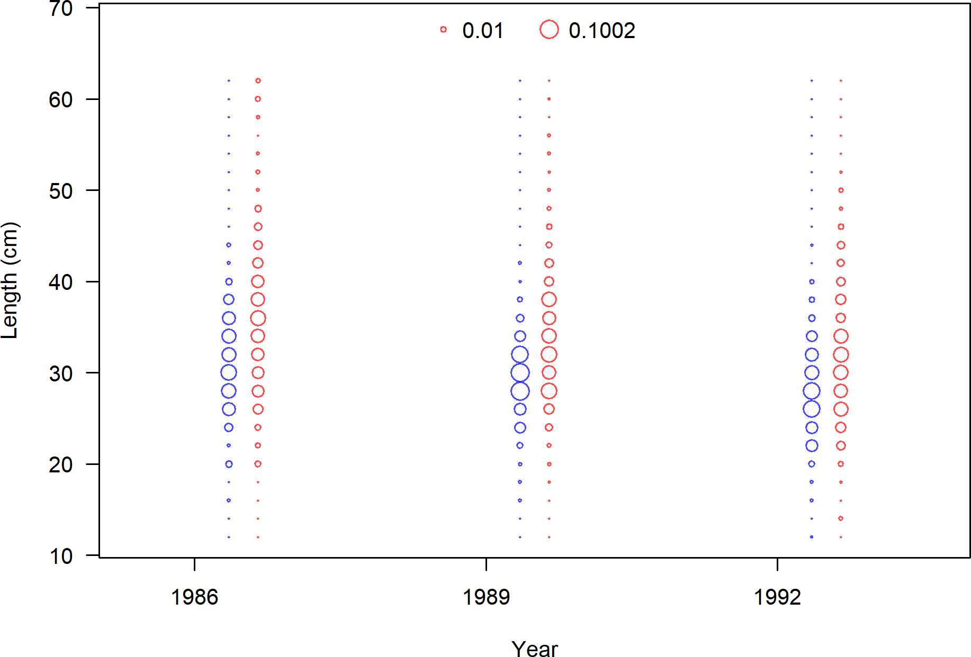

Figure 27: Length frequency by sex for the Triennial Early Survey data.

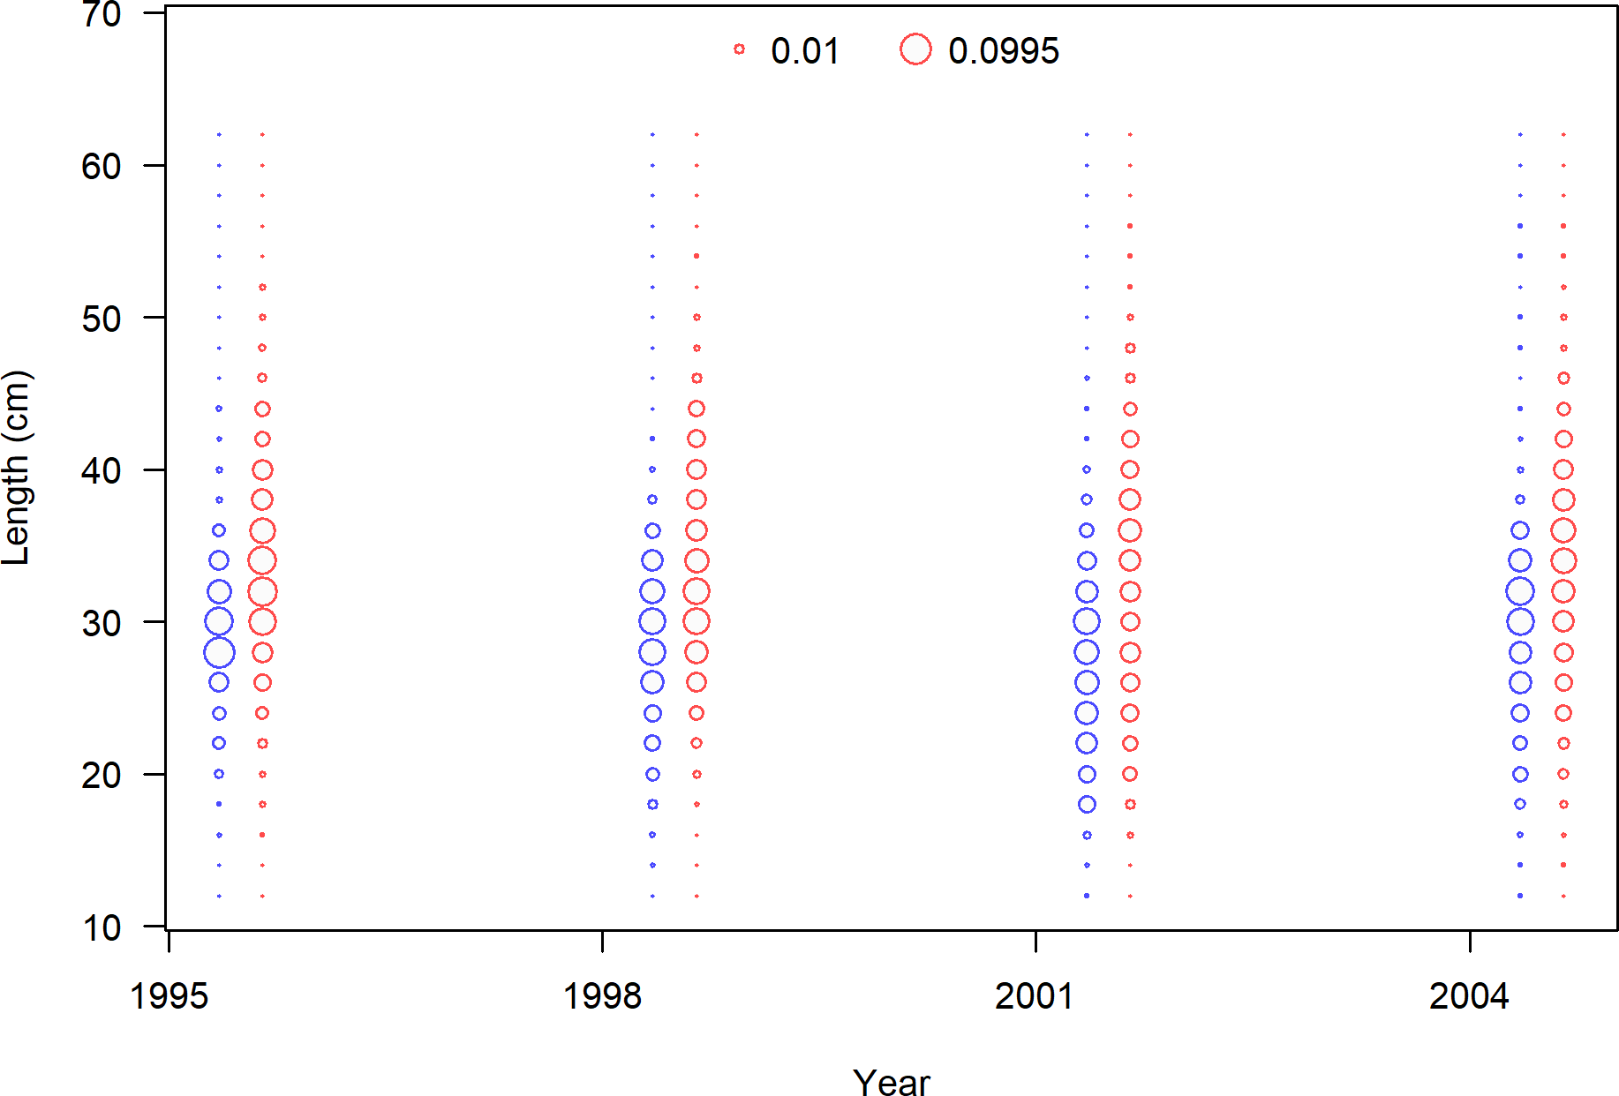

Figure 28: Length frequency by sex for the Triennial Late Survey data.

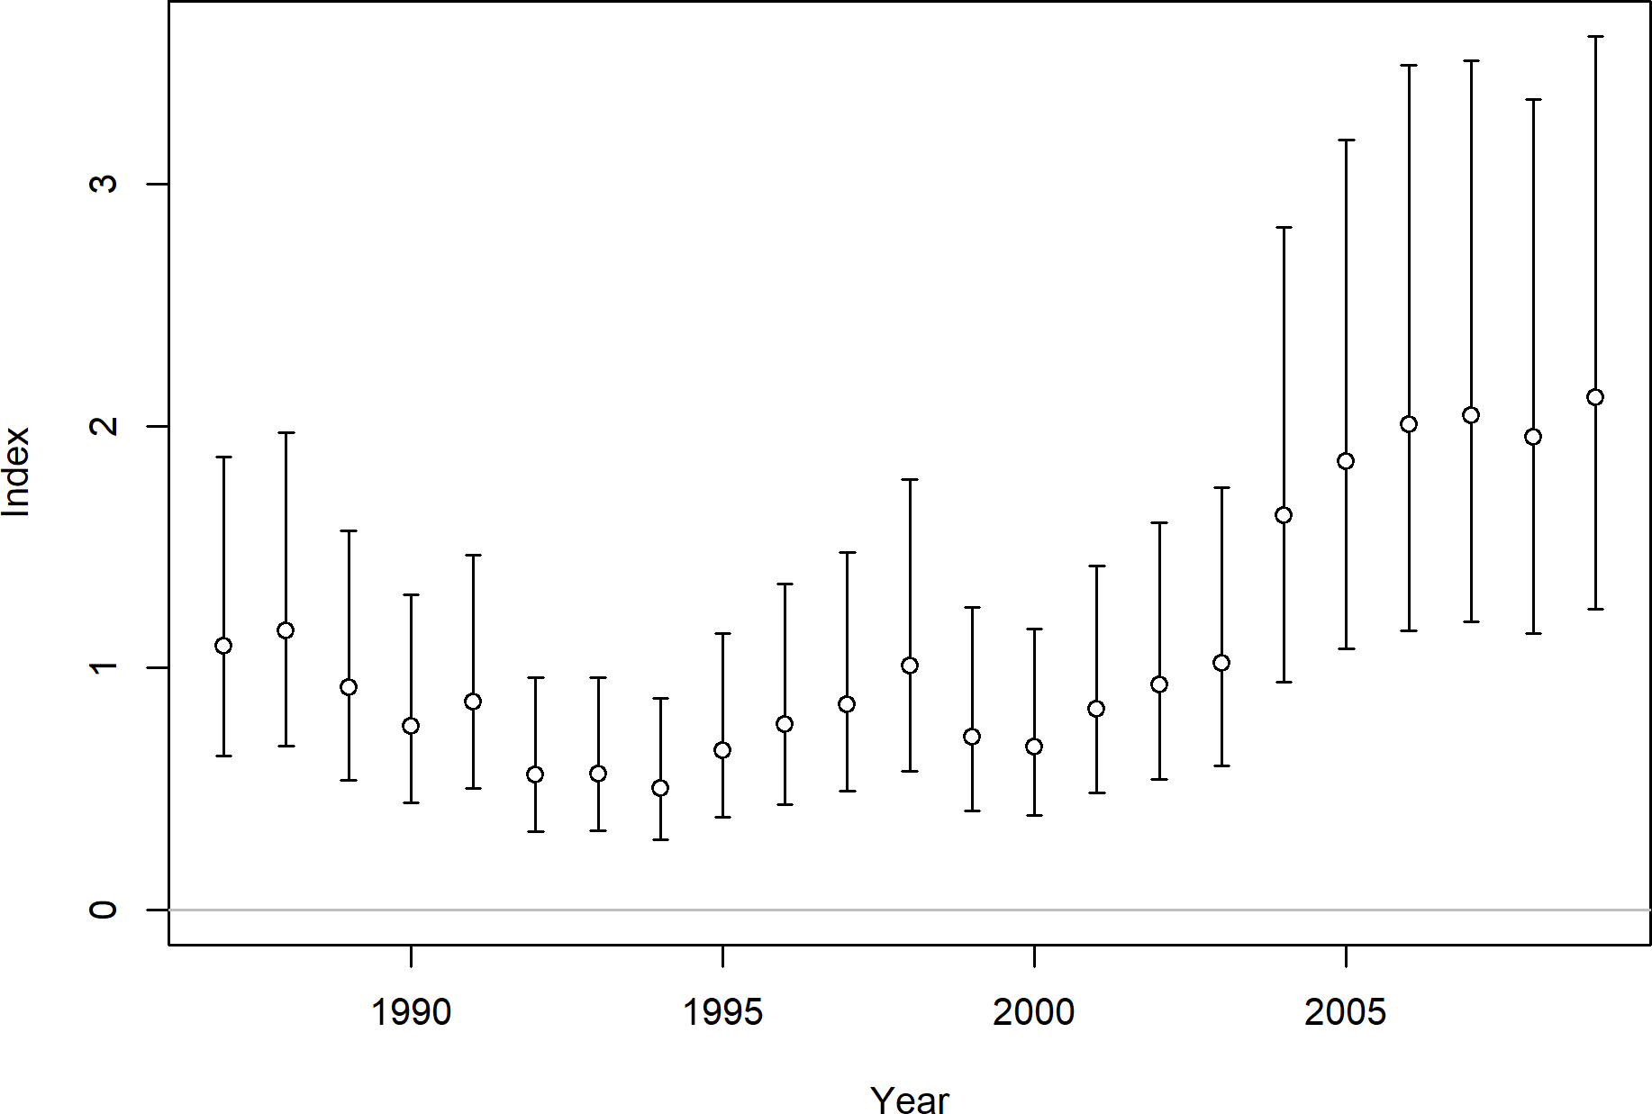

Figure 29: The Northern Winter fishery catch-per-unit-effort based on logbook data for petrale sole.

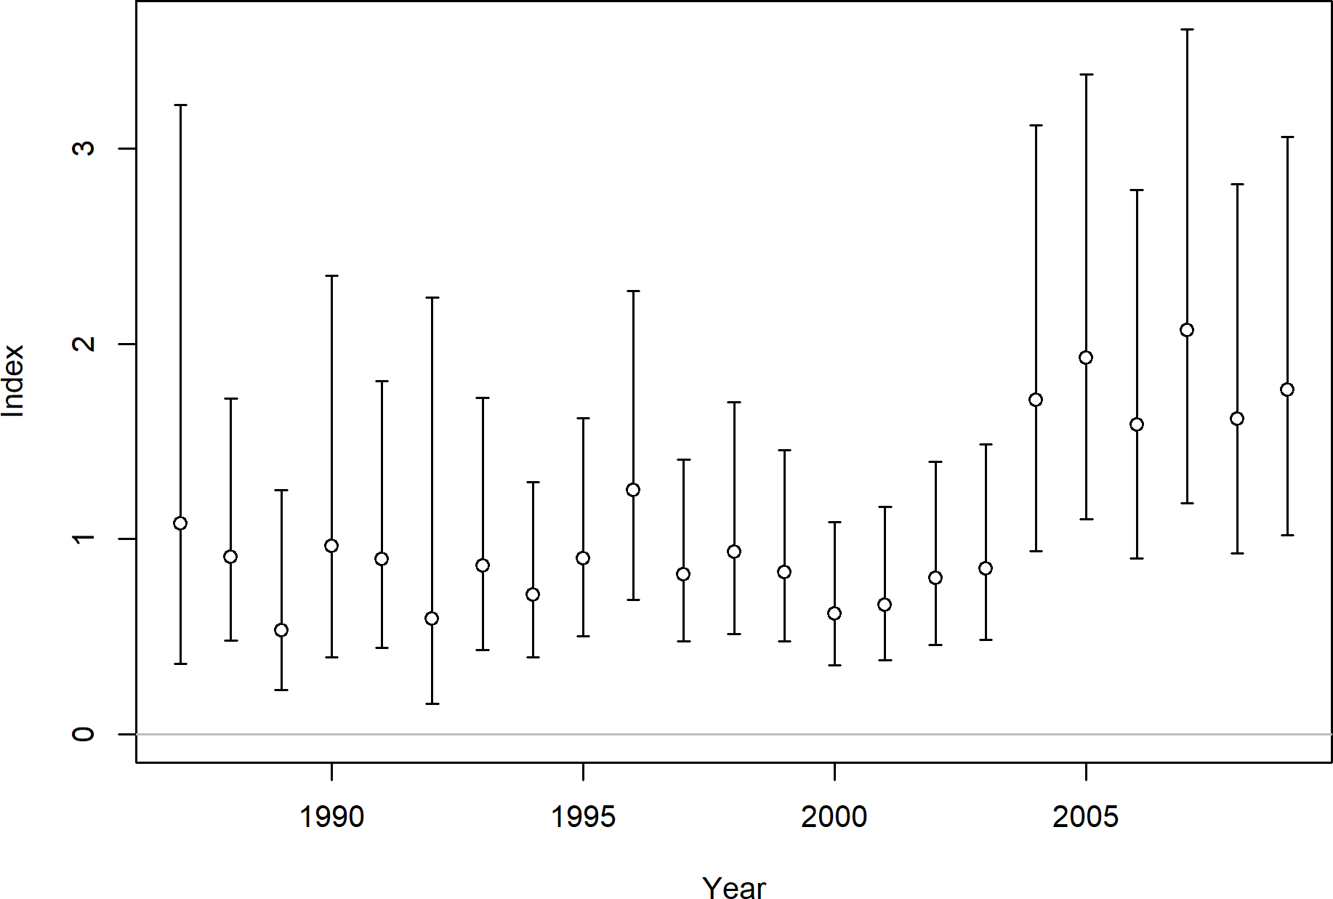

Figure 30: The Southern Winter fishery catch-per-unit-effort based on logbook data for petrale sole.

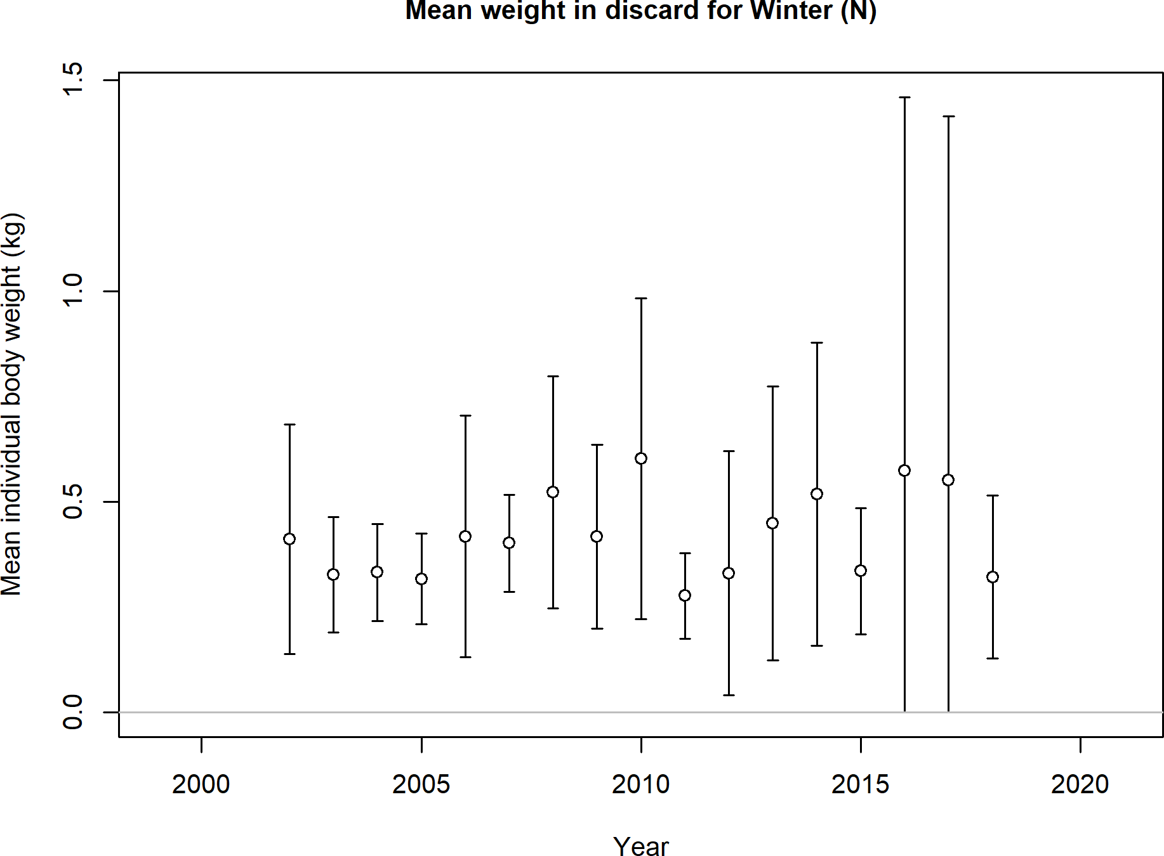

Figure 31: Northern winter fishery mean body weights of discarded fish for petrale sole.

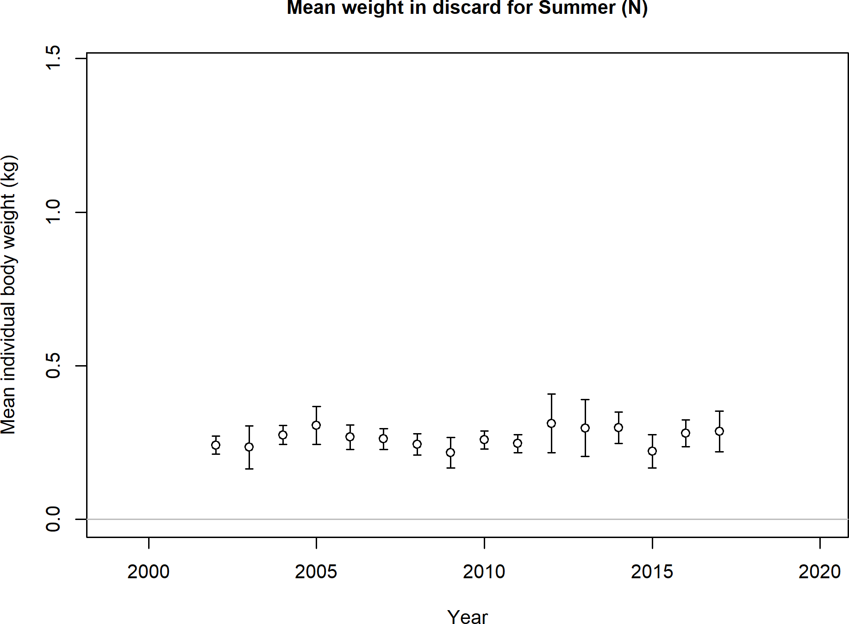

Figure 32: Northern summer fishery mean body weights of discarded fish for petrale sole.

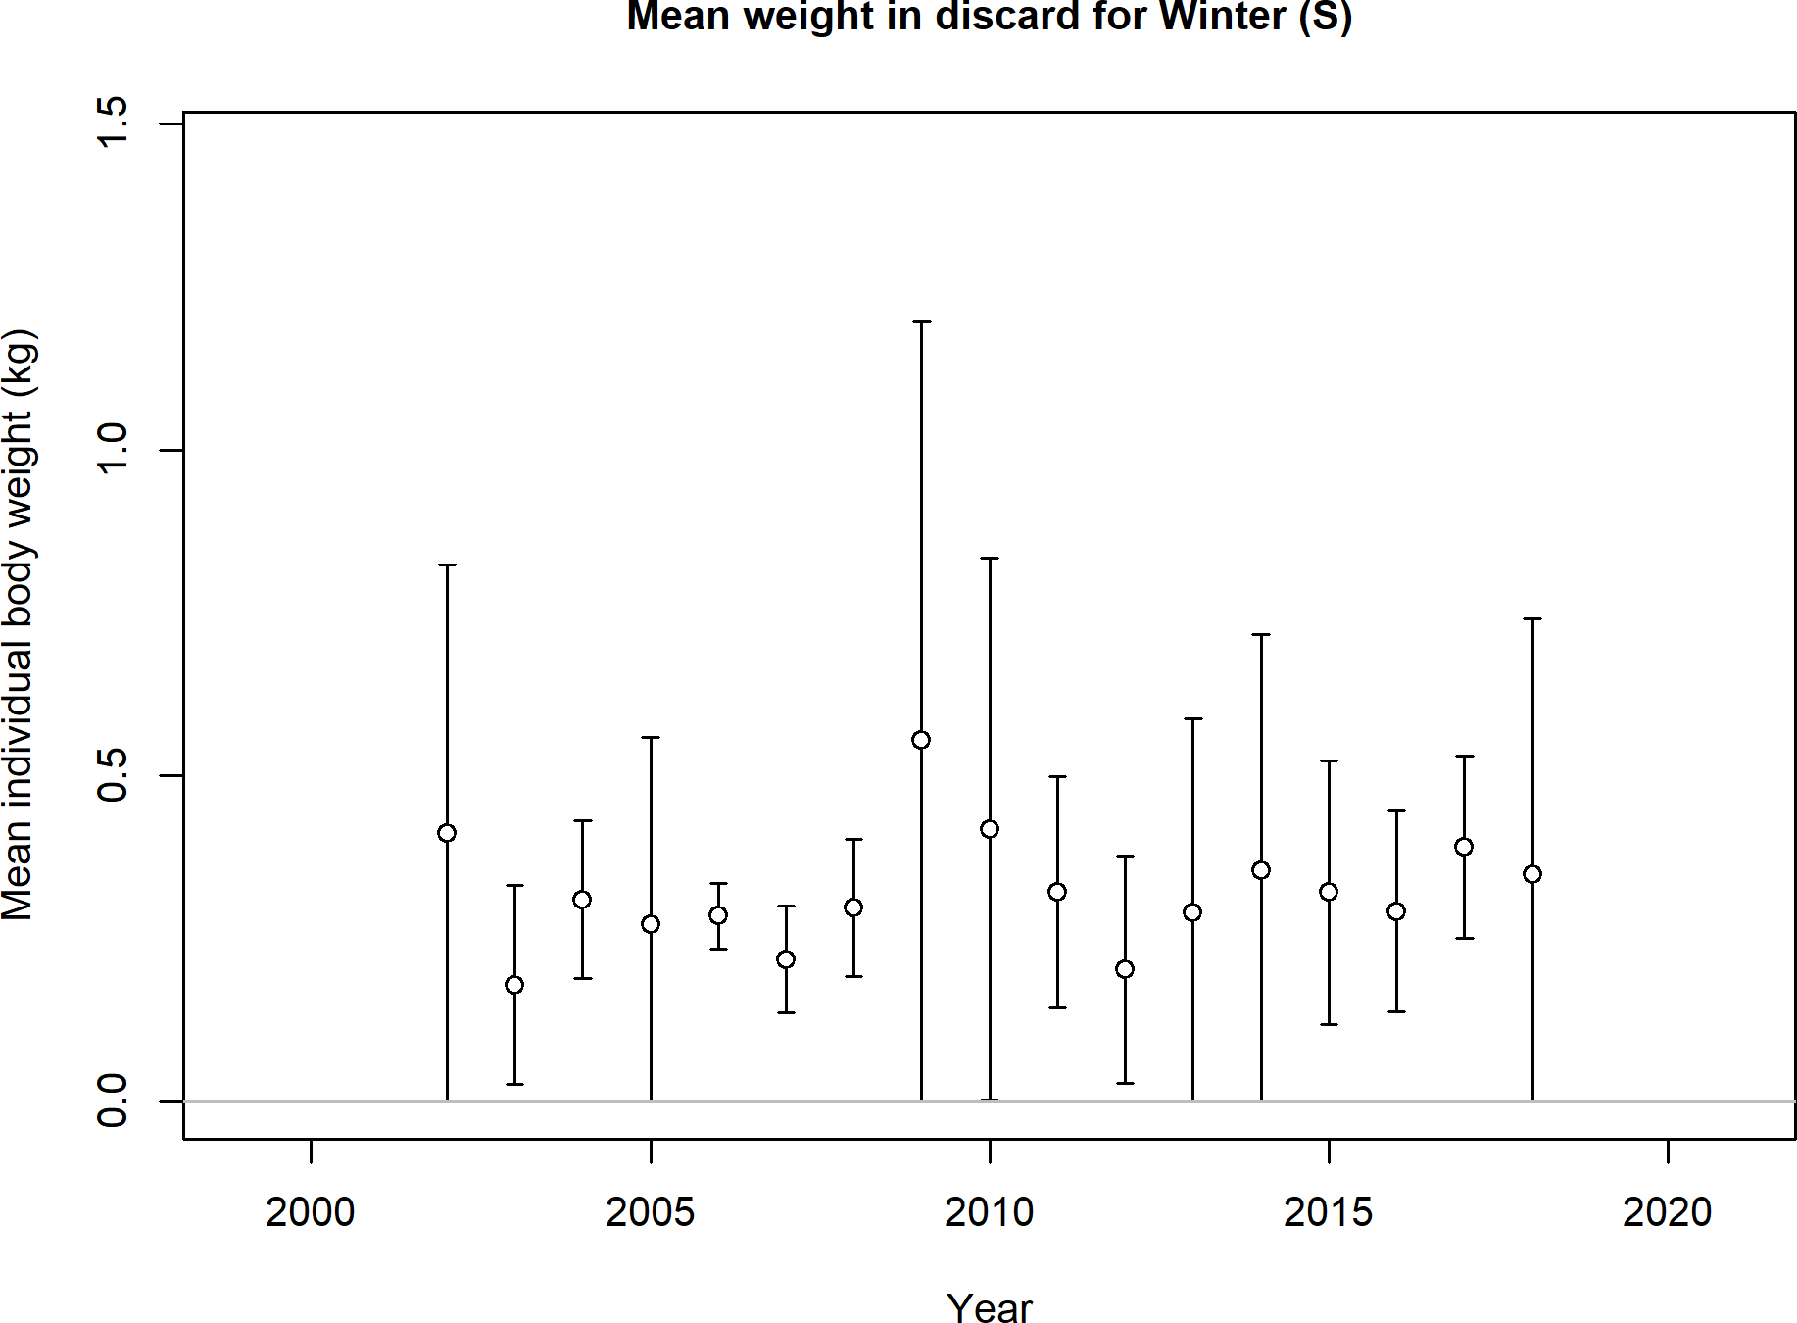

Figure 33: Southern winter fishery mean body weights of discarded fish for petrale sole.

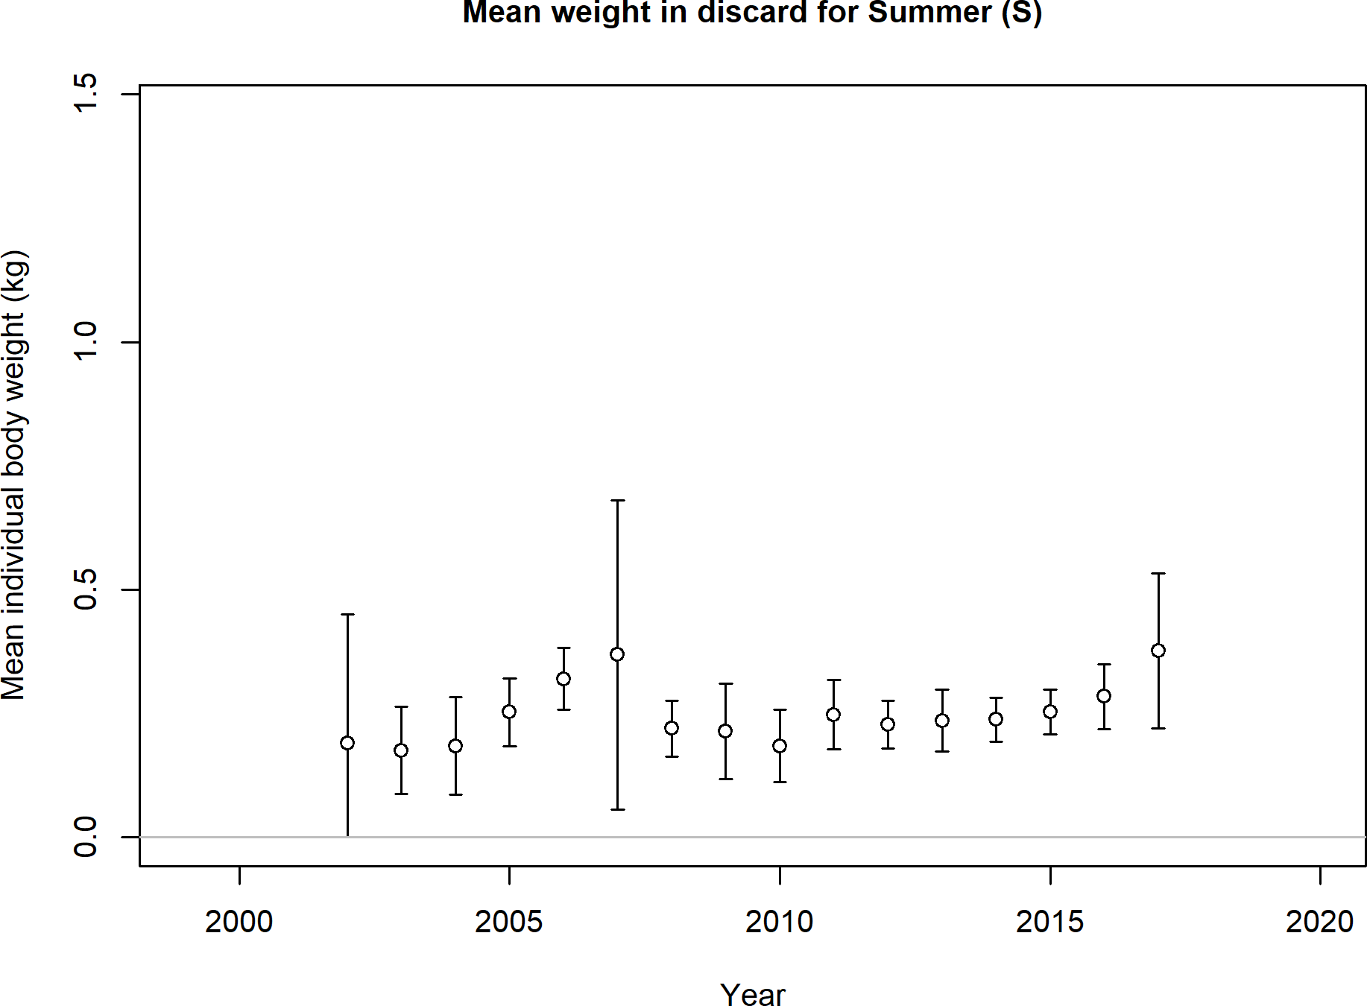

Figure 34: Southern summer fishery mean body weights of discarded fish for petrale sole.

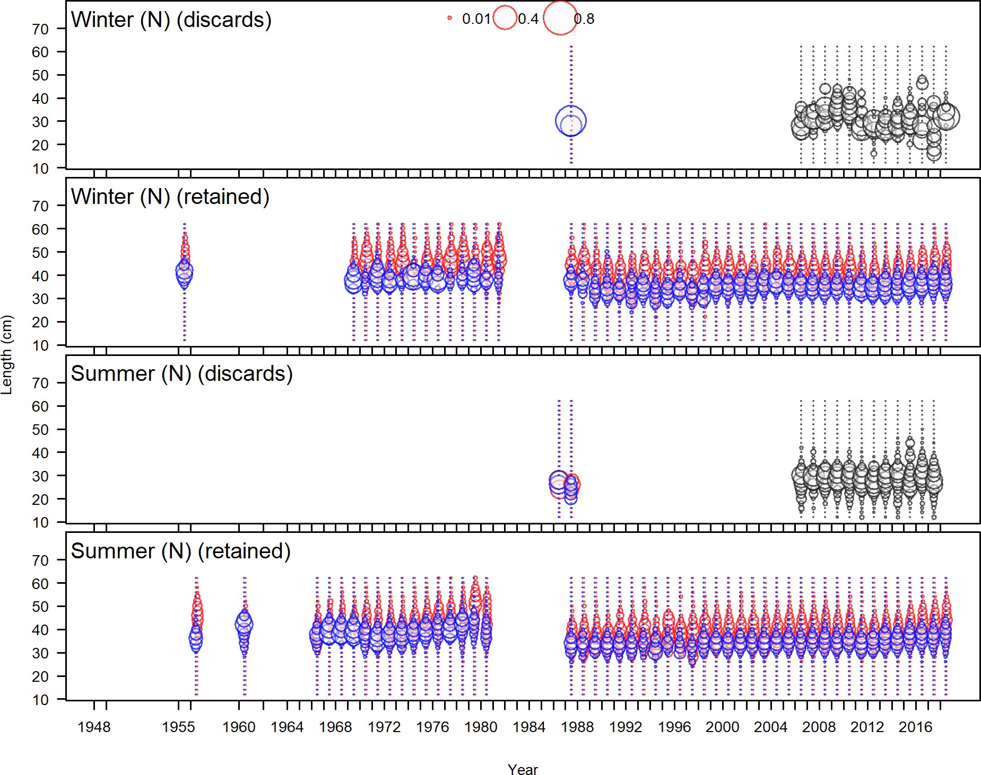

Figure 35: Northern, winter and summer fleets, retained and discarded length frequency distributions for petrale sole.

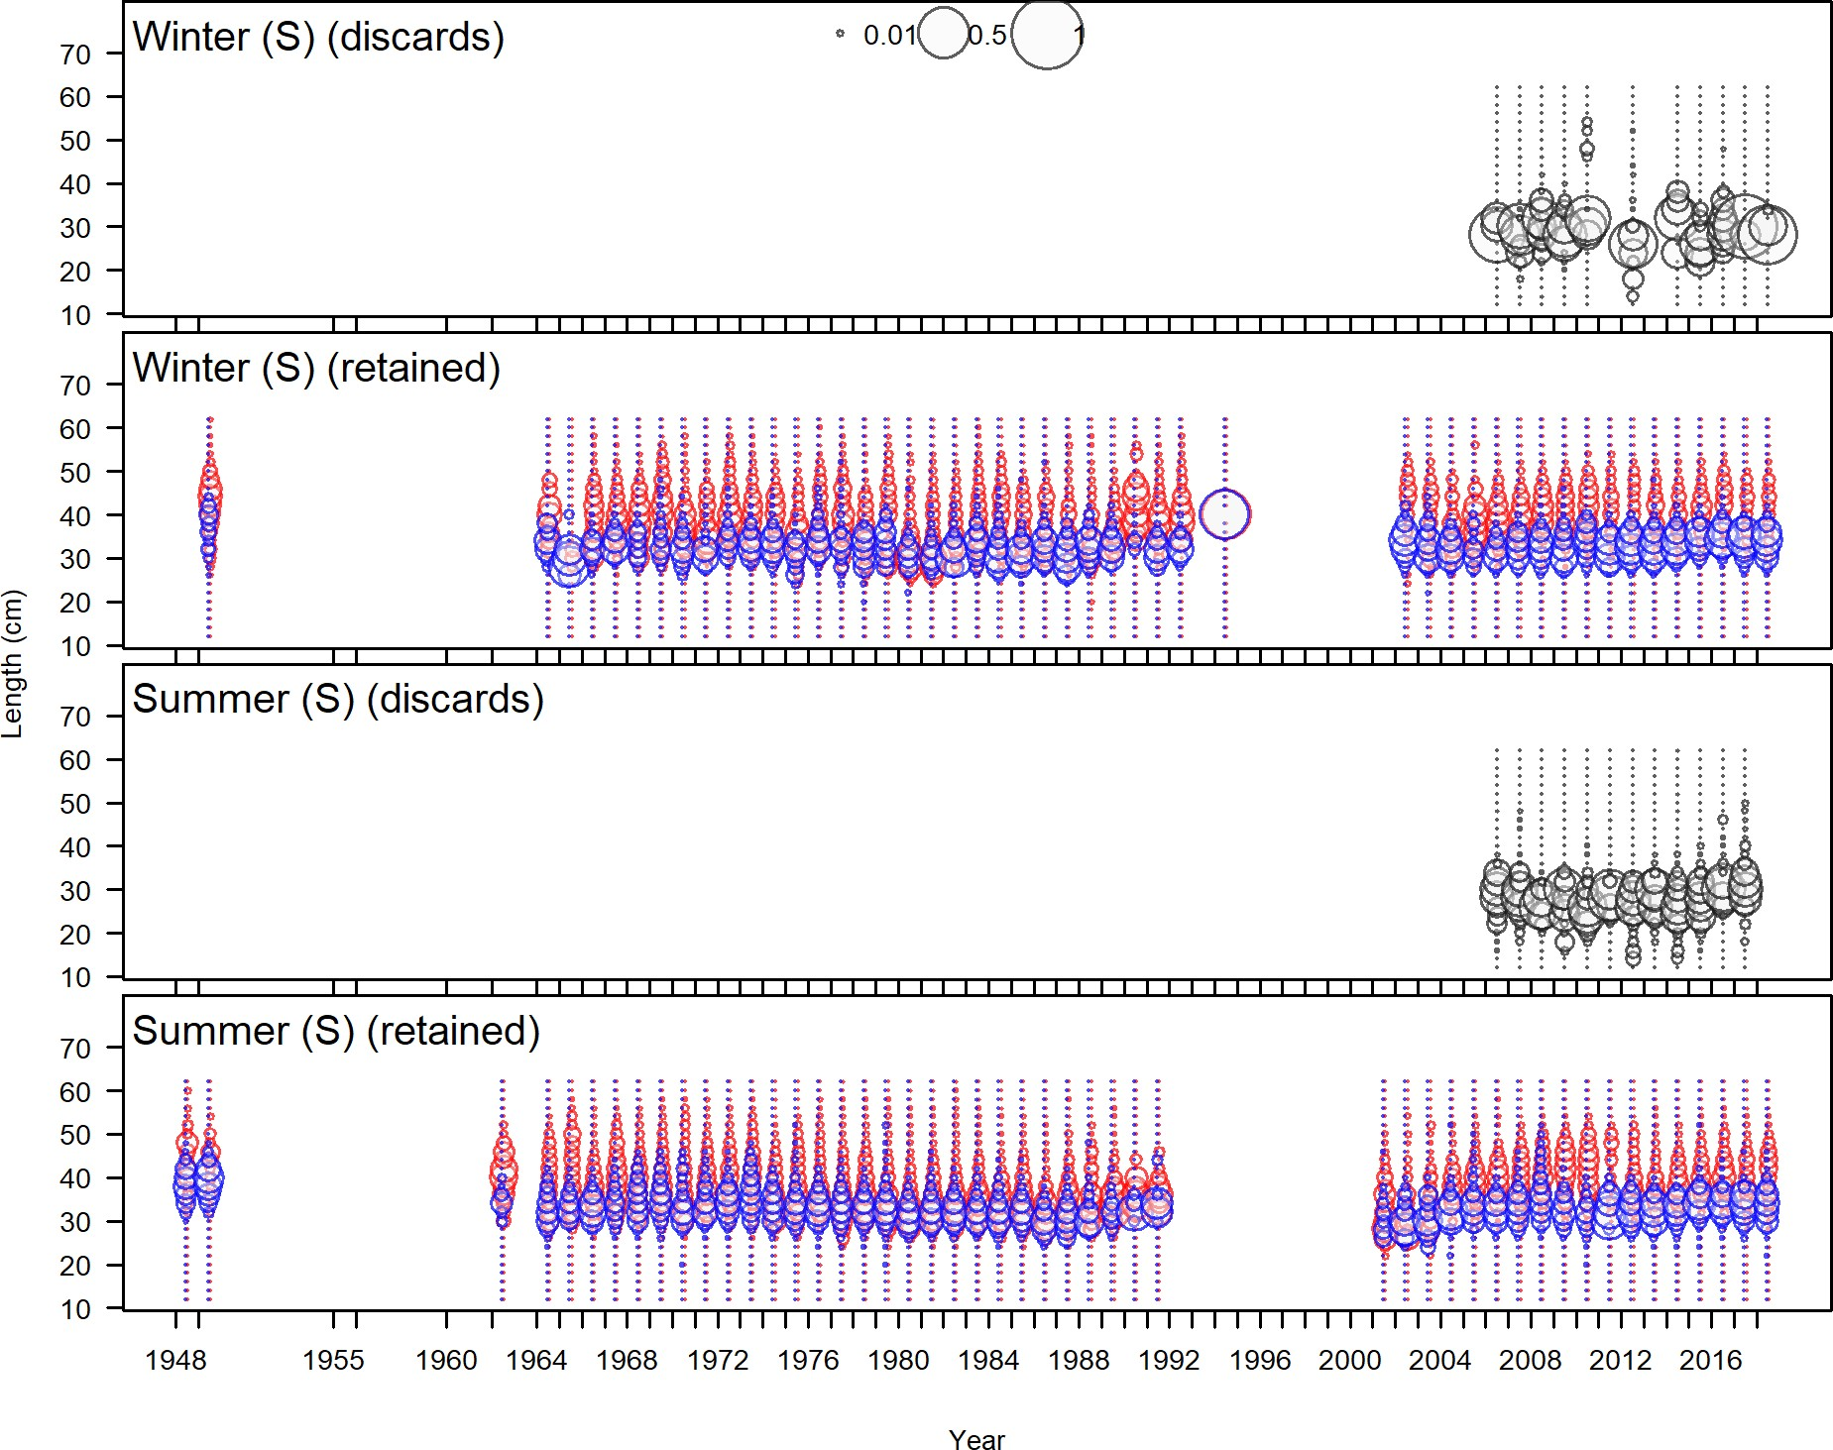

Figure 36: Northern, winter and summer fleets, retained and discarded length frequency distributions for petrale sole.

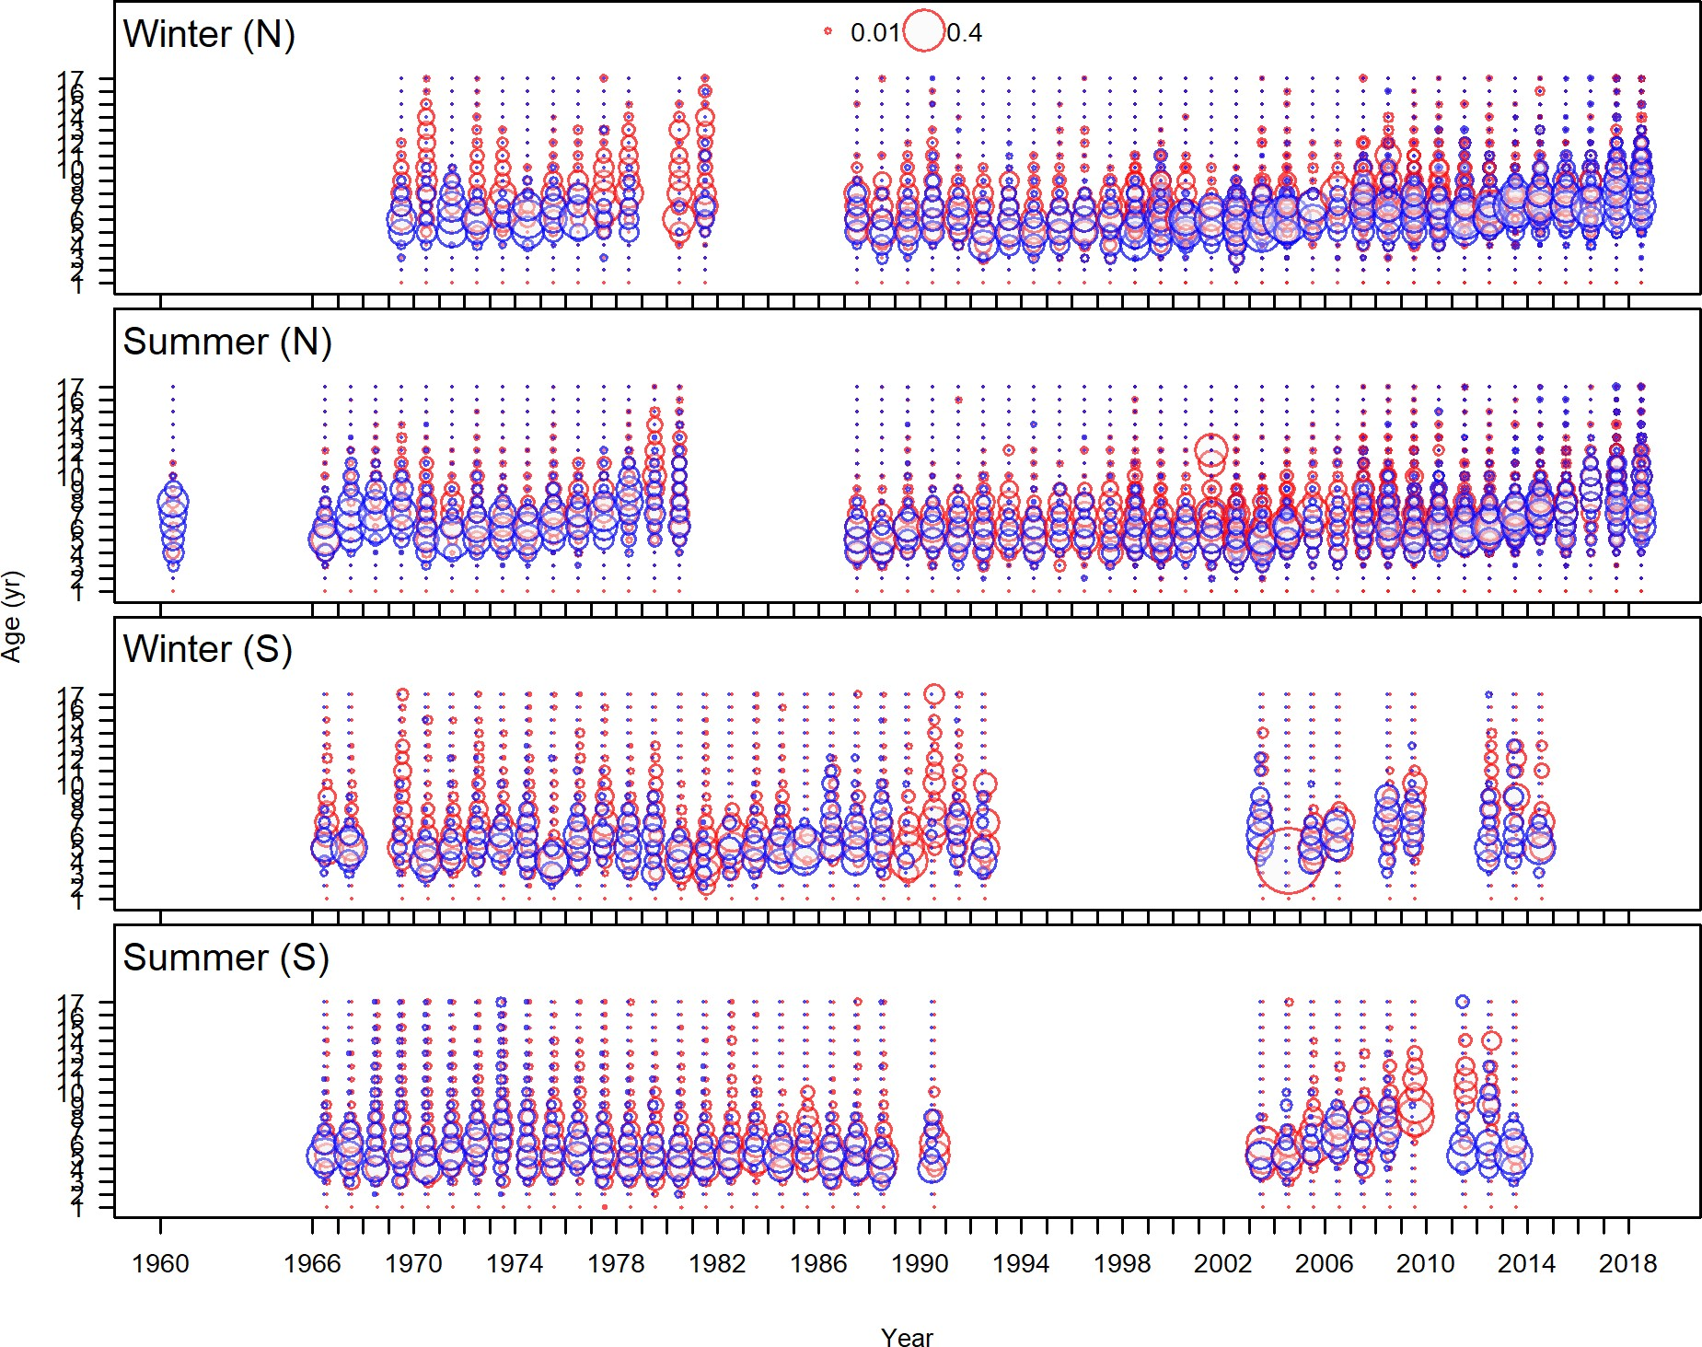

Figure 37: Commercial fishery age frequency distributions for petrale sole.

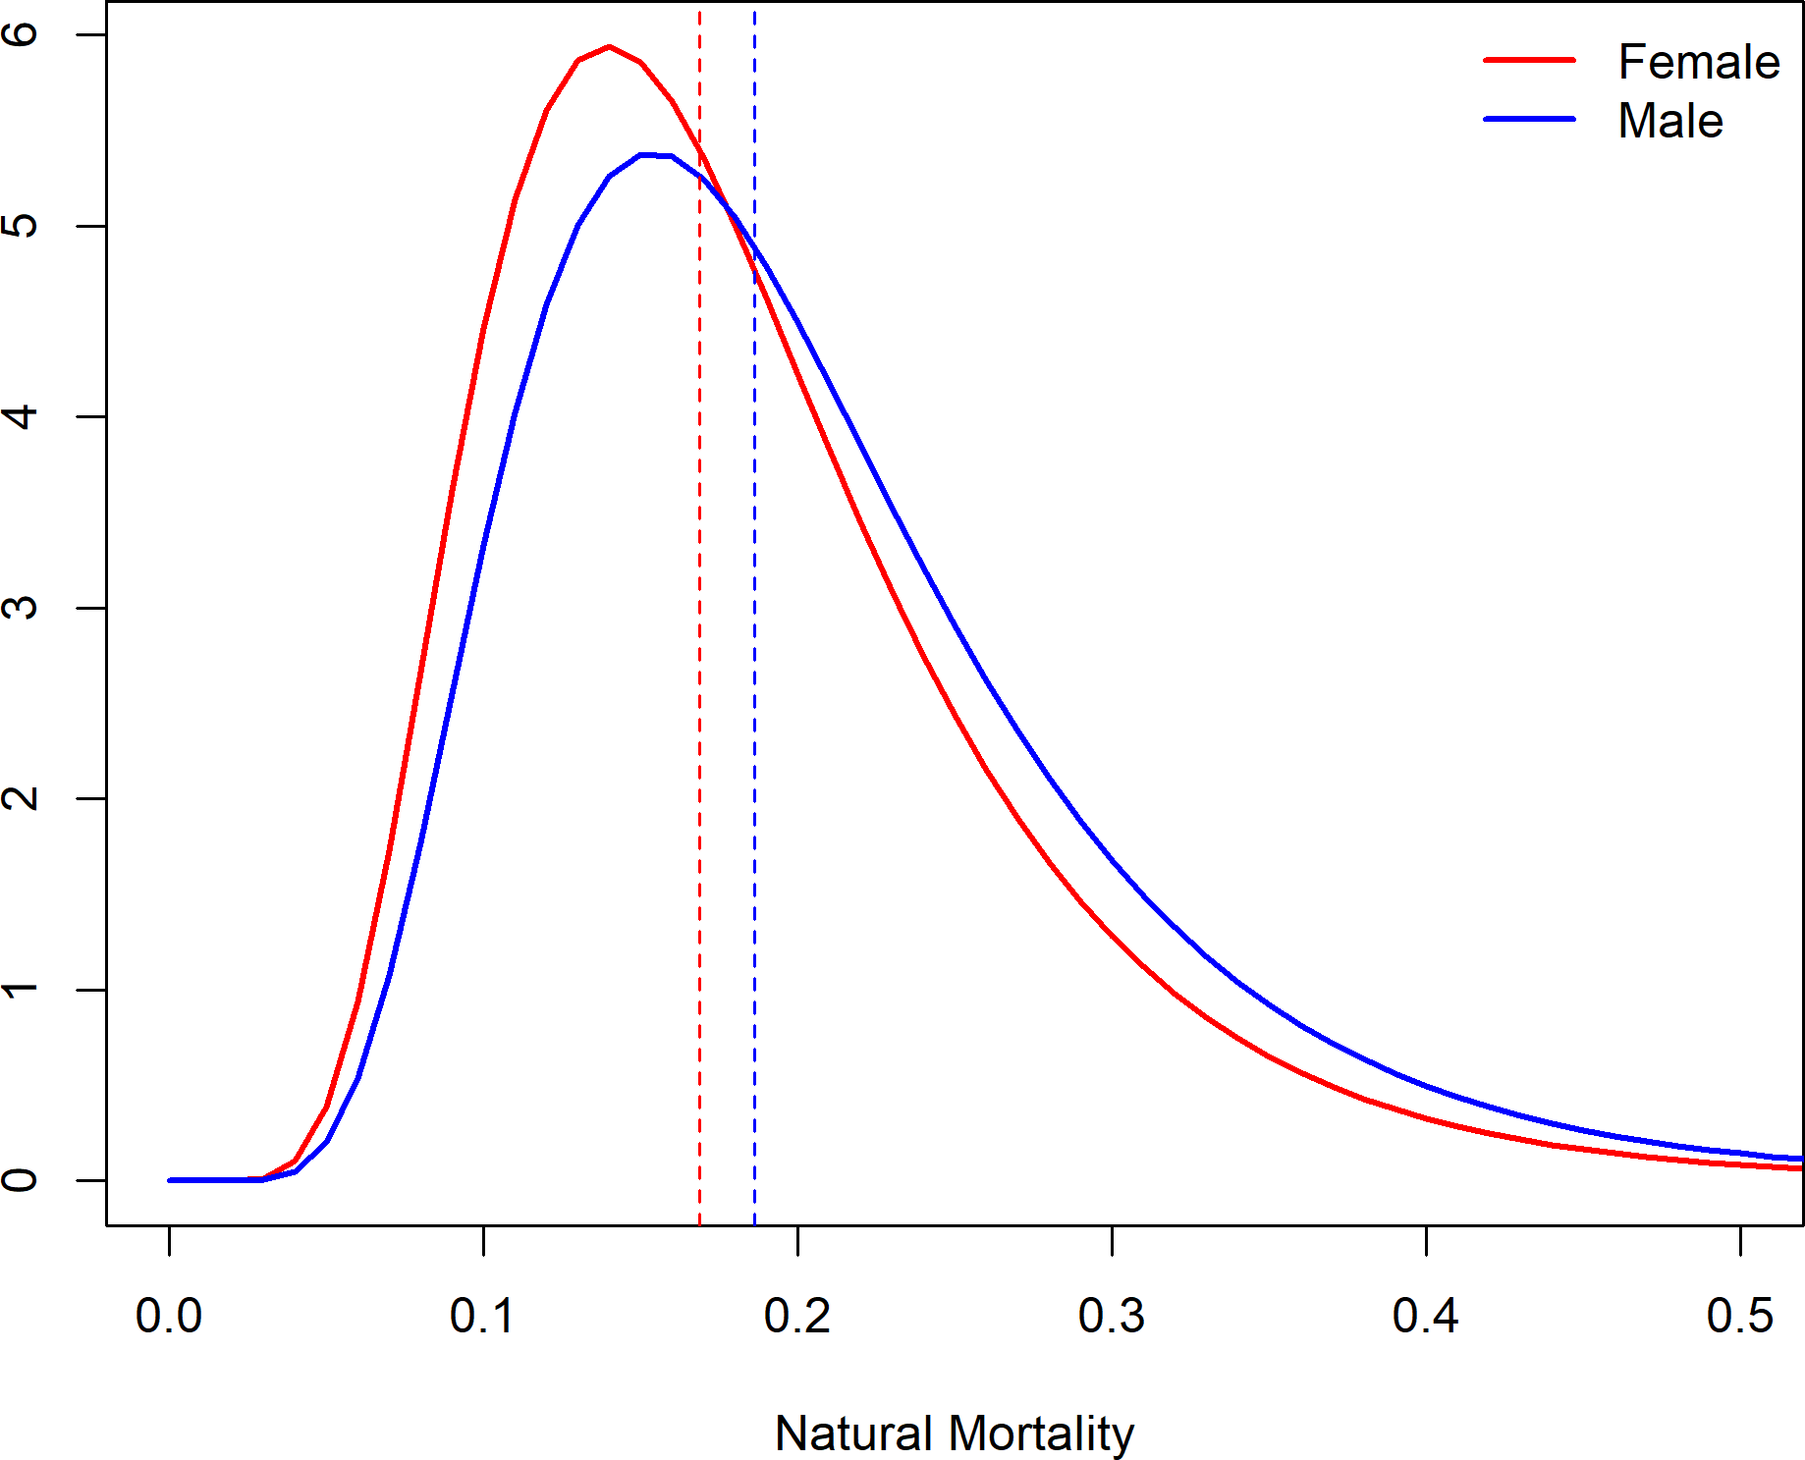

Figure 38: Prior distribution for natural mortality for female and male petrale sole.

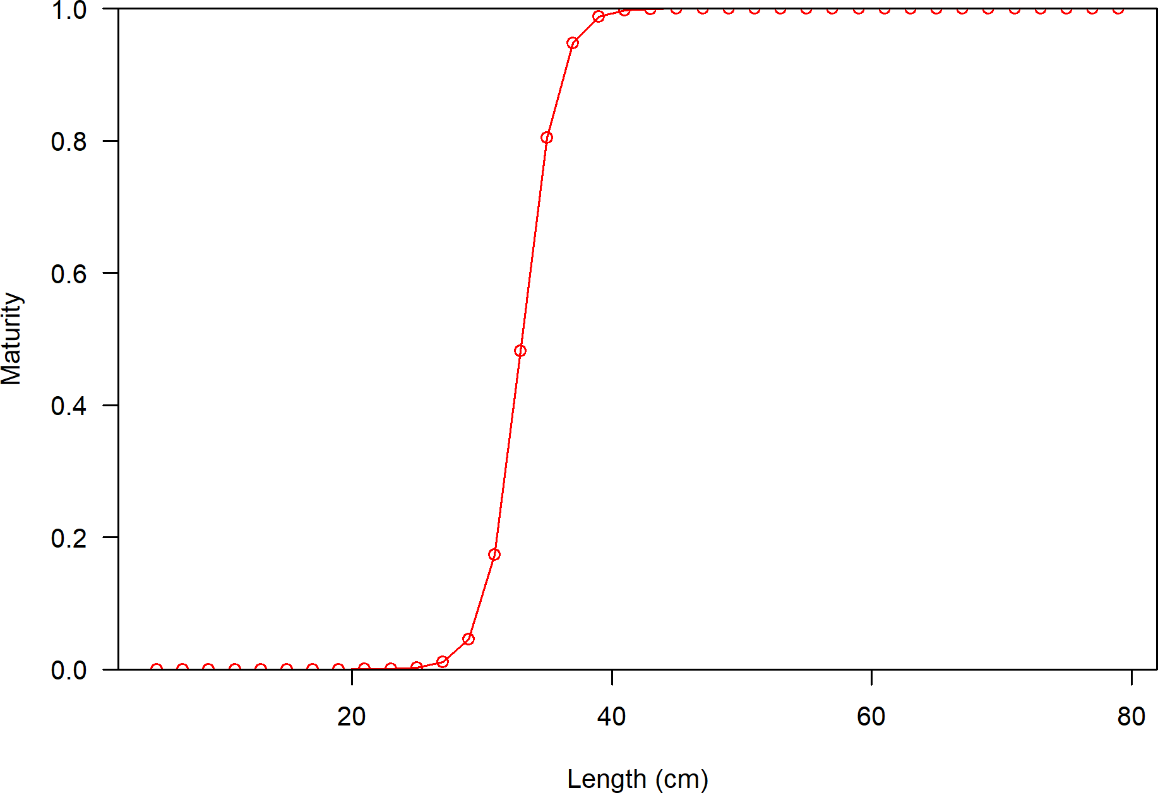

Figure 39: Assumed maturity-at-length for petrale sole.

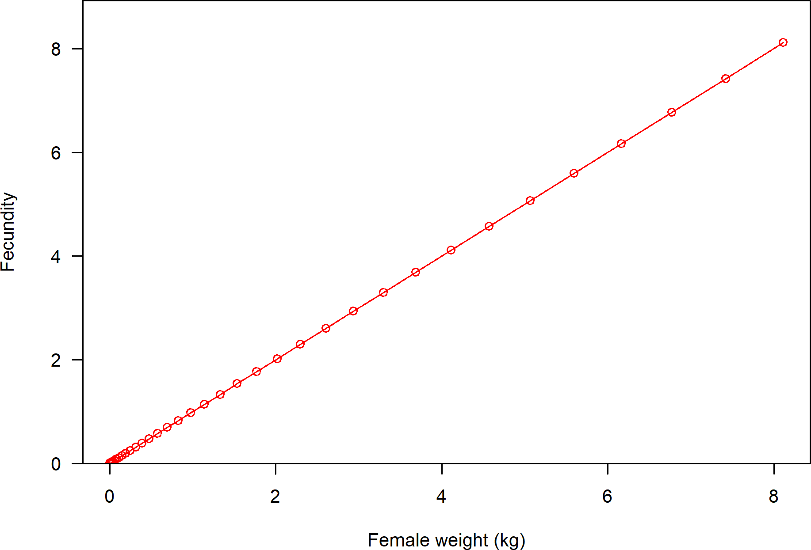

Figure 40: Fecundity-at-length assumed in the model for petrale sole.

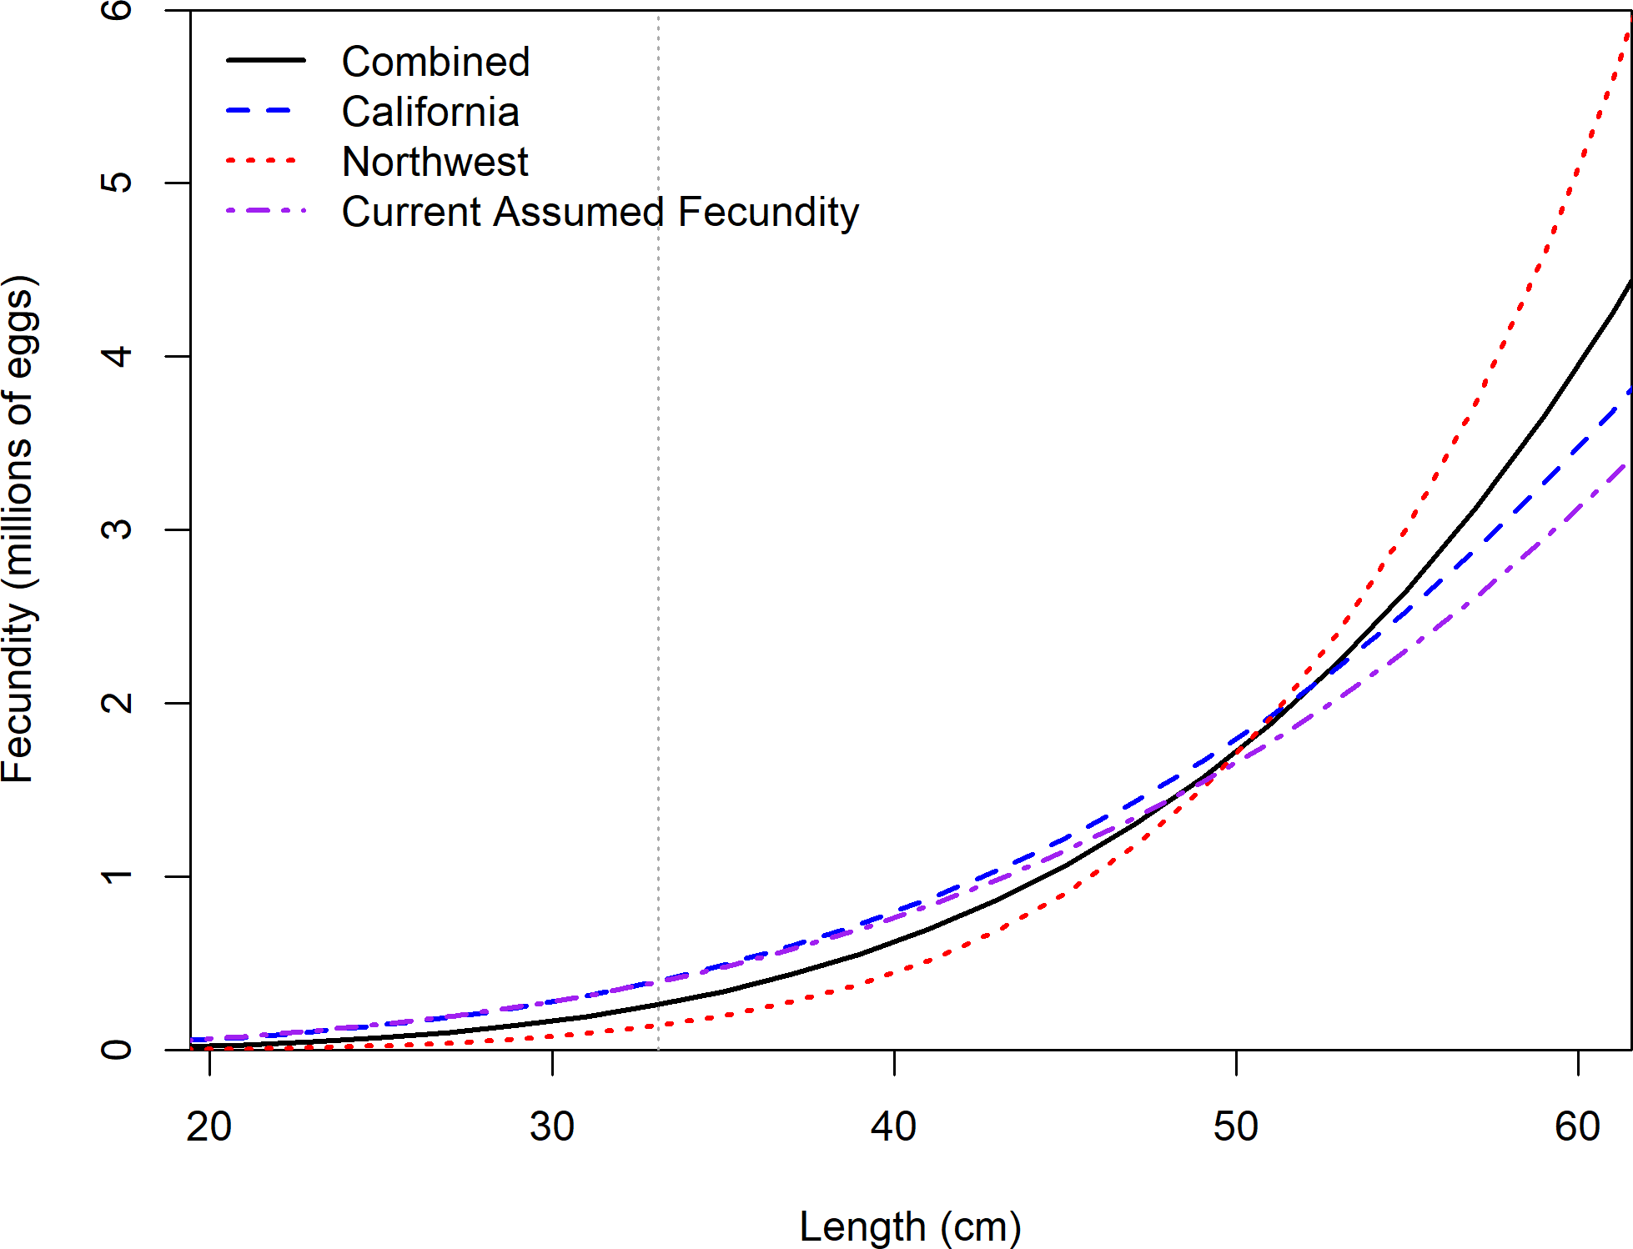

Figure 41: Estimated fecundity-at-length for petrale sole based on Lefebvre et al. (in press).

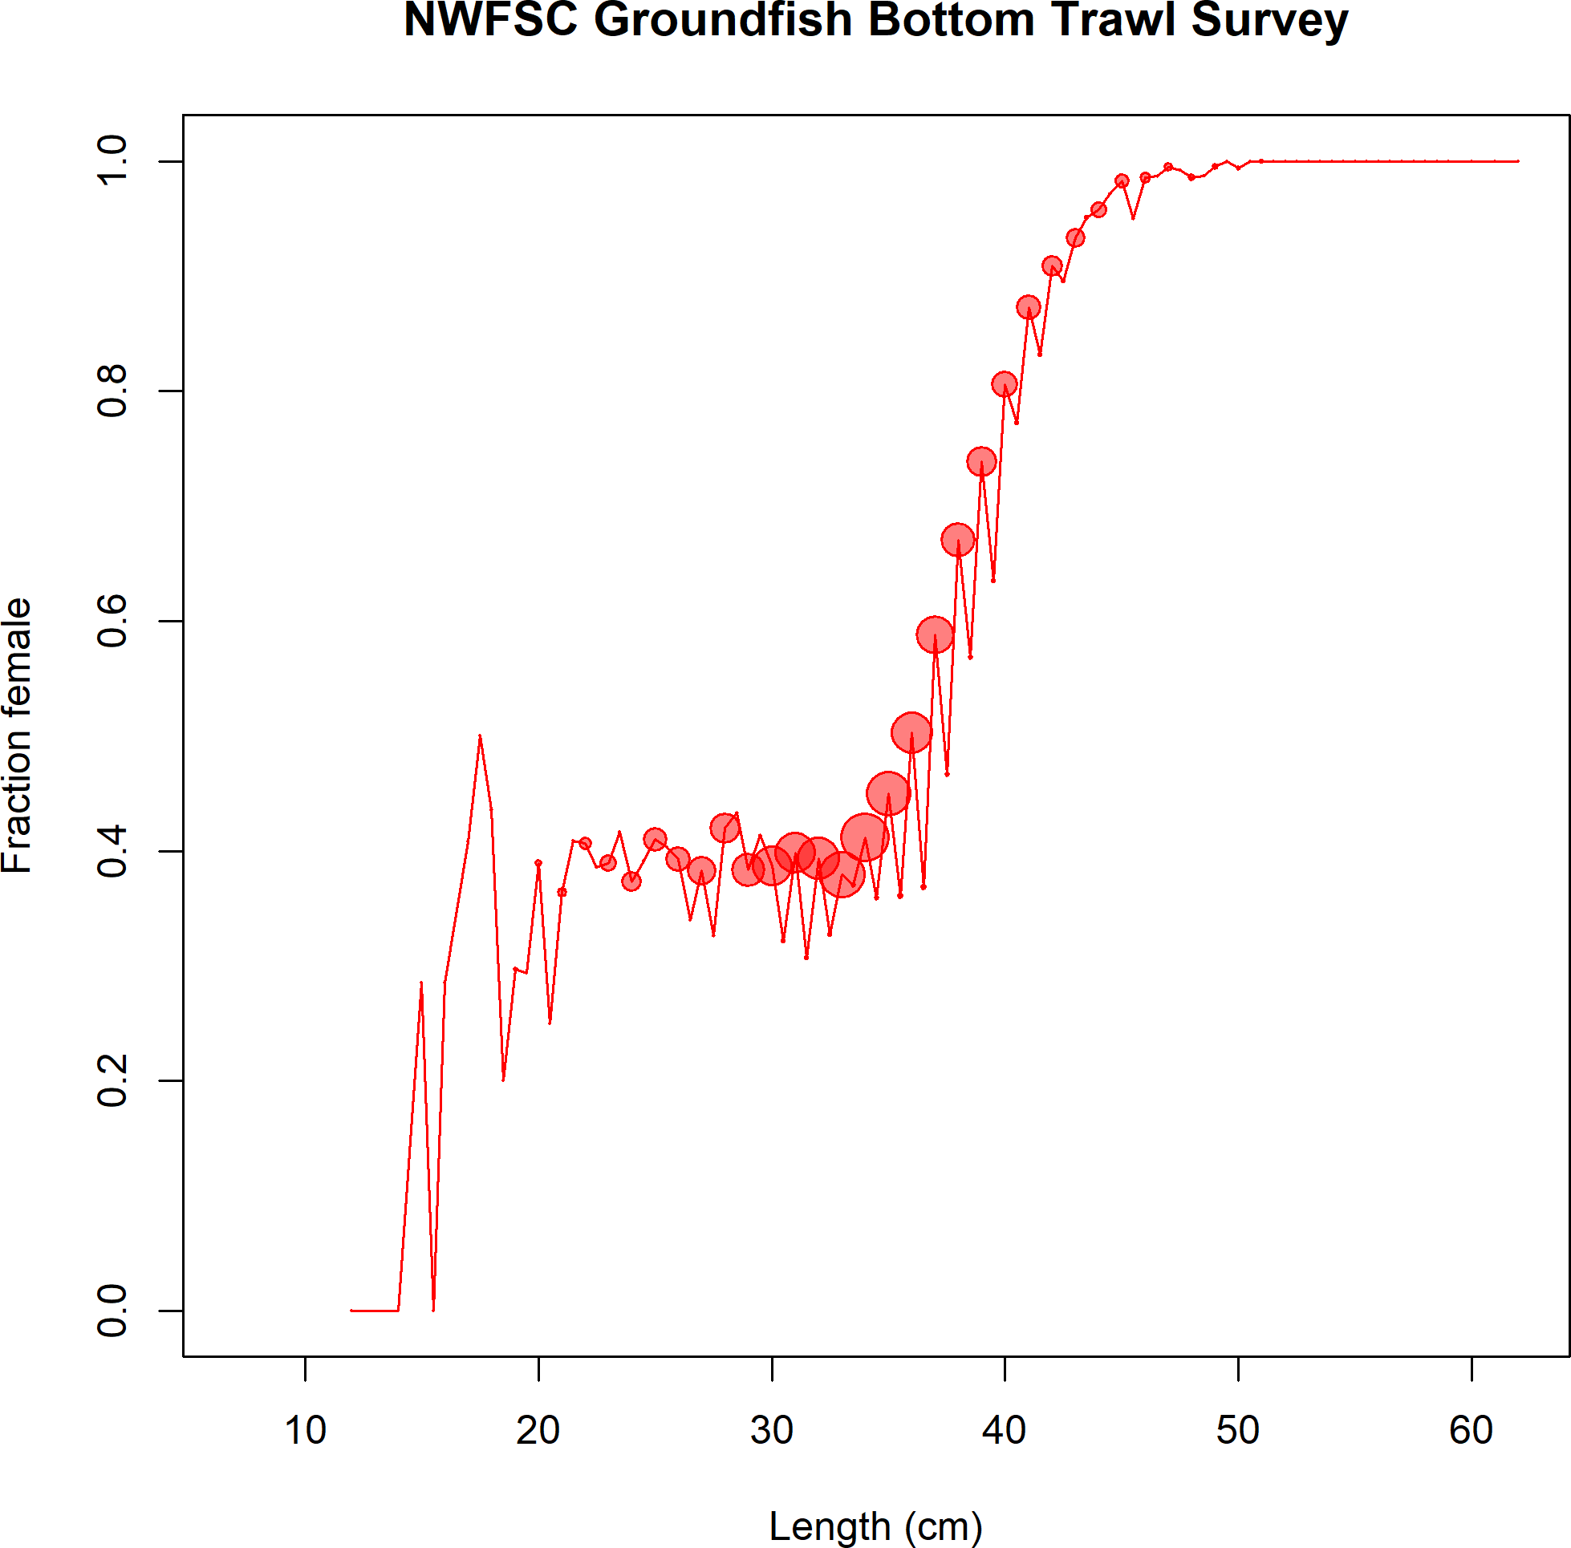

Figure 42: Estimated proportion of female fish collected by the NWFSC West Coast Ground- fish Bottom Trawl Survey across all years for petrale sole.

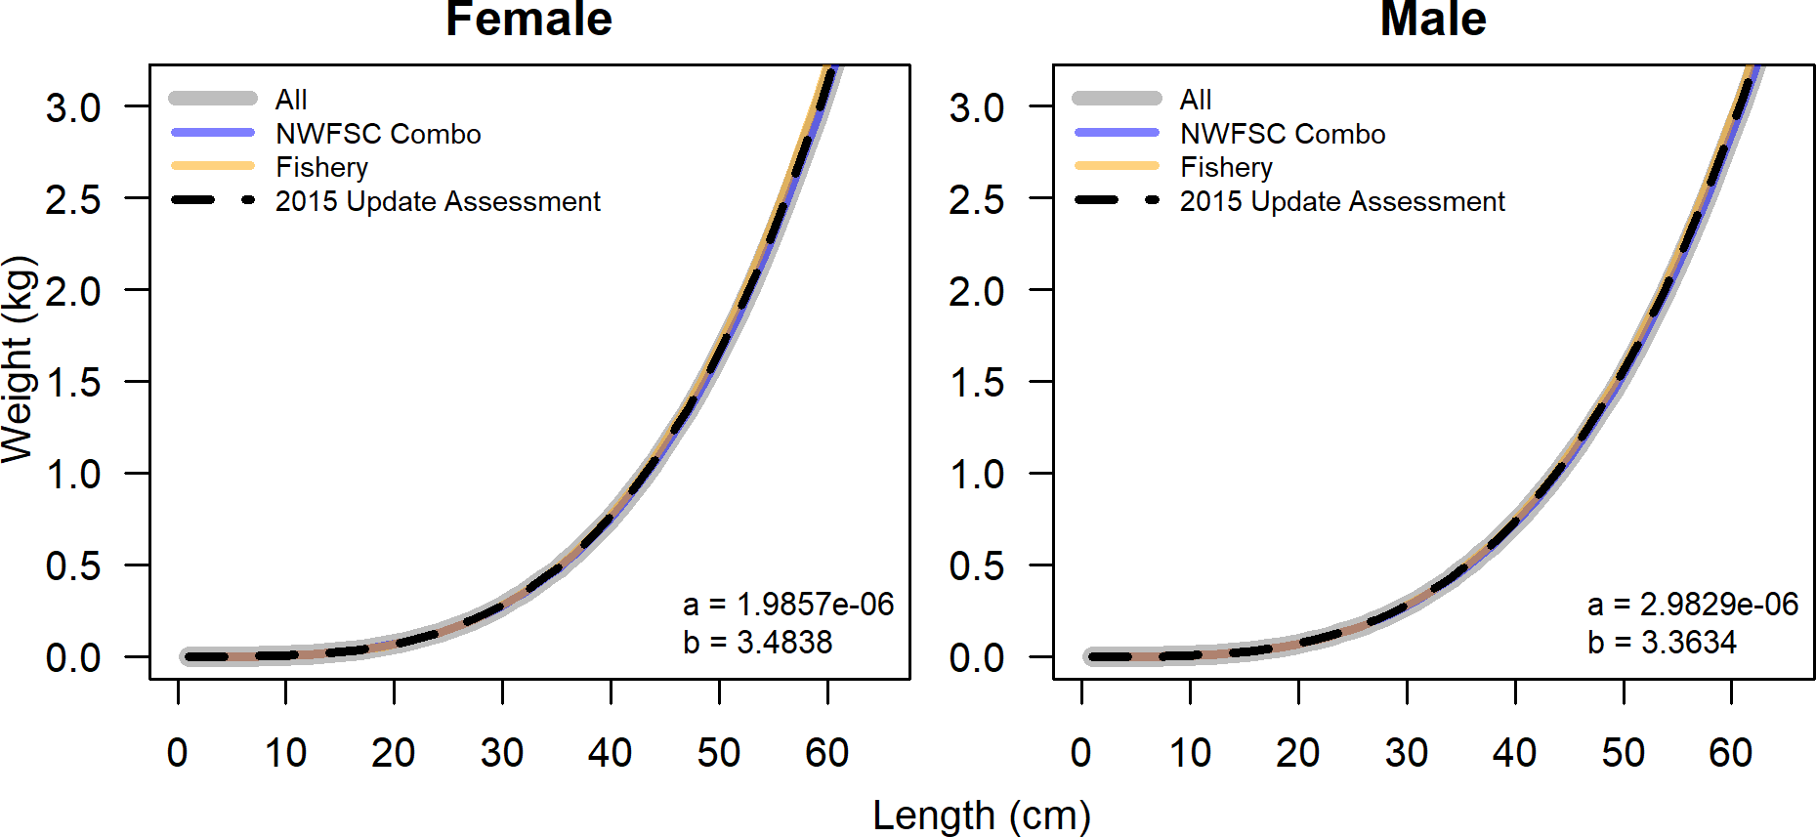

Figure 43: Estimated weight-at-length for female and male petrale sole.

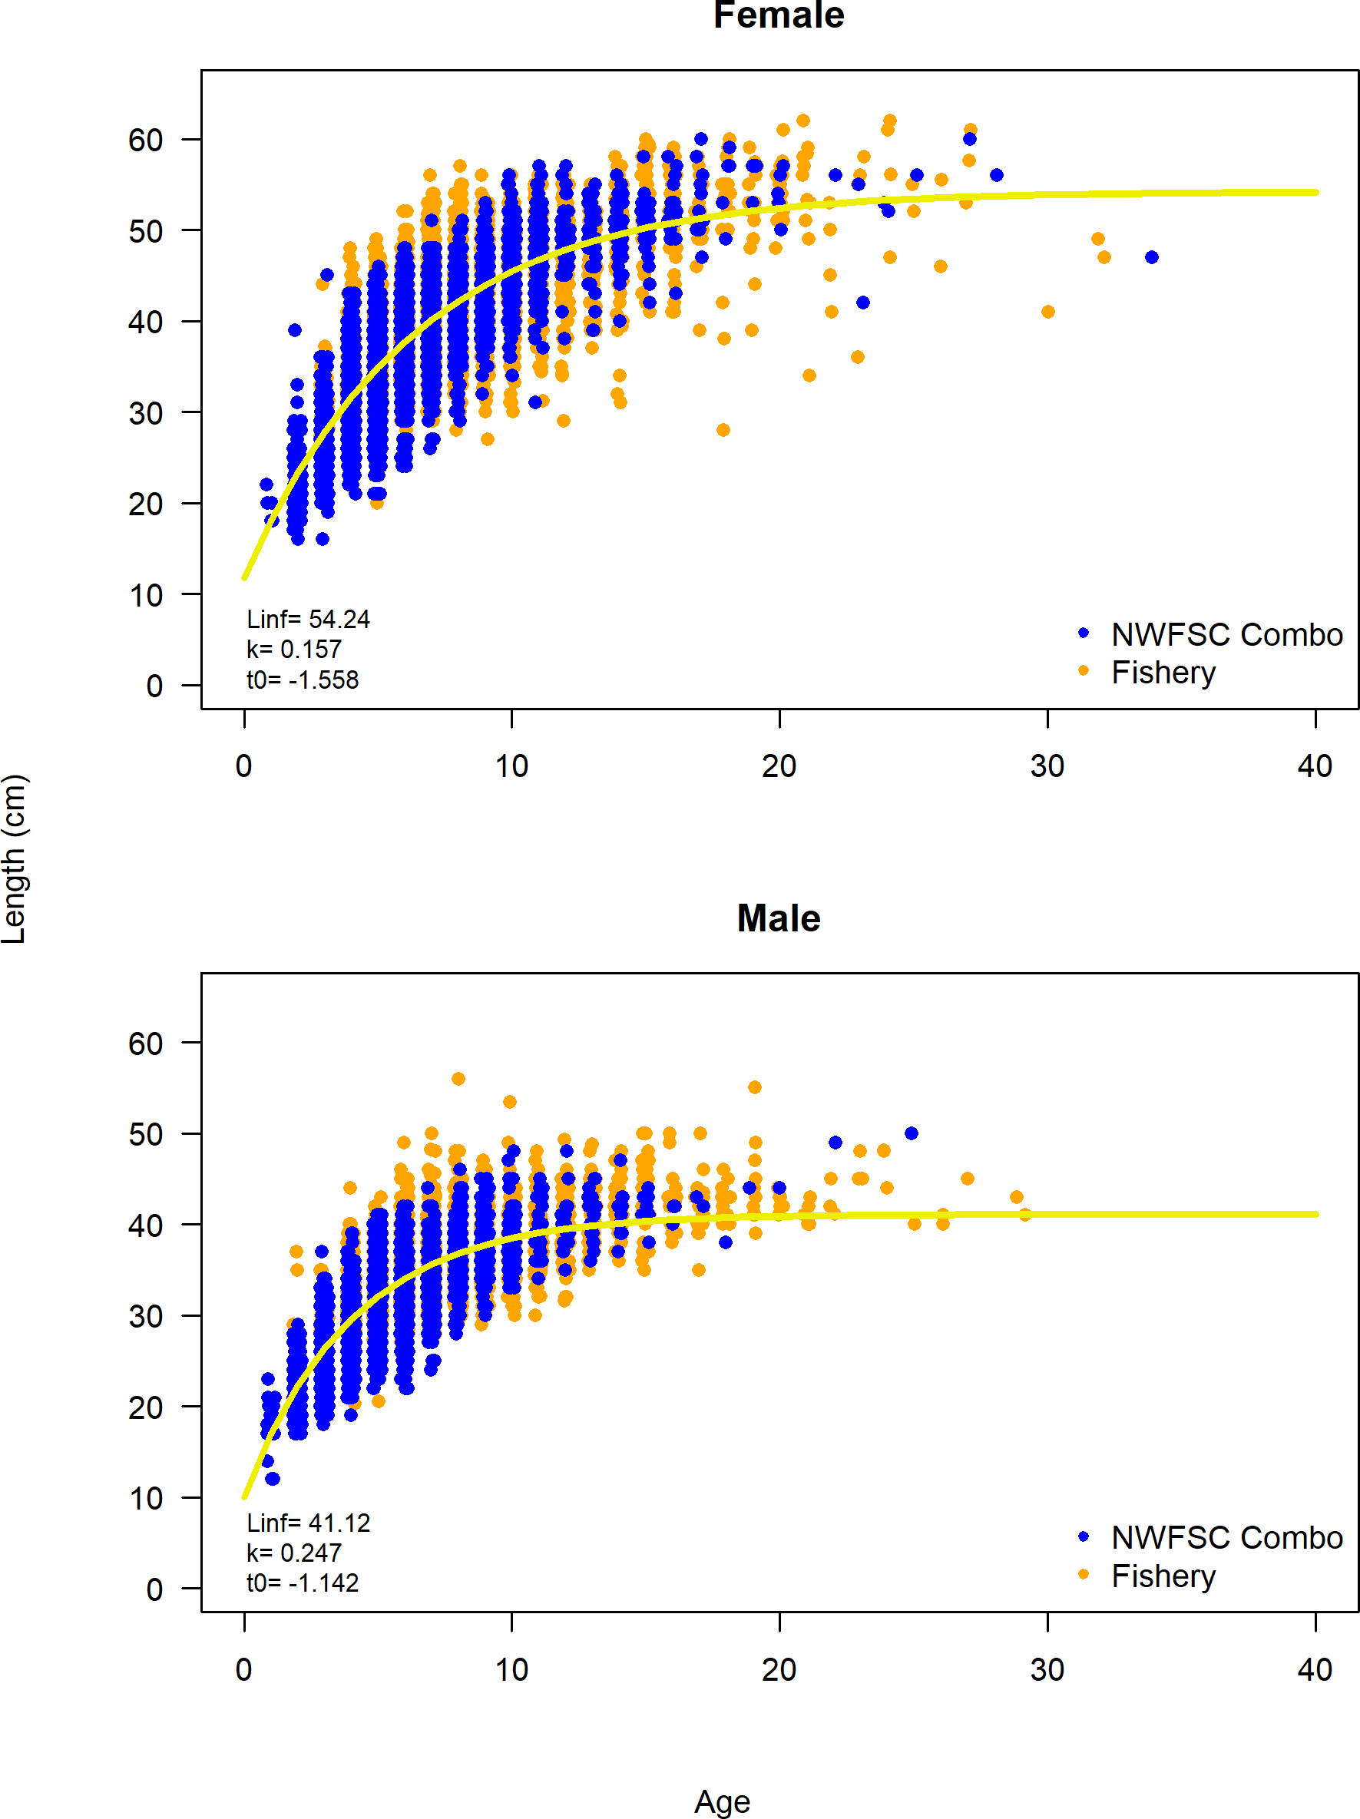

Figure 44: Length-at-age across data sources for female and male petrale sole.

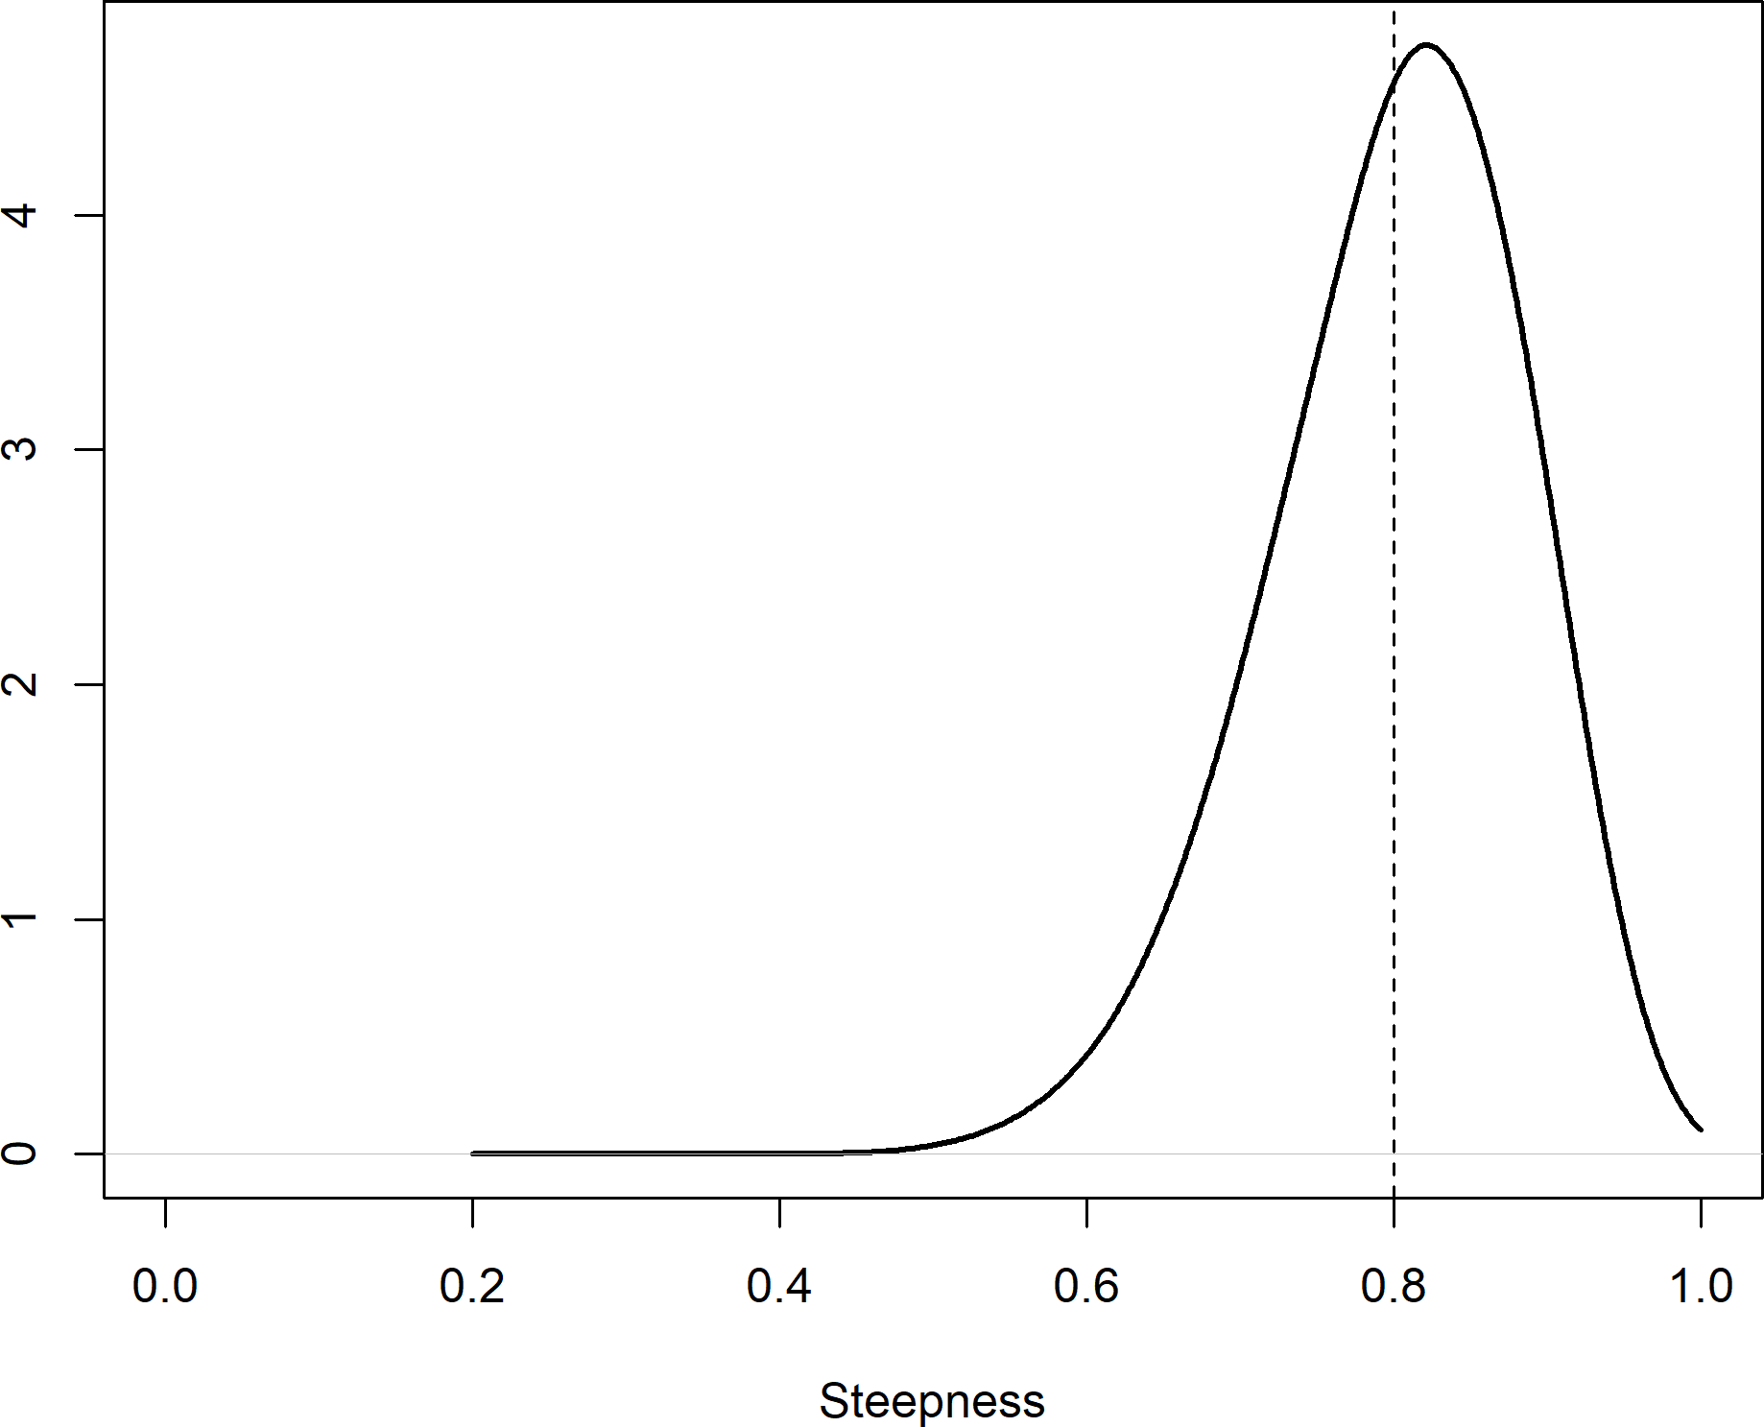

Figure 45: Prior distribution for steepness petrale sole.

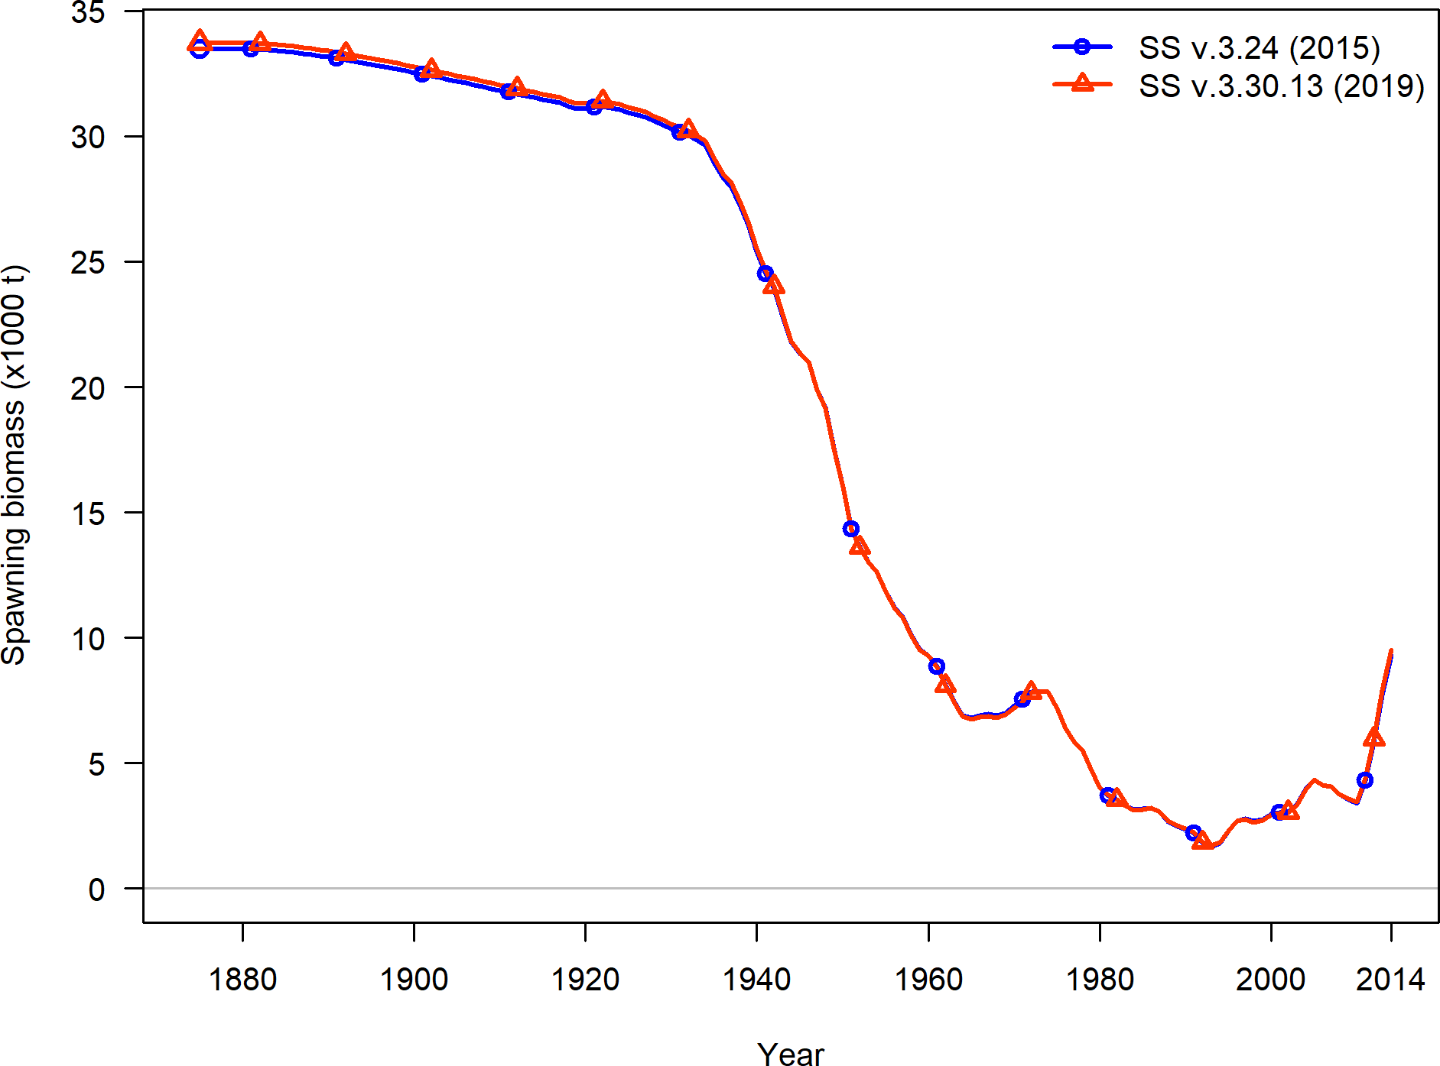

Figure 46: Comparison of model bridging estimates from Stock Synthesis version 3.30.13 and 3.24U for petrale sole for the 2015 assessment.

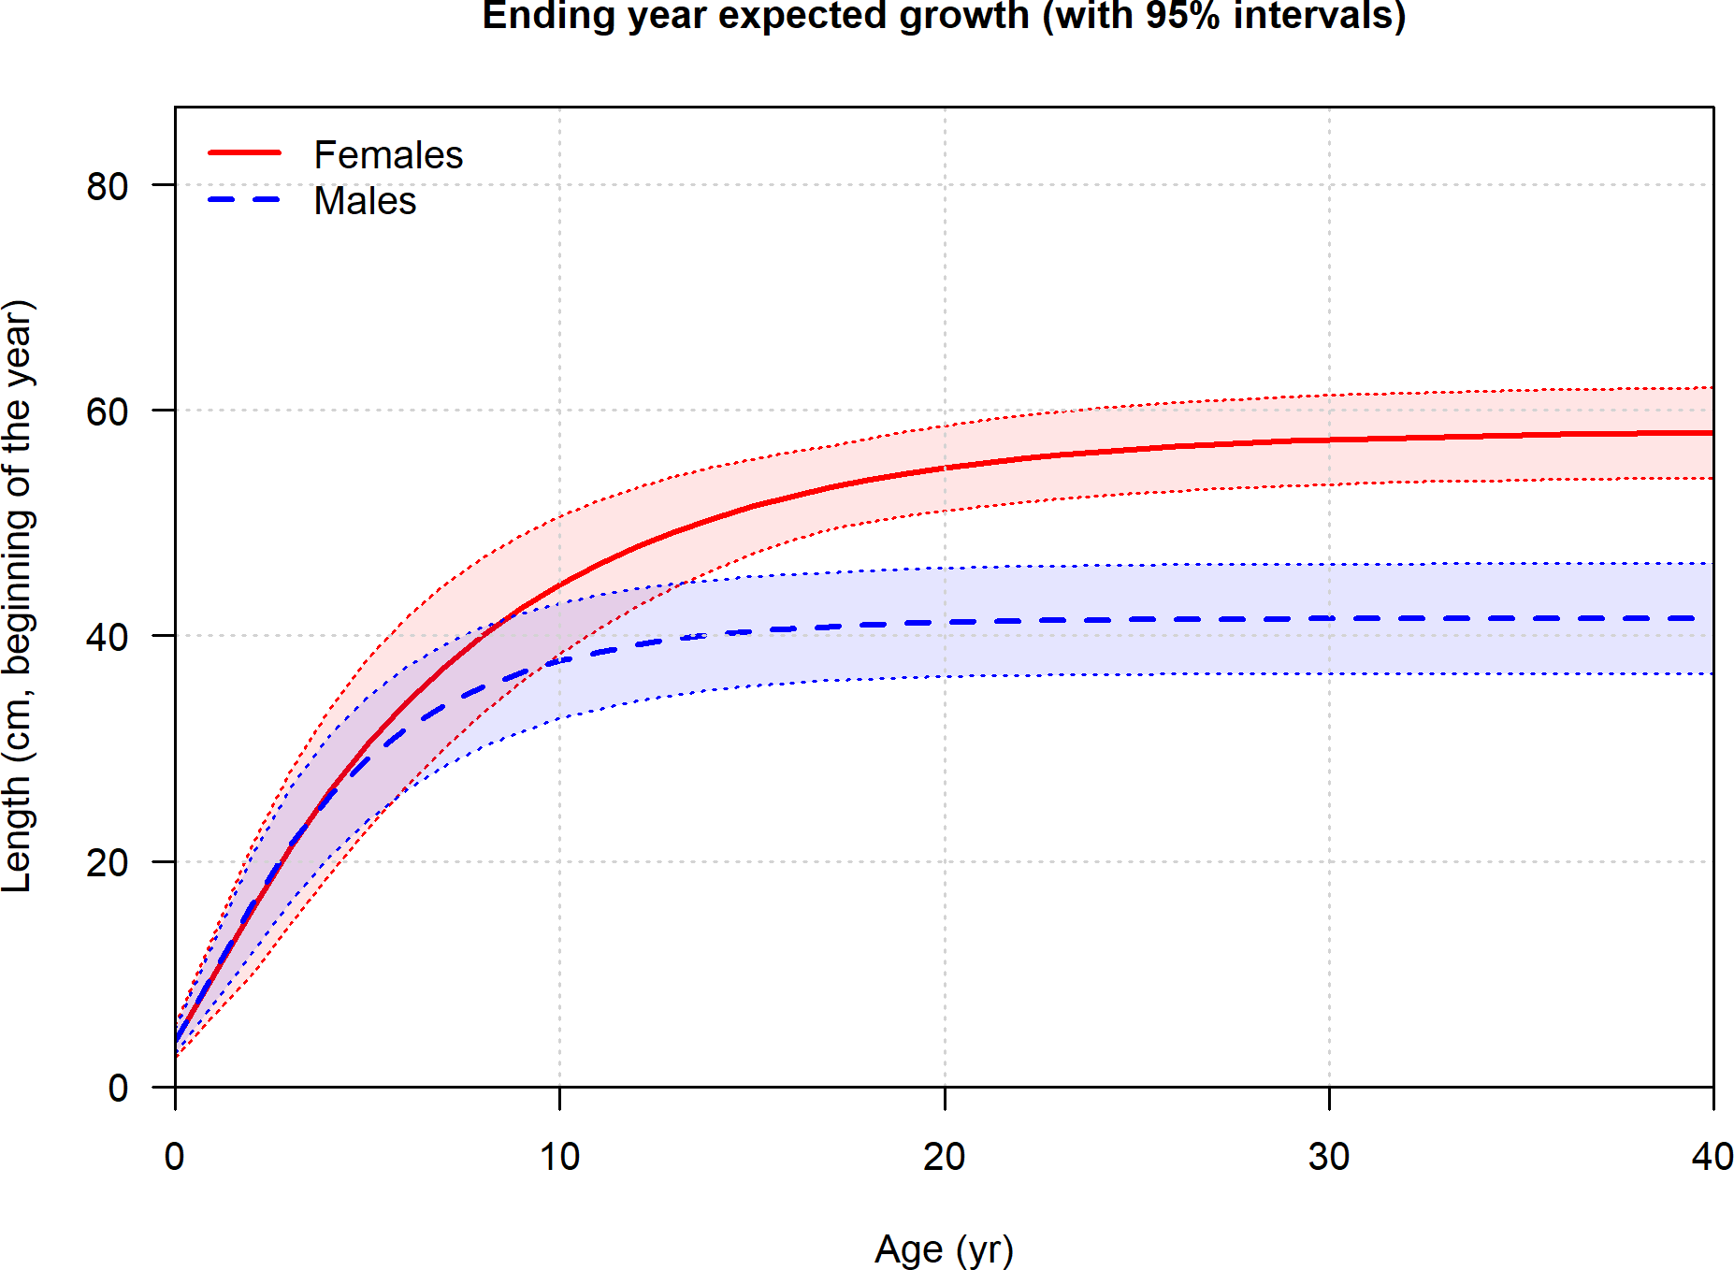

Figure 47: Estimated length-at-age for male and female for petrale sole with estimated CV.

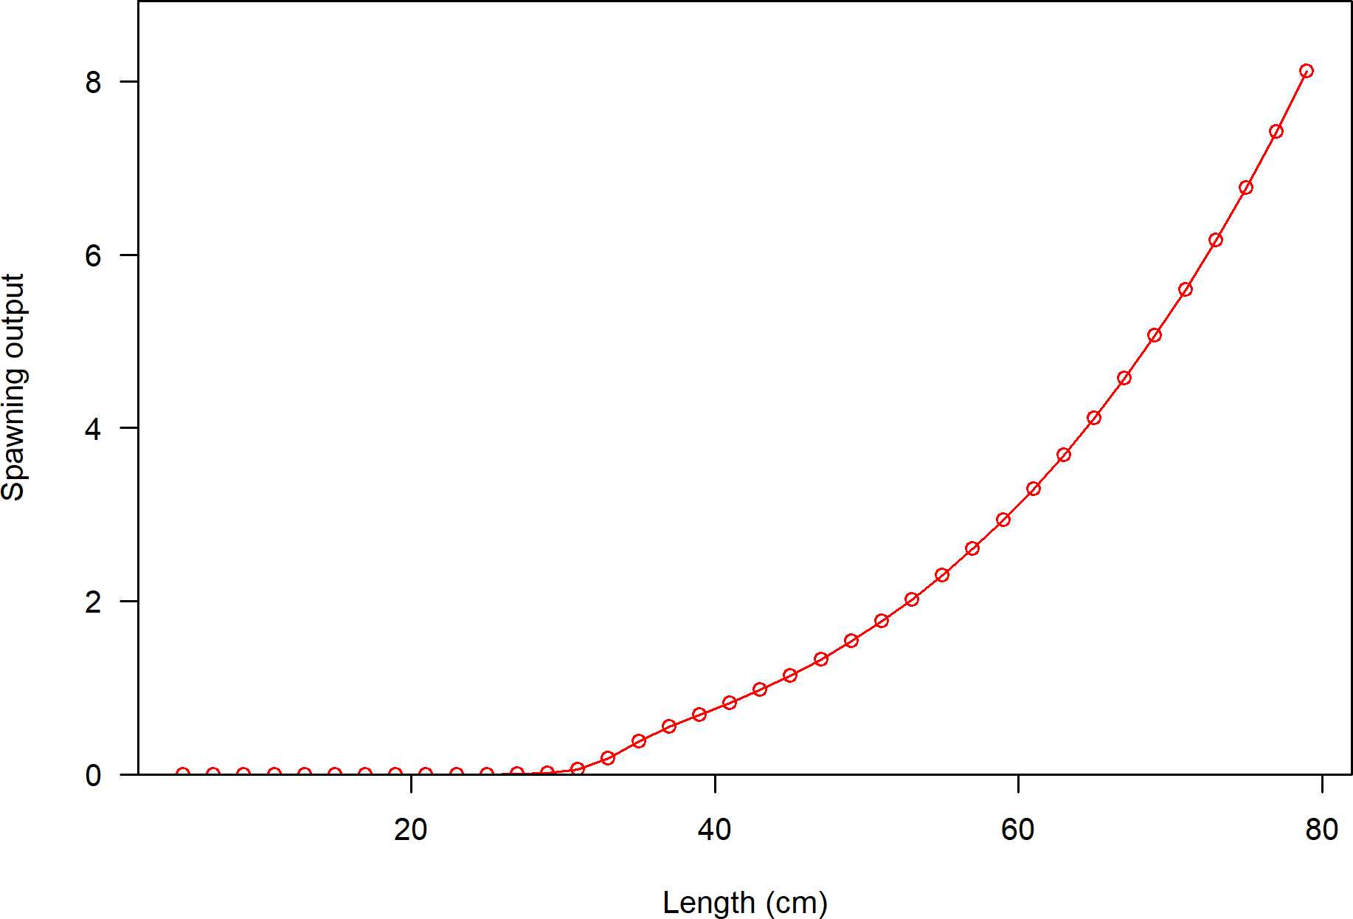

Figure 48: Estimated spawning output-at-length for female petrale sole.

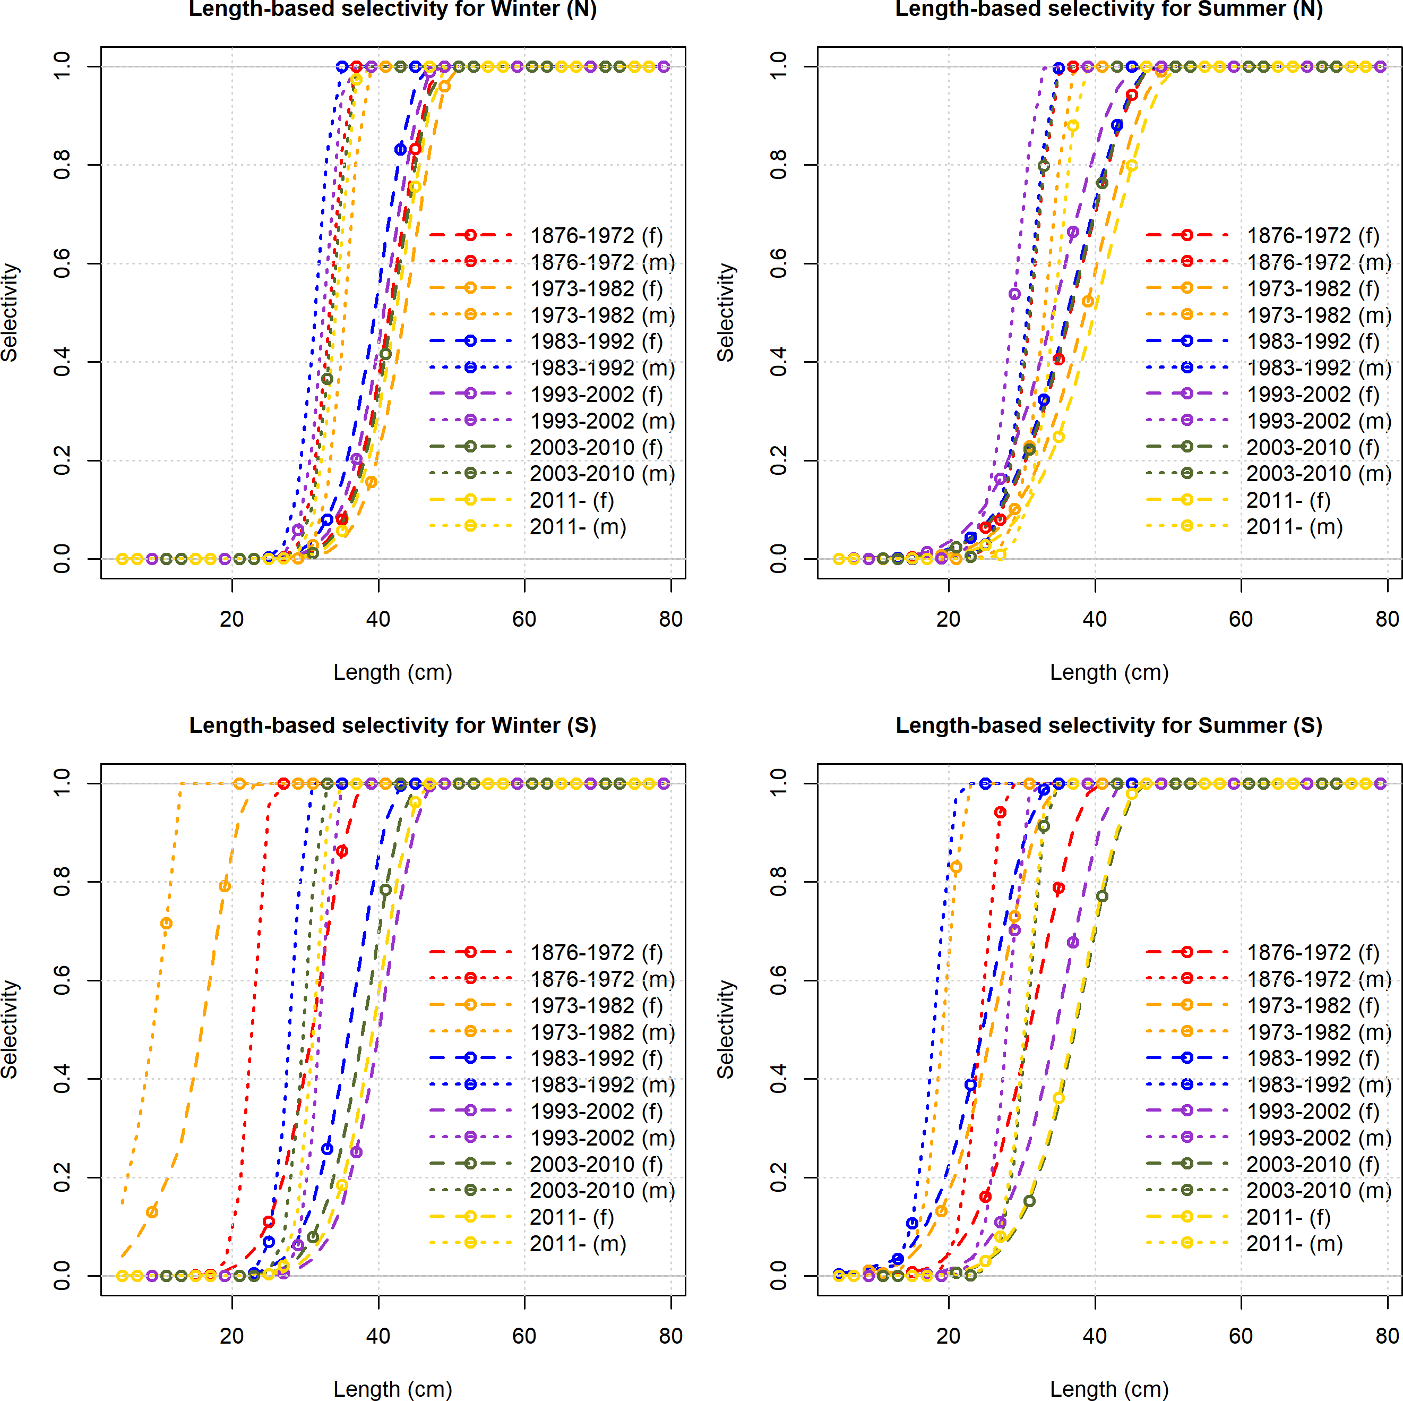

Figure 49: Estimated selectivity for each commerical fleet over the assessment period for female and male petrale sole.

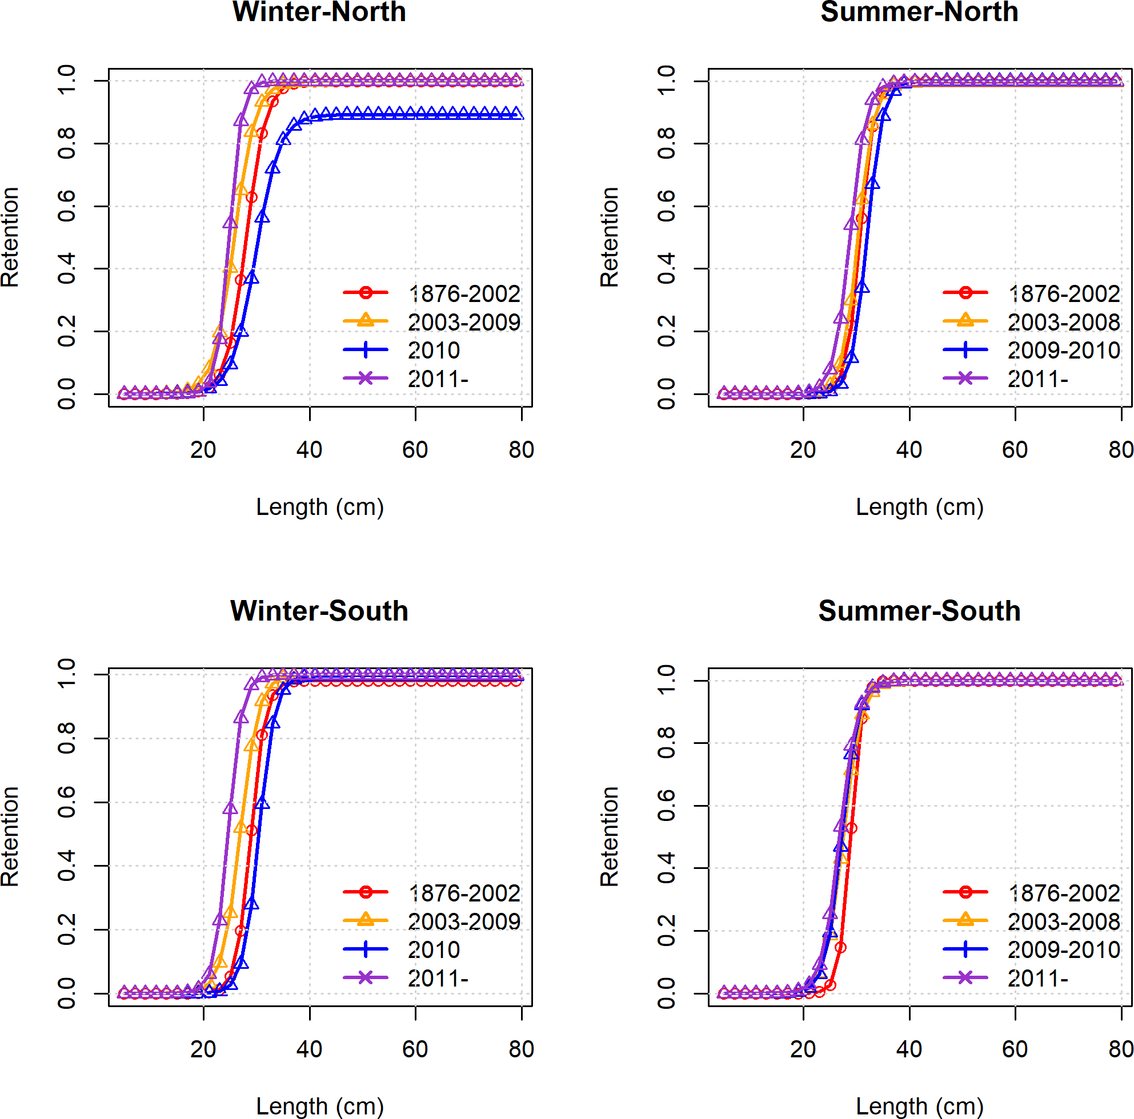

Figure 50: Estimated retention for each commerical fleet over the assessment period for petrale sole. Retention was not estimated to be sex-specific.

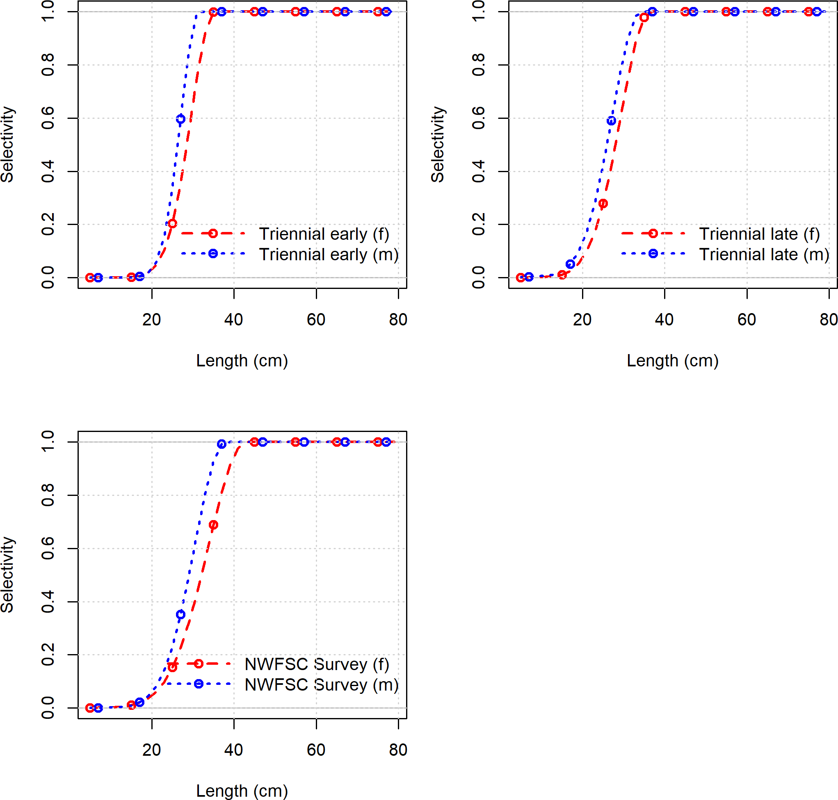

Figure 51: Estimated selectivity for each survey over the assessment period for female and male petrale sole.



Figure 52: Estimated time-series of recruitment for petrale sole.

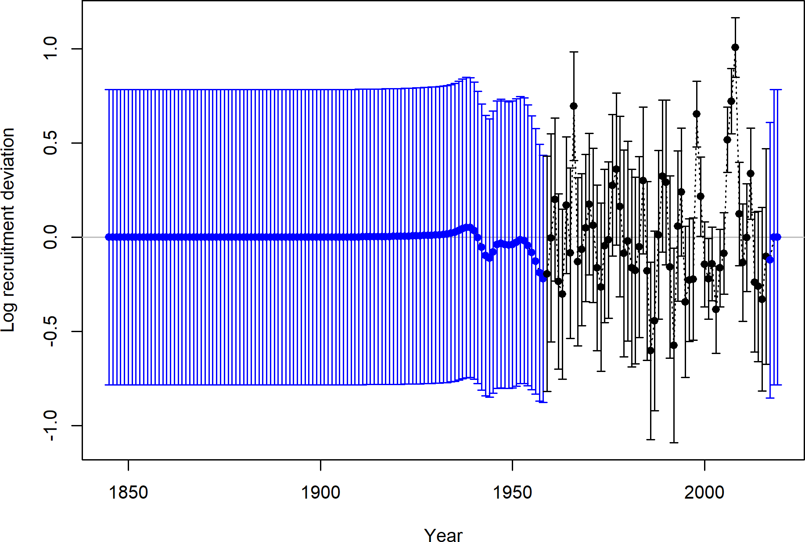

Figure 53: Estimated time-series of recruitment deviations for petrale sole.

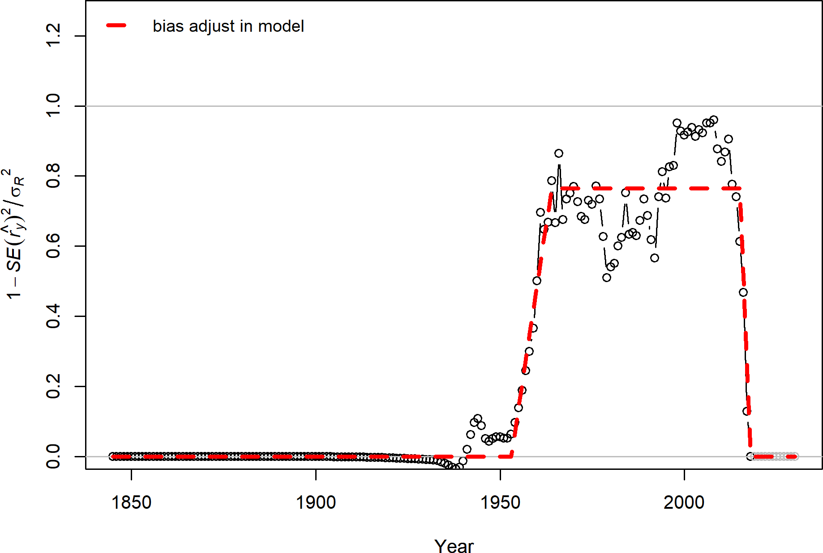

Figure 54: Recruitment bias adjustment in the model.

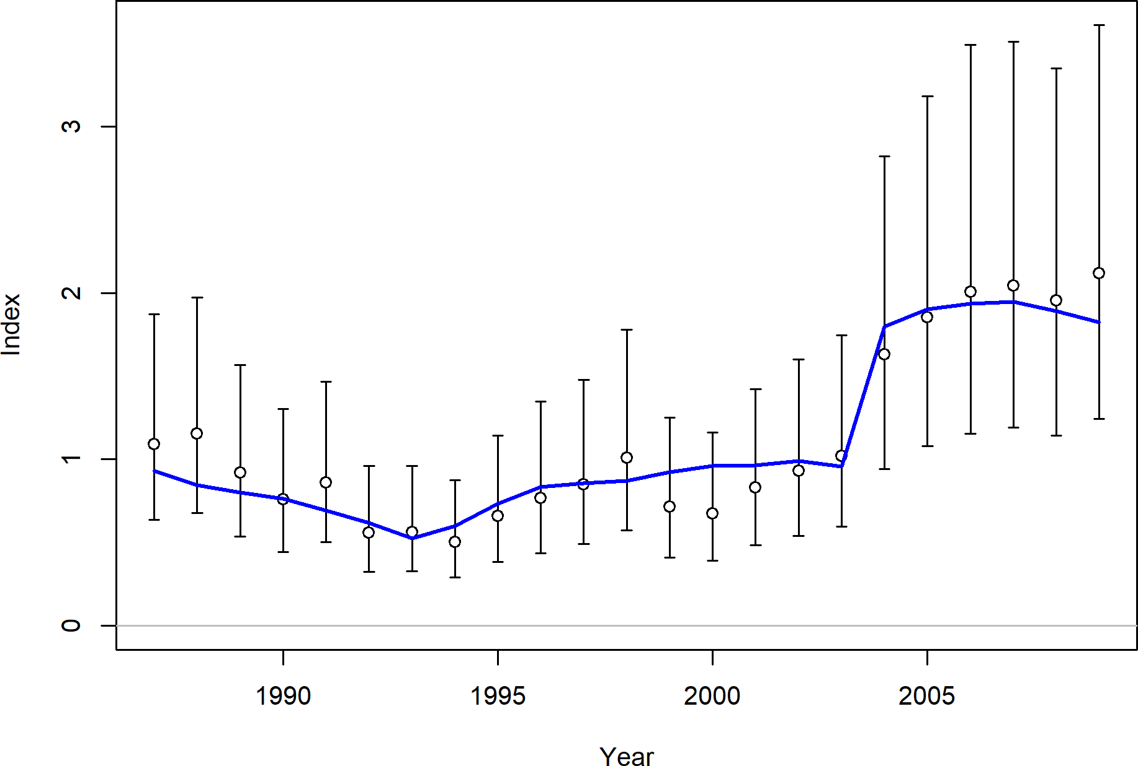

Figure 55: Fit to the Winter North catch-per-unit-effort time series for petrale sole.

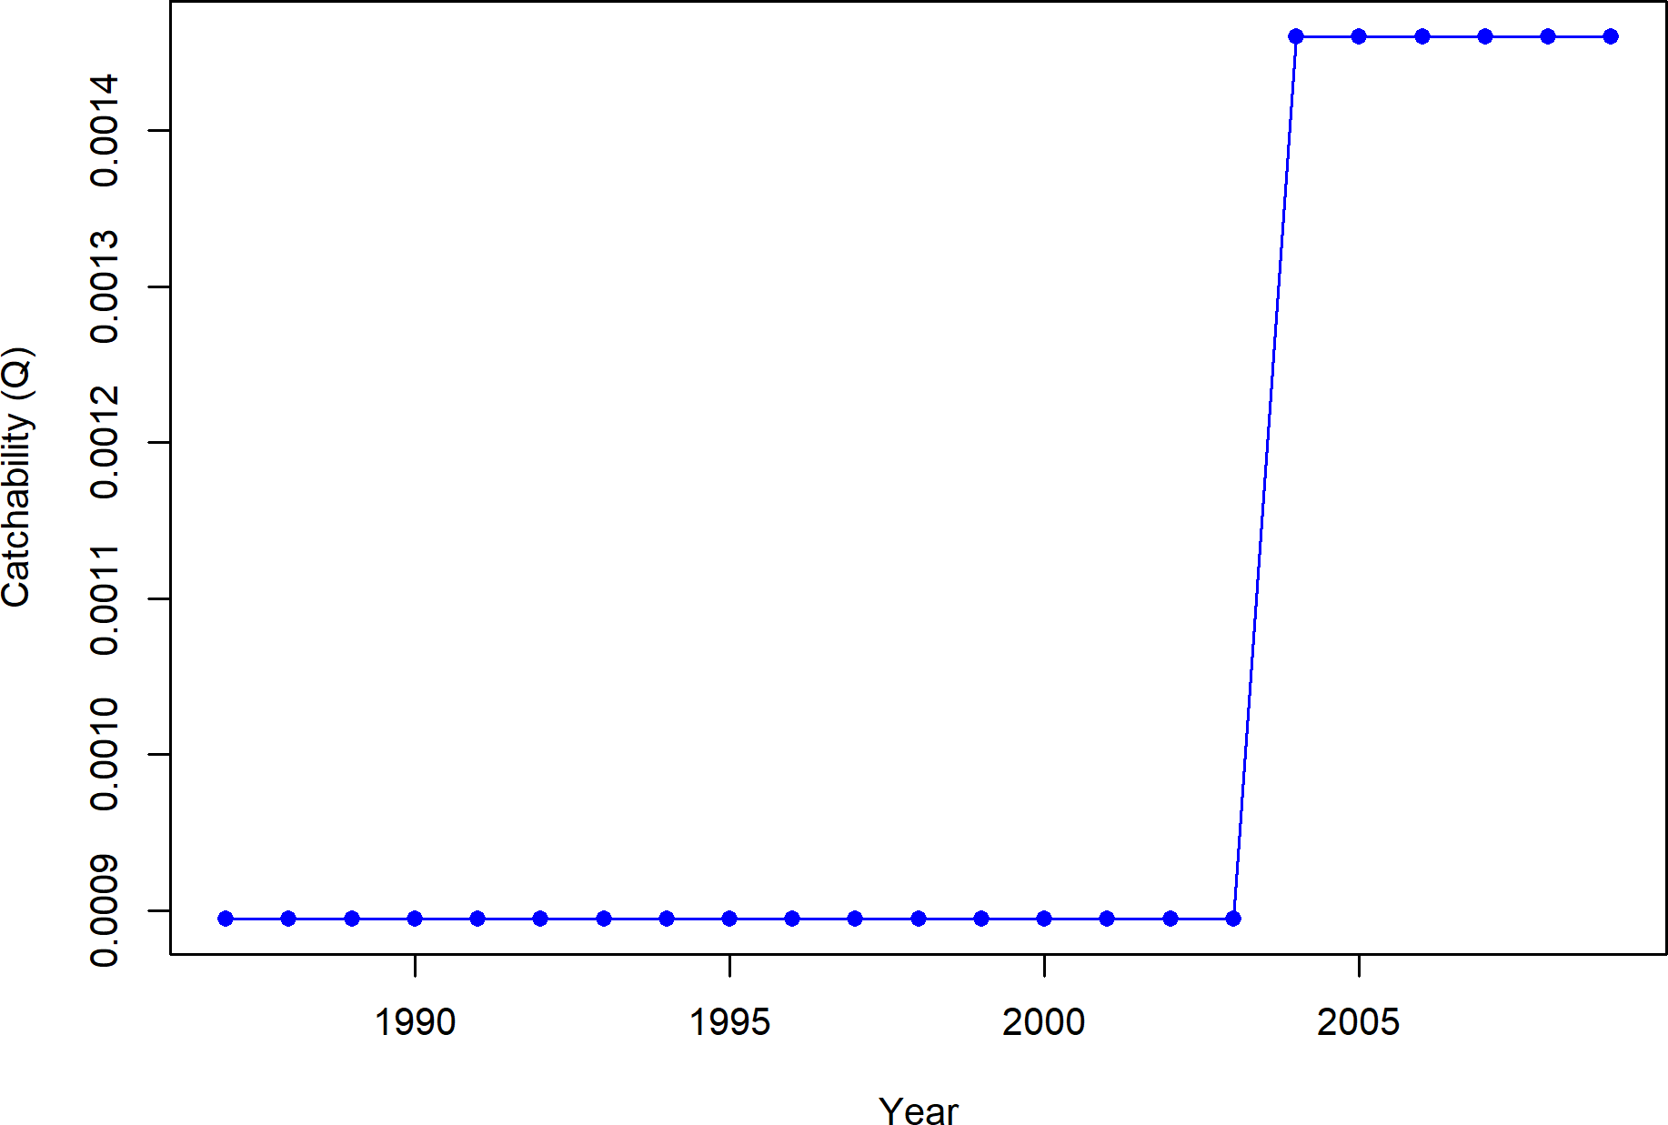

Figure 56: Catchability to the Winter North catch-per-unit-effort time series.

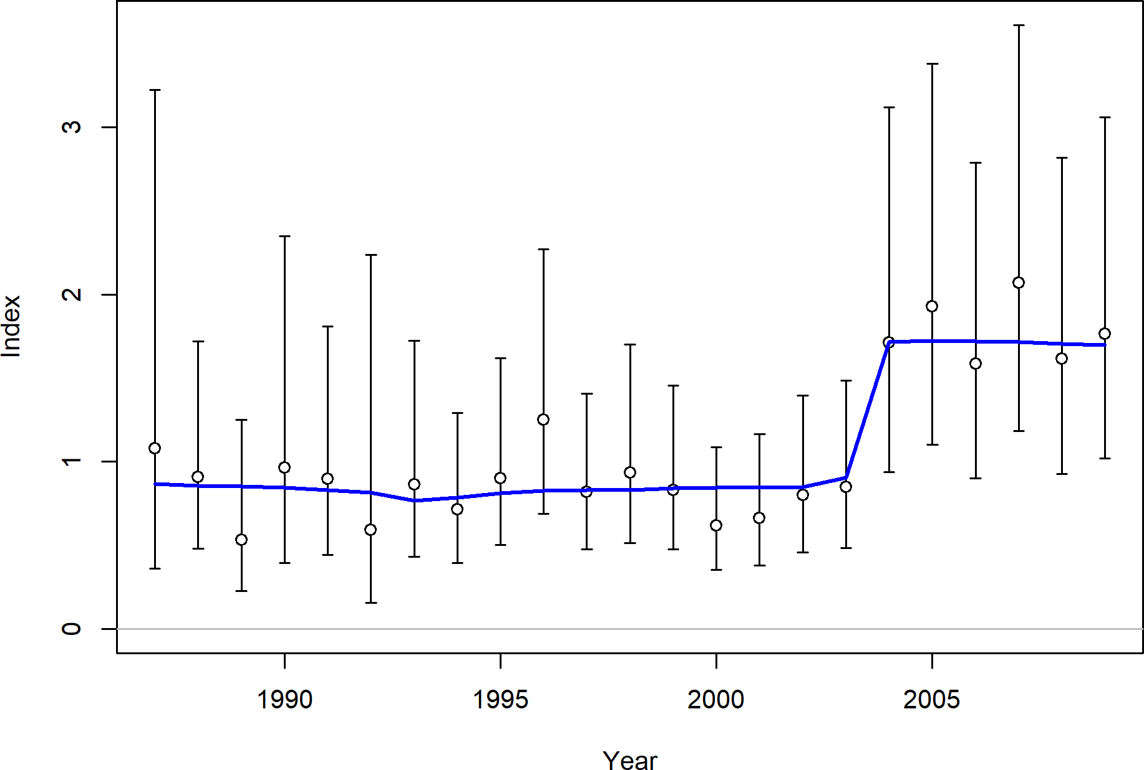

Figure 57: Fit to the Winter South catch-per-unit-effort time series for petrale sole.

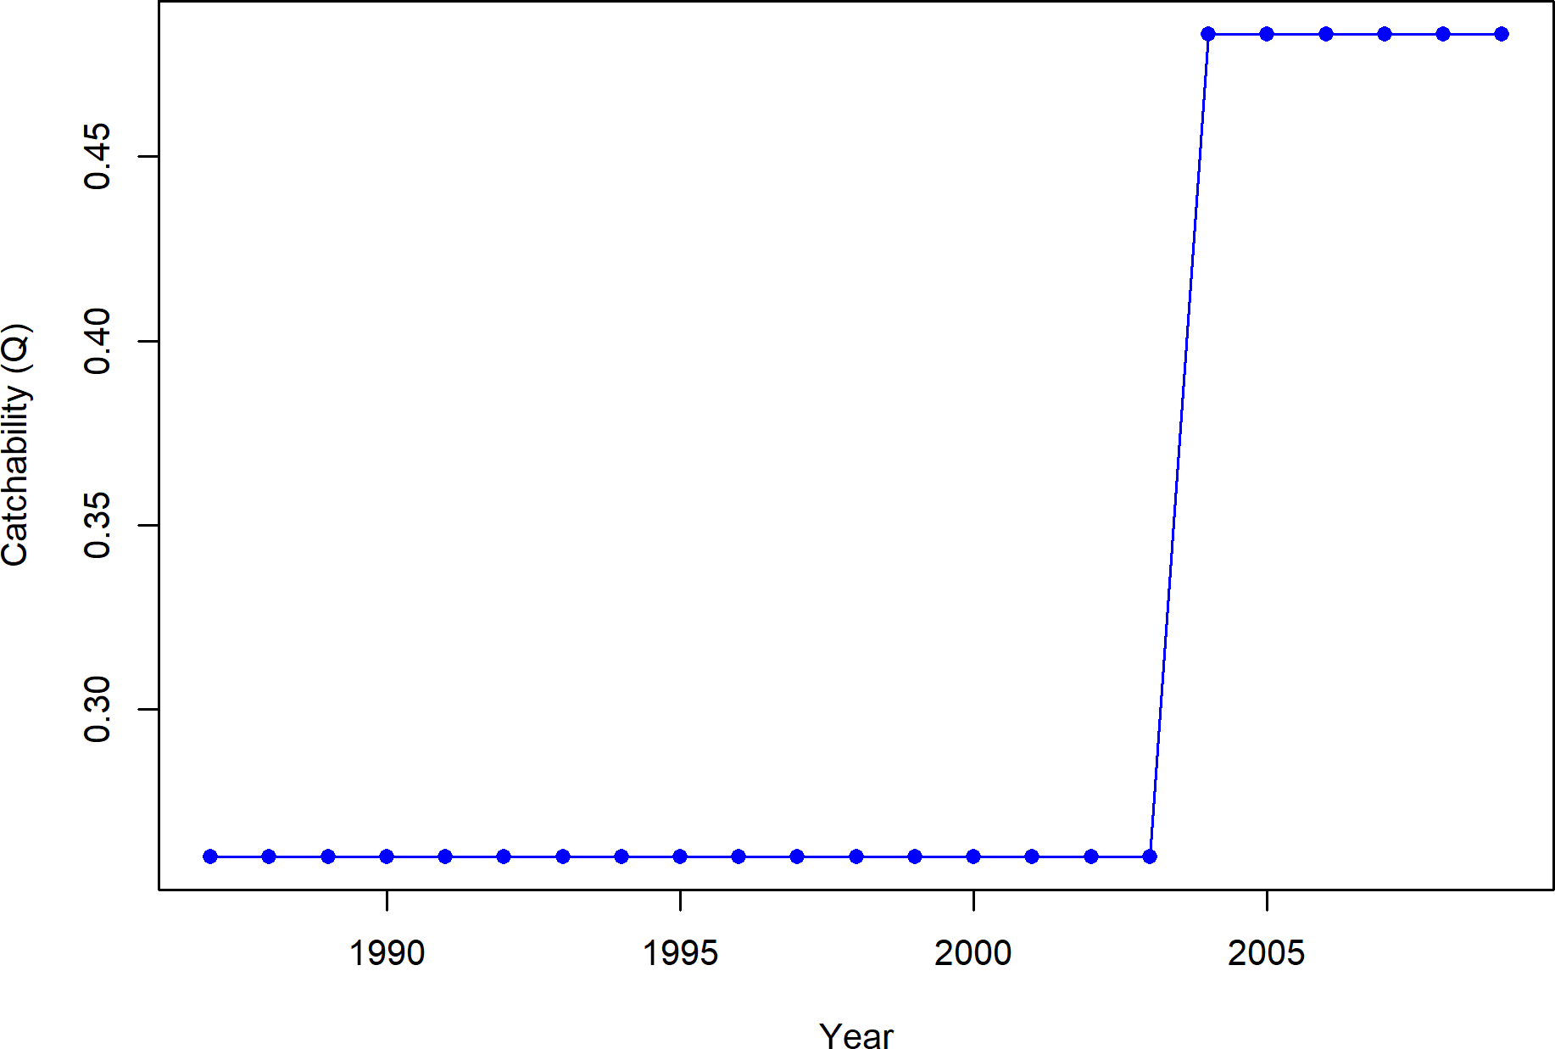

Figure 58: Catchability to the Winter South catch-per-unit-effort time series.

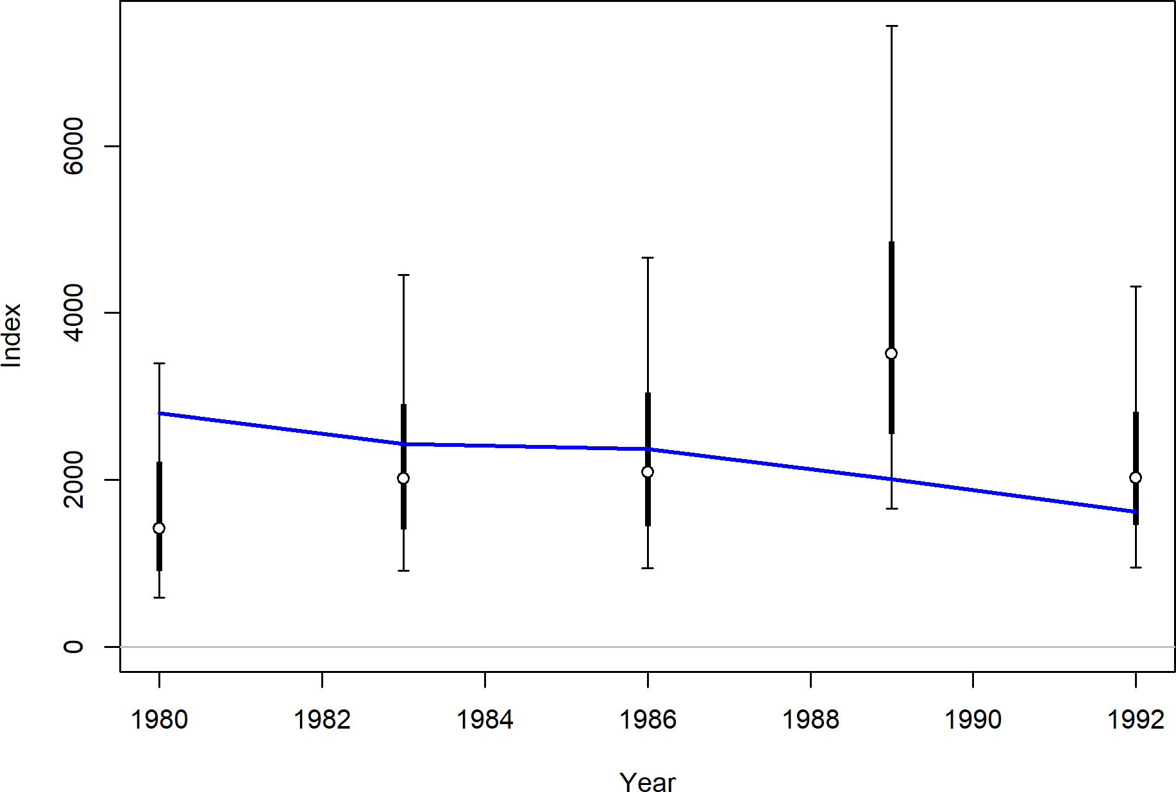

Figure 59: Fit to the Triennial Survey Early time series for petrale sole.

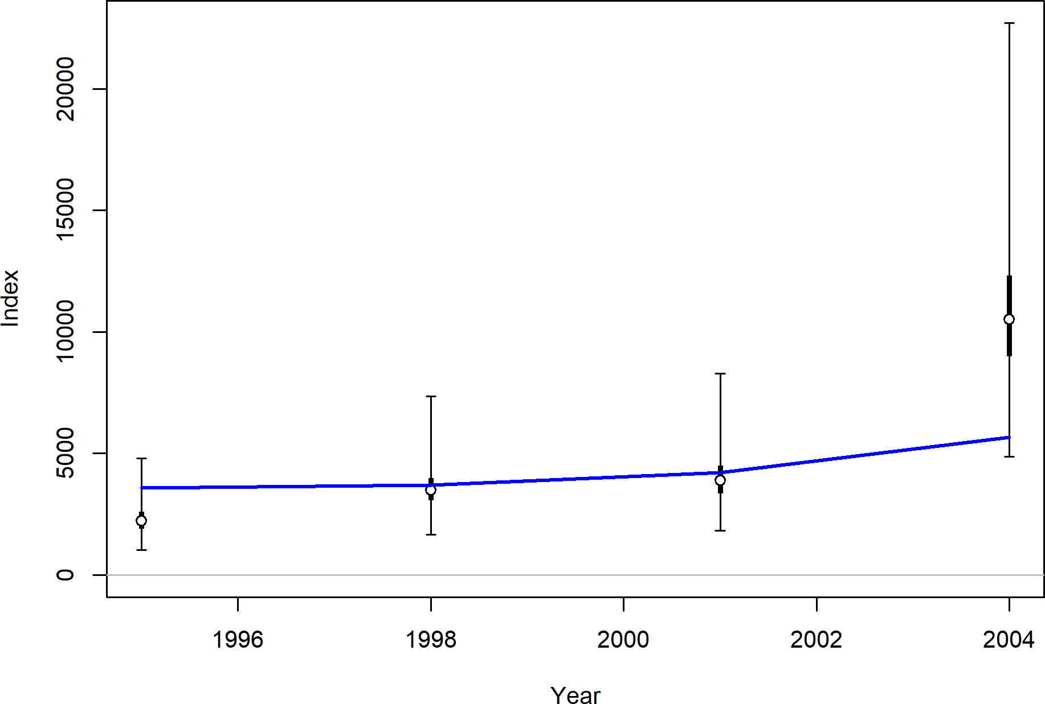

Figure 60: Fit to the Triennial Survey Late time series for petrale sole.

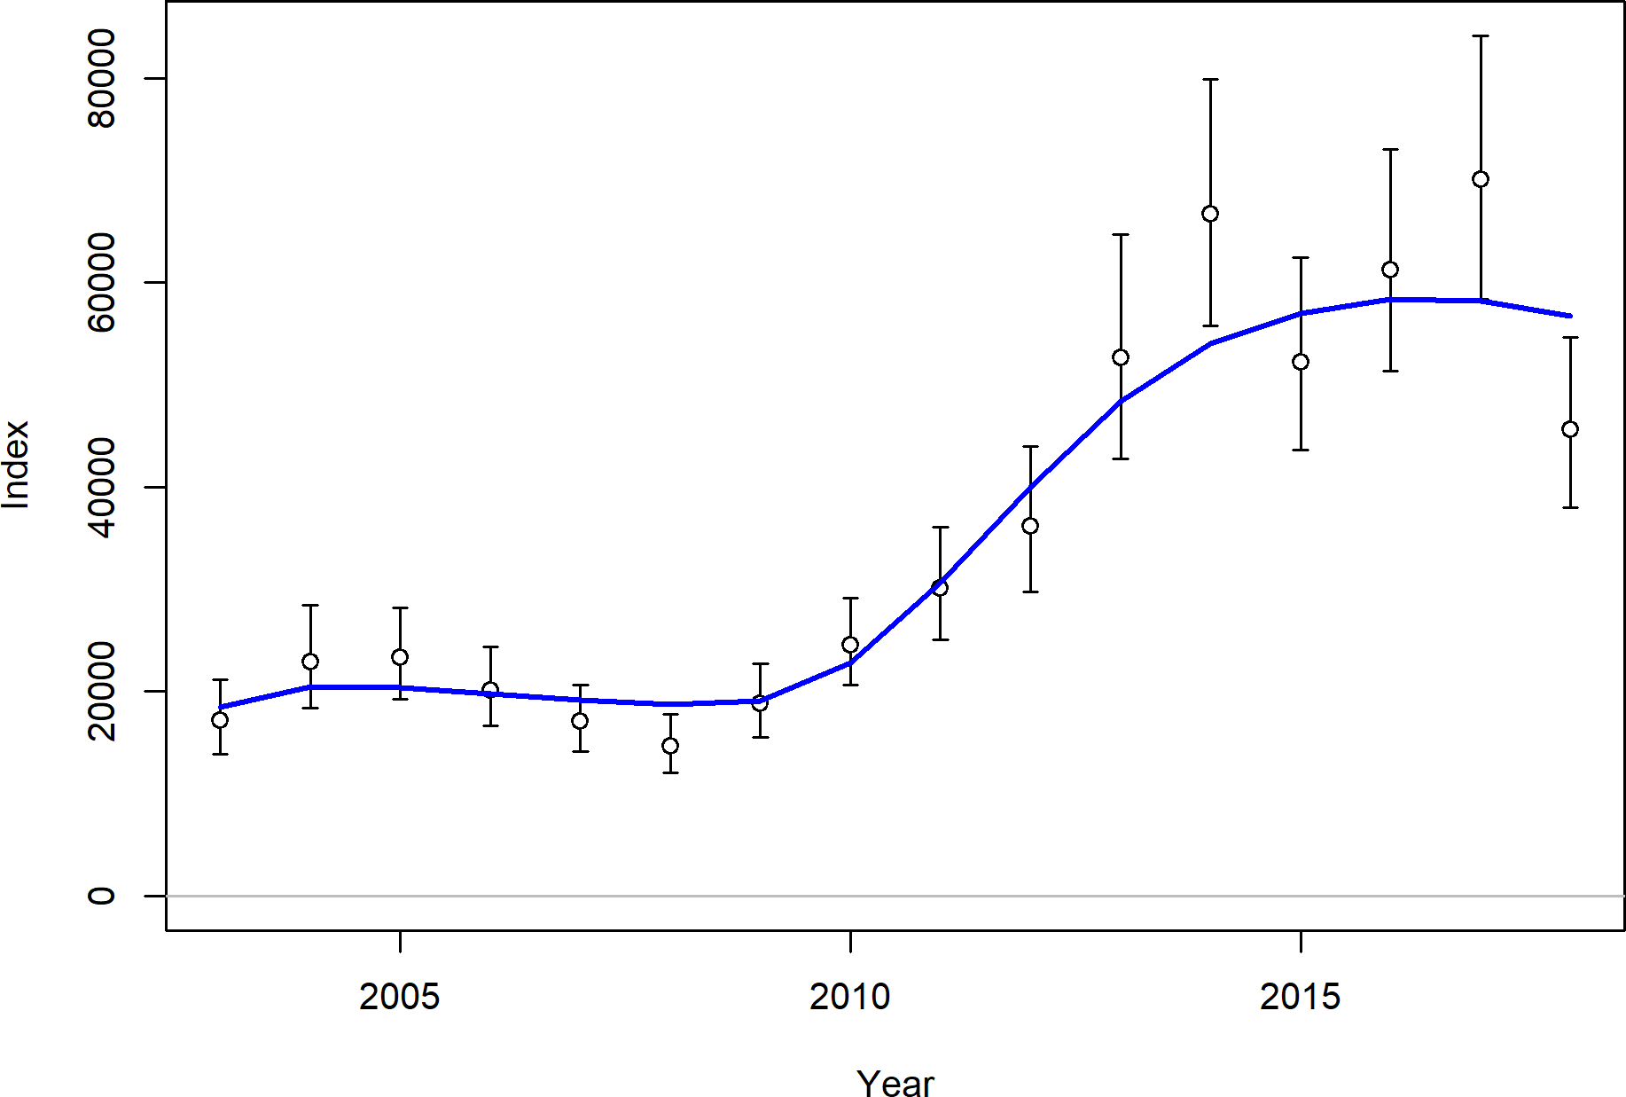

Figure 61: Fit to the NWFSC West Coast Groundfish Bottom Trawl Survey time series for petrale sole.

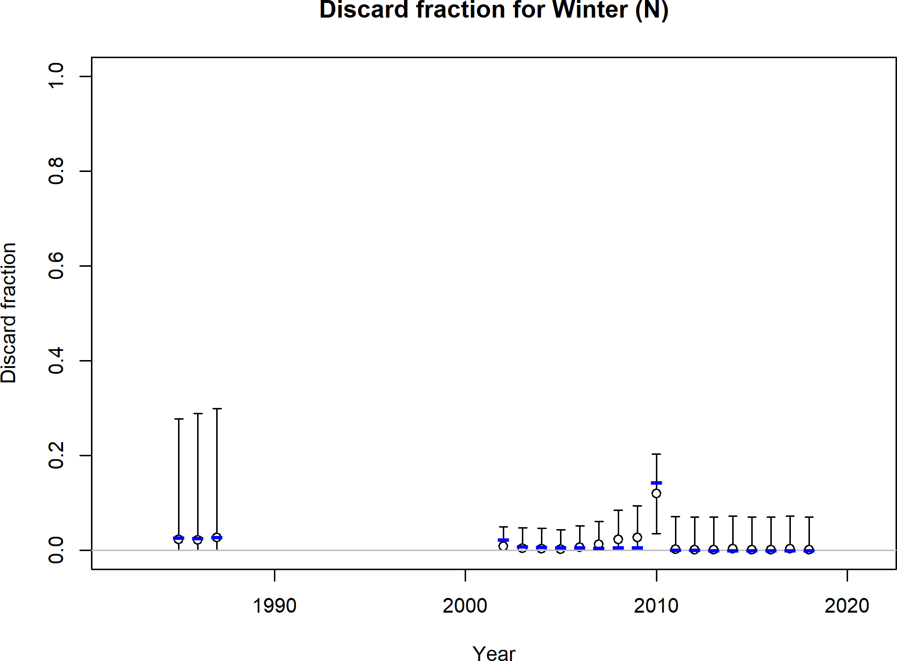

Figure 62: Fit to the discard rates for the Winter North fleet for petrale sole.

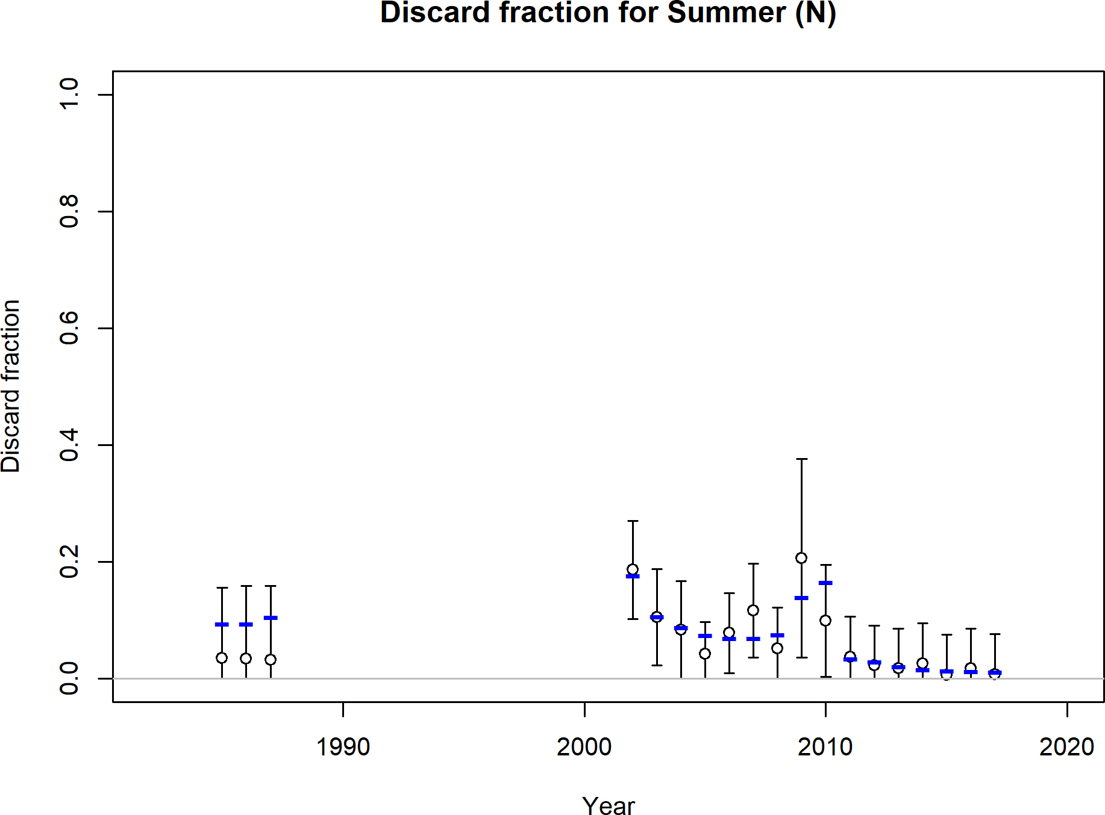

Figure 63: Fit to the discard rates for the Summer North fleet for petrale sole.

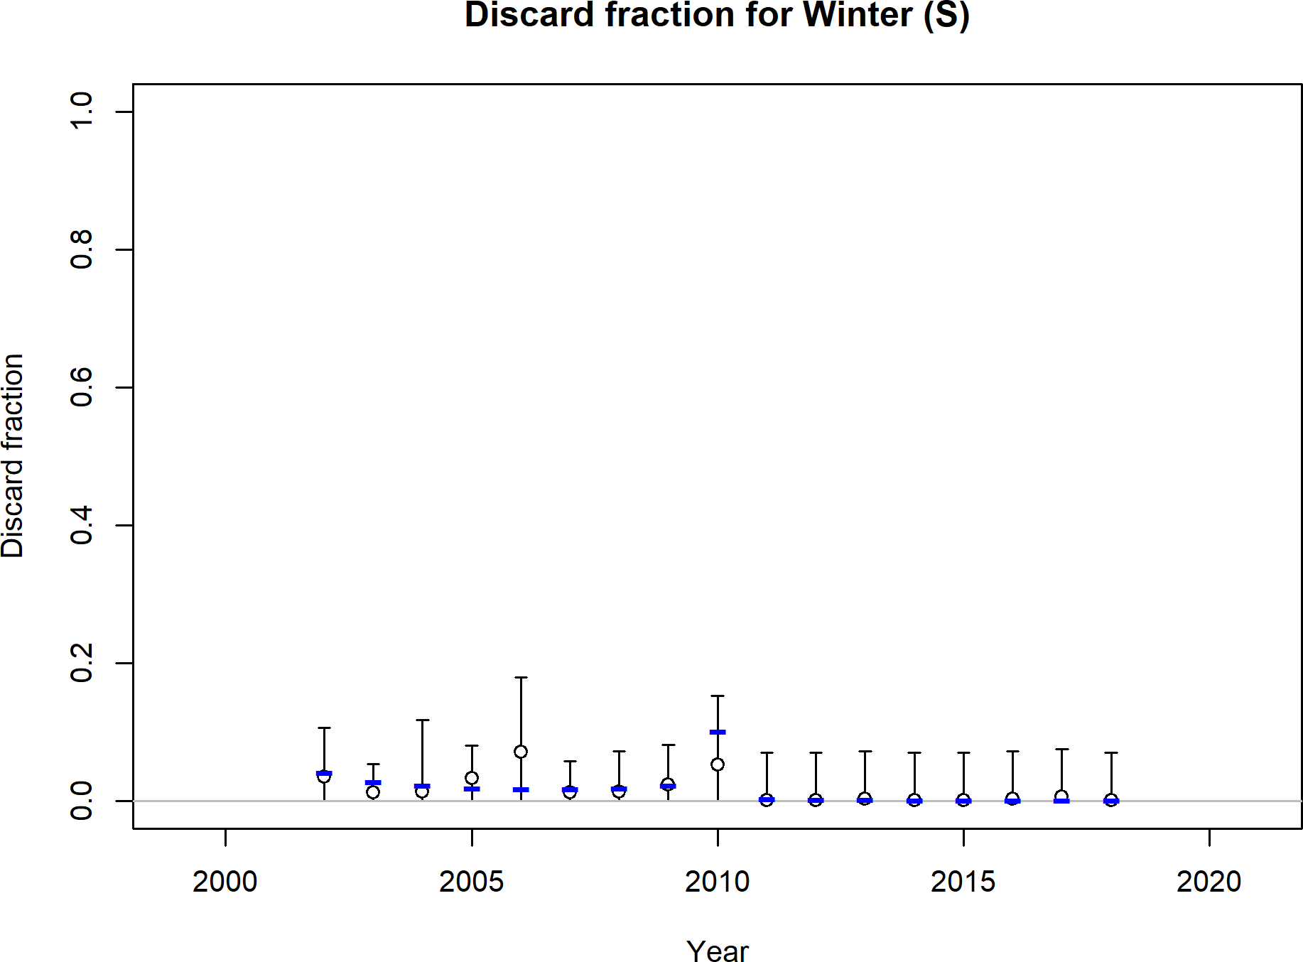

Figure 64: Fit to the discard rates for the Winter South fleet for petrale sole.

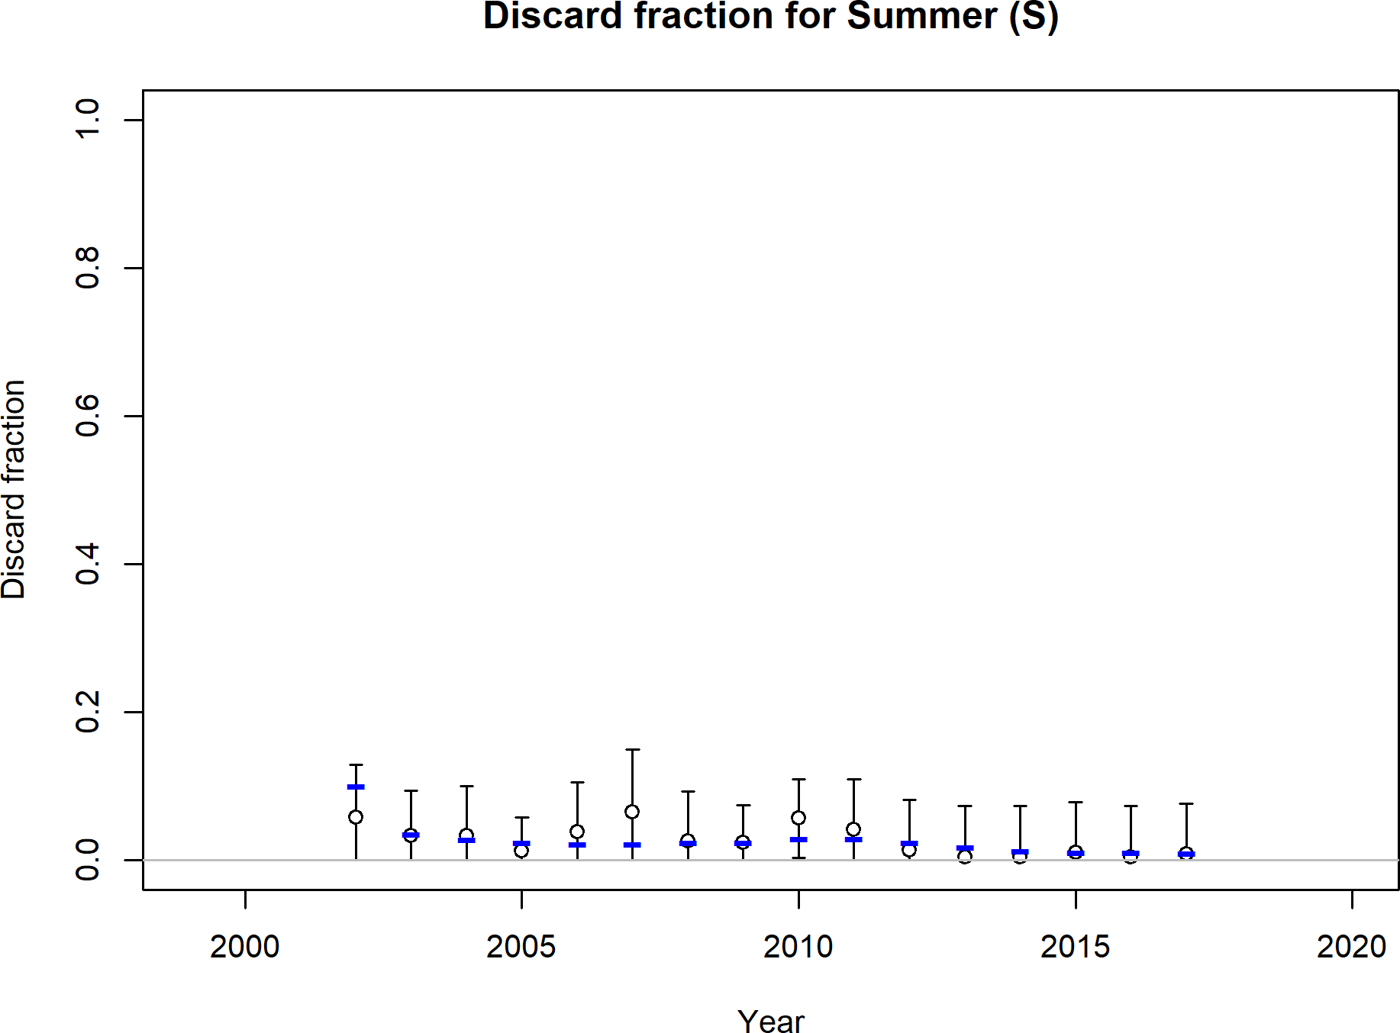

Figure 65: Fit to the discard rates for the Summer South fleet for petrale sole.

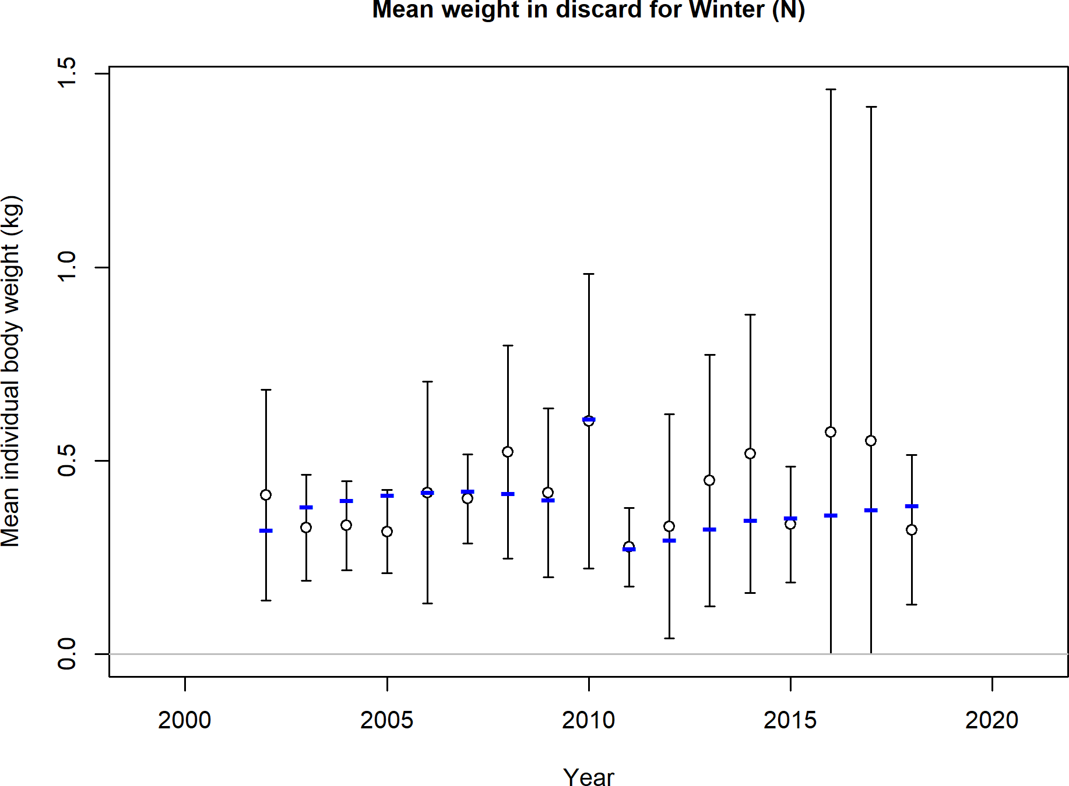

Figure 66: Fit to the Northern winter fishery mean body weights of discarded fish for petrale sole.

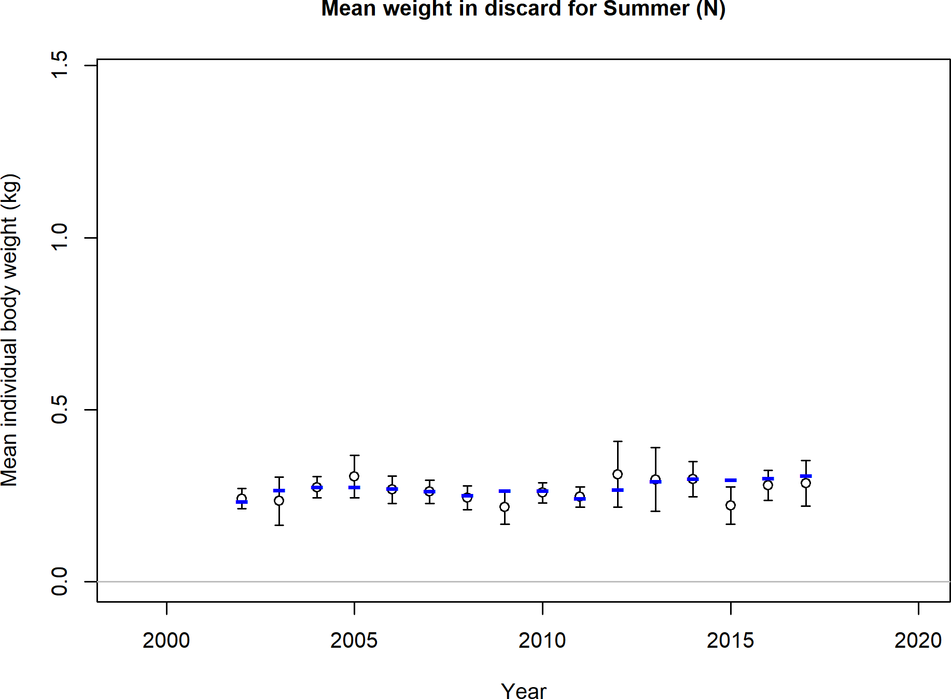

Figure 67: Fit to the Northern summer fishery mean body weights of discarded fish for petrale sole.

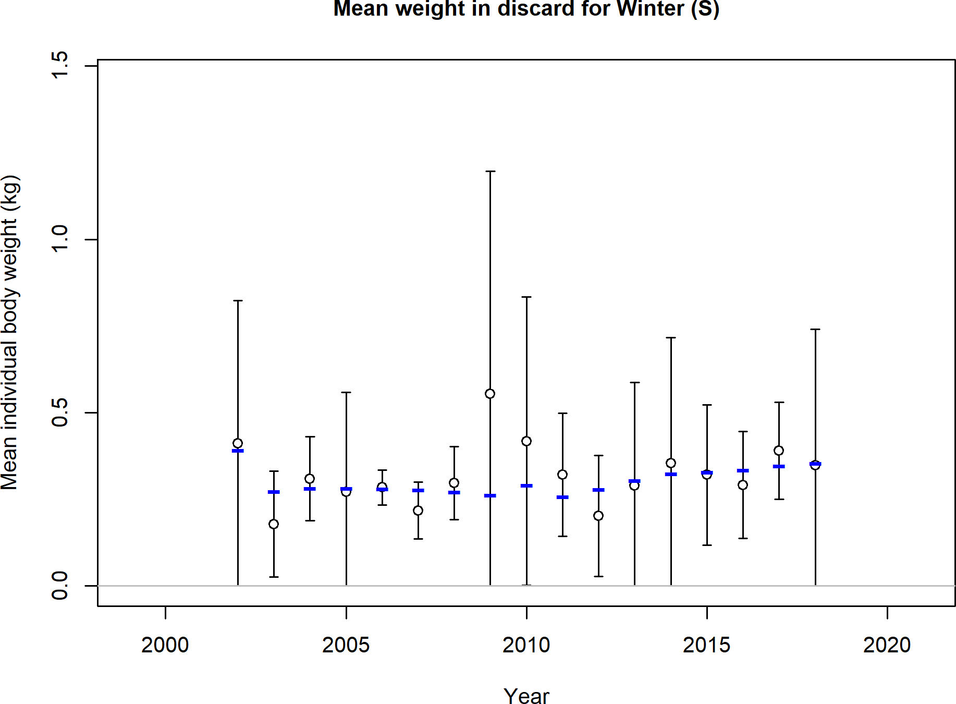

Figure 68: Fit to the Southern winter fishery mean body weights of discarded fish for petrale sole.

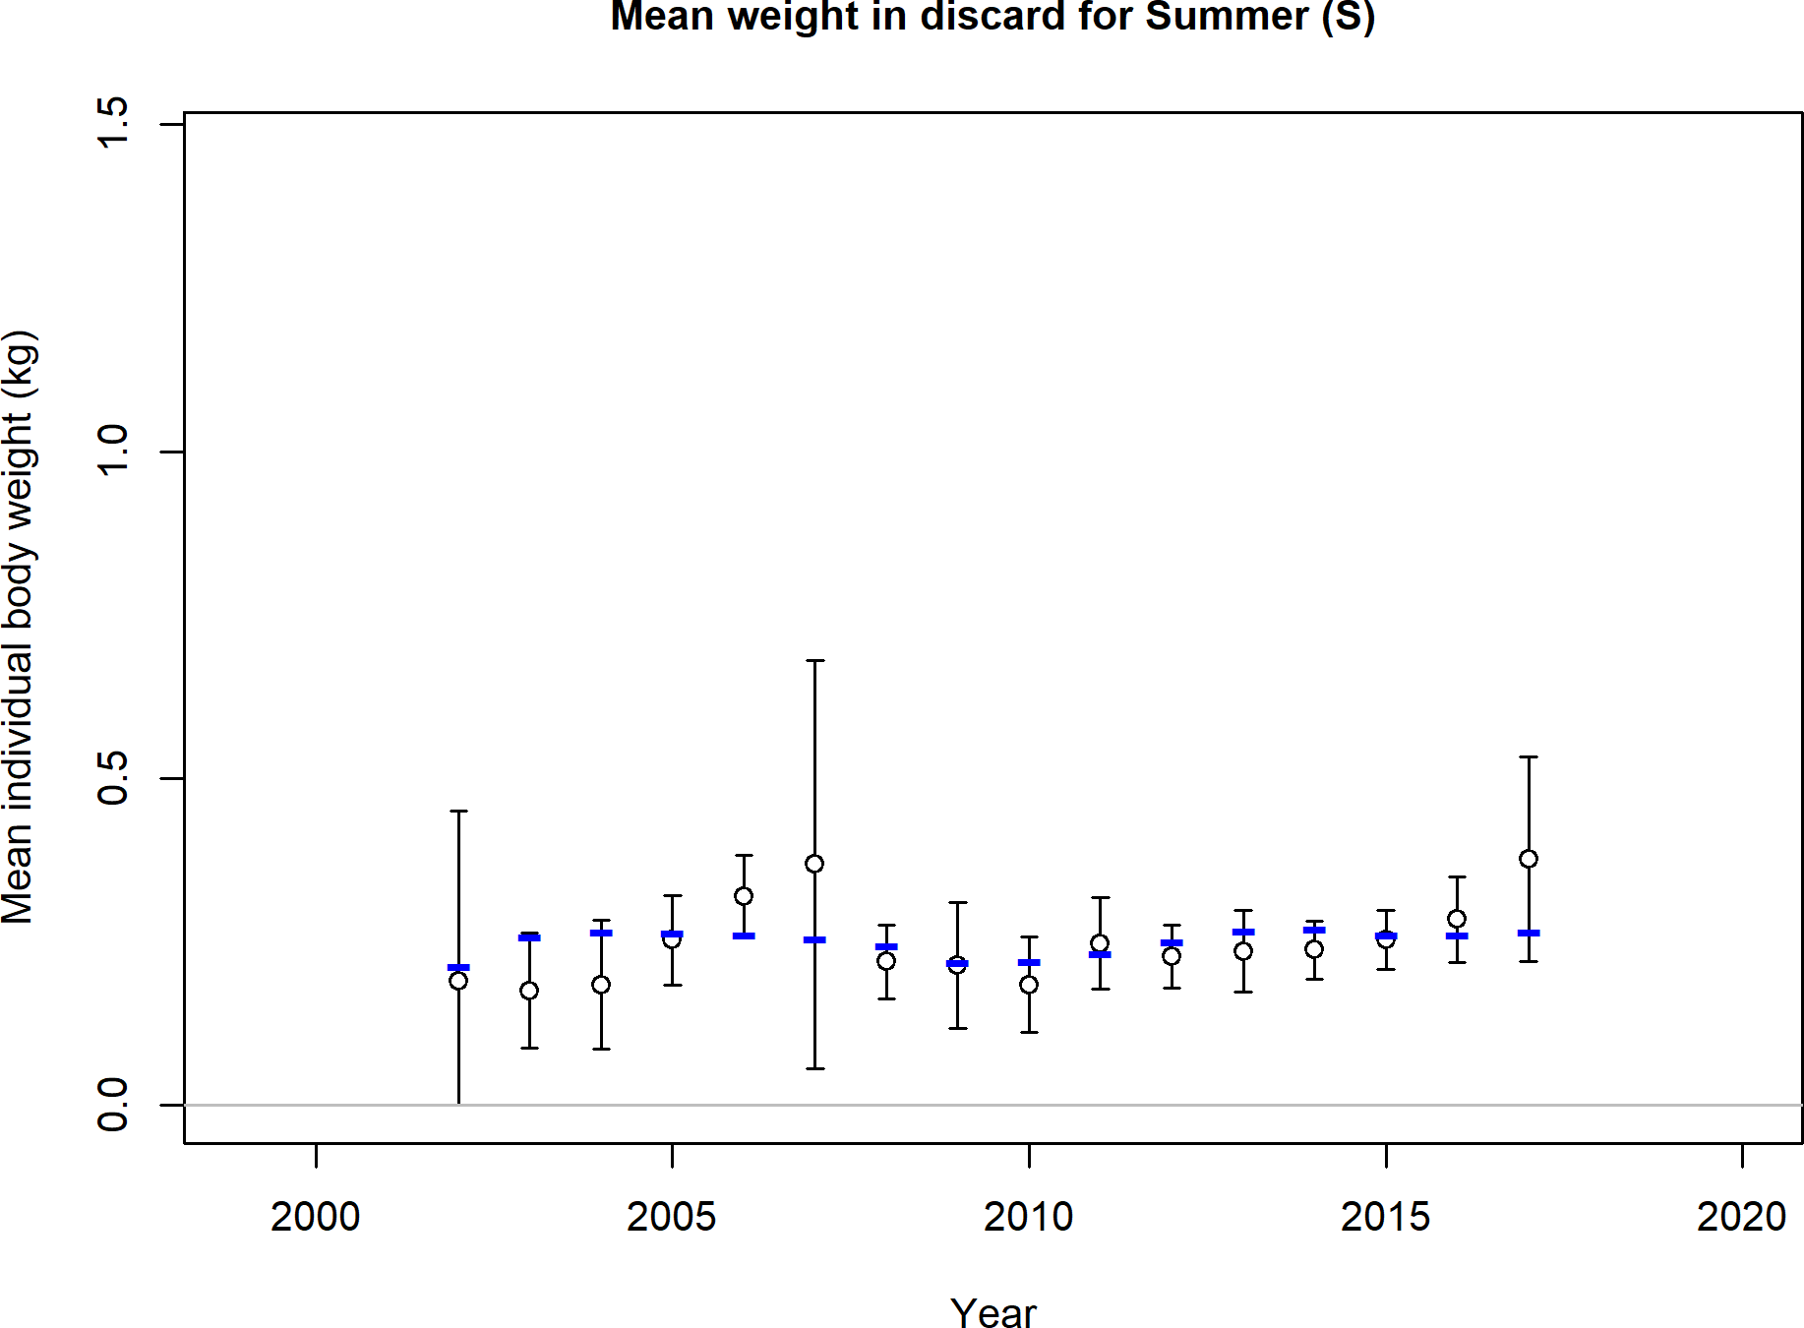

Figure 69: Fit to the Southern summer fishery mean body weights of discarded fish for petrale sole.

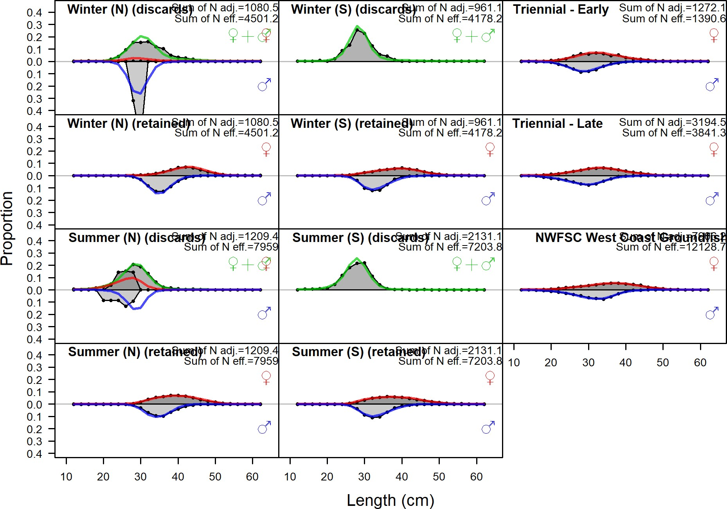

Figure 70: Length compositions aggregated across time by fleet. Labels ‘retained’ and ‘discard’ indicate retained or discarded samples for each fleet. Panels without this designation represent the whole catch.

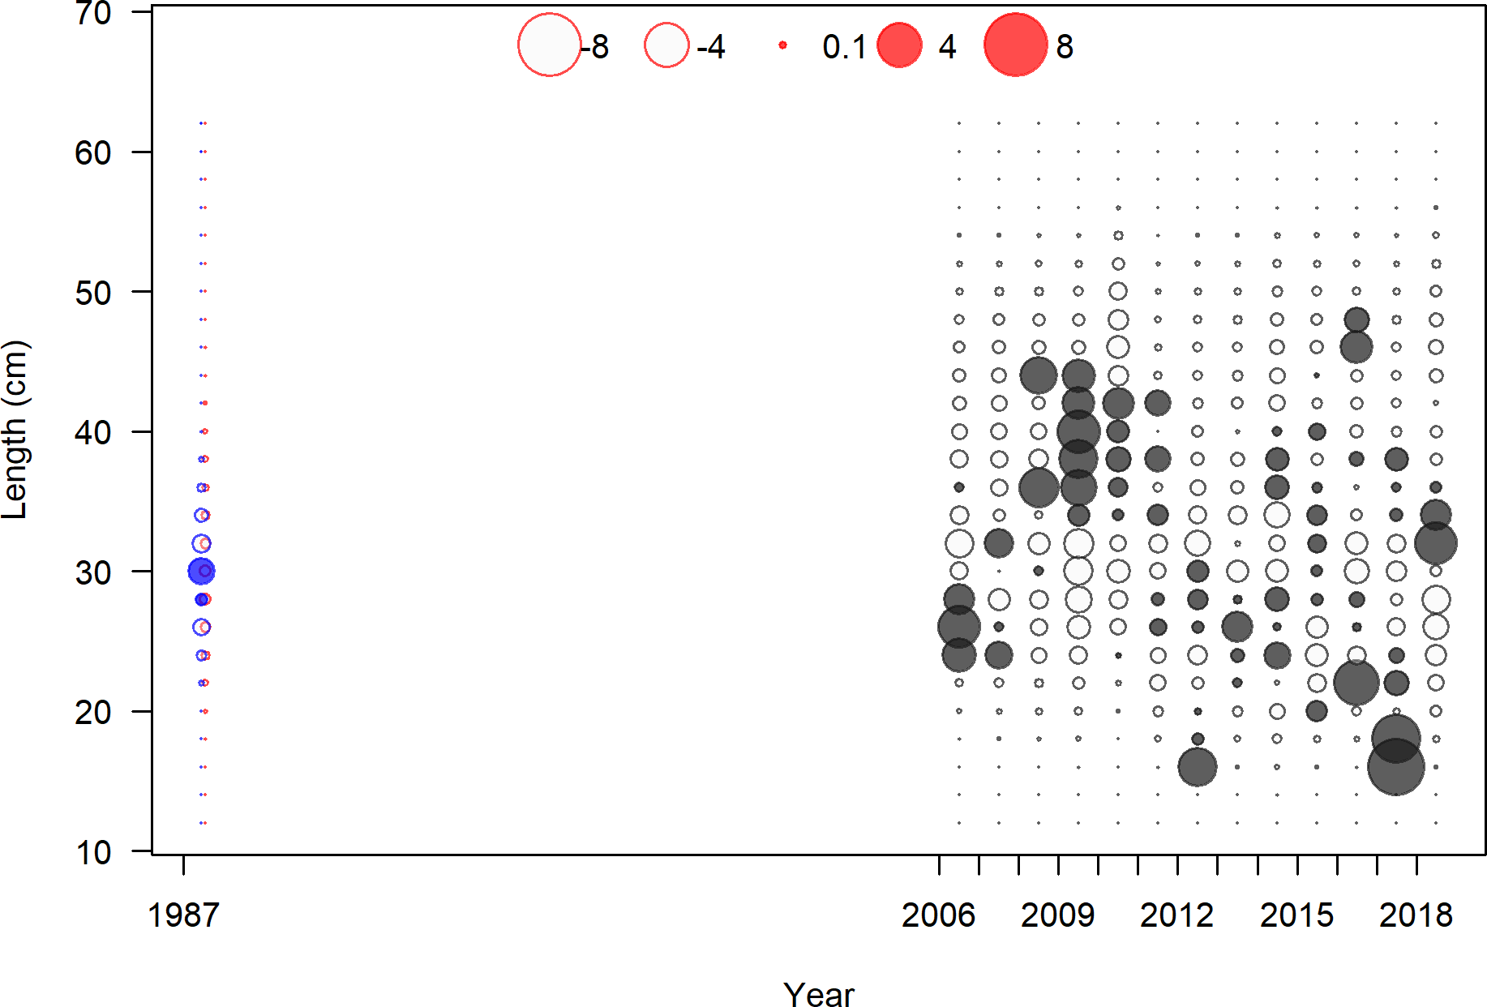

Figure 71: Pearson residuals, discard, Winter (N) (max=6.35)

Closed bubbles are positive residuals (observed *>* expected) and open bubbles are negative residuals (observed *<* expected).

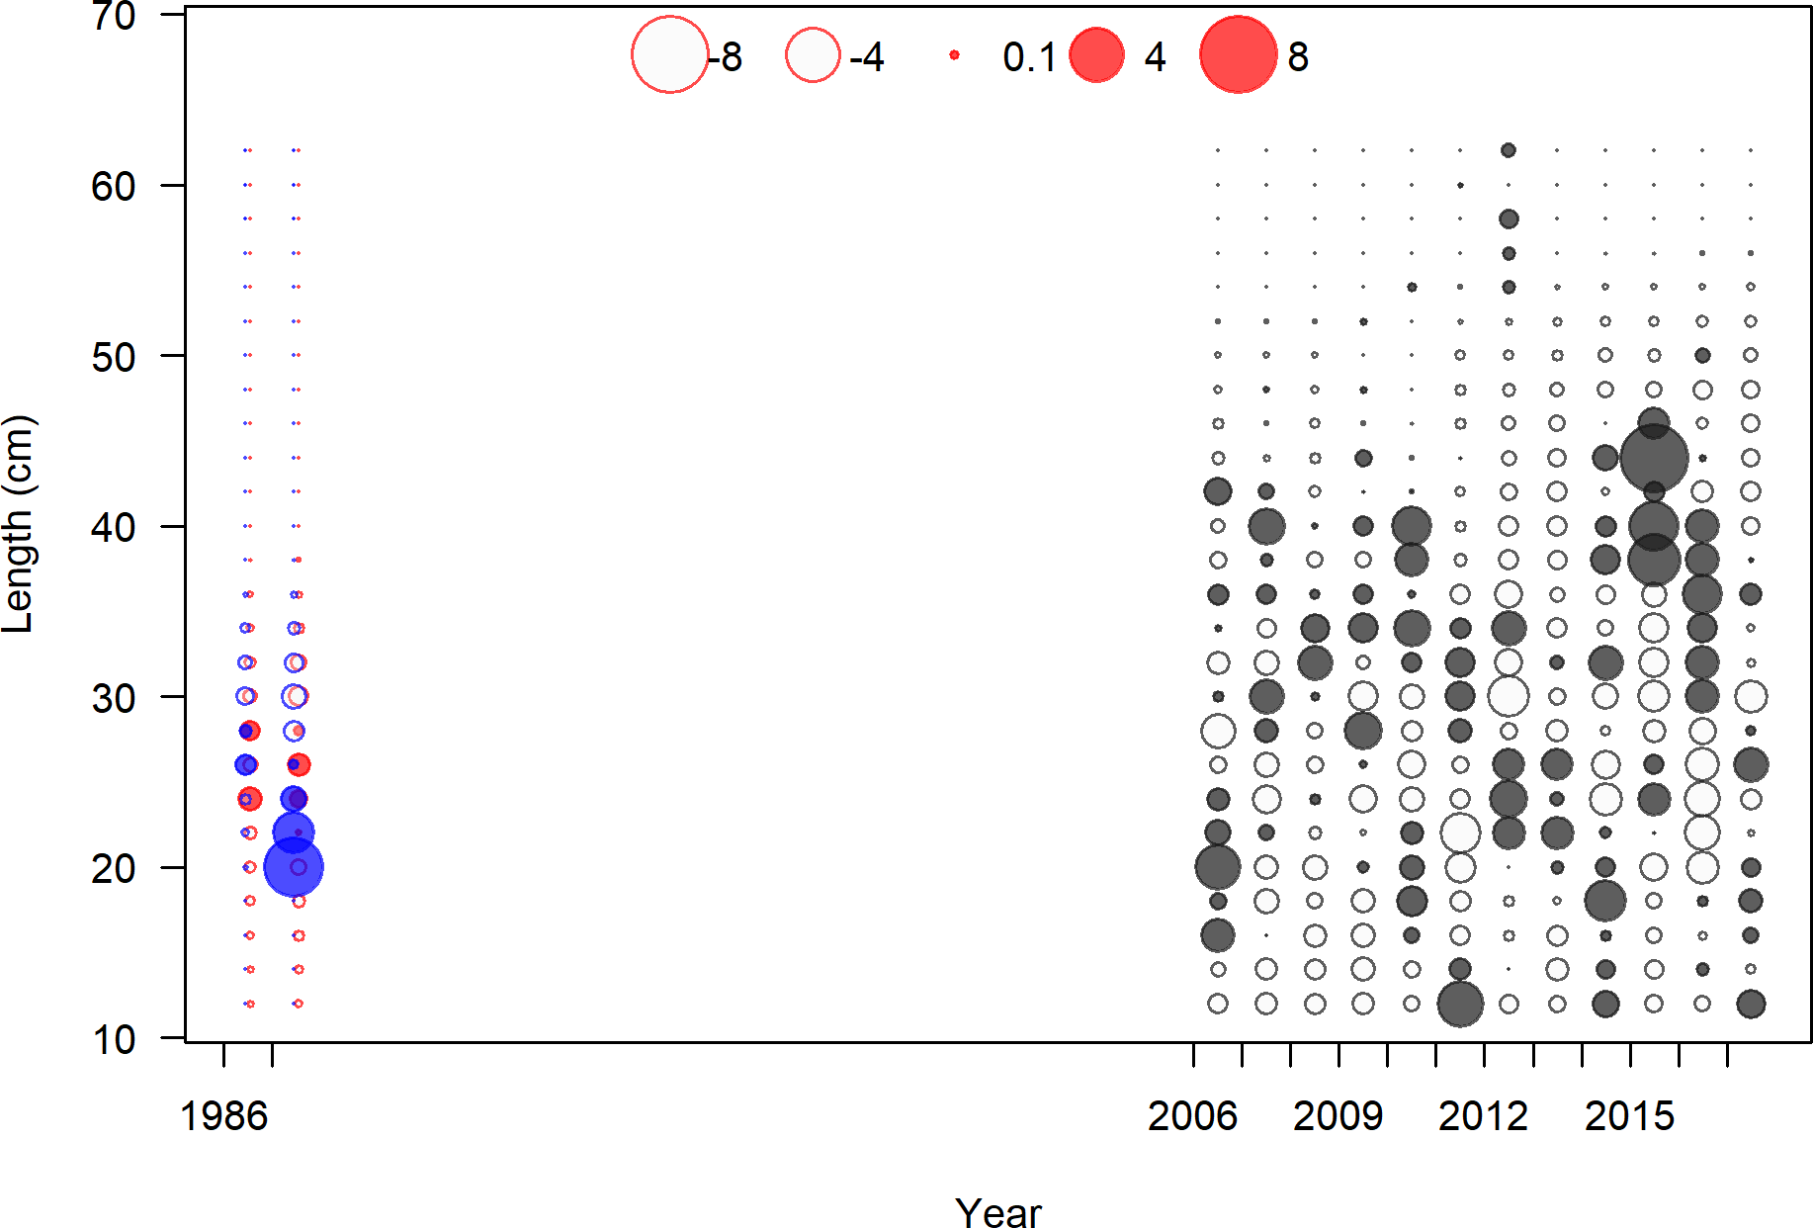

Figure 72: Pearson residuals, discard, Summer (N) (max=6.21)

Closed bubbles are positive residuals (observed *>* expected) and open bubbles are negative residuals (observed *<* expected).

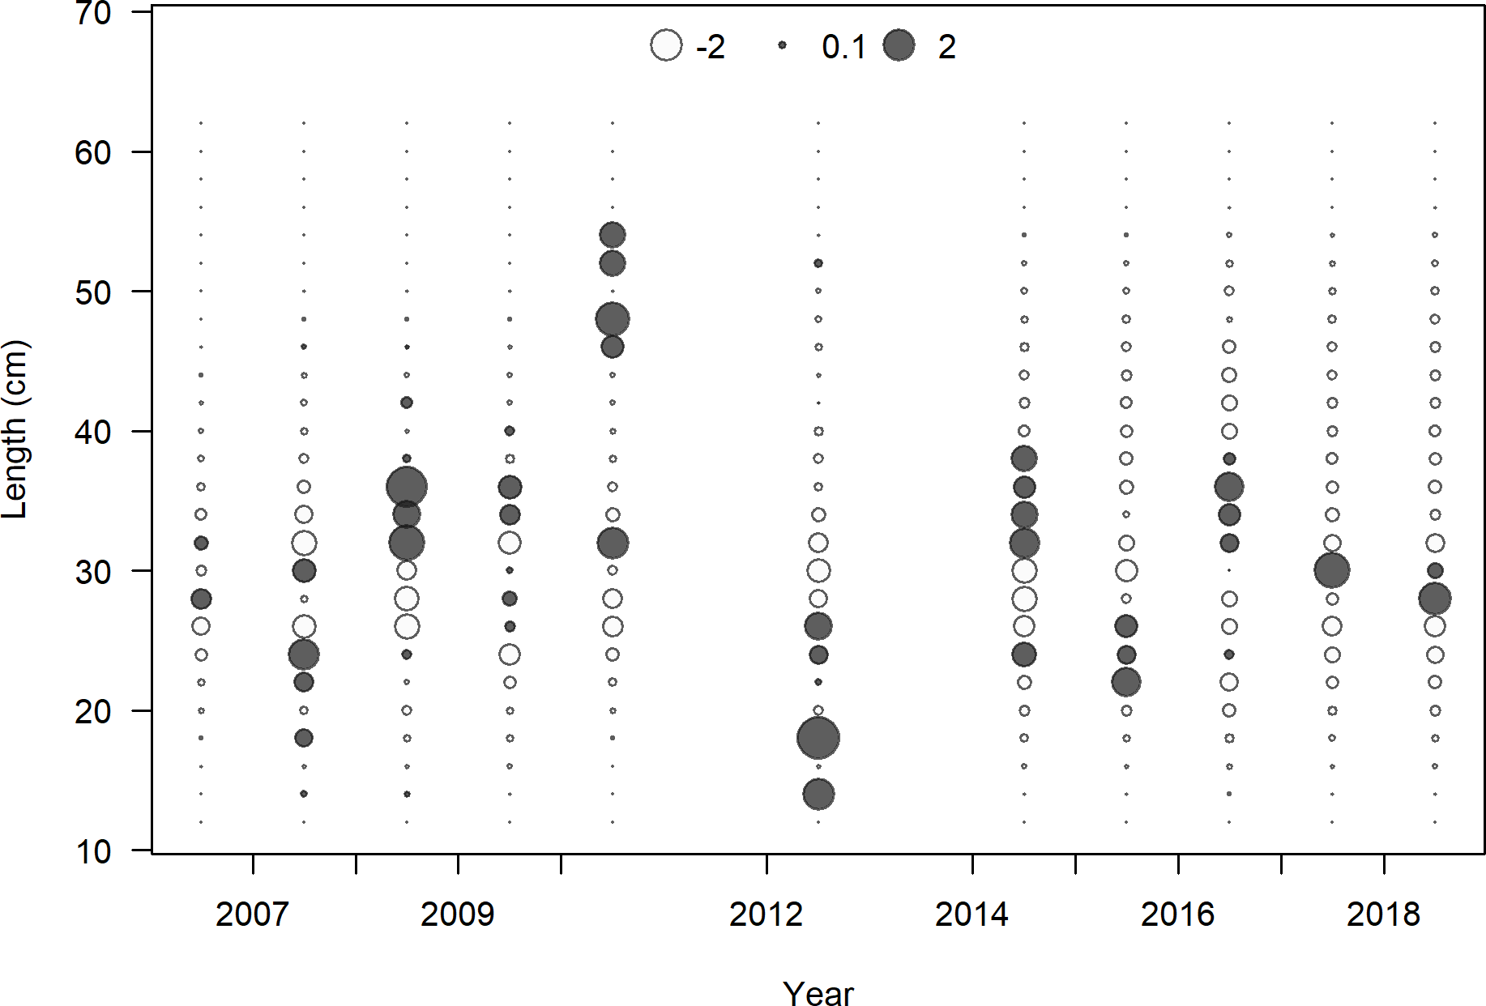

Figure 73: Pearson residuals, discard, Winter (S) (max=3.58)

Closed bubbles are positive residuals (observed *>* expected) and open bubbles are negative residuals (observed *<* expected).



Figure 74: Pearson residuals, discard, Winter (S) (max=3.58)

Closed bubbles are positive residuals (observed *>* expected) and open bubbles are negative residuals (observed *<* expected).

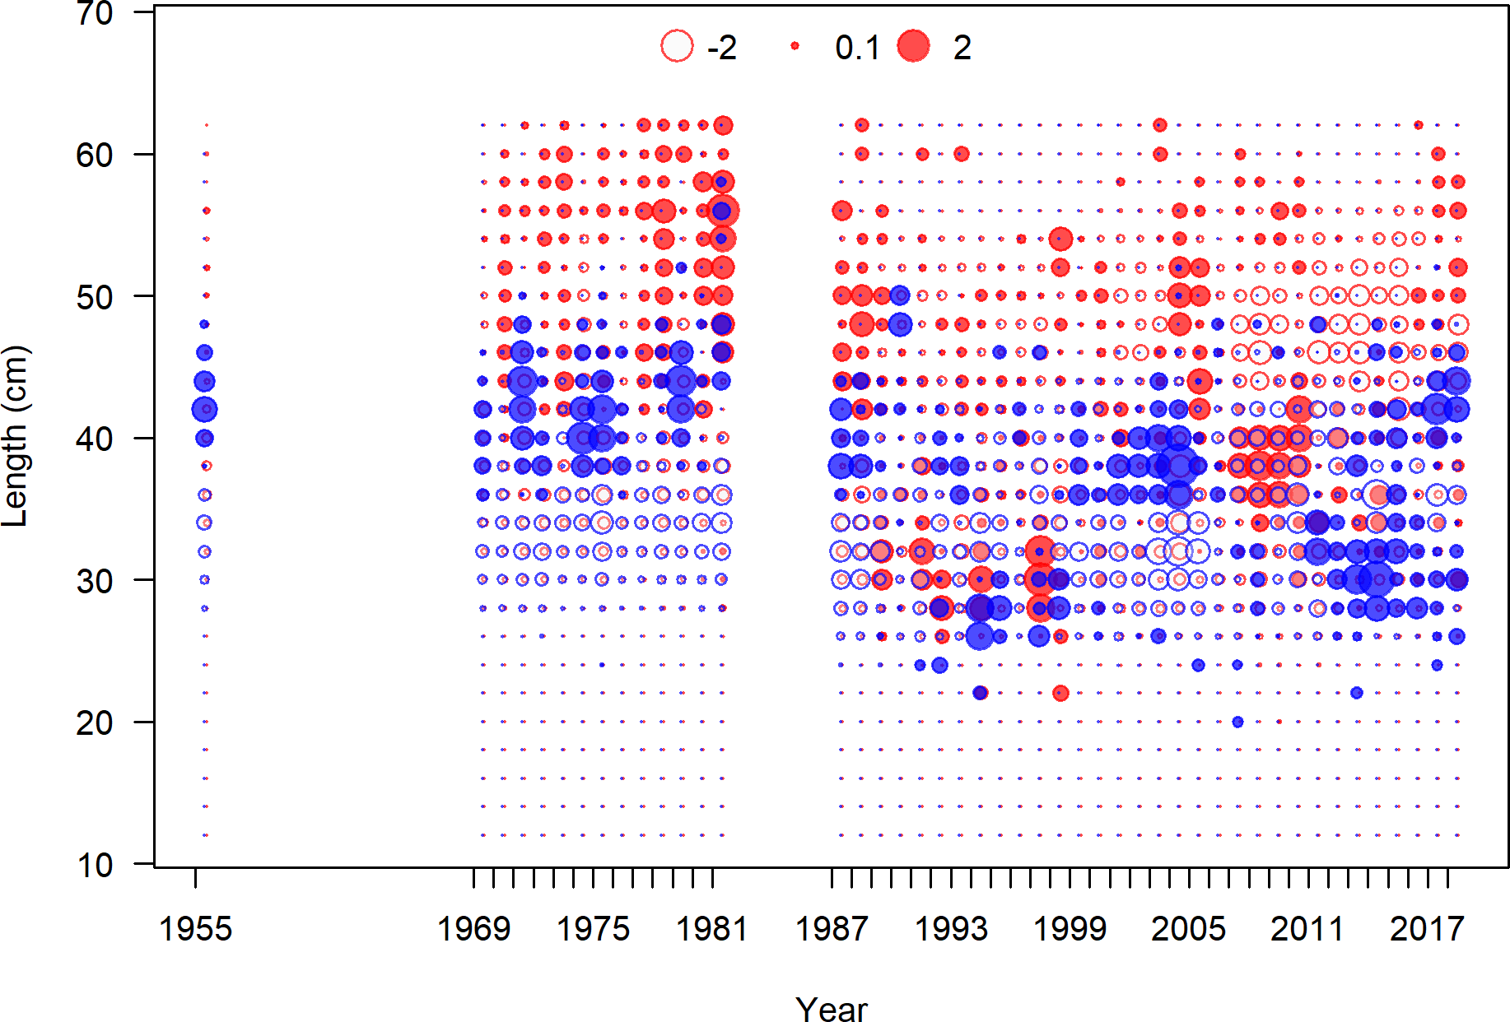

Figure 75: Pearson residuals, retained, Winter (N) (max=3.47) (plot 3 of 3)

Closed bubbles are positive residuals (observed *>* expected) and open bubbles are negative residuals (observed *<* expected).

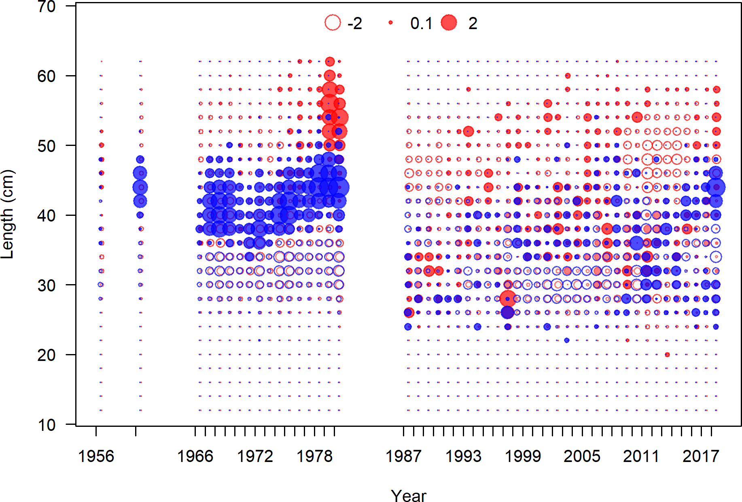

Figure 76: Pearson residuals, retained, Summer (N) (max=3.37) (plot 4 of 4)

Closed bubbles are positive residuals (observed *>* expected) and open bubbles are negative residuals (observed *<* expected).

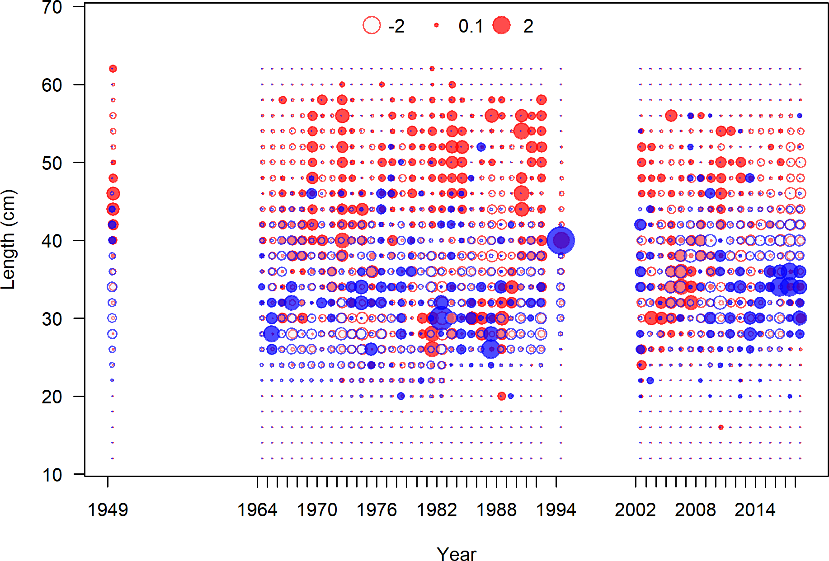

Figure 77: Pearson residuals, retained, Winter (S) (max=4.93) (plot 3 of 3)

Closed bubbles are positive residuals (observed *>* expected) and open bubbles are negative residuals (observed *<* expected).

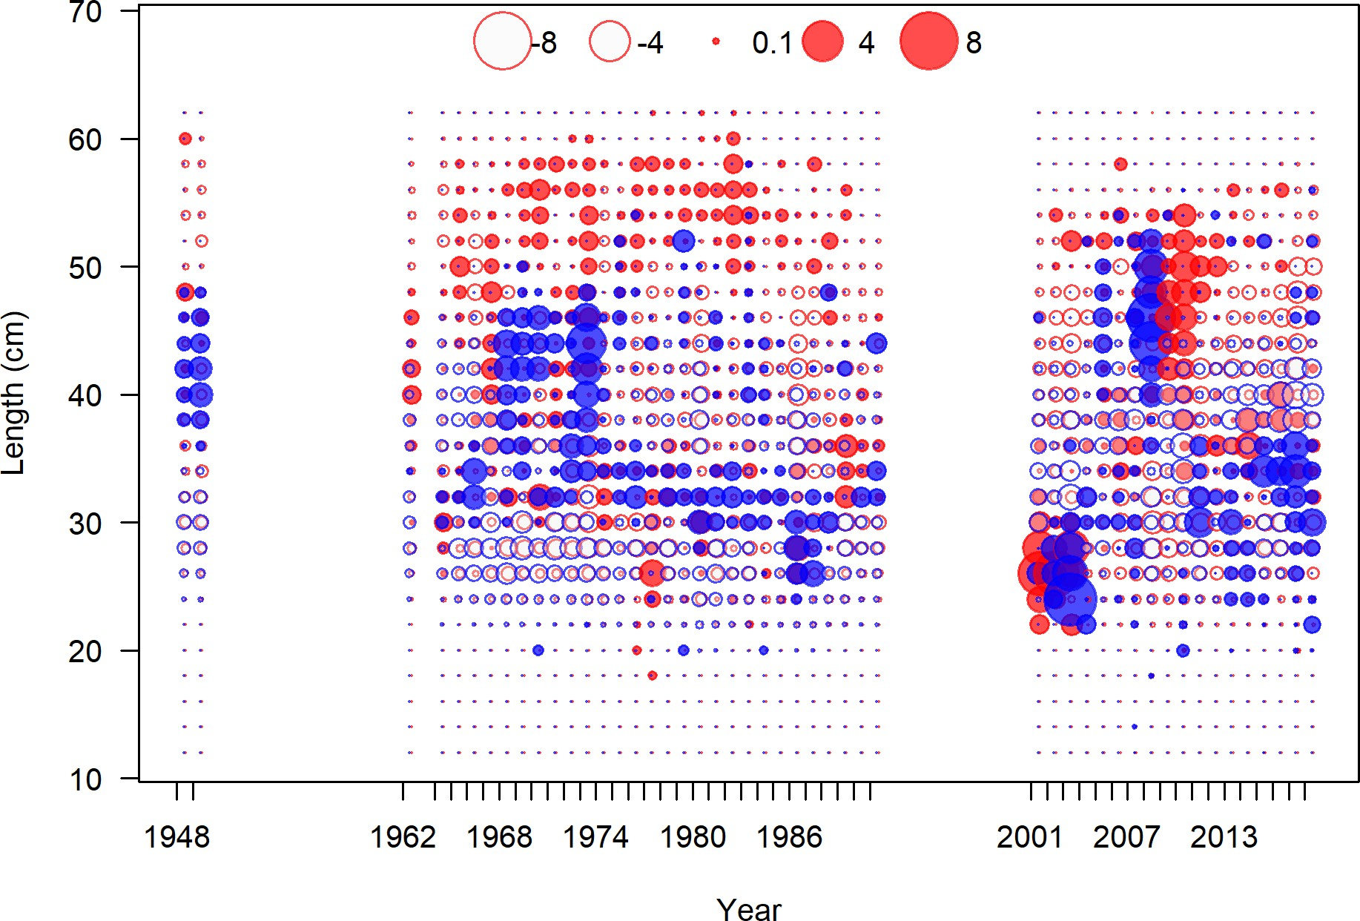

Figure 78: Pearson residuals, retained, Summer (S) (max=6.55) (plot 4 of 4)

Closed bubbles are positive residuals (observed *>* expected) and open bubbles are negative residuals (observed *<* expected).

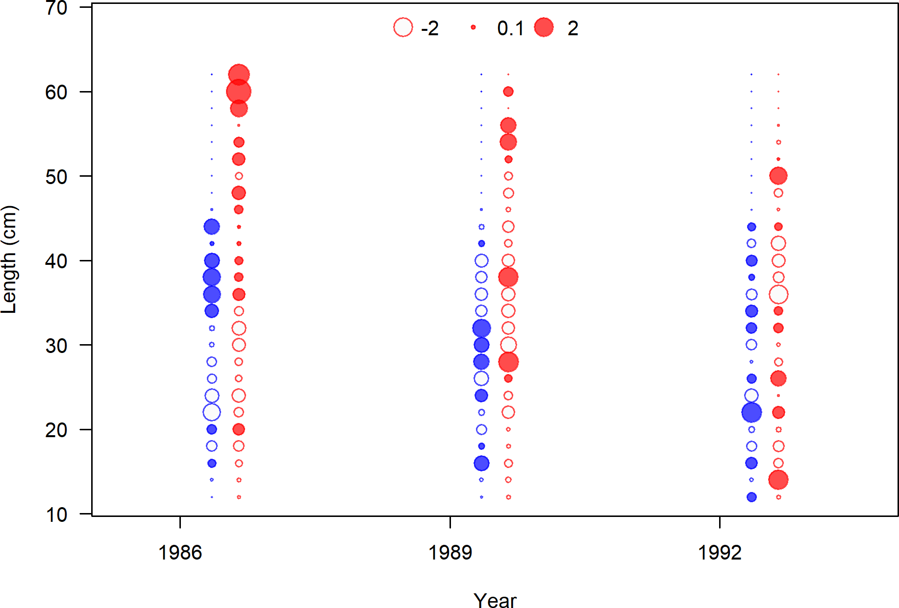

Figure 79: Pearson residuals, whole catch, Triennial Early (max=3.22)

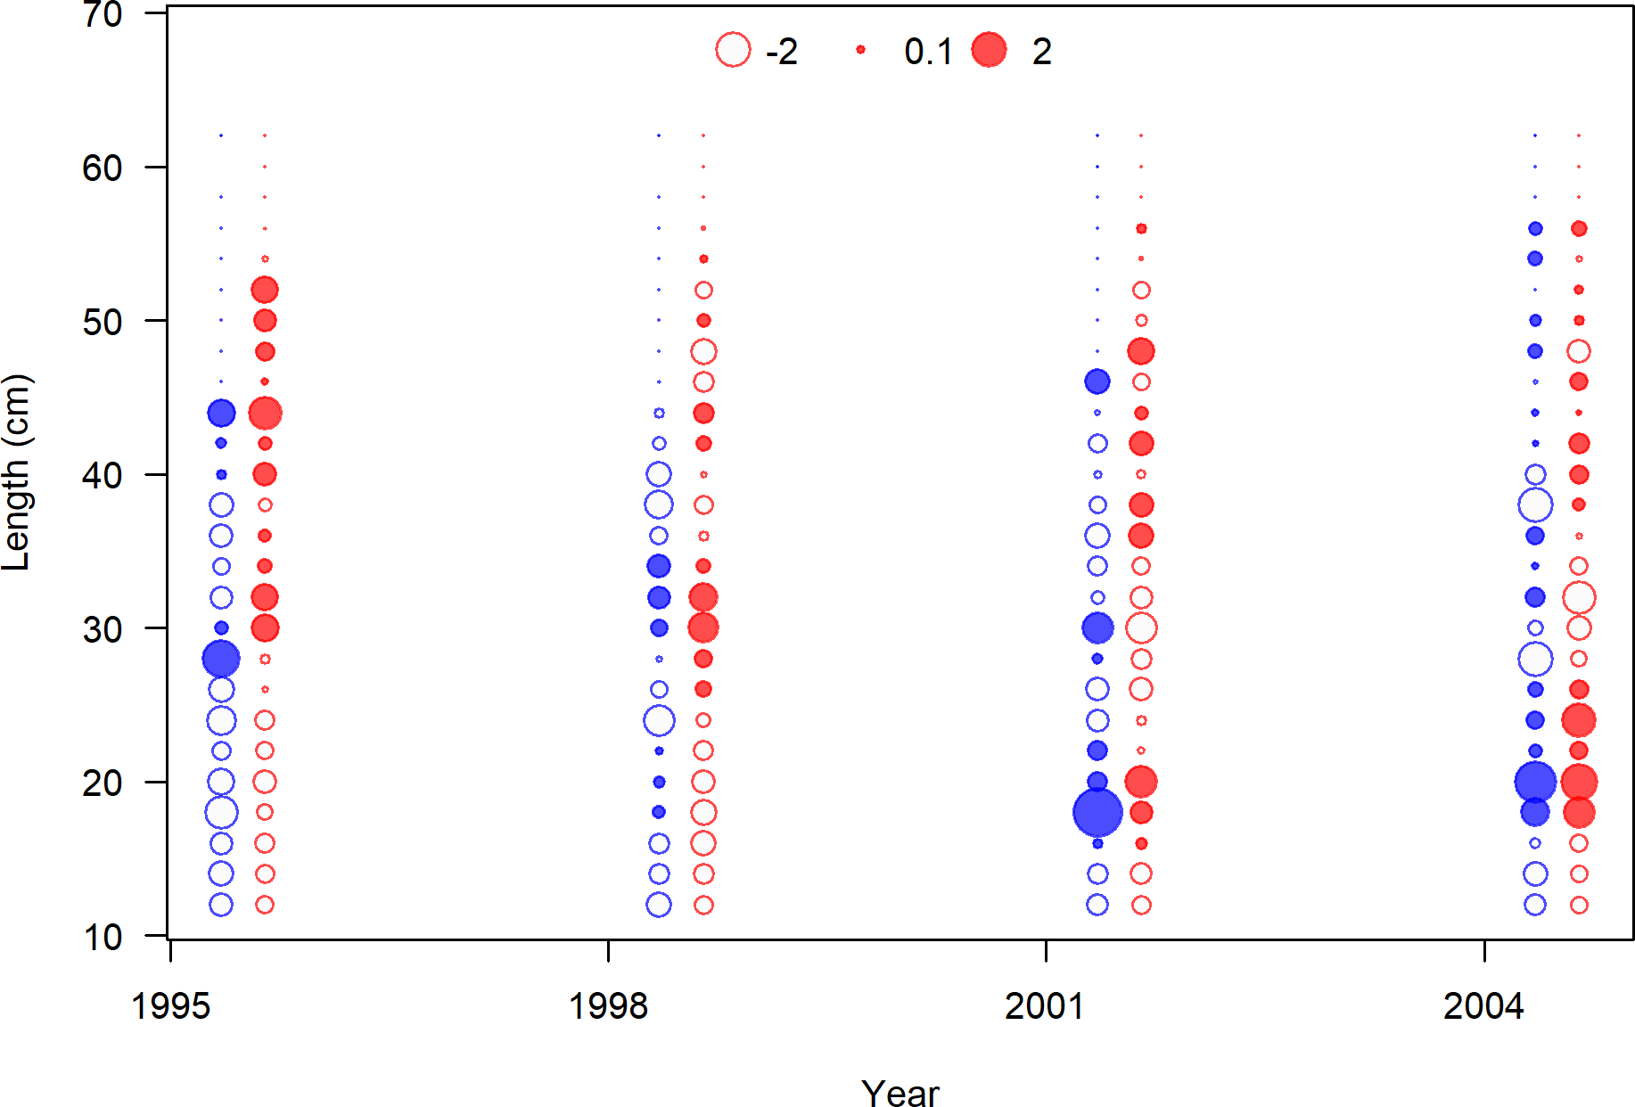

Figure 80: Pearson residuals, whole catch, Triennial Late (max=3.9)

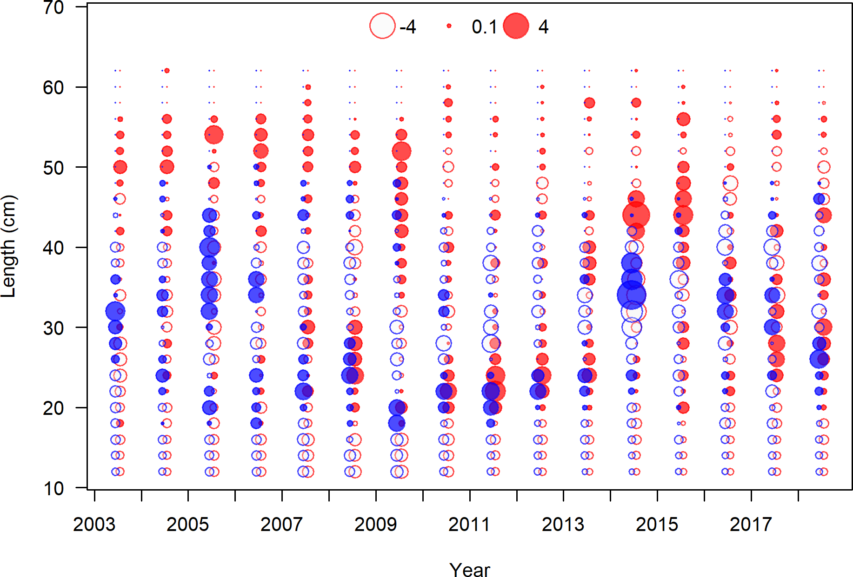

Figure 81: Pearson residuals, whole catch, NWFSC West Coast Groundfish Bottom Trawl Survey (max=5.08)

Closed bubbles are positive residuals (observed *>* expected) and open bubbles are negative residuals (observed *<* expected).

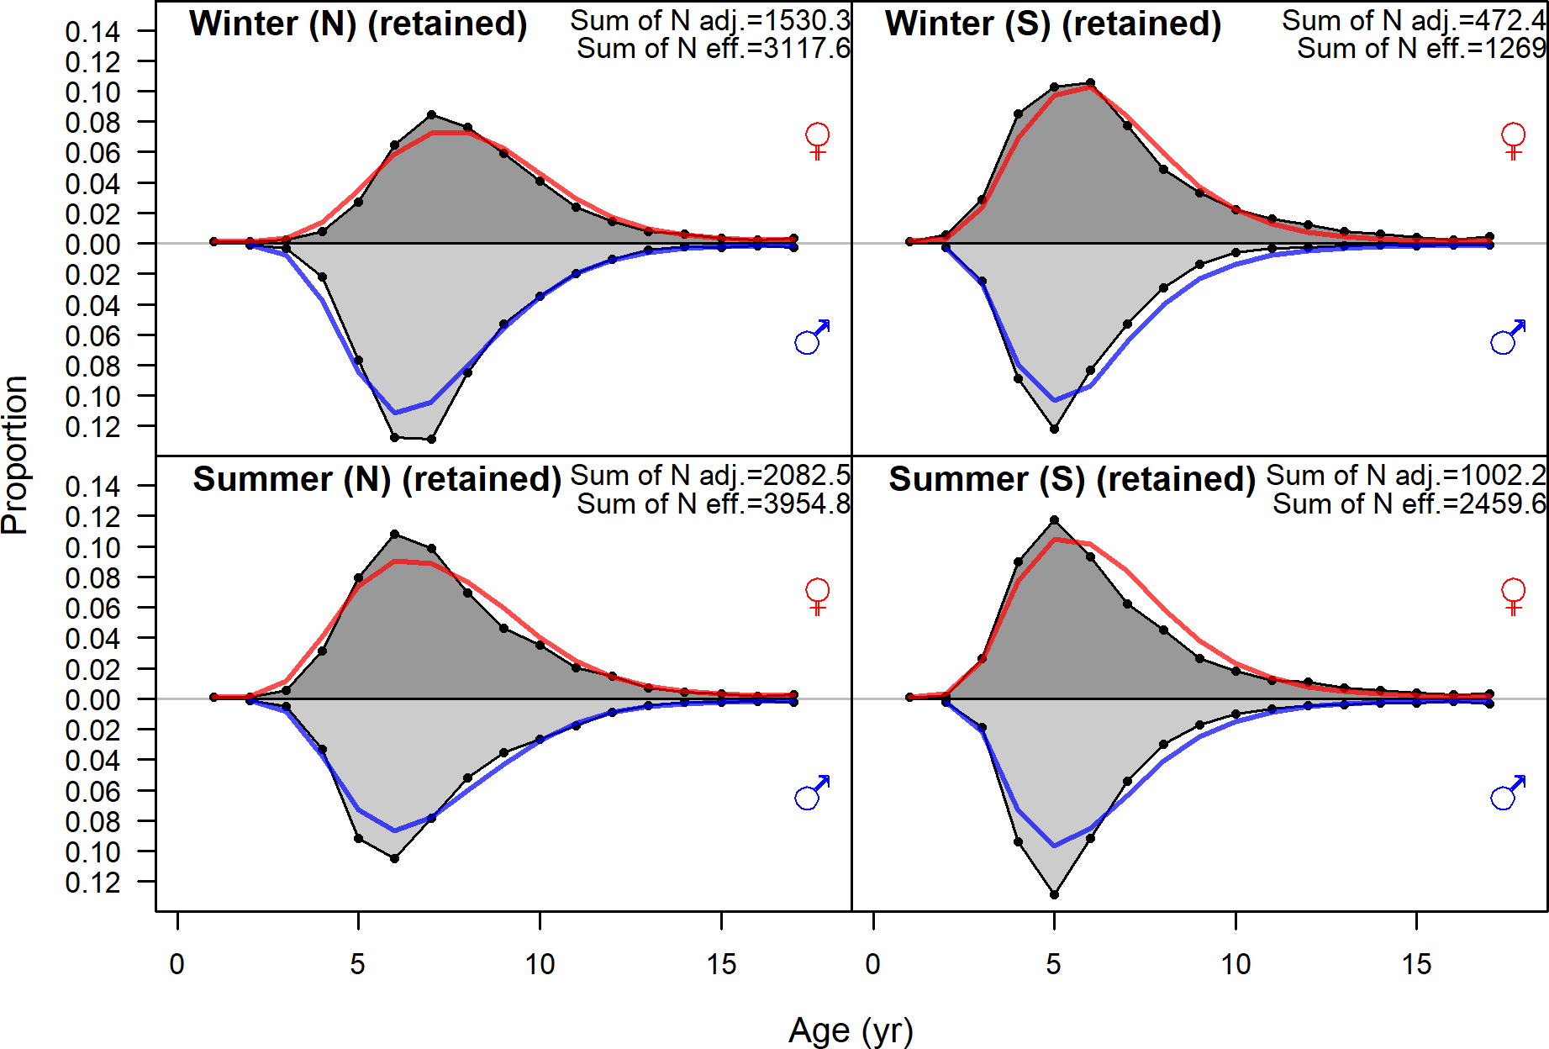

Figure 82: Age compositions aggregated across time for each fishery fleet.

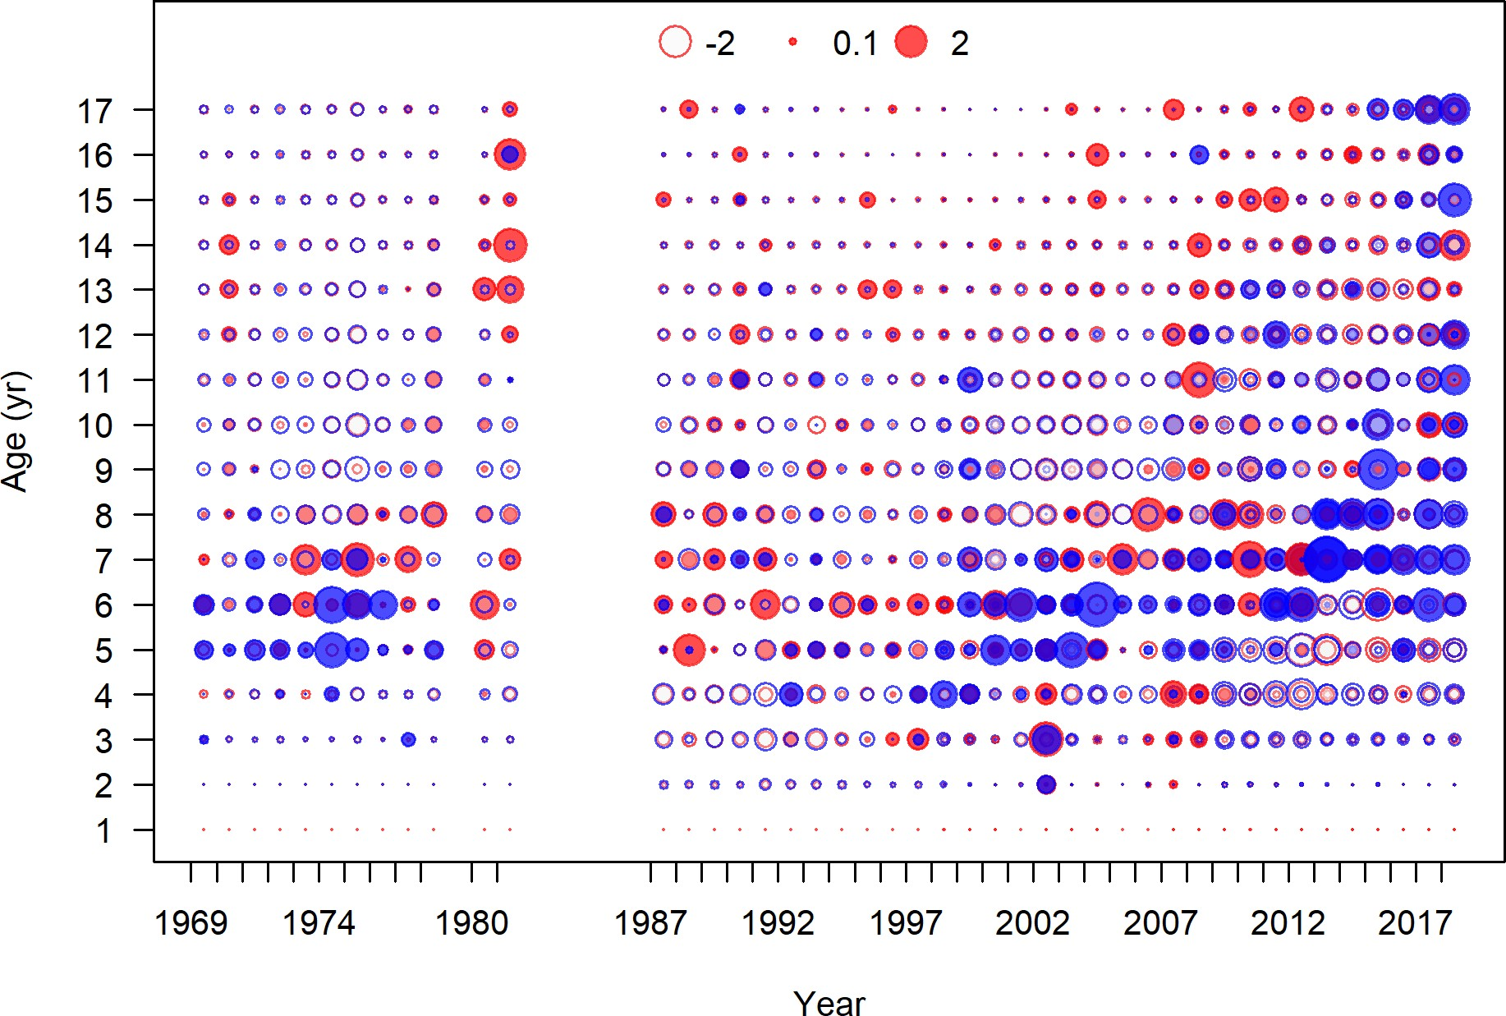

Figure 83: Pearson residuals, retained, Winter (N) (max=4.05) (plot 4 of 4)

Closed bubbles are positive residuals (observed *>* expected) and open bubbles are negative residuals (observed *<* expected).

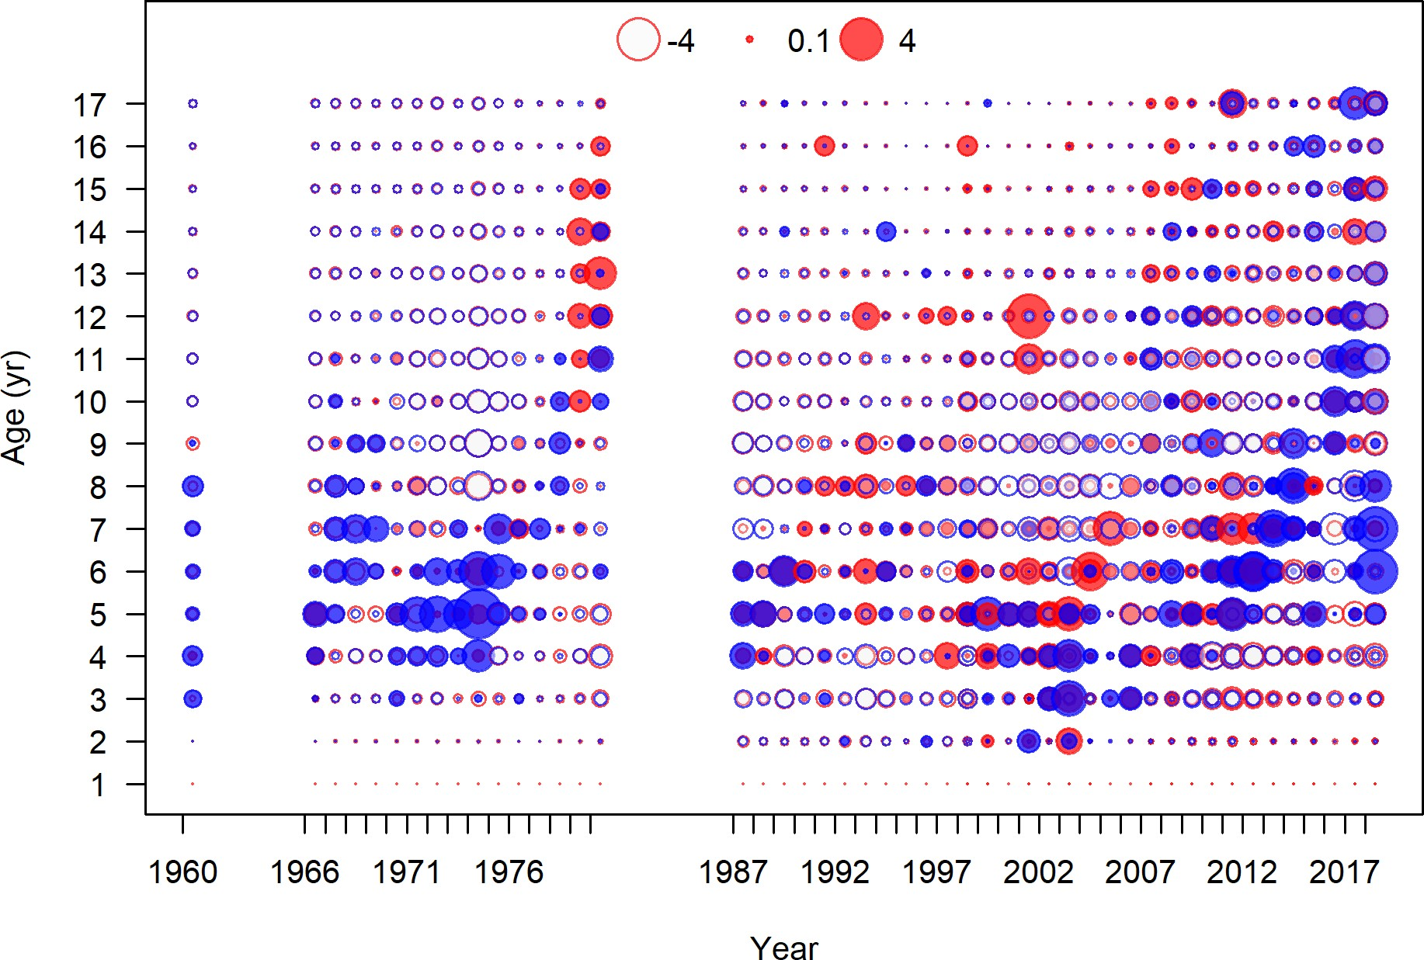

Figure 84: Pearson residuals, retained, Summer (N) (max=5.4) (plot 5 of 5)

Closed bubbles are positive residuals (observed *>* expected) and open bubbles are negative residuals (observed *<* expected).

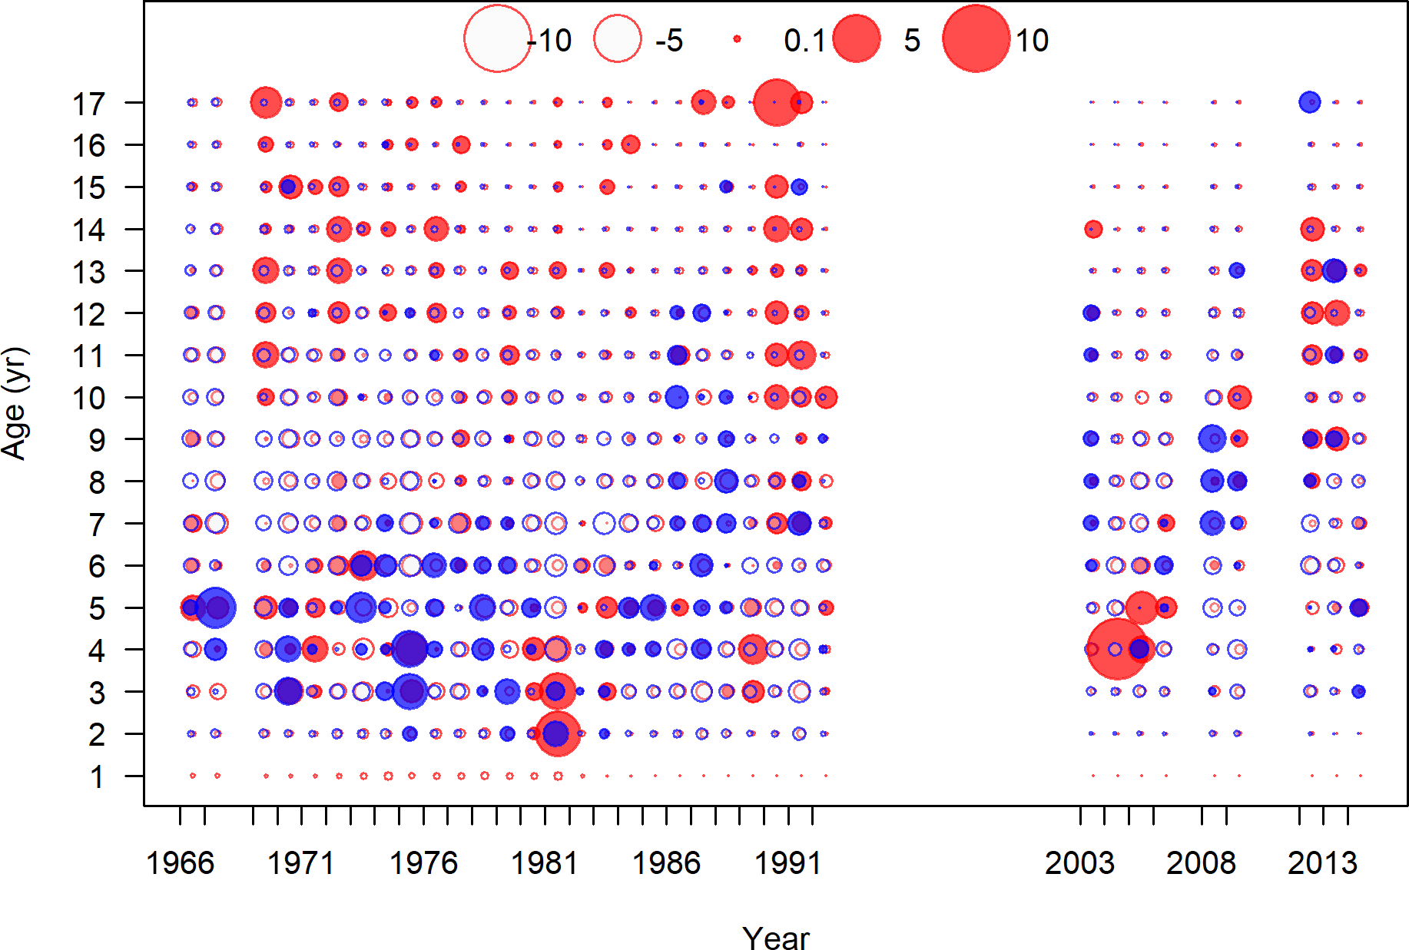

Figure 85: Pearson residuals, retained, Winter (S) (max=8.32) (plot 3 of 3)

Closed bubbles are positive residuals (observed *>* expected) and open bubbles are negative residuals (observed *<* expected).

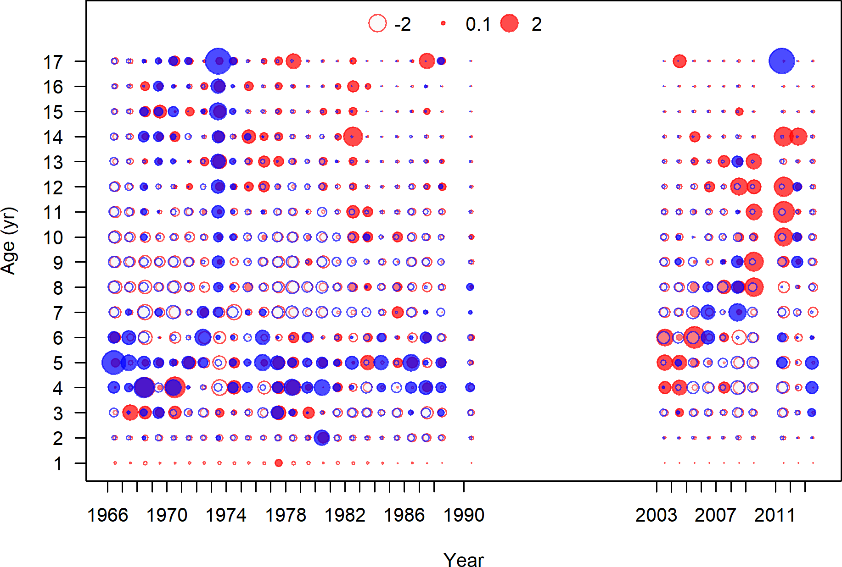

Figure 86: Pearson residuals, retained, Summer (S) (max=4.26) (plot 3 of 3)

Closed bubbles are positive residuals (observed *>* expected) and open bubbles are negative residuals (observed *<* expected).

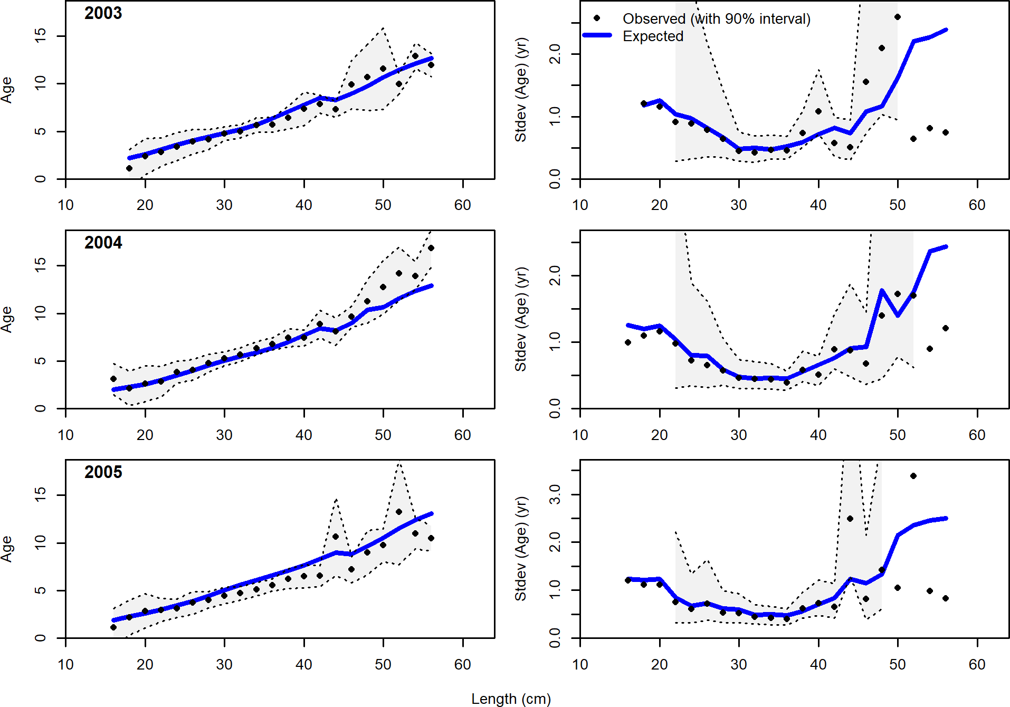

Figure 87: Conditional AAL plot, whole catch, NWFSC West Coast Groundfish Bottom Trawl Survey (plot 1 of 6) These plots show mean age and std. dev. in conditional AAL. Left plots are mean AAL by size class (obs. and pred.) with 90% CIs based on adding 1.64 SE of mean to the data. Right plots in each pair are SE of mean AAL (obs. and pred.) with 90% CIs based on the chi square distribution.

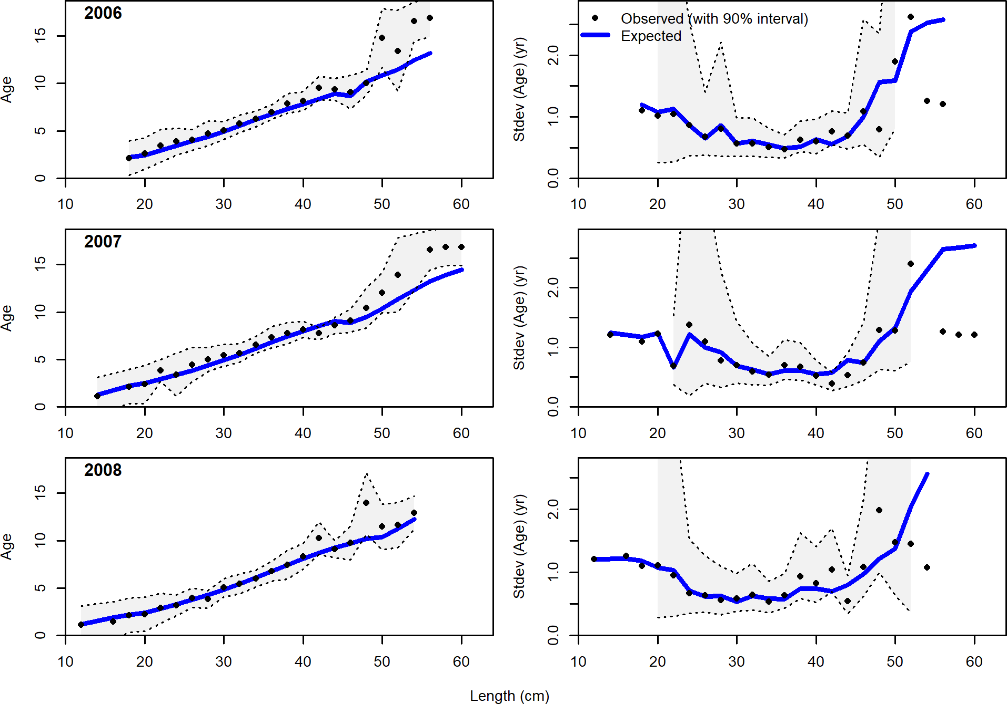

Figure 88: Conditional AAL plot, whole catch, NWFSC West Coast Groundfish Bottom Trawl Survey (plot 2 of 6)

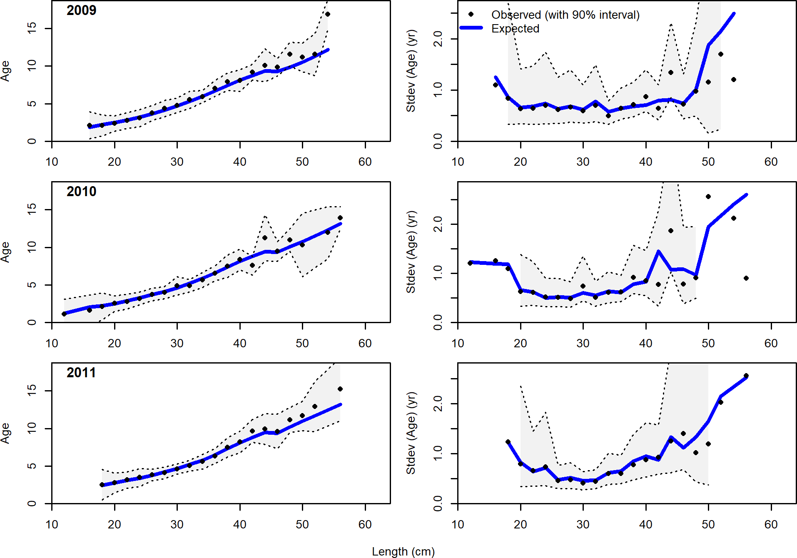

Figure 89: Conditional AAL plot, whole catch, NWFSC West Coast Groundfish Bottom Trawl Survey (plot 3 of 6)

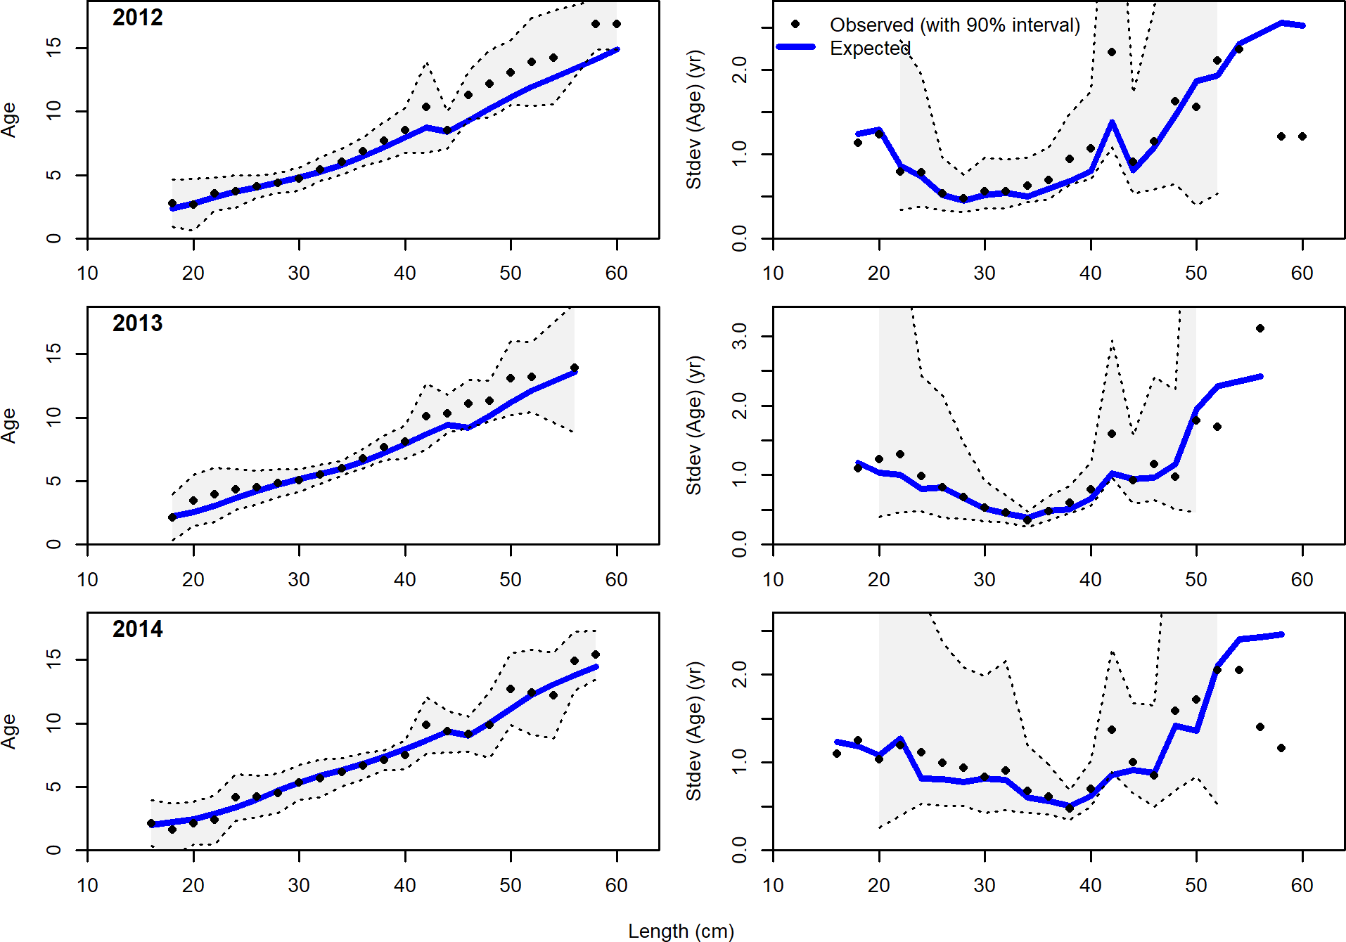

Figure 90: Conditional AAL plot, whole catch, NWFSC West Coast Groundfish Bottom Trawl Survey (plot 4 of 6)

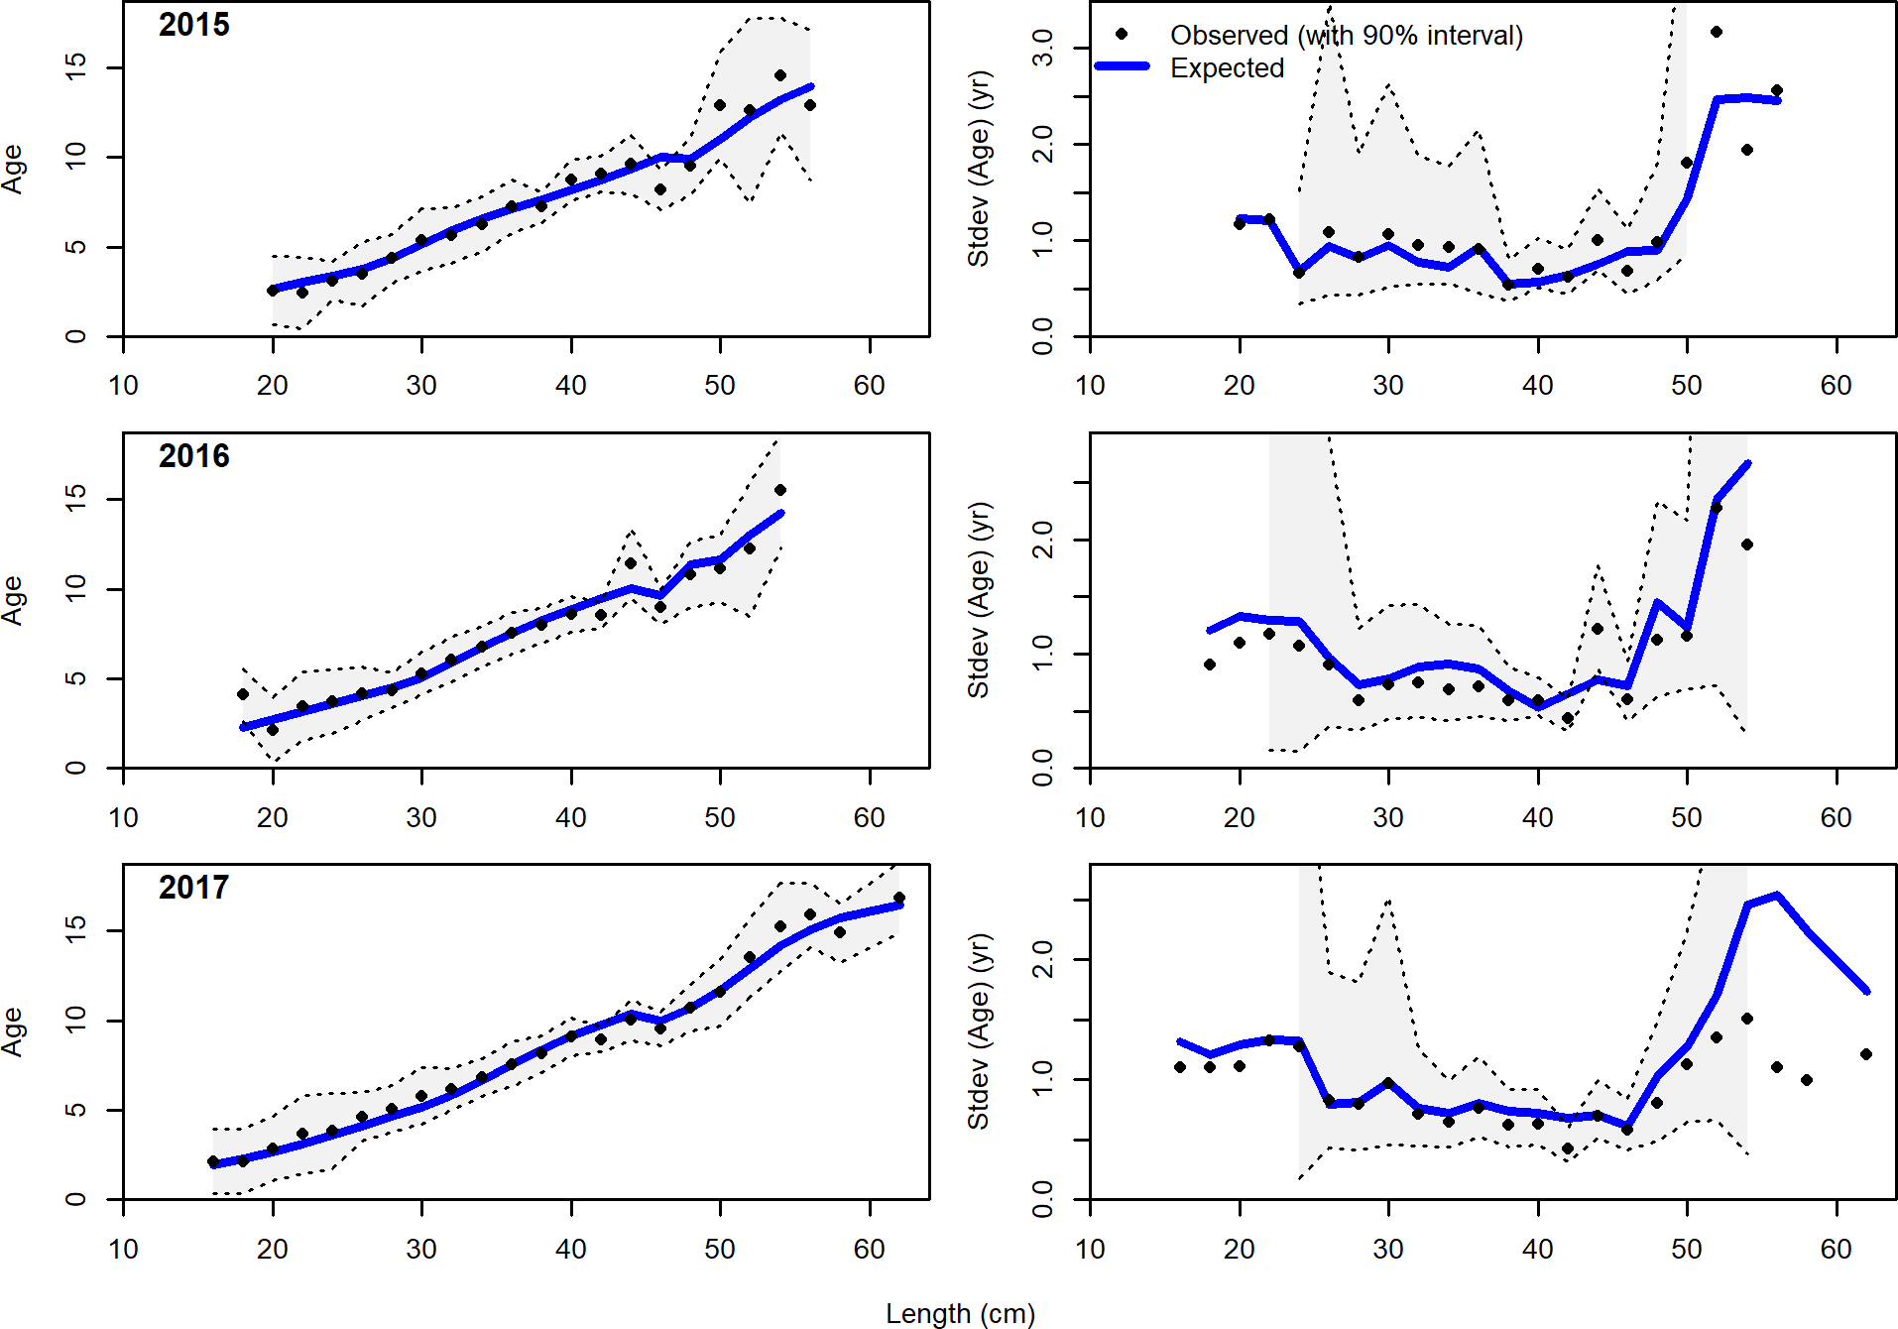

Figure 91: Conditional AAL plot, whole catch, NWFSC West Coast Groundfish Bottom Trawl Survey (plot 5 of 6)

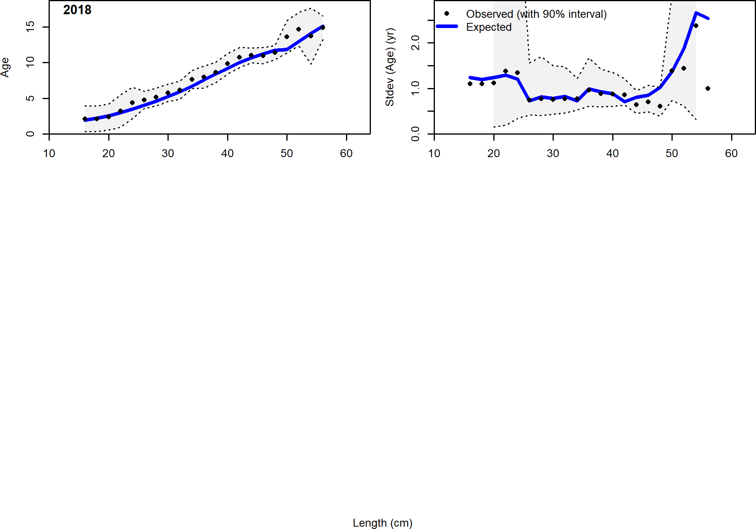

Figure 92: Conditional AAL plot, whole catch, NWFSC West Coast Groundfish Bottom Trawl Survey (plot 6 of 6)

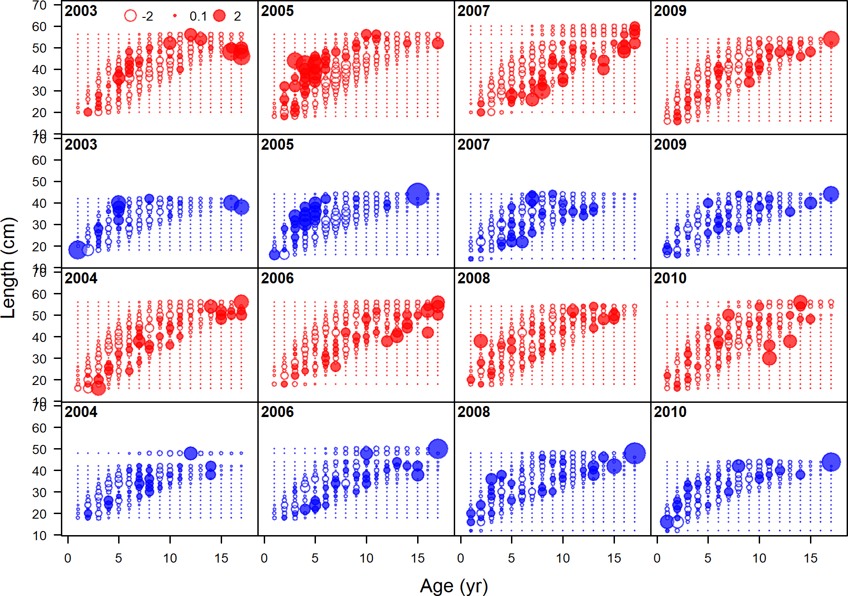

Figure 93: Pearson residuals, whole catch, NWFSC West Coast Groundfish Bottom Trawl Survey (max=7.1) (plot 1 of 2)

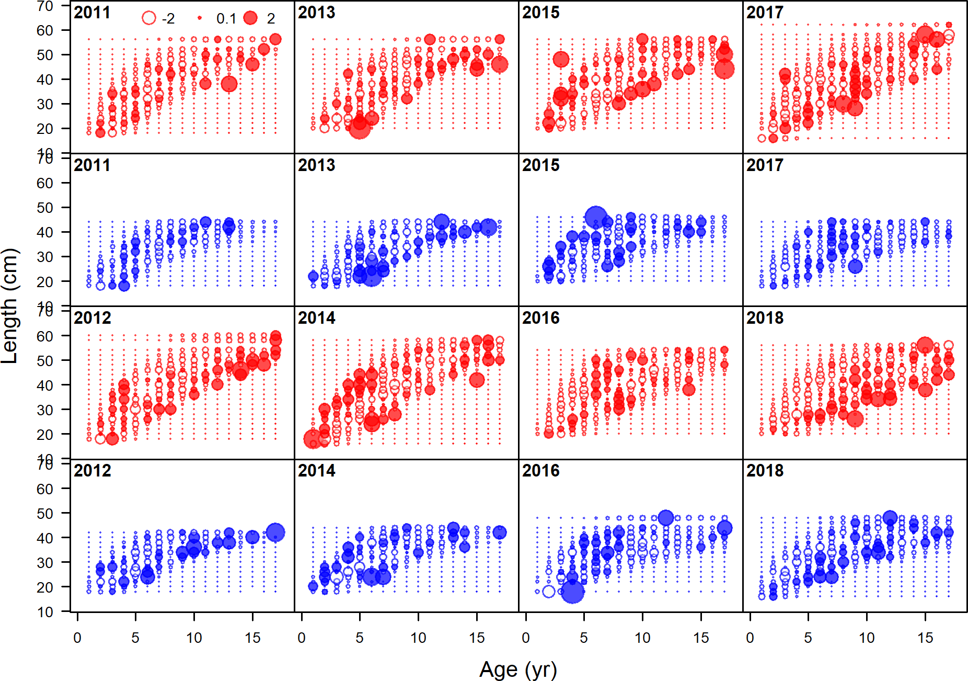

Figure 94: Pearson residuals, whole catch, NWFSC West Coast Groundfish Bottom Trawl Survey (max=7.1) (plot 1 of 2) (plot 2 of 2)



Figure 95: Estimated time-series of spawning biomass trajectory (circles and line: median; light broken lines: 95% credibility intervals) for petrale sole.

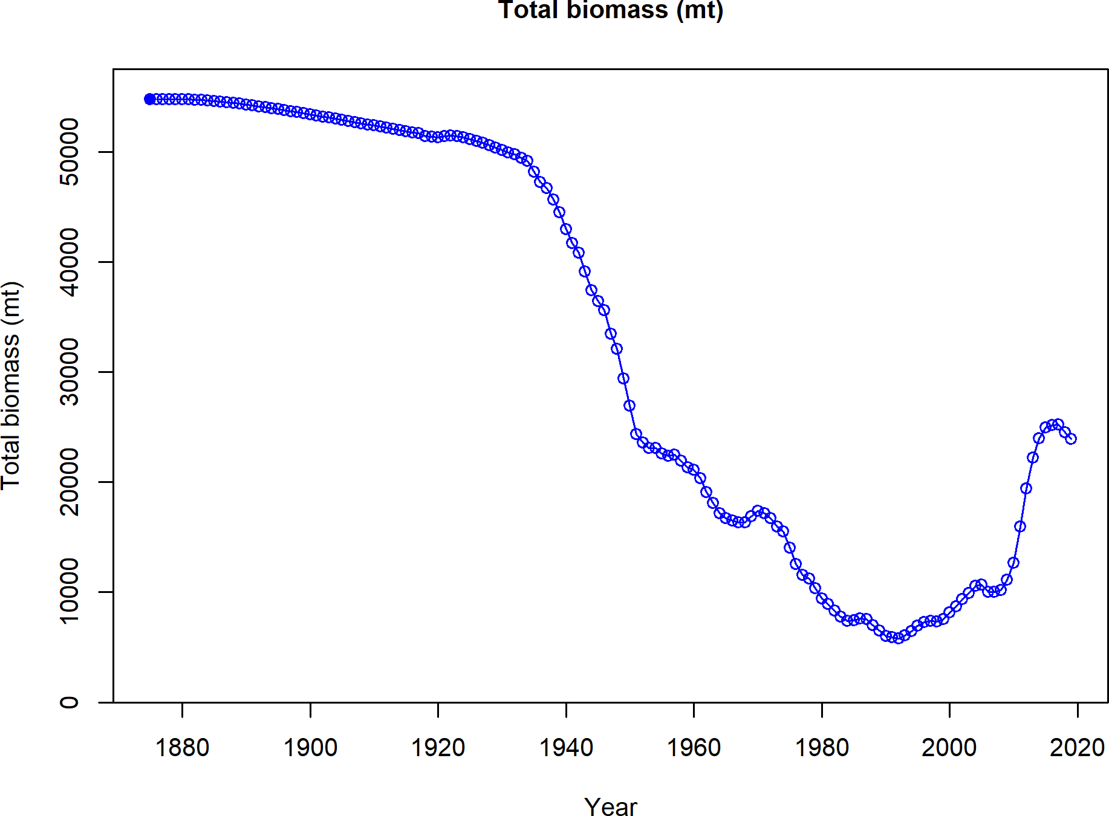

Figure 96: Estimated time-series of total biomass for petrale sole.



Figure 97: Estimated time-series of relative spawning biomass (depletion) (circles and line: median; light broken lines: 95% credibility intervals) for petrale sole.

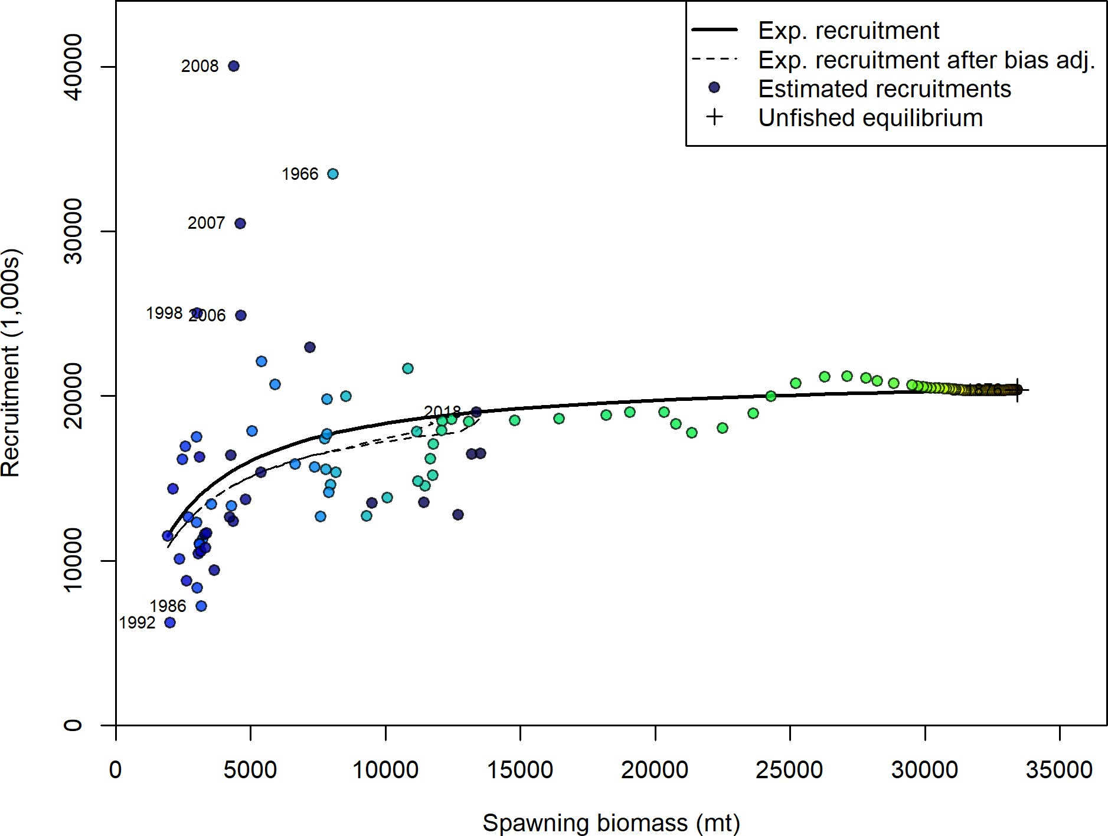

Figure 98: Estimated recruitment (colored circles) and the assumed stock-recruit relationship (solid black line). The dashed line shows the effect of the bias correction for the lognormal distribution.

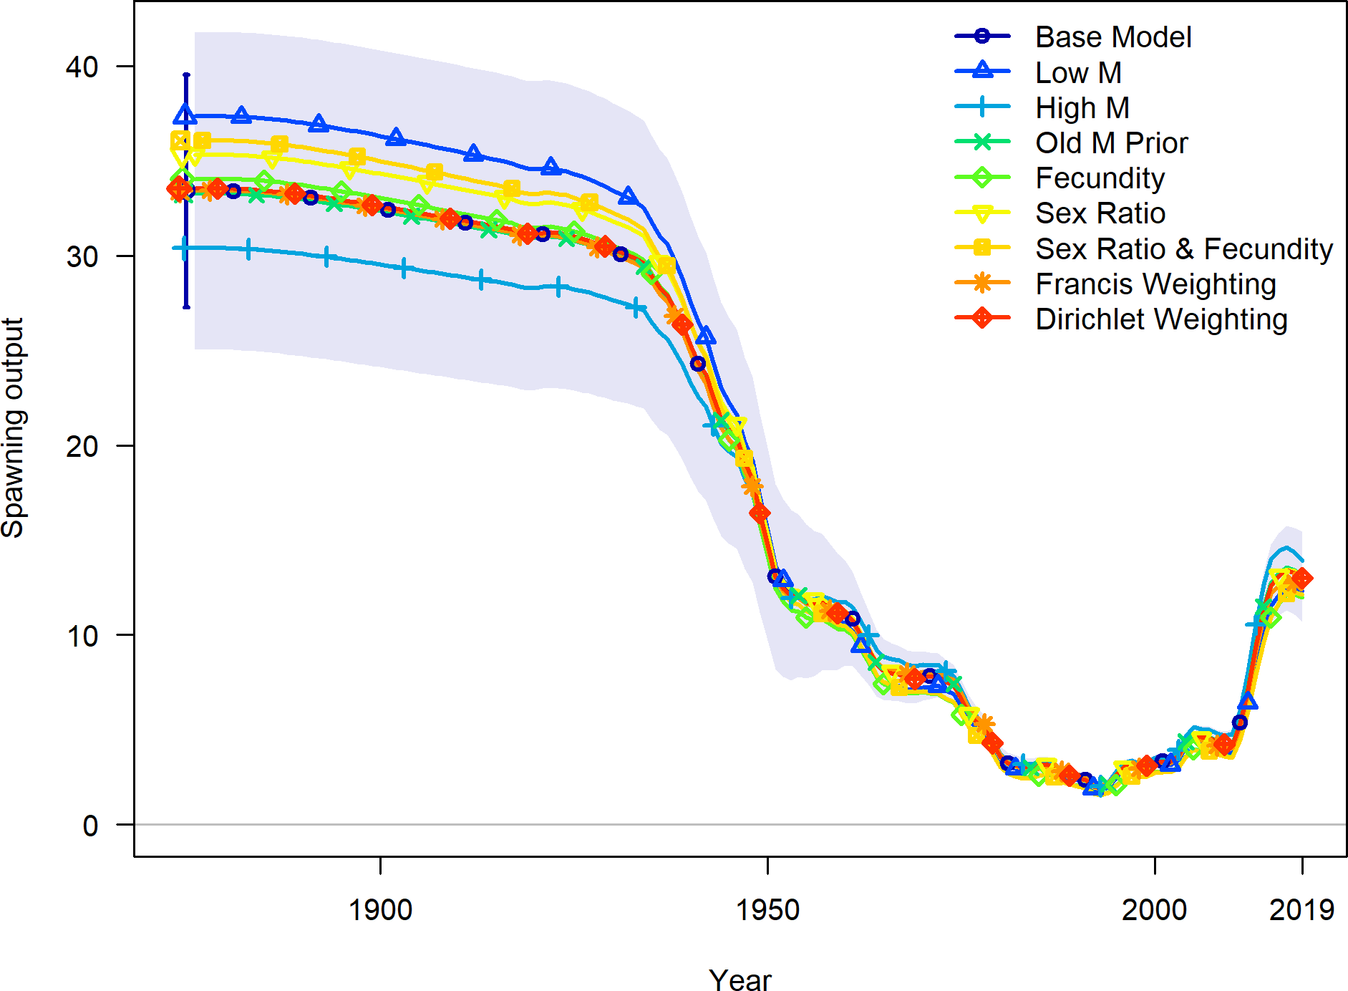

Figure 99: Estimated spawning biomass for the base model and each sensitivity.

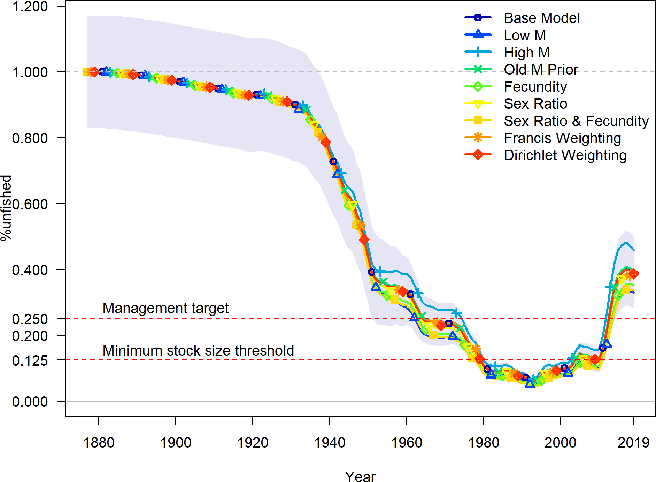

Figure 100: Estimated relative spawning biomass for the base model and each sensitivity.

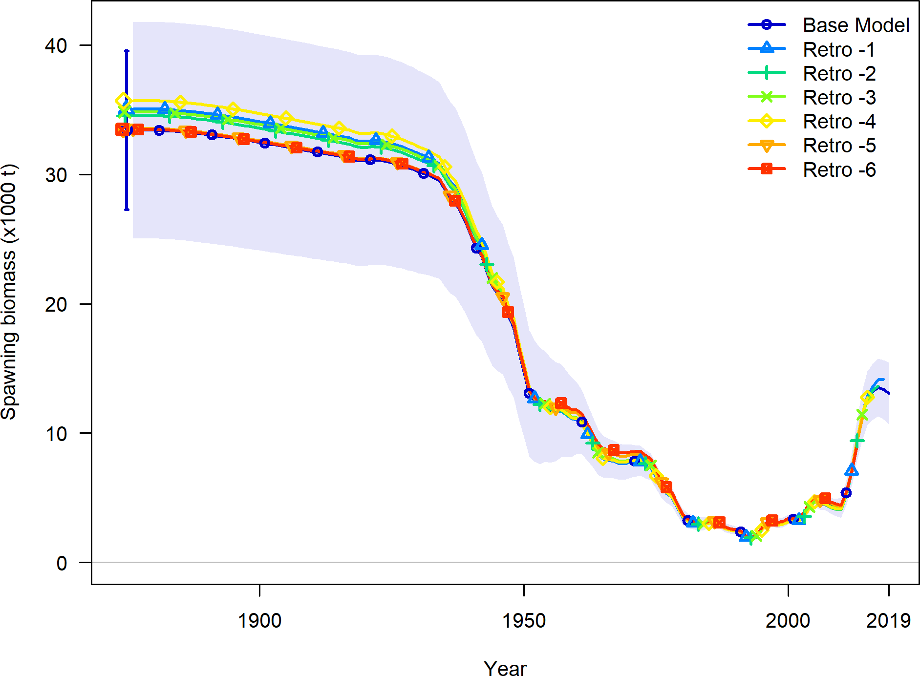

Figure 101: Retrospective pattern for spawning biomass.

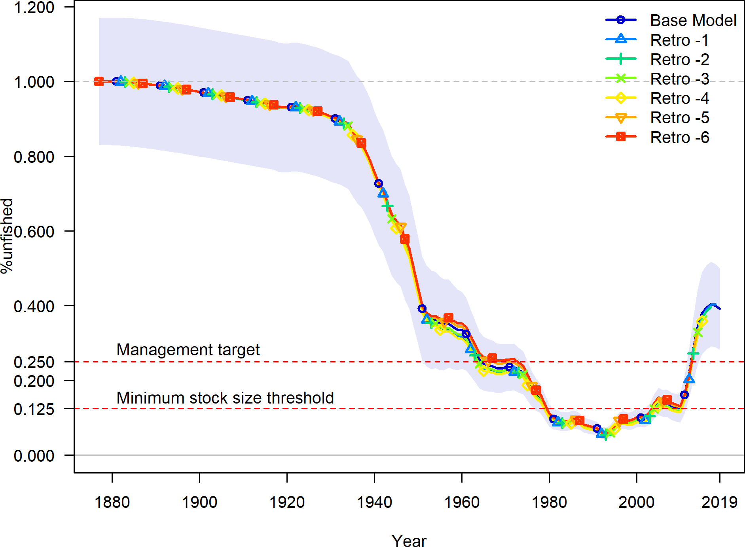

Figure 102: Retrospective pattern for relative spawning biomass.

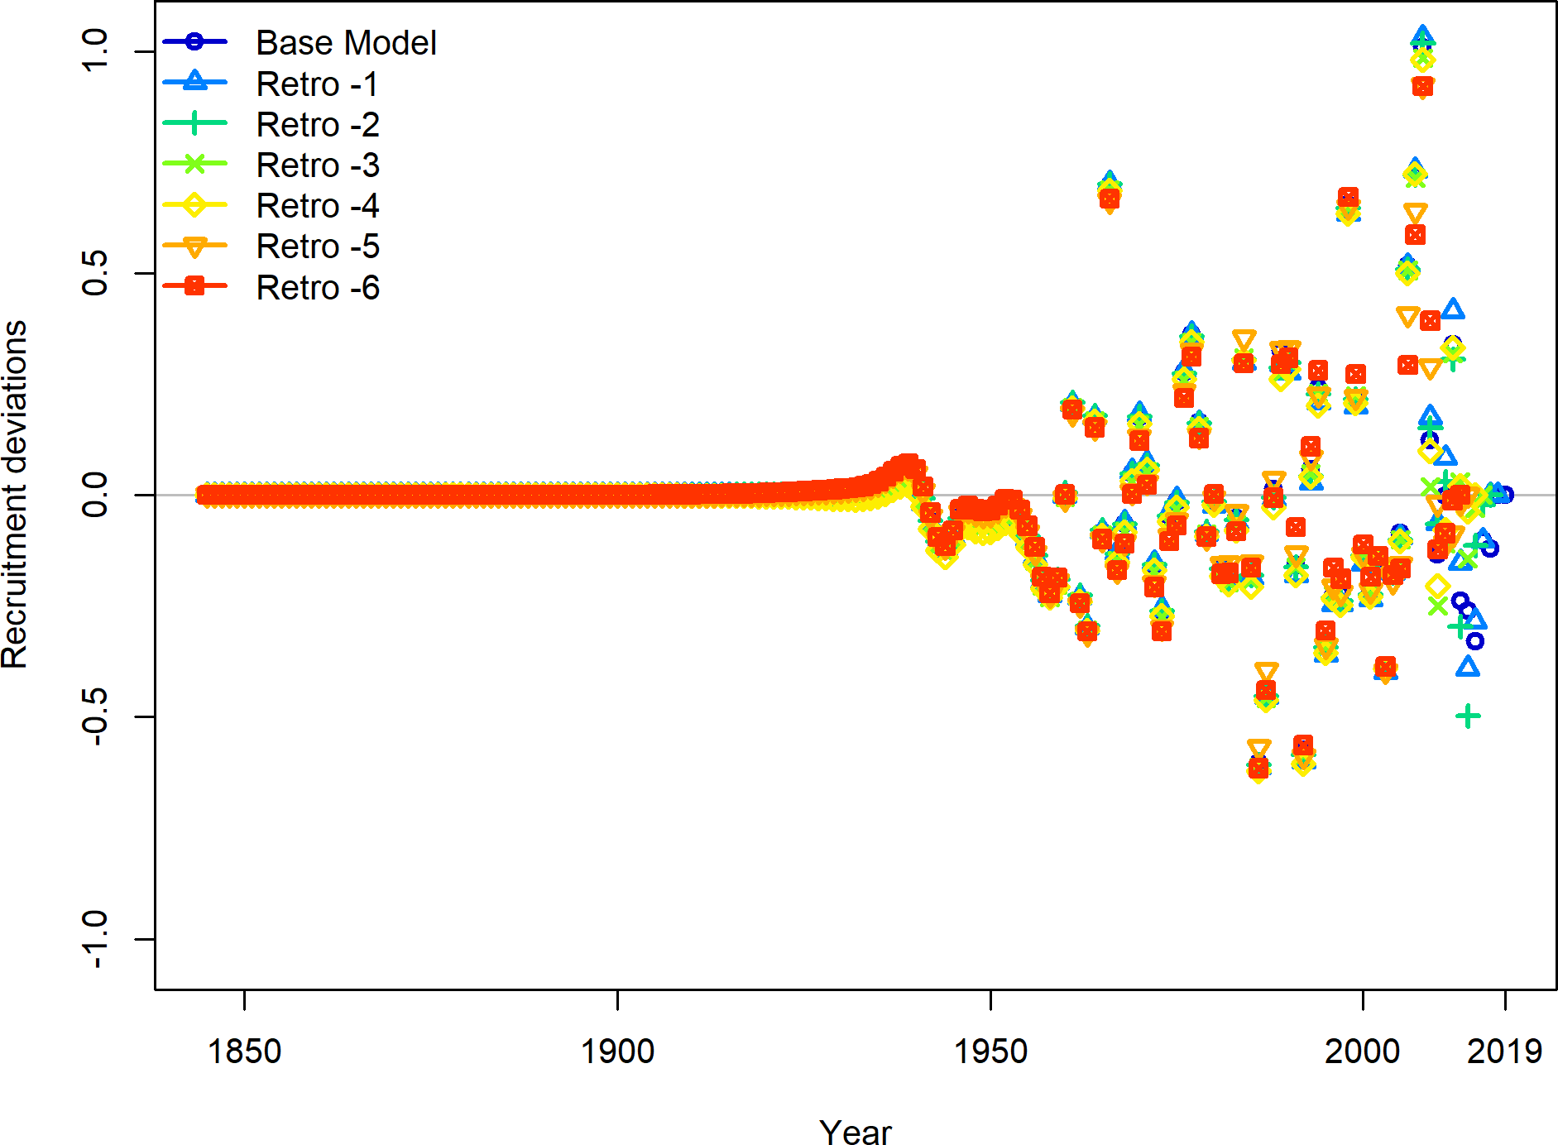

Figure 103: Retrospective pattern for estimated recruitment deviations.

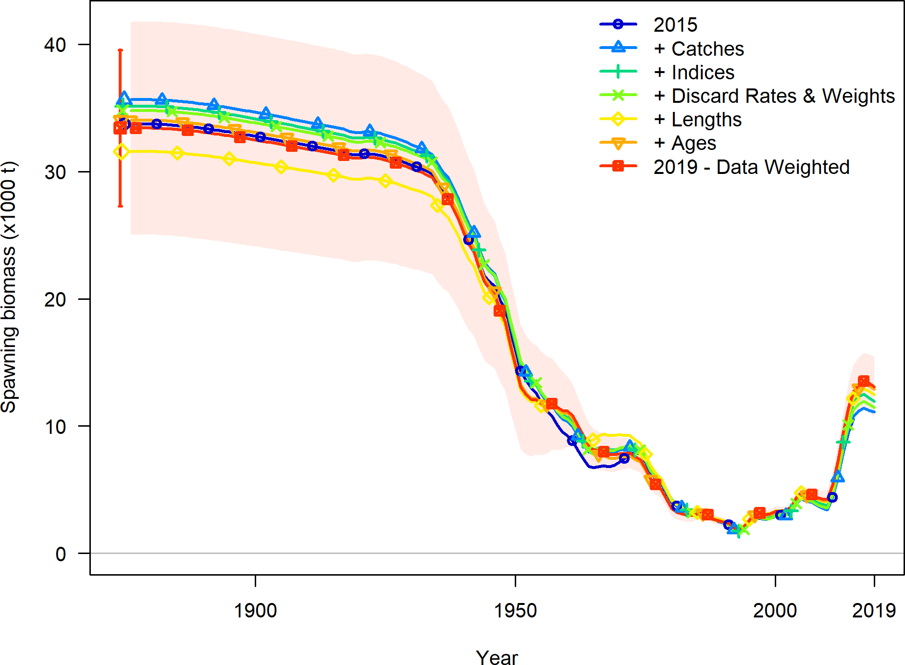

Figure 104: The estimated spawning output trajectory as each data source was updated relative to the 2015 update assessment.

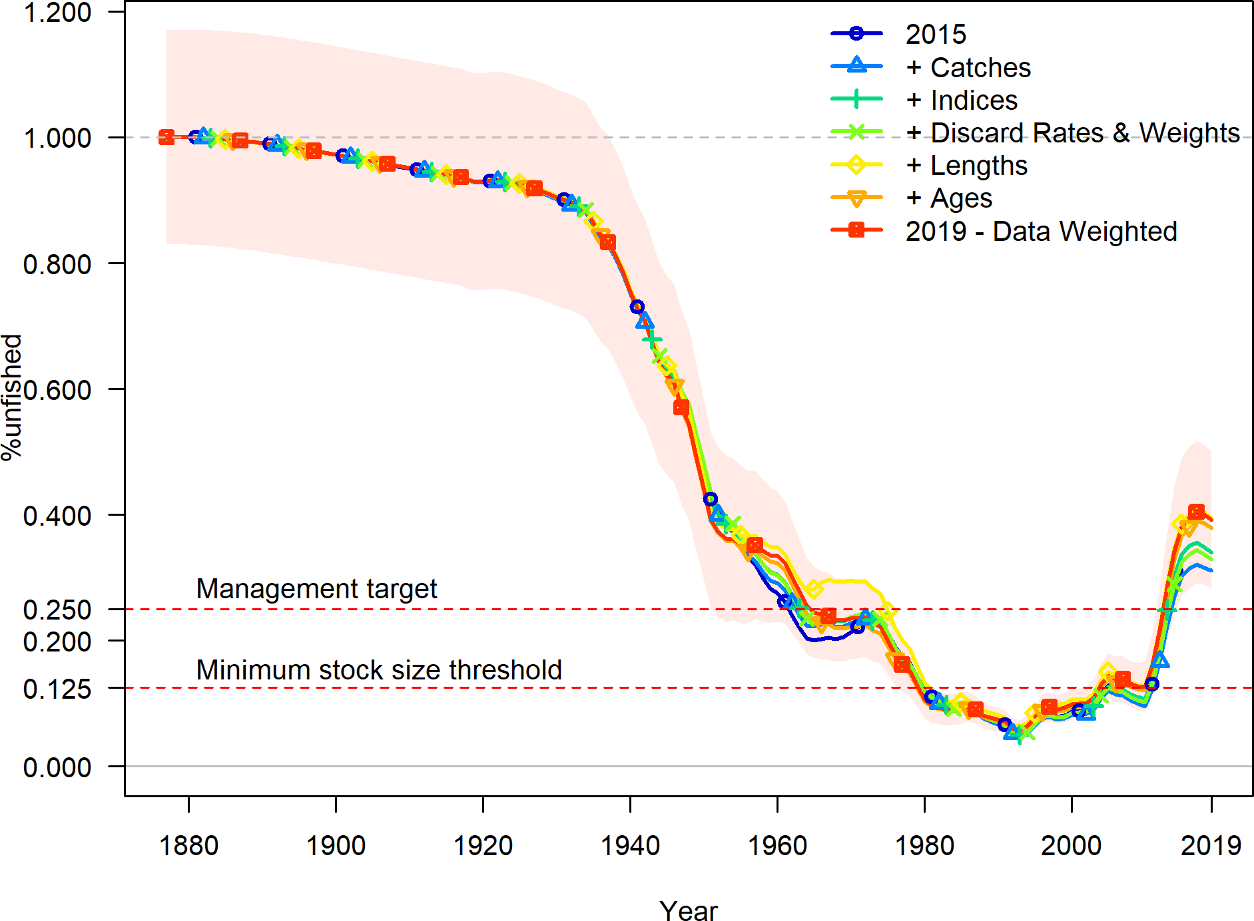

Figure 105: The estimated relative spawning output trajectory as each data source was updated relative to the 2015 update assessment.

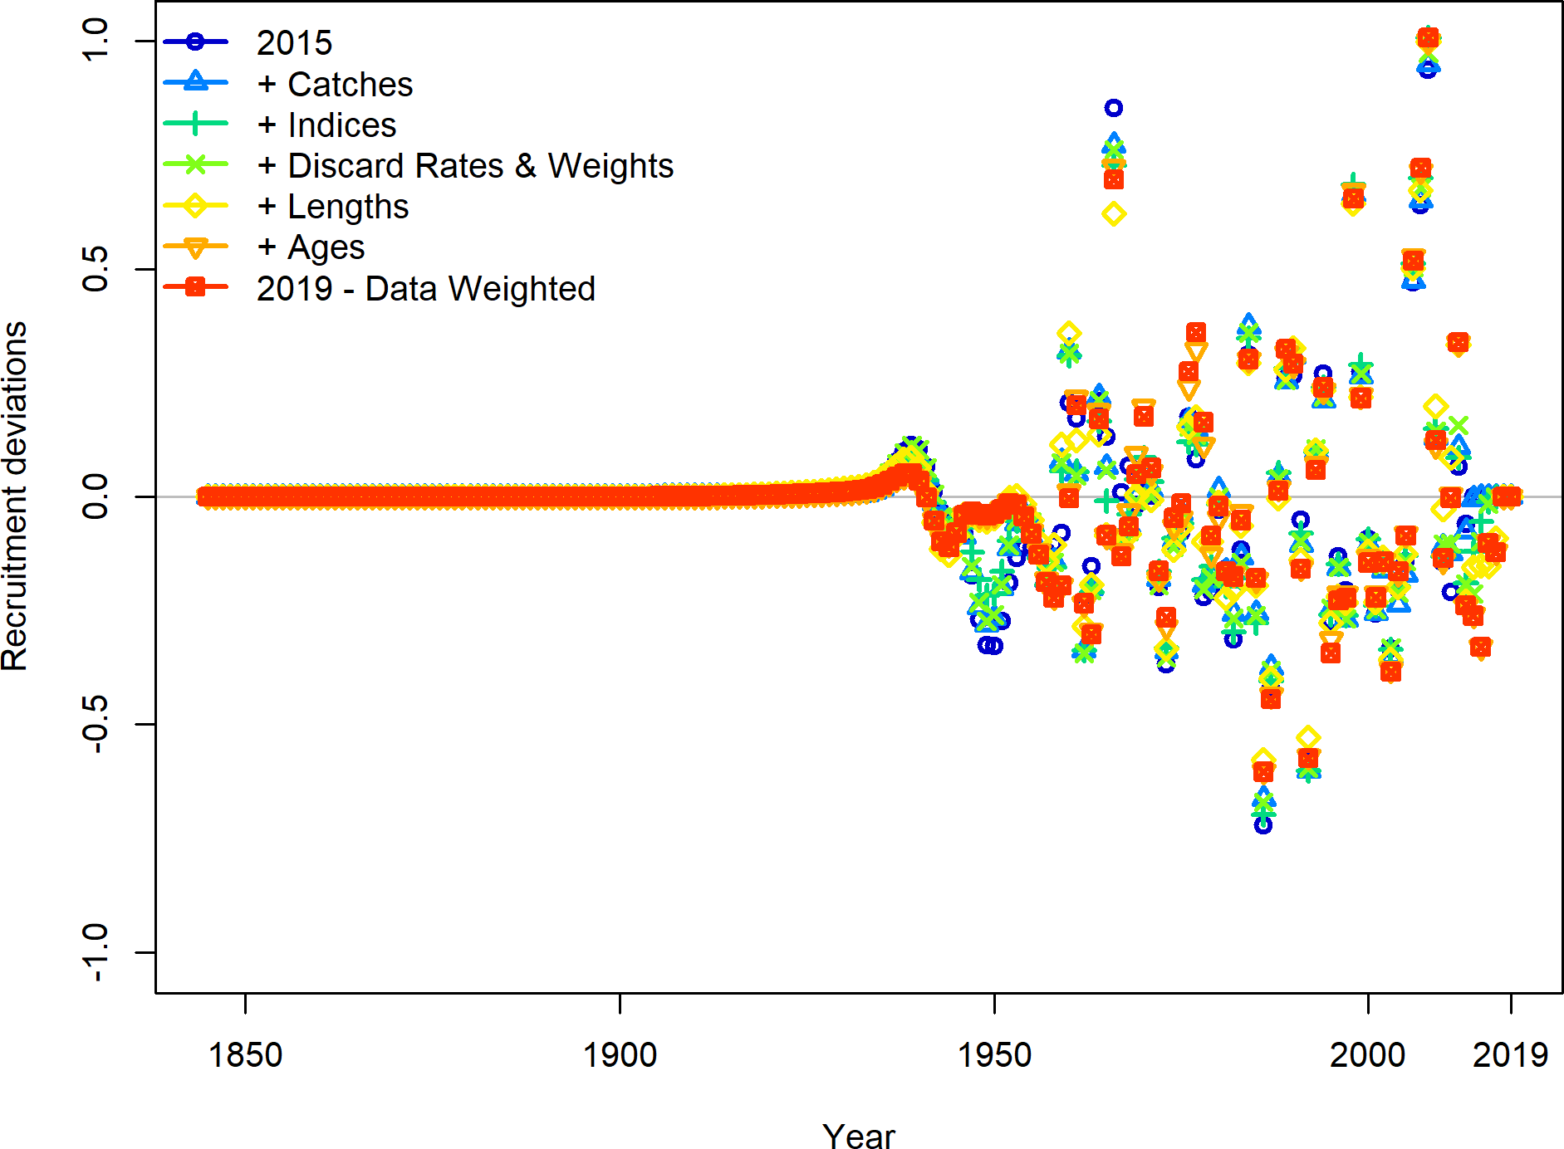

Figure 106: The estimated annual recruitment deviations as each data source was updated relative to the 2015 update assessment.

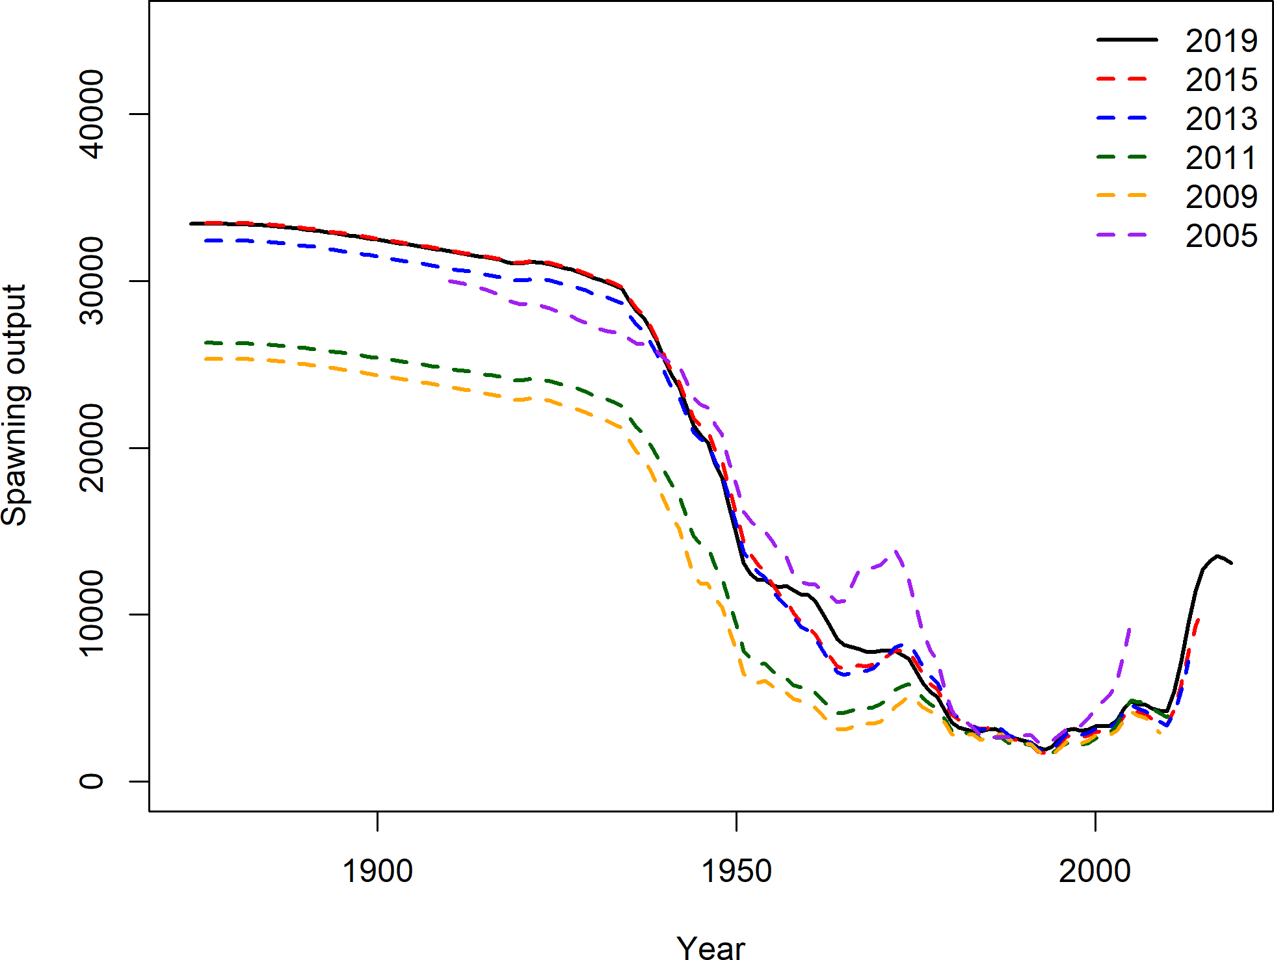

Figure 107: The estimated spawning output from each assessment since 2005.

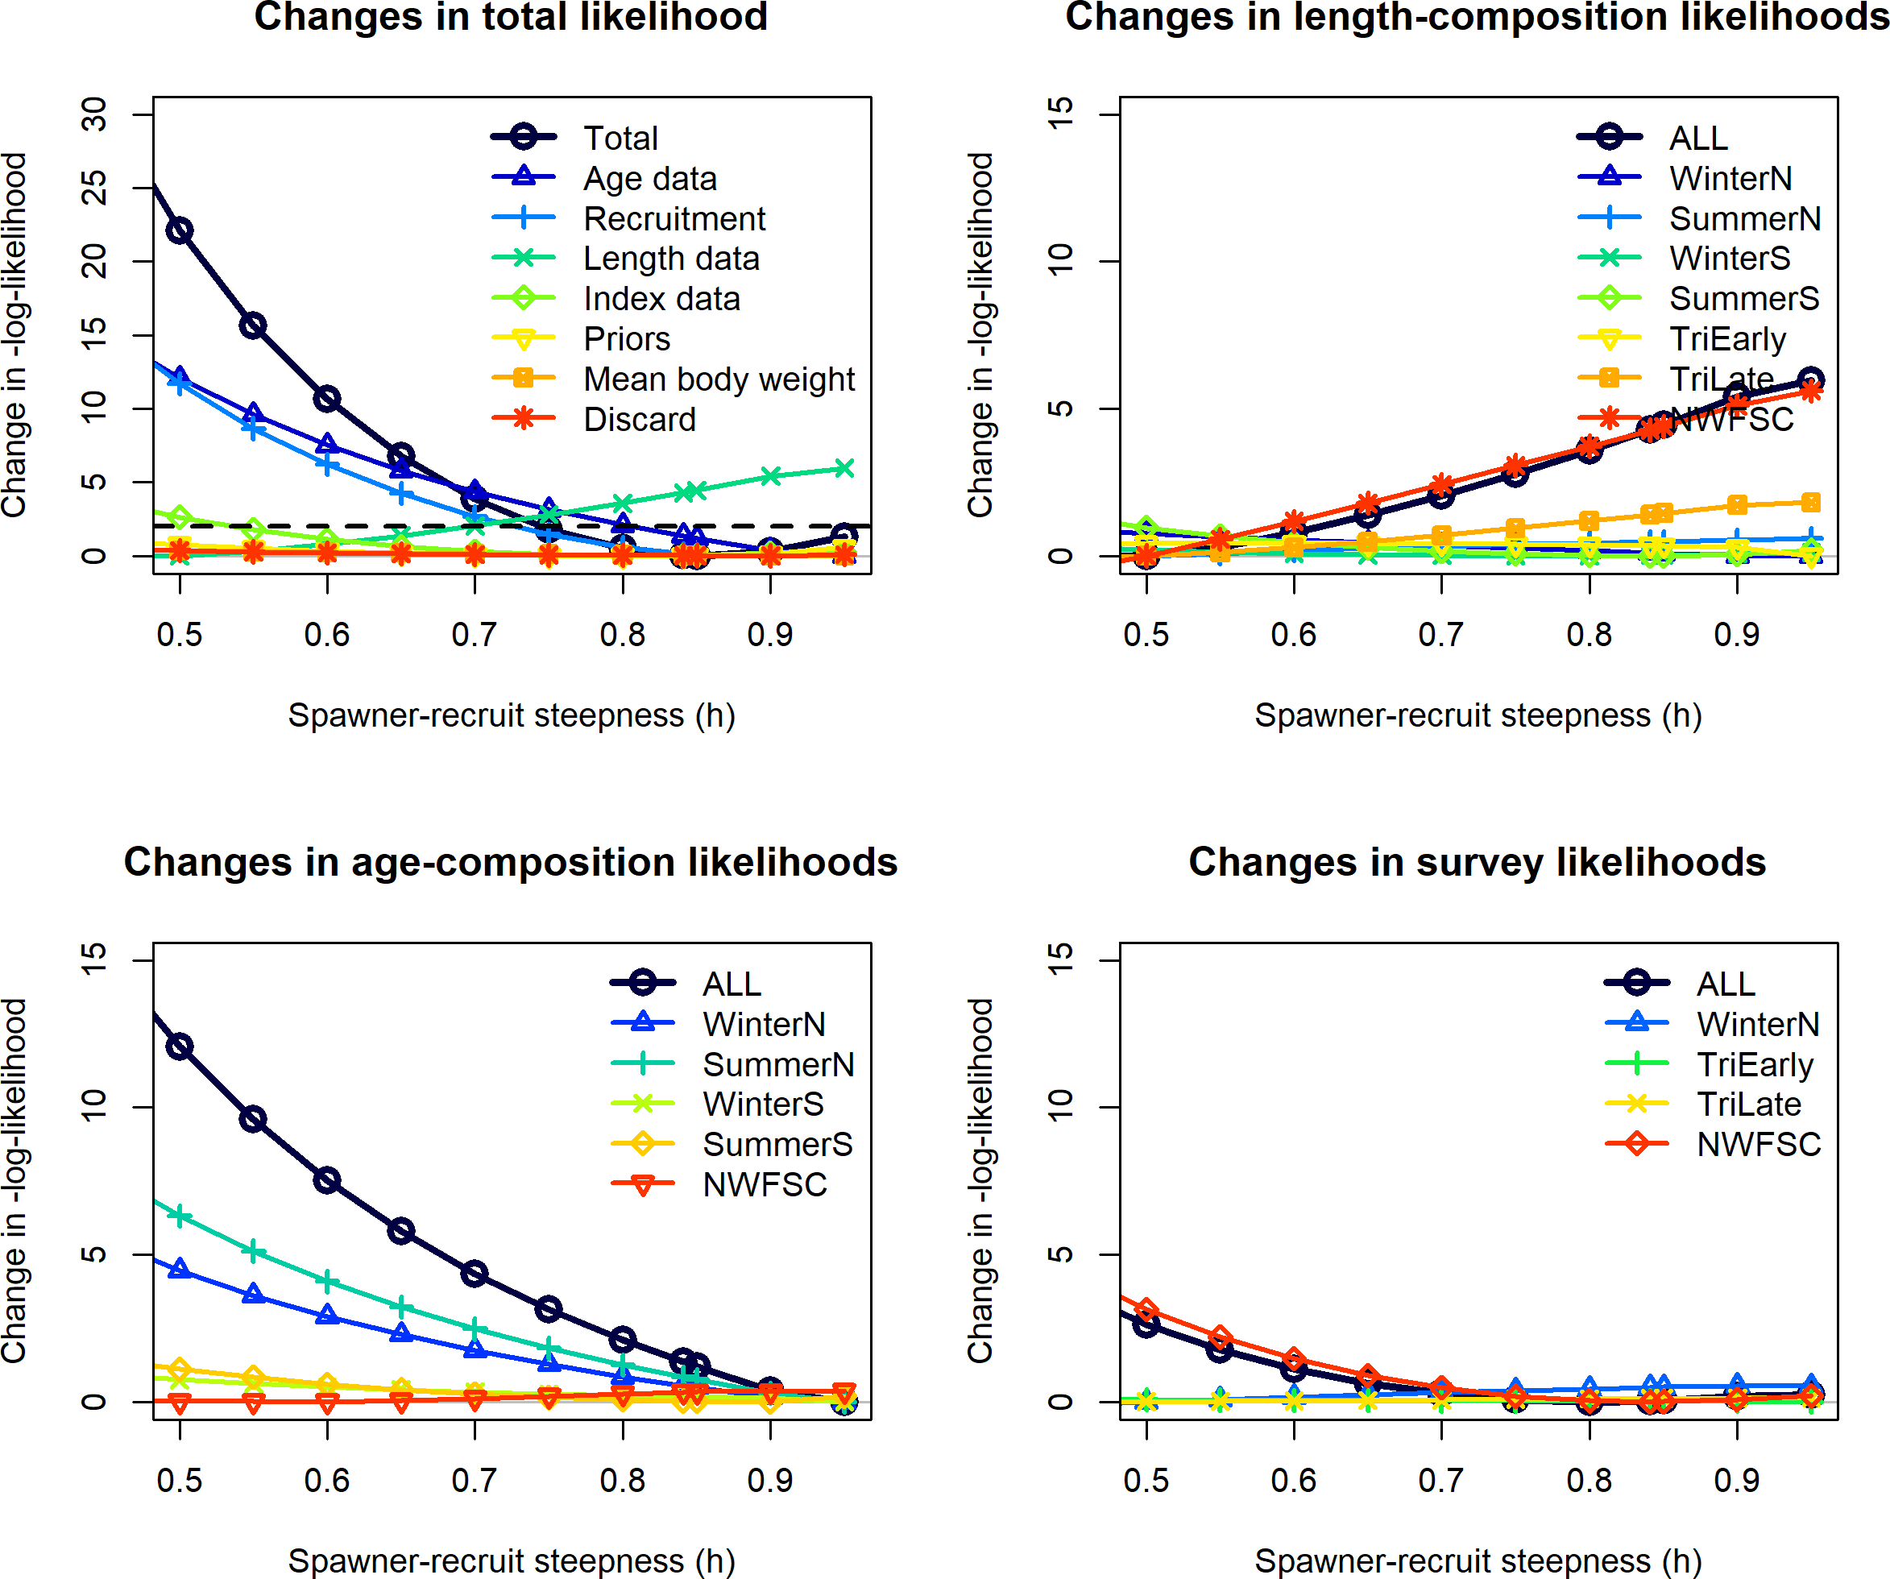

Figure 108: Likelihood profile across steepness values.

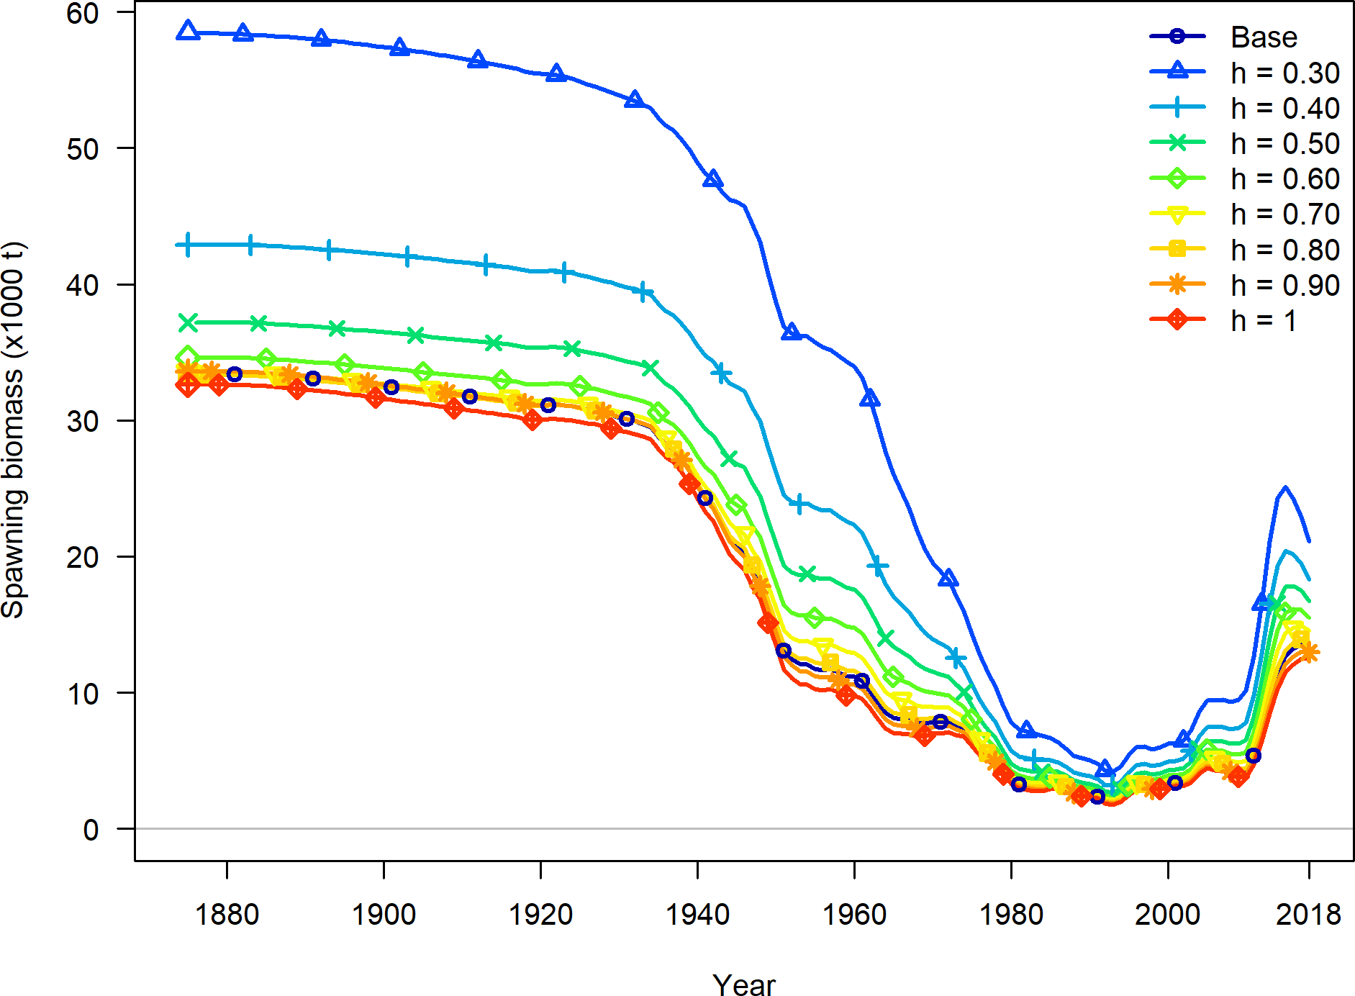

Figure 109: Trajectories of spawning output across values of steepness.

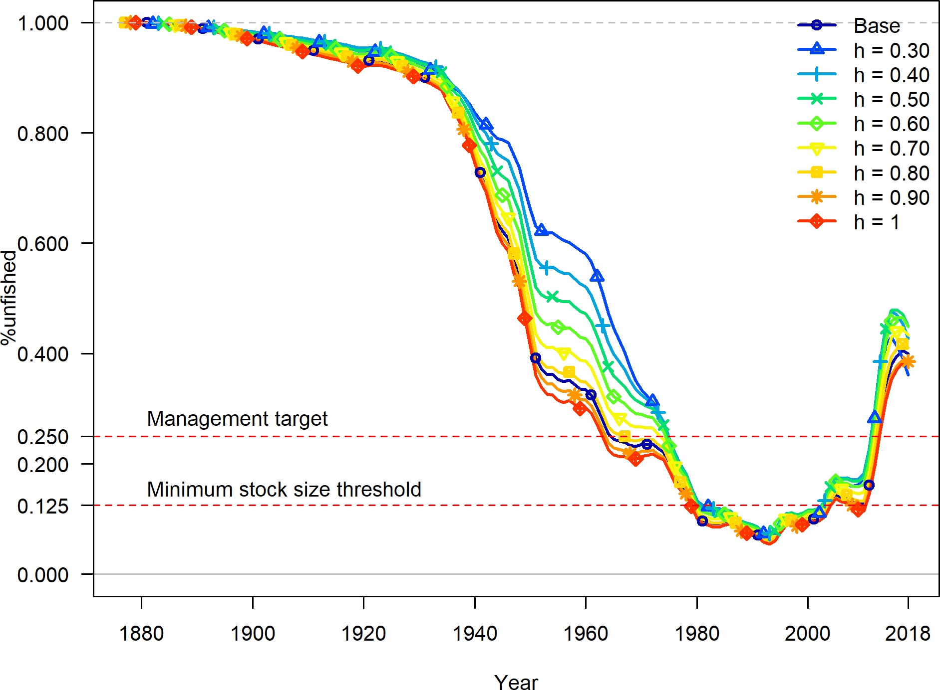

Figure 110: Trajectories of relative spawning output across values of steepness.

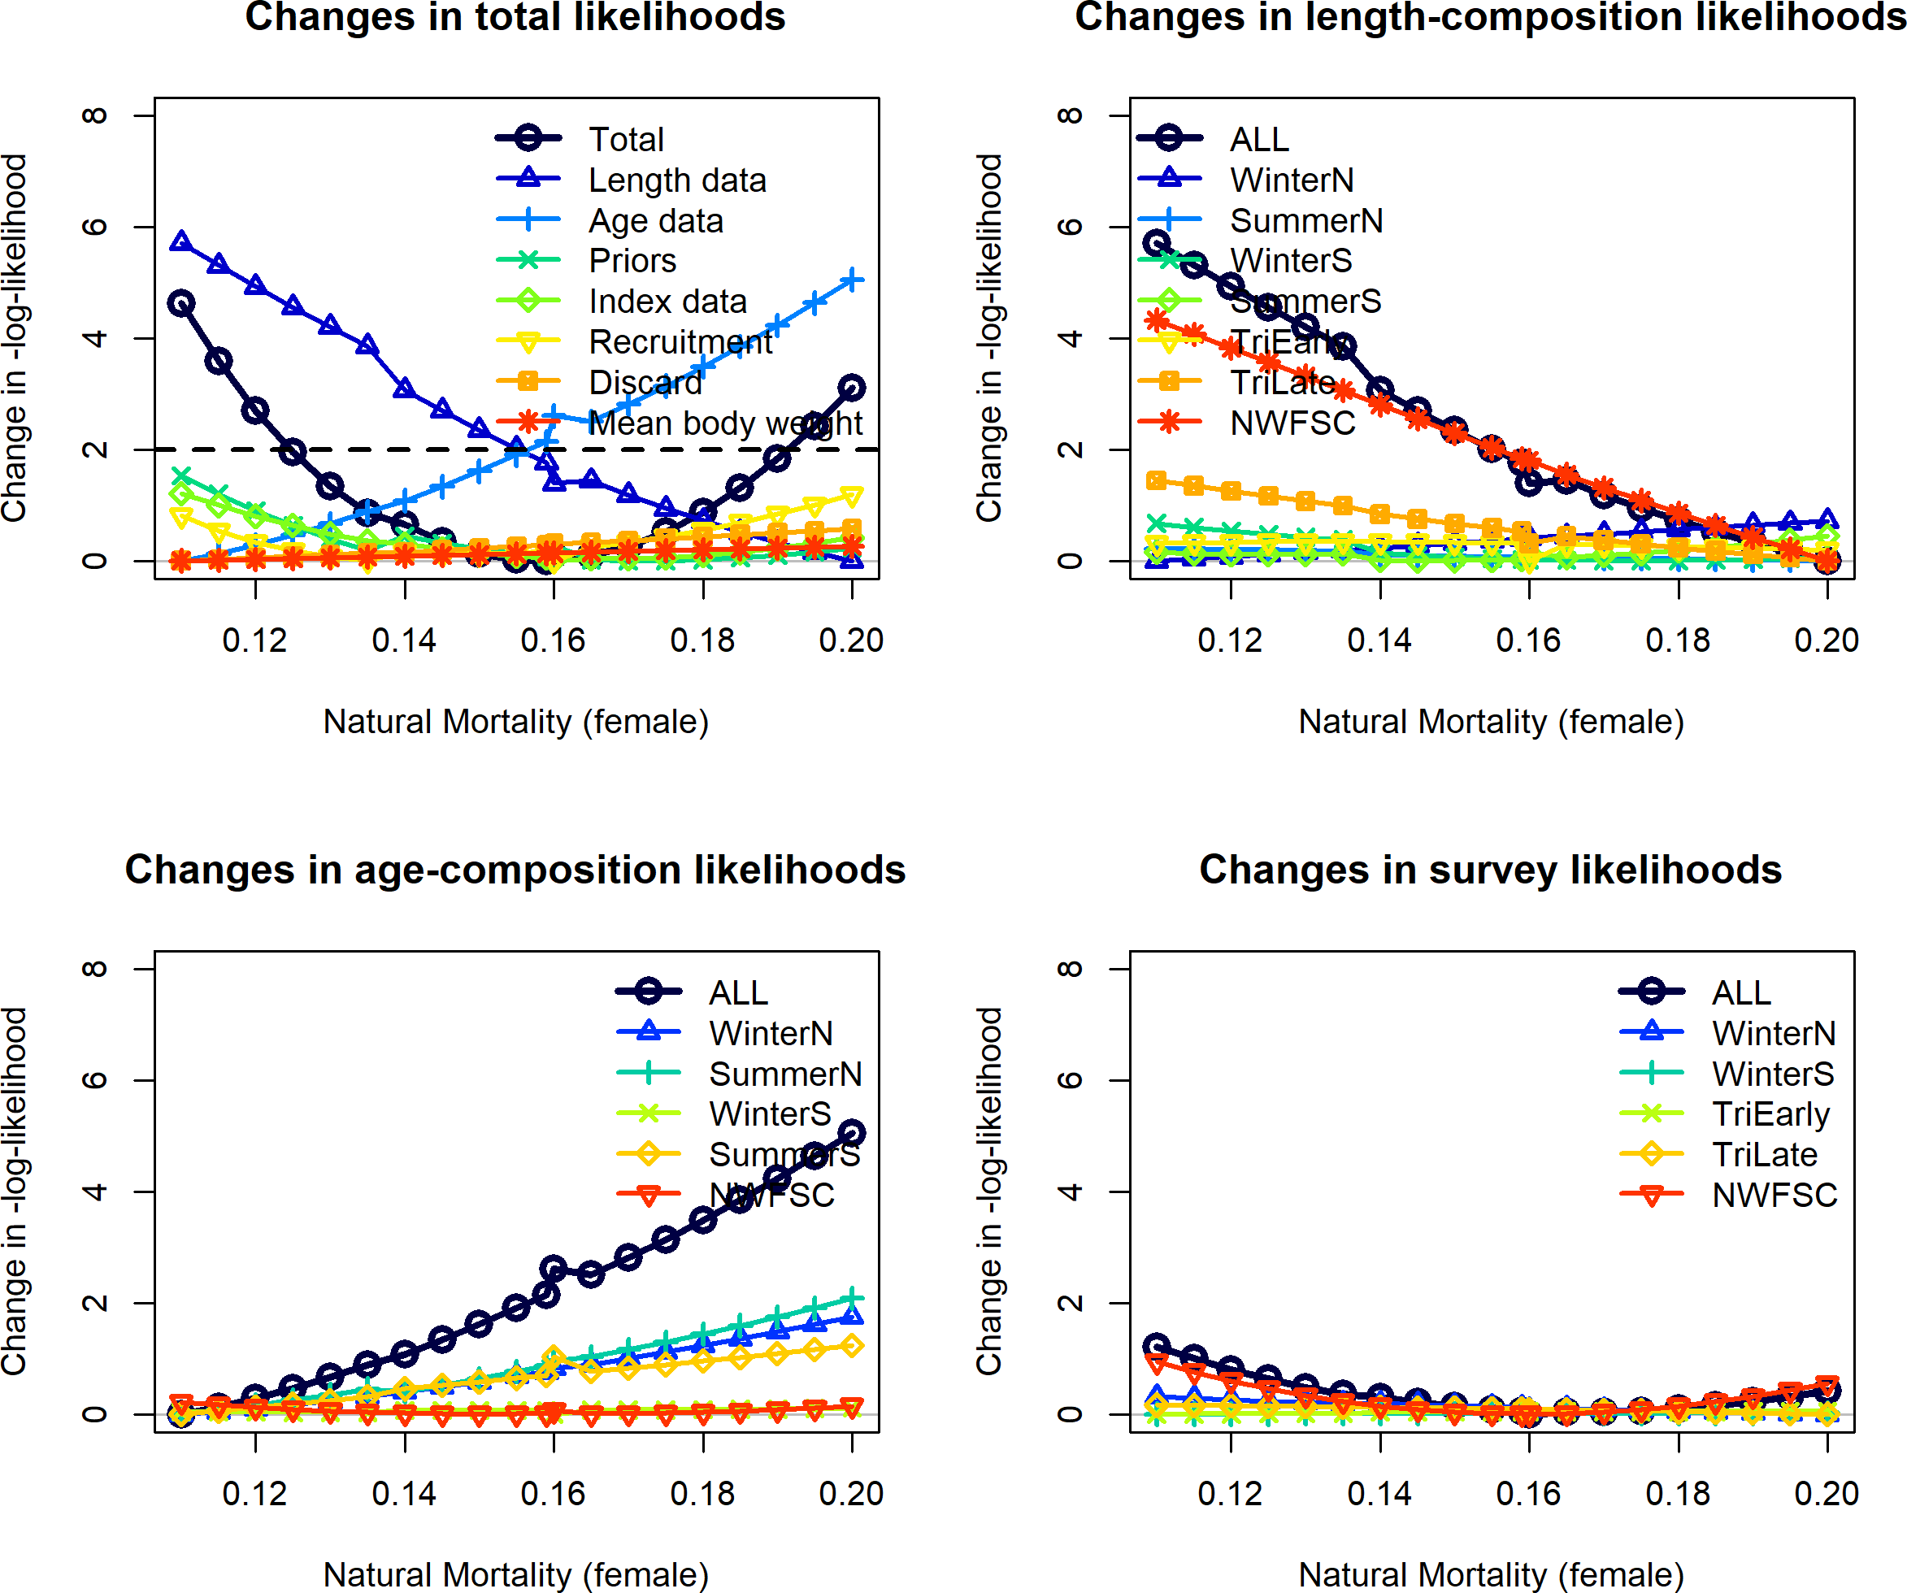

Figure 111: Likelihood profile across female natural mortality values. Male natural mortality was estimated.

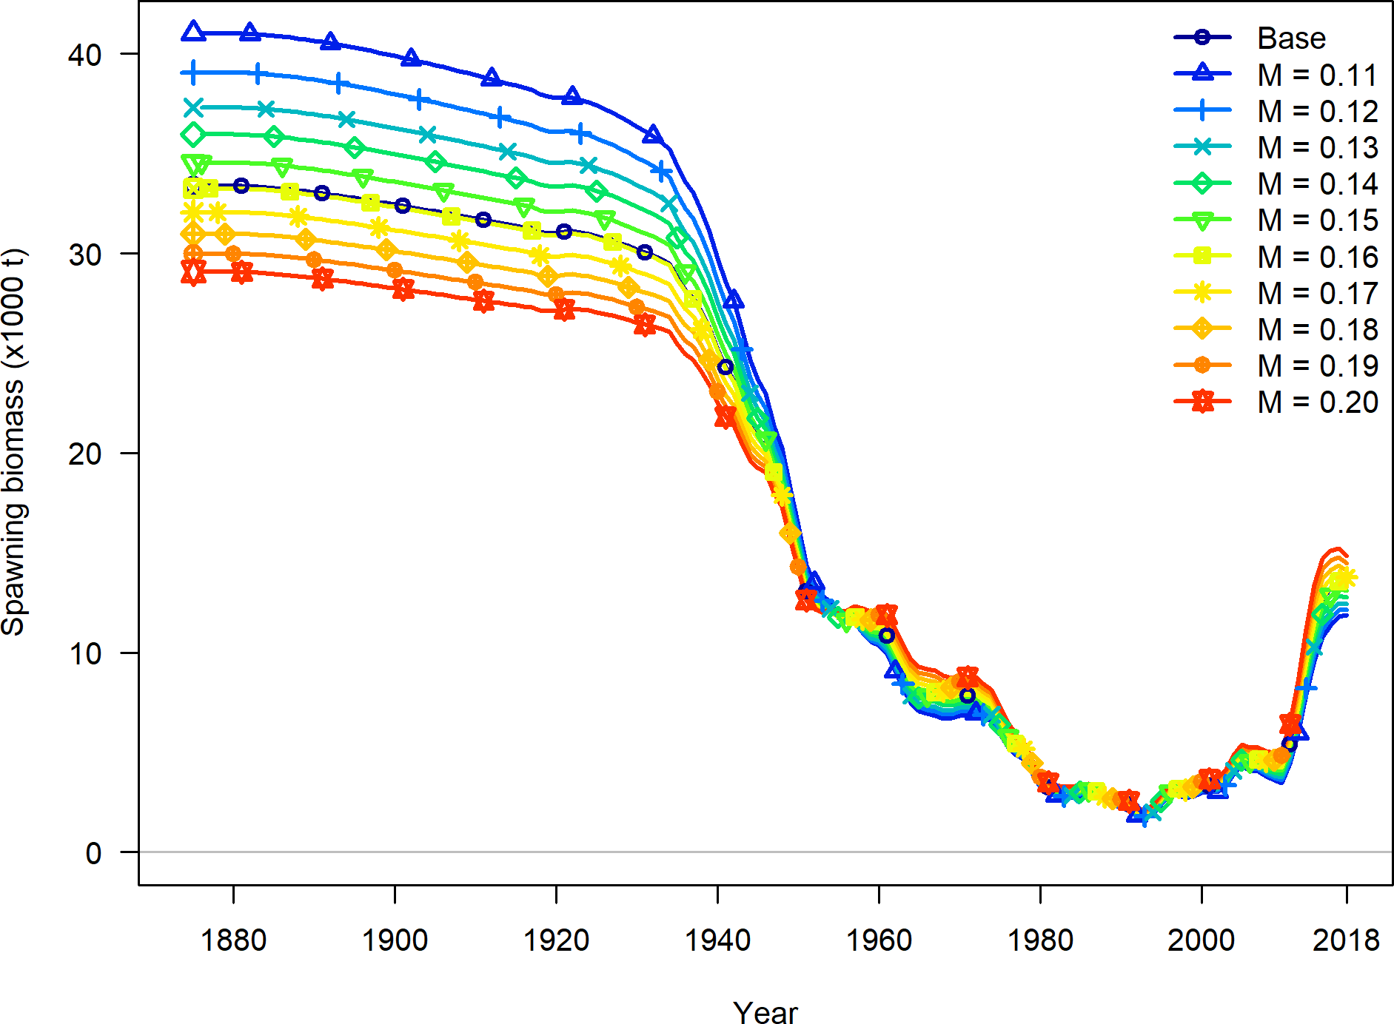

Figure 112: Trajectories of spawning output across values of natural mortality.

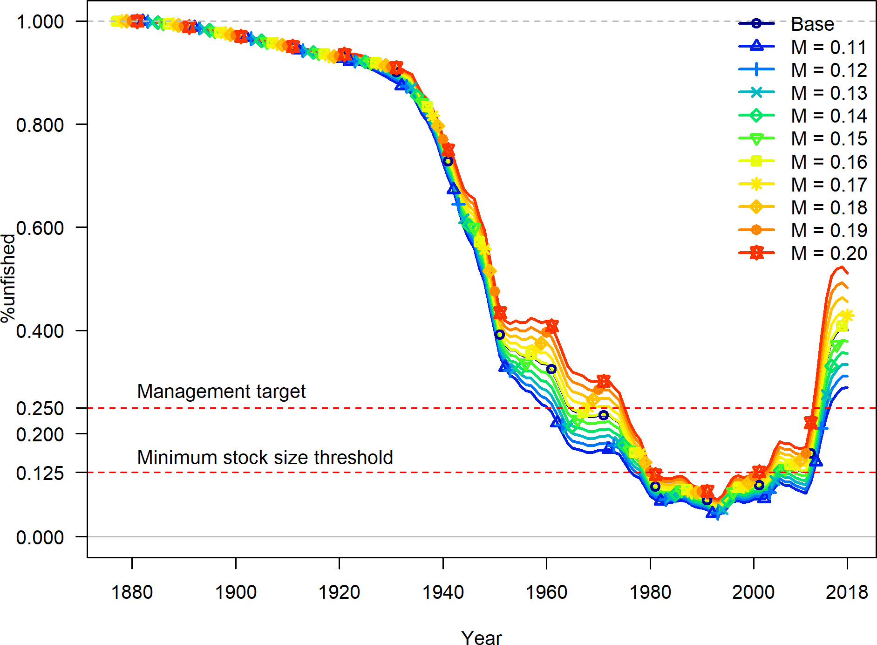

Figure 113: Trajectories of relative spawning output across values of natural mortality.

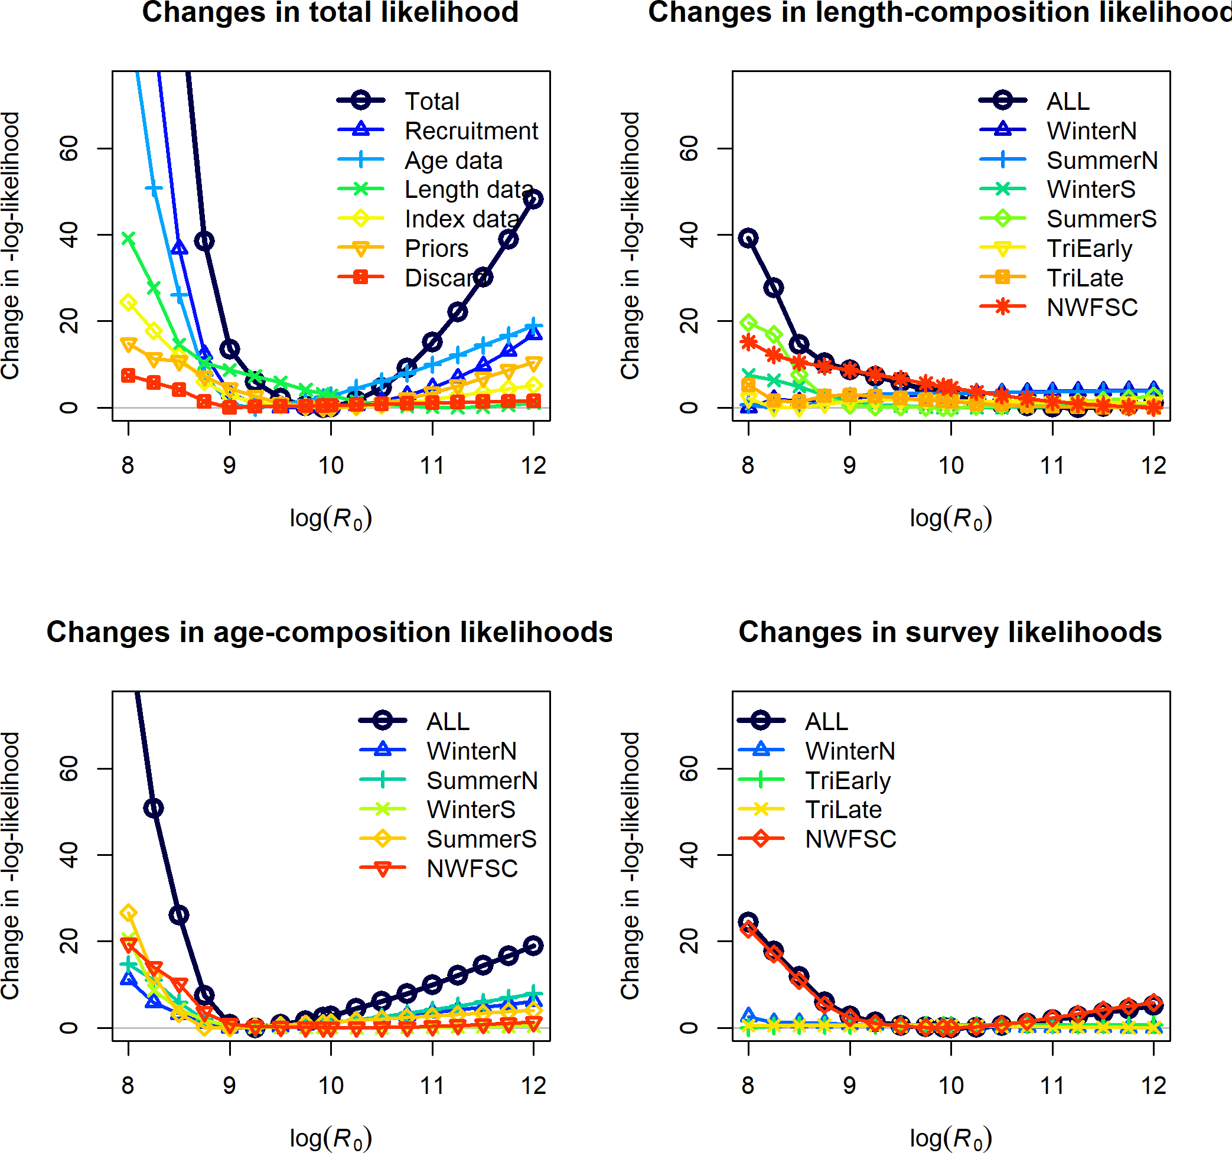

Figure 114: Likelihood profile across R0 values.



Figure 115: Estimated relative spawning potential ratio 1-SPR for the base model. One minus SPR is plotted so that higher exploitation rates occur on the upper portion of the y-axis. The management target is plotted as a red horizontal line and values above this reflect harvests in excess of the overfishing proxy based on the SPR30% harvest rate. The last year in the time-series is 2018.



Figure 116: Equilibrium yield curve for the base case model. Values are based on the 2018 fishery selectivity and with steepness estimated at 0.84.

1. **Appendix A. Detailed Fit to Length Composition Data**

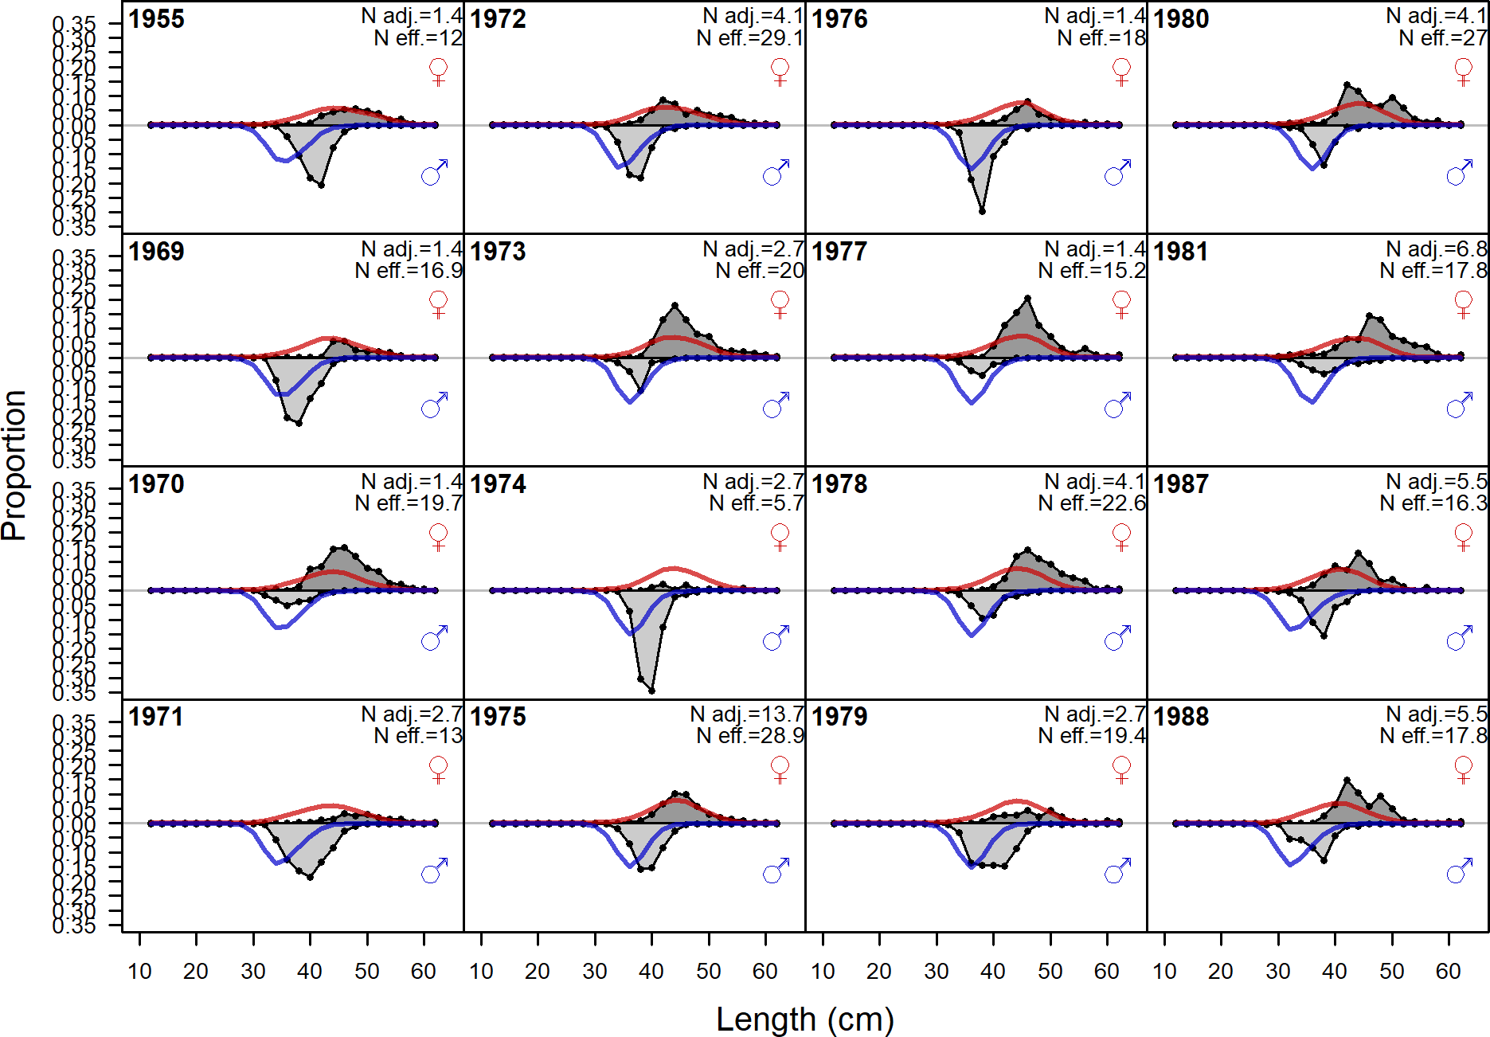

Figure 117: Length comps, retained, Winter (N) (plot 1 of 3). ‘N adj.’ is the input sample size after data weighting adjustment. N eff. is the calculated effective sample size used in the McAllister Iannelli tuning method.

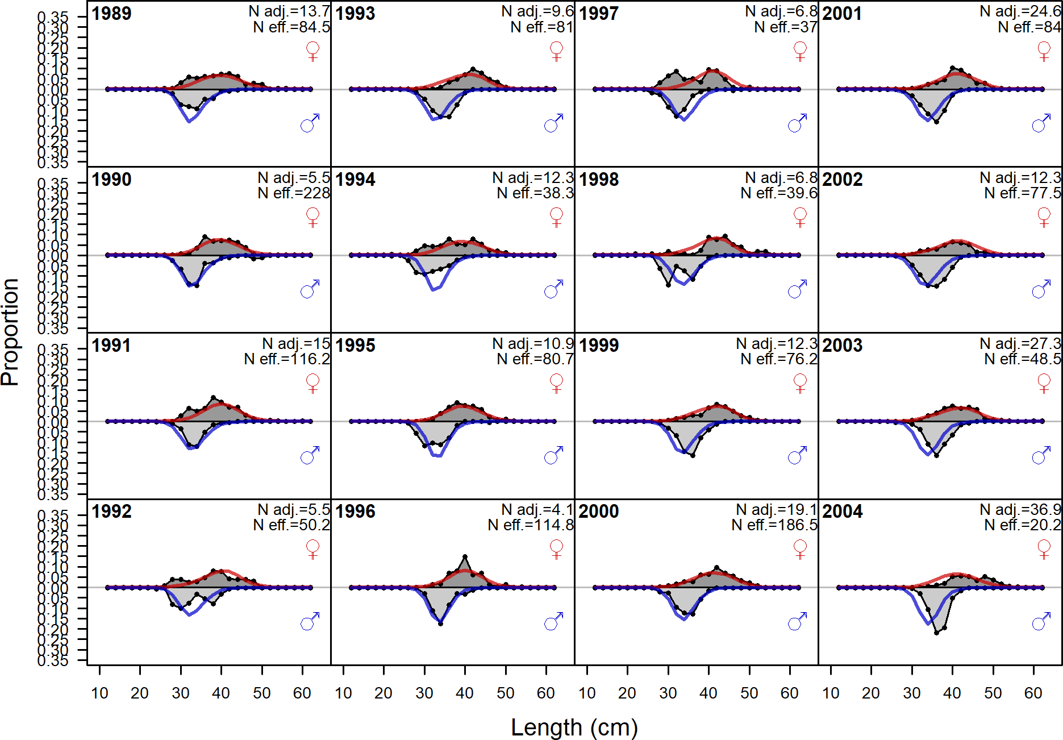

Figure 118: Length comps, retained, Winter (N) (plot 2 of 3)

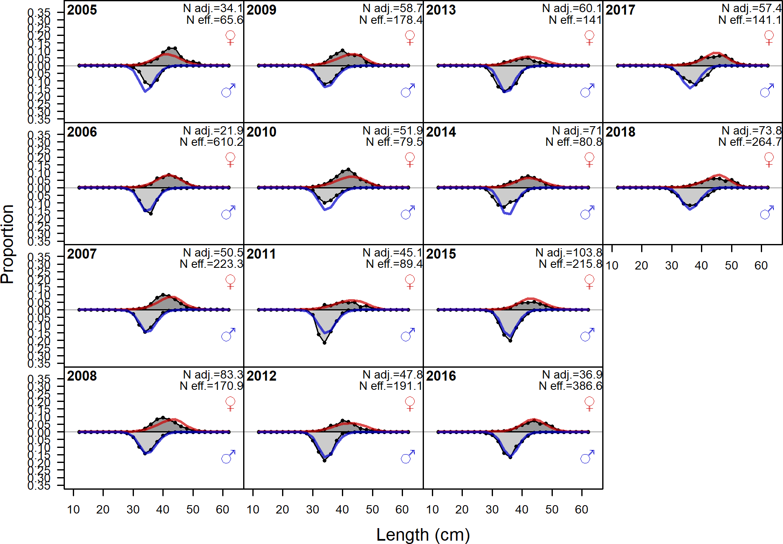

Figure 119: Length comps, retained, Winter (N) (plot 3 of 3)

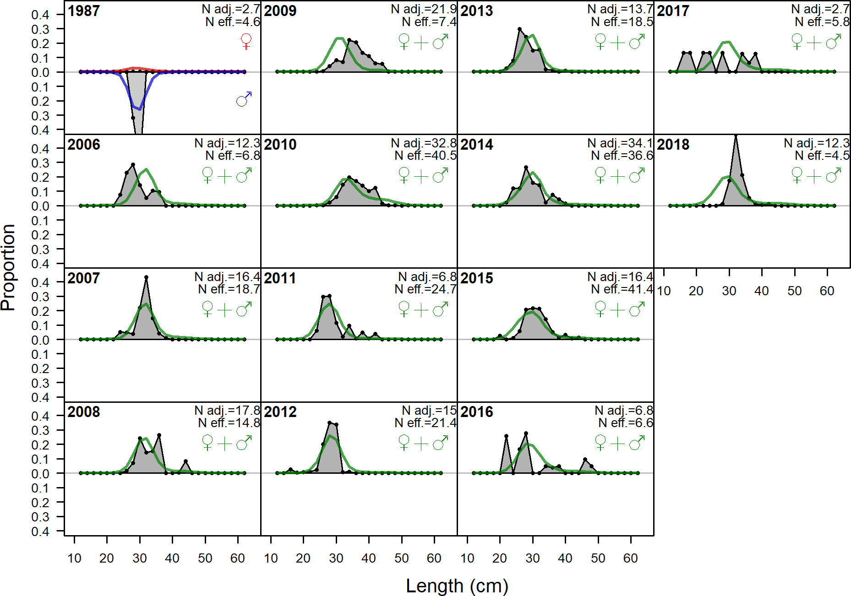

Figure 120: Length comps, discard, Winter (N). ‘N adj.’ is the input sample size after data weighting adjustment. N eff. is the calculated effective sample size used in the McAllis- ter Iannelli tuning method.

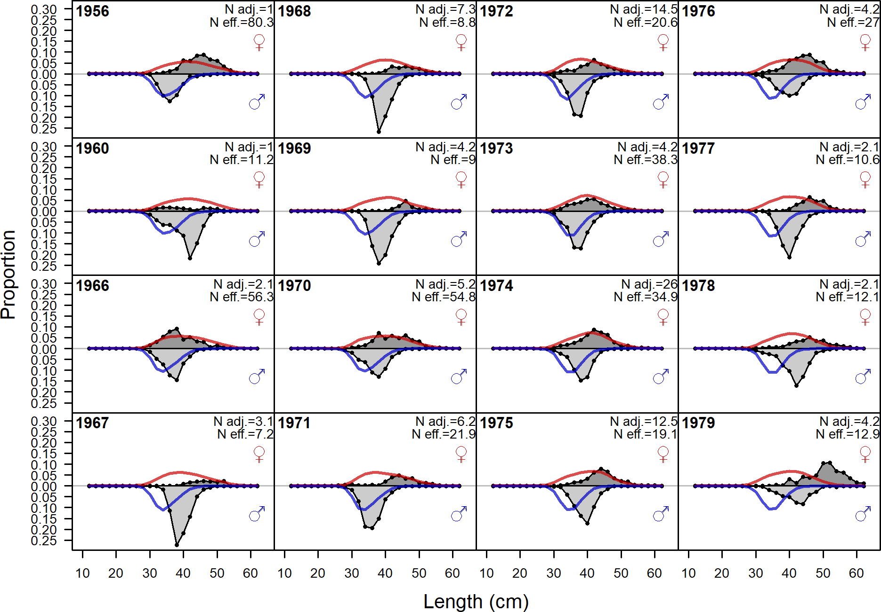

Figure 121: Length comps, retained, Summer (N) (plot 1 of 4). ‘N adj.’ is the input sample size after data weighting adjustment. N eff. is the calculated effective sample size used in the McAllister Iannelli tuning method.

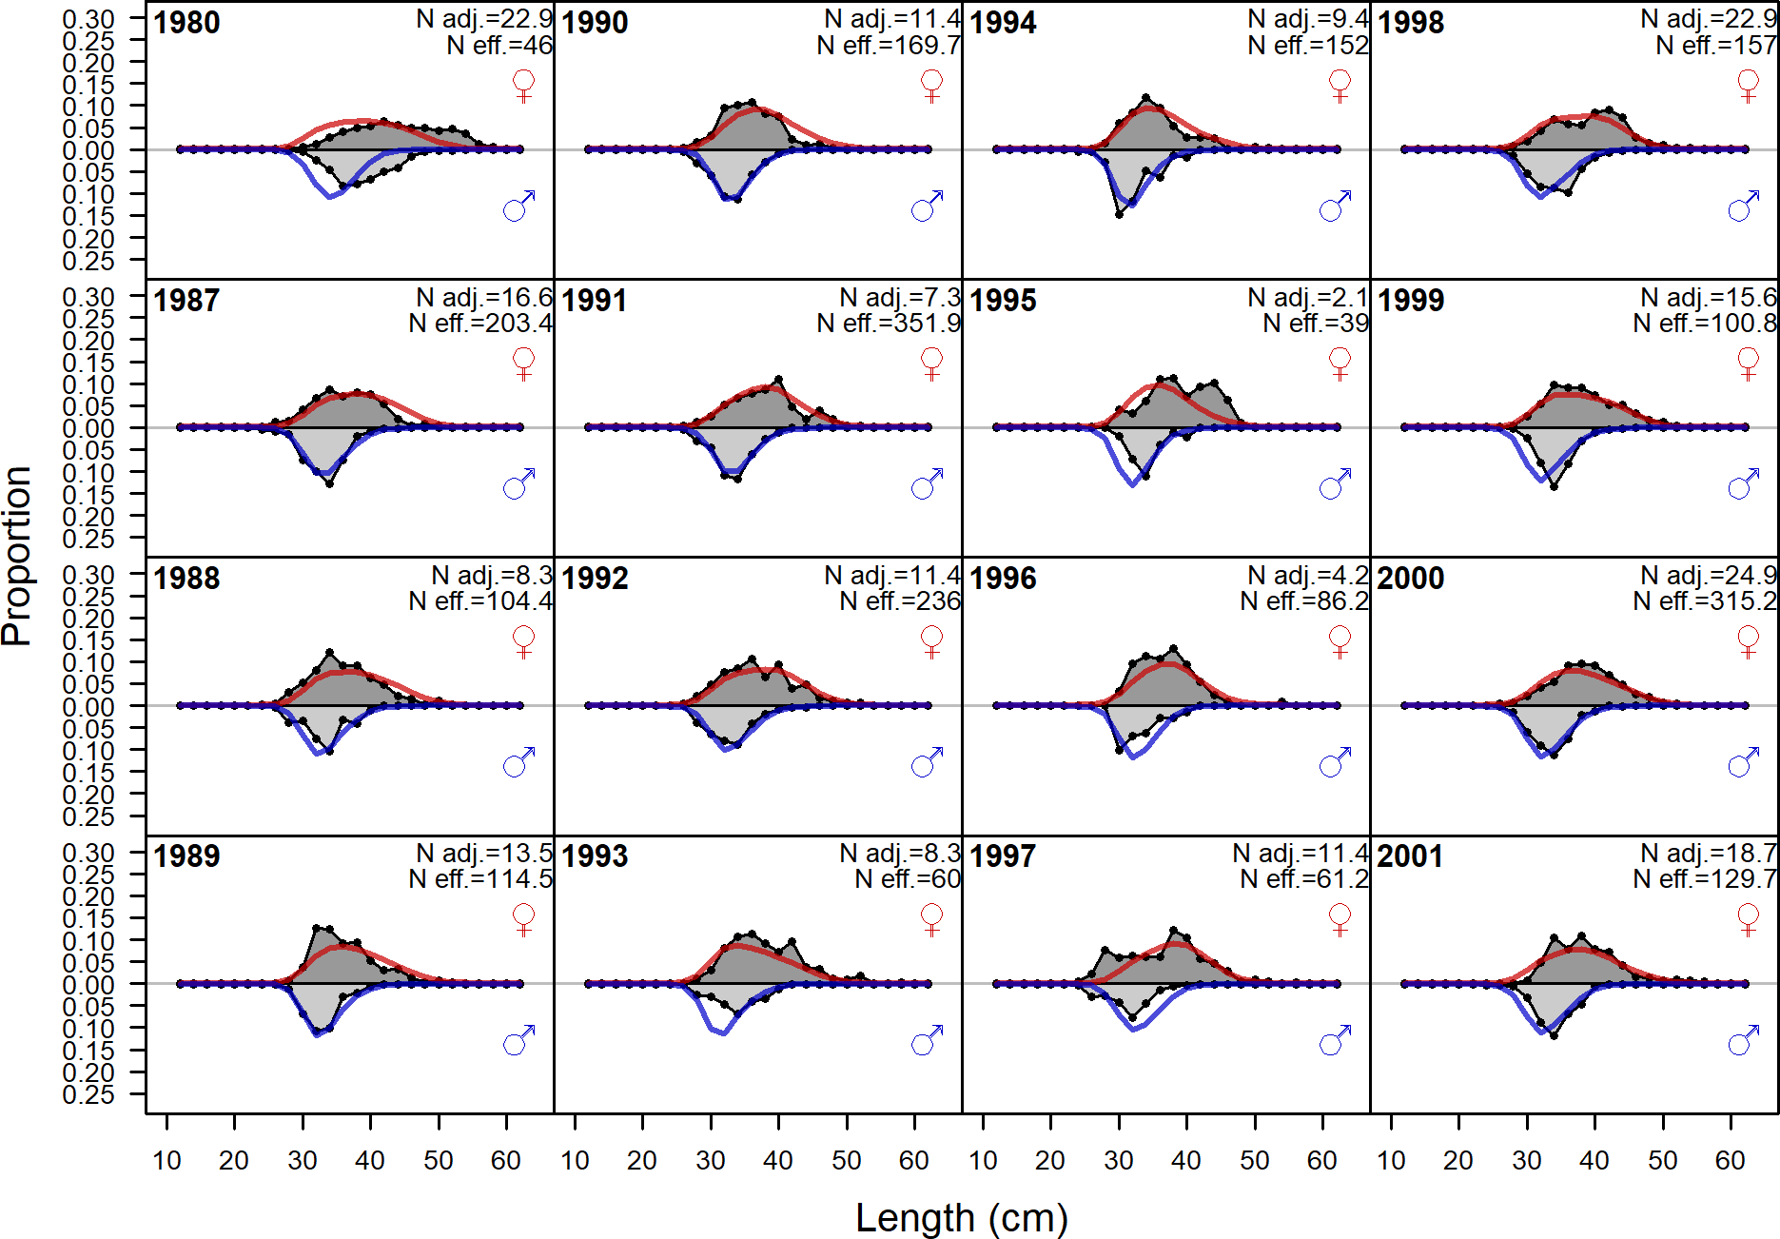

Figure 122: Length comps, retained, Summer (N) (plot 2 of 4)

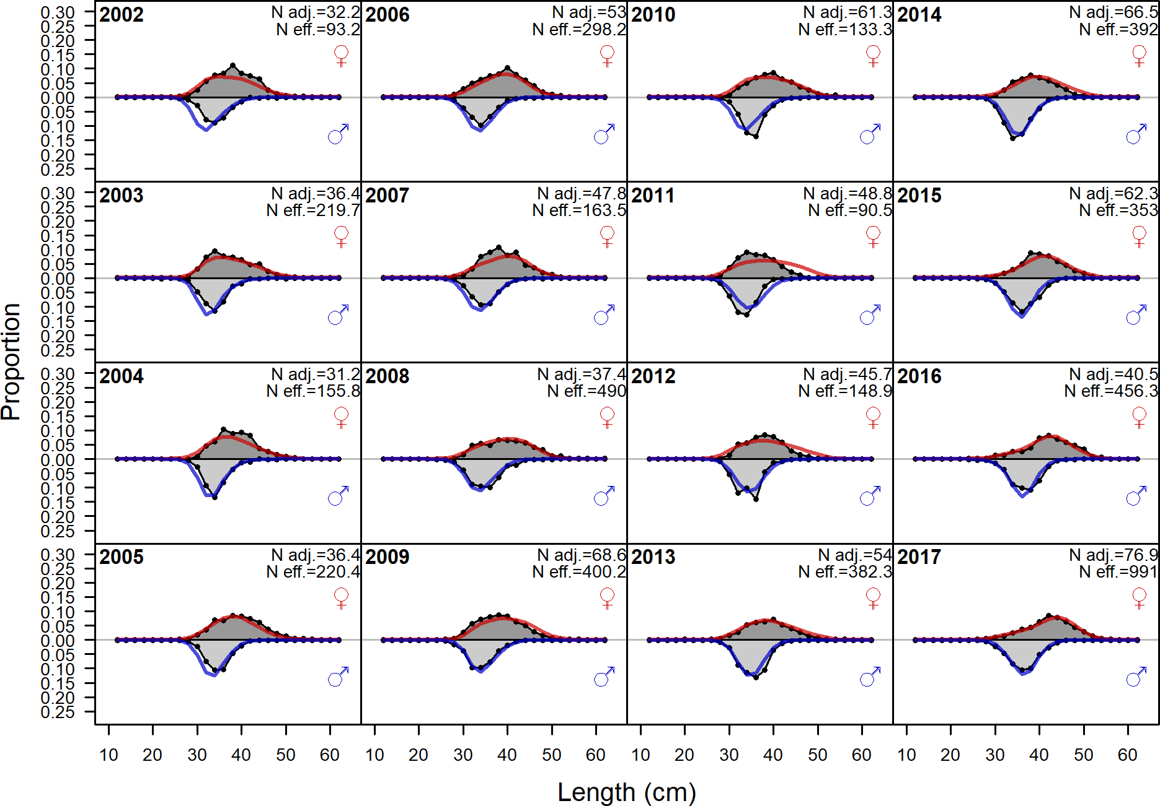

Figure 123: Length comps, retained, Summer (N) (plot 3 of 4)

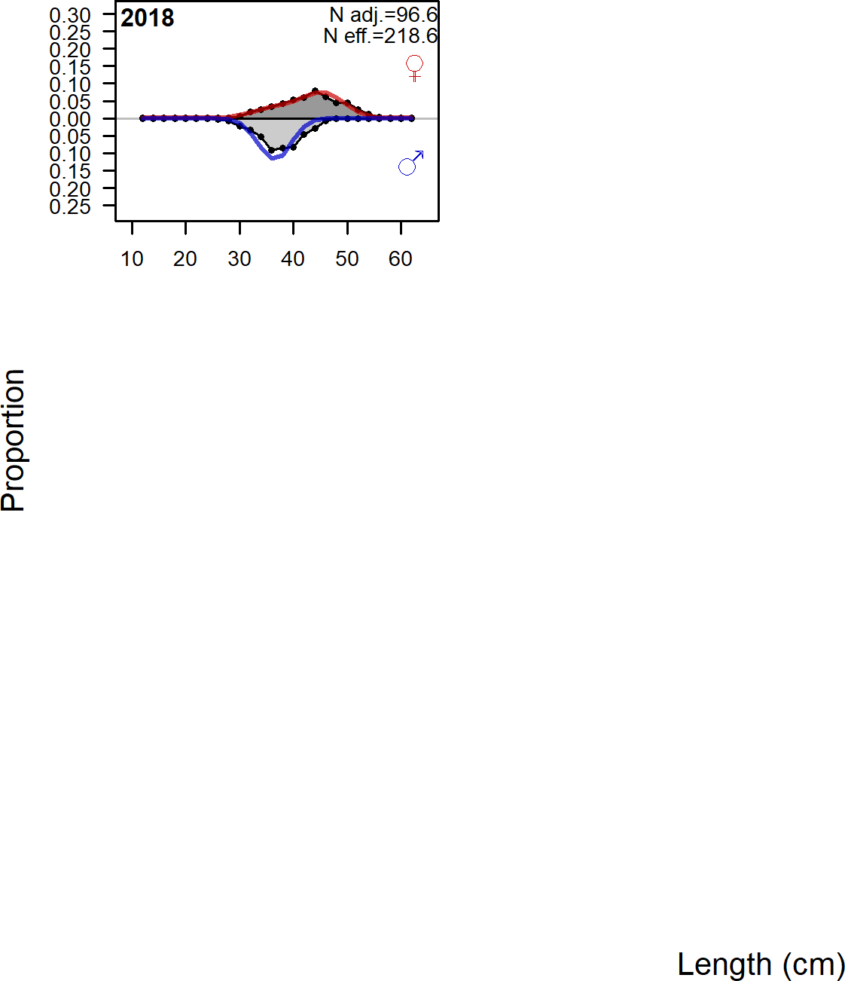

Figure 124: Length comps, retained, Summer (N) (plot 4 of 4)

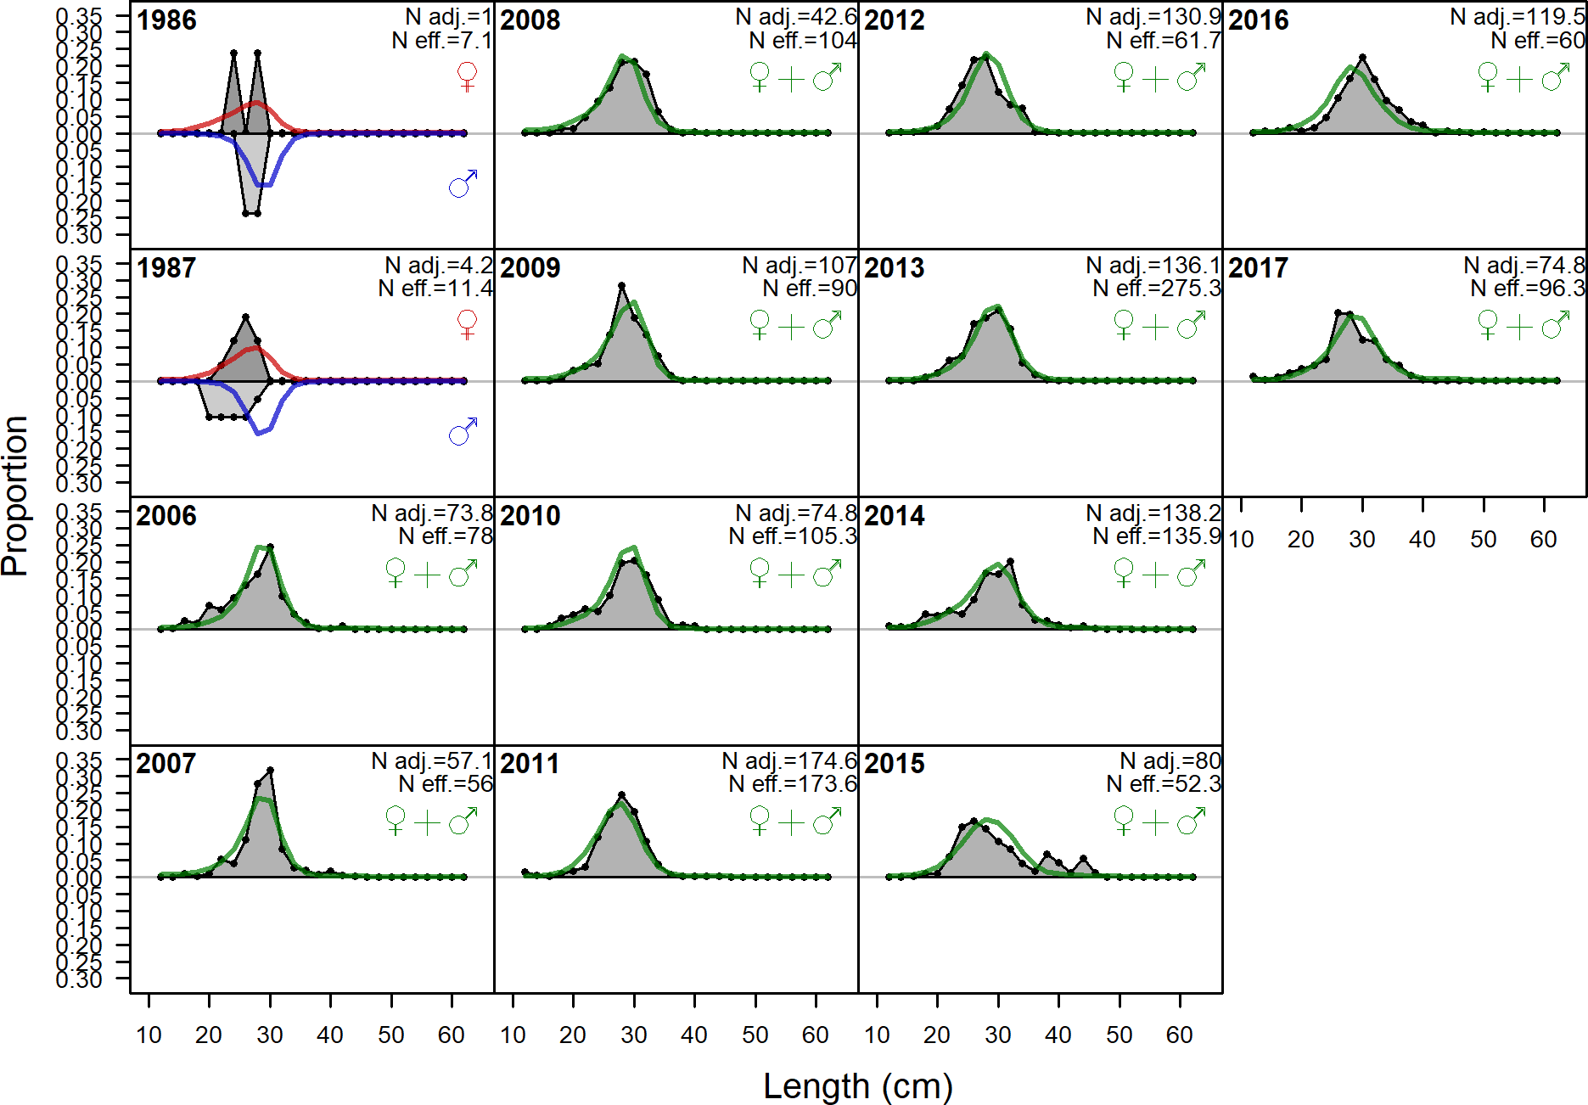

Figure 125: Length comps, discard, Summer (N). ‘N adj.’ is the input sample size af- ter data weighting adjustment. N eff. is the calculated effective sample size used in the McAllister Iannelli tuning method.

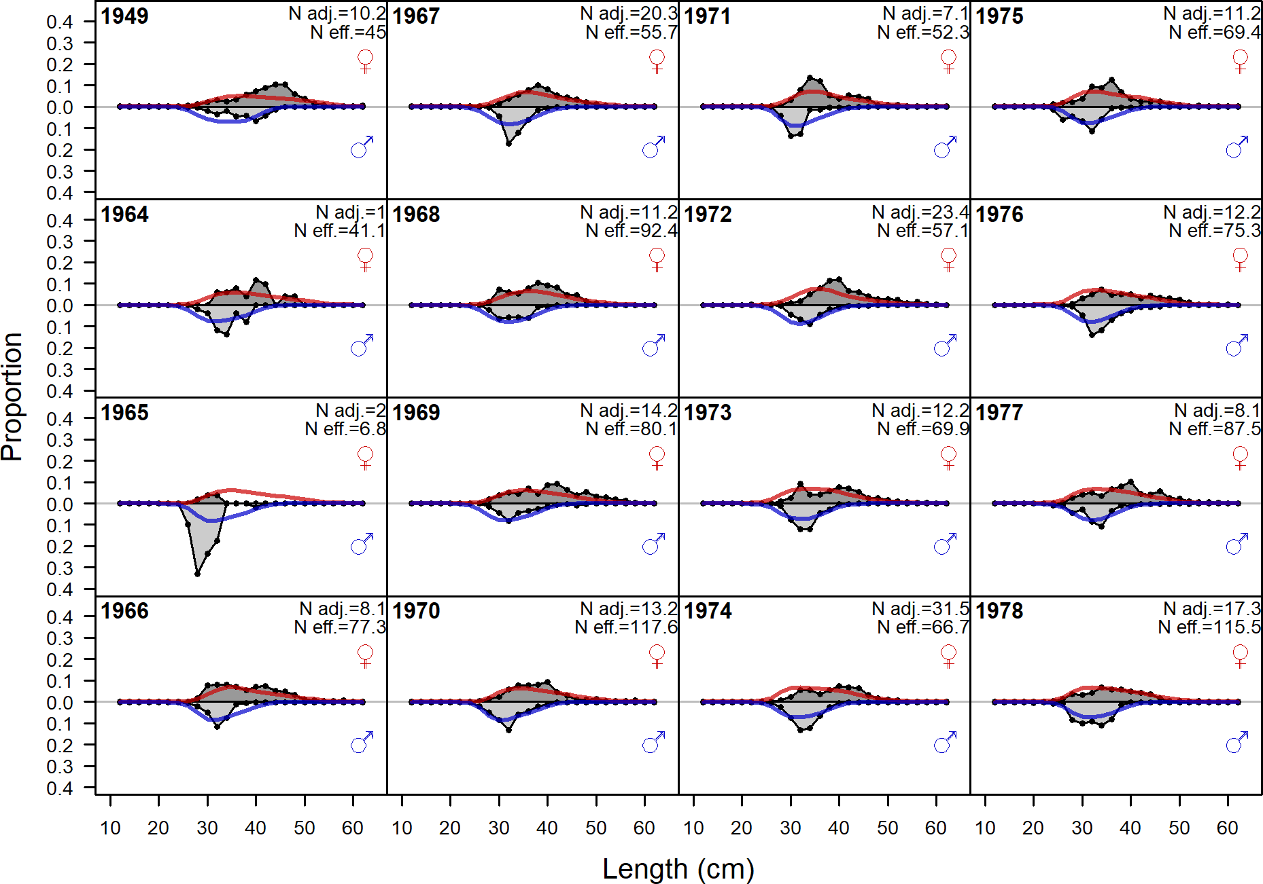

Figure 126: Length comps, retained, Winter (S) (plot 1 of 3). ‘N adj.’ is the input sample size after data weighting adjustment. N eff. is the calculated effective sample size used in the McAllister Iannelli tuning method.

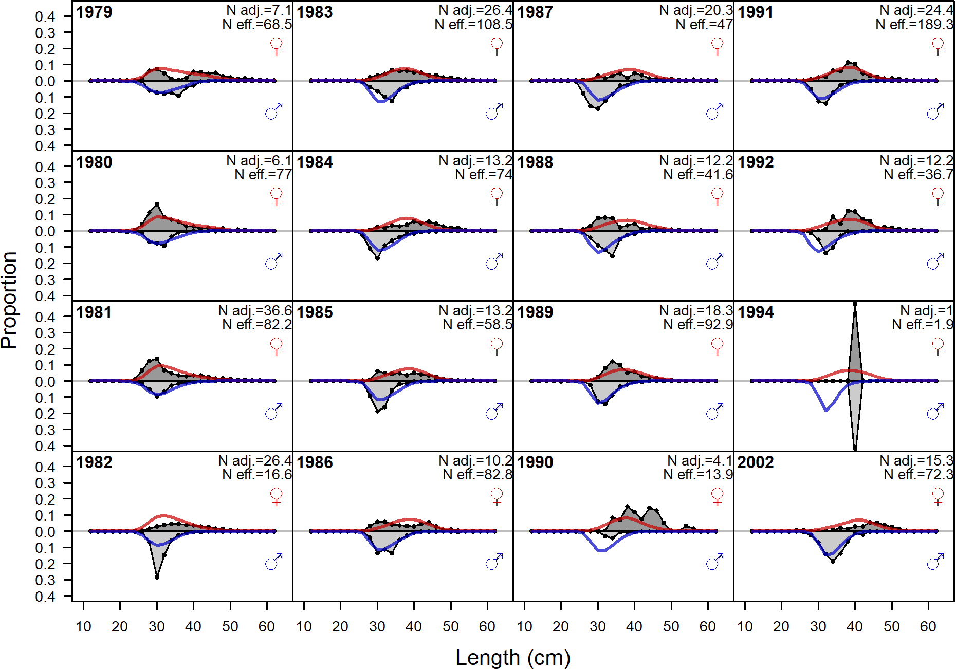

Figure 127: Length comps, retained, Winter (S) (plot 2 of 3)

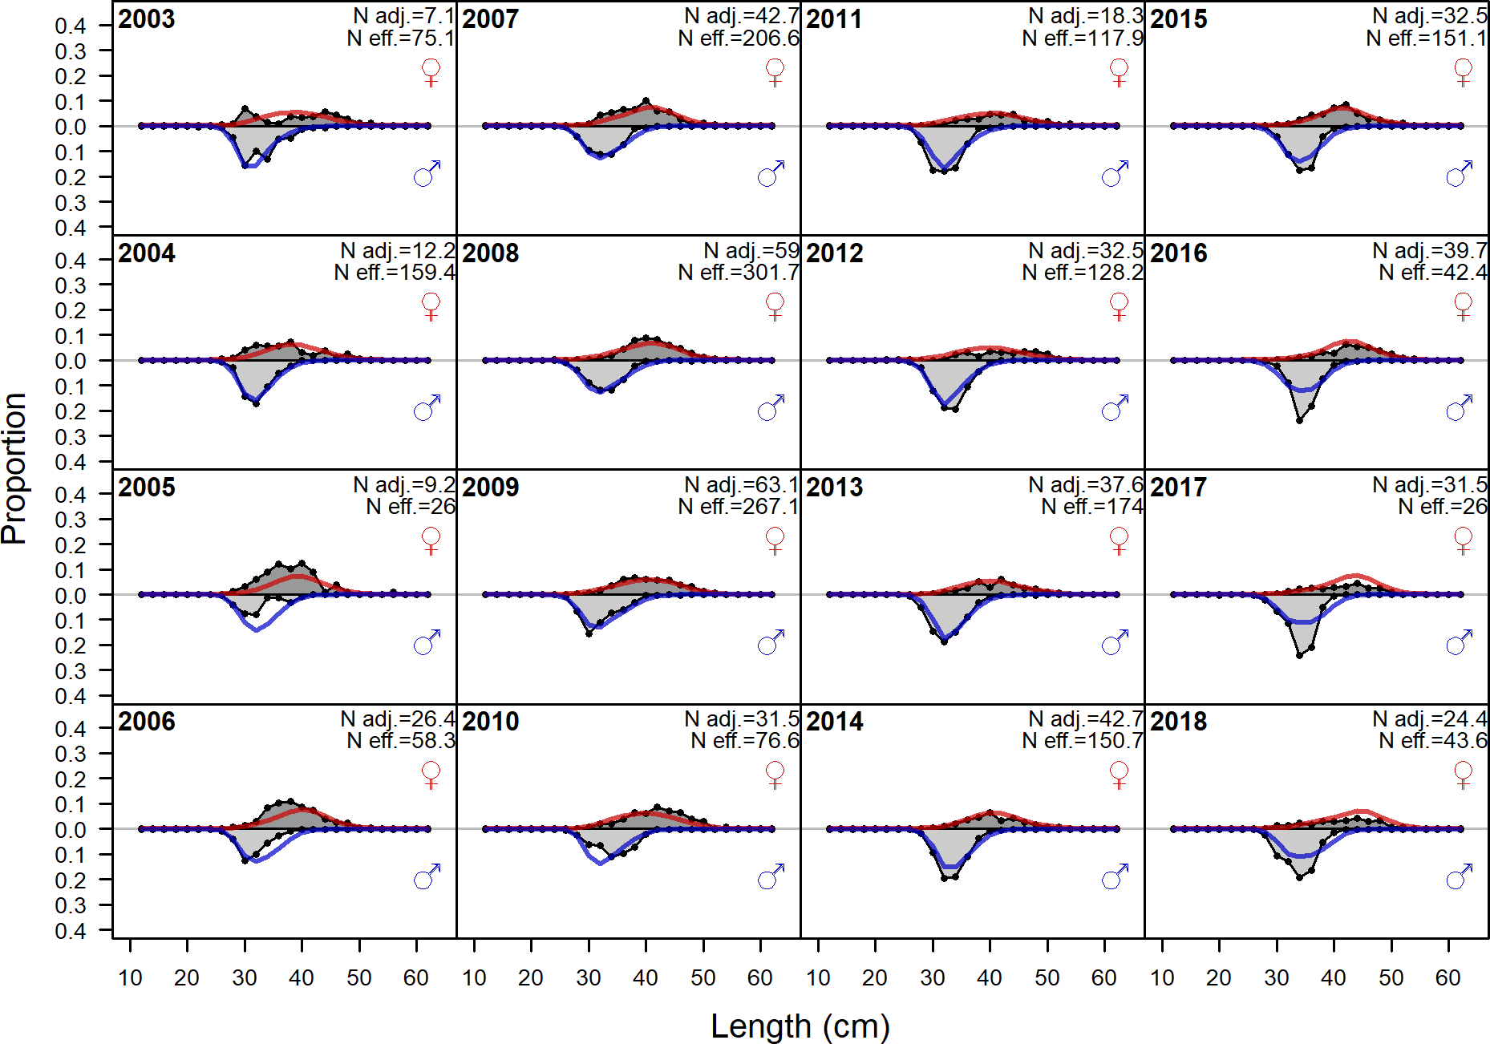

Figure 128: Length comps, retained, Winter (S) (plot 3 of 3)

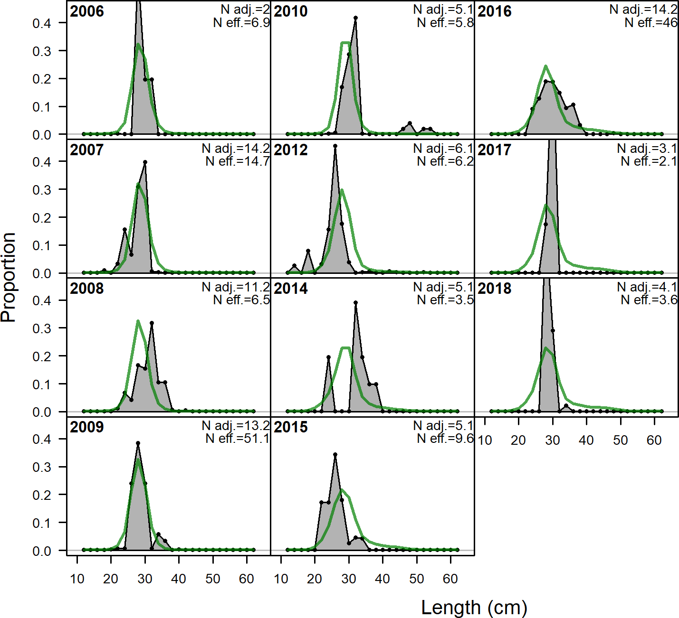

Figure 129: Length comps, discard, Winter (S). ‘N adj.’ is the input sample size after data weighting adjustment. N eff. is the calculated effective sample size used in the McAllis- ter Iannelli tuning method.

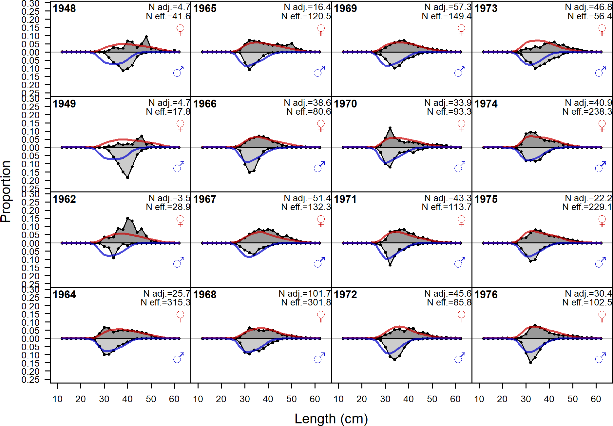

Figure 130: Length comps, retained, Summer (S) (plot 1 of 4). ‘N adj.’ is the input sample size after data weighting adjustment. N eff. is the calculated effective sample size used in the McAllister Iannelli tuning method.

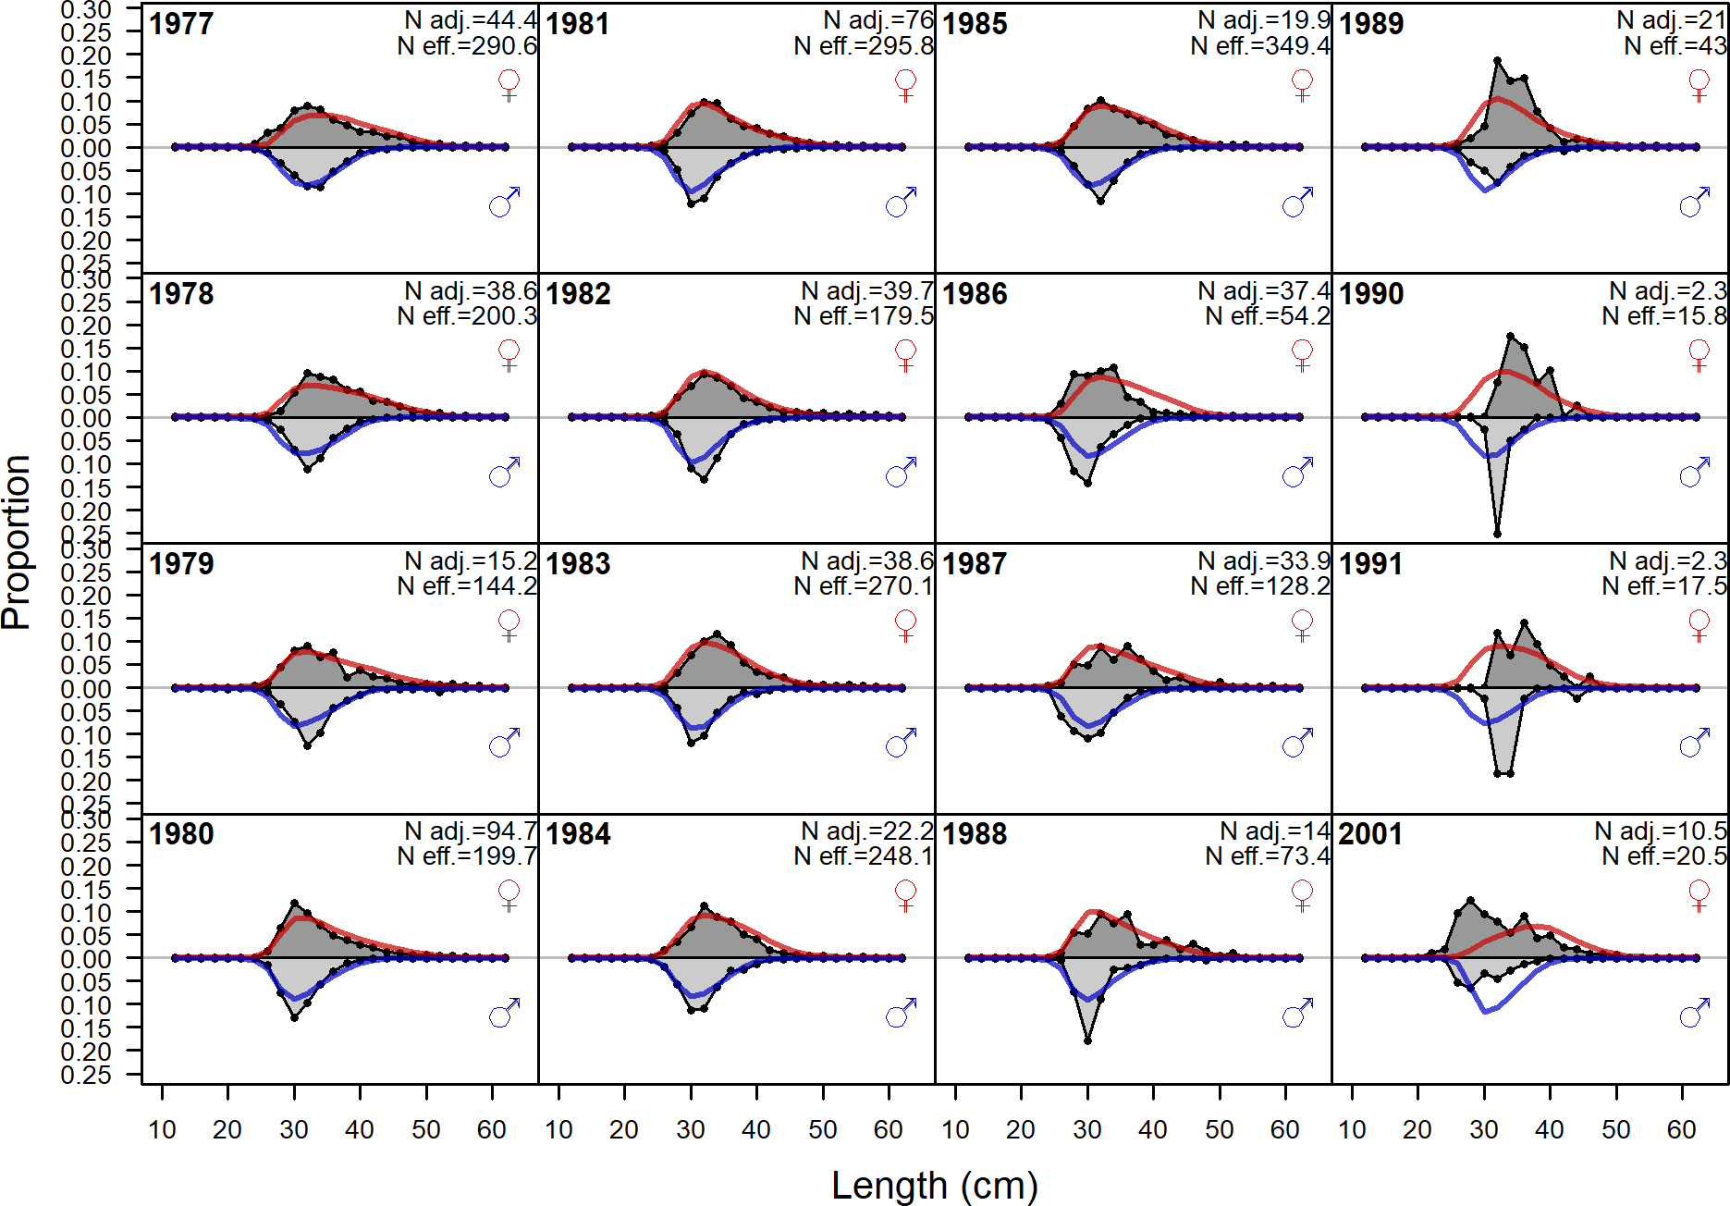

Figure 131: Length comps, retained, Summer (S) (plot 2 of 4)

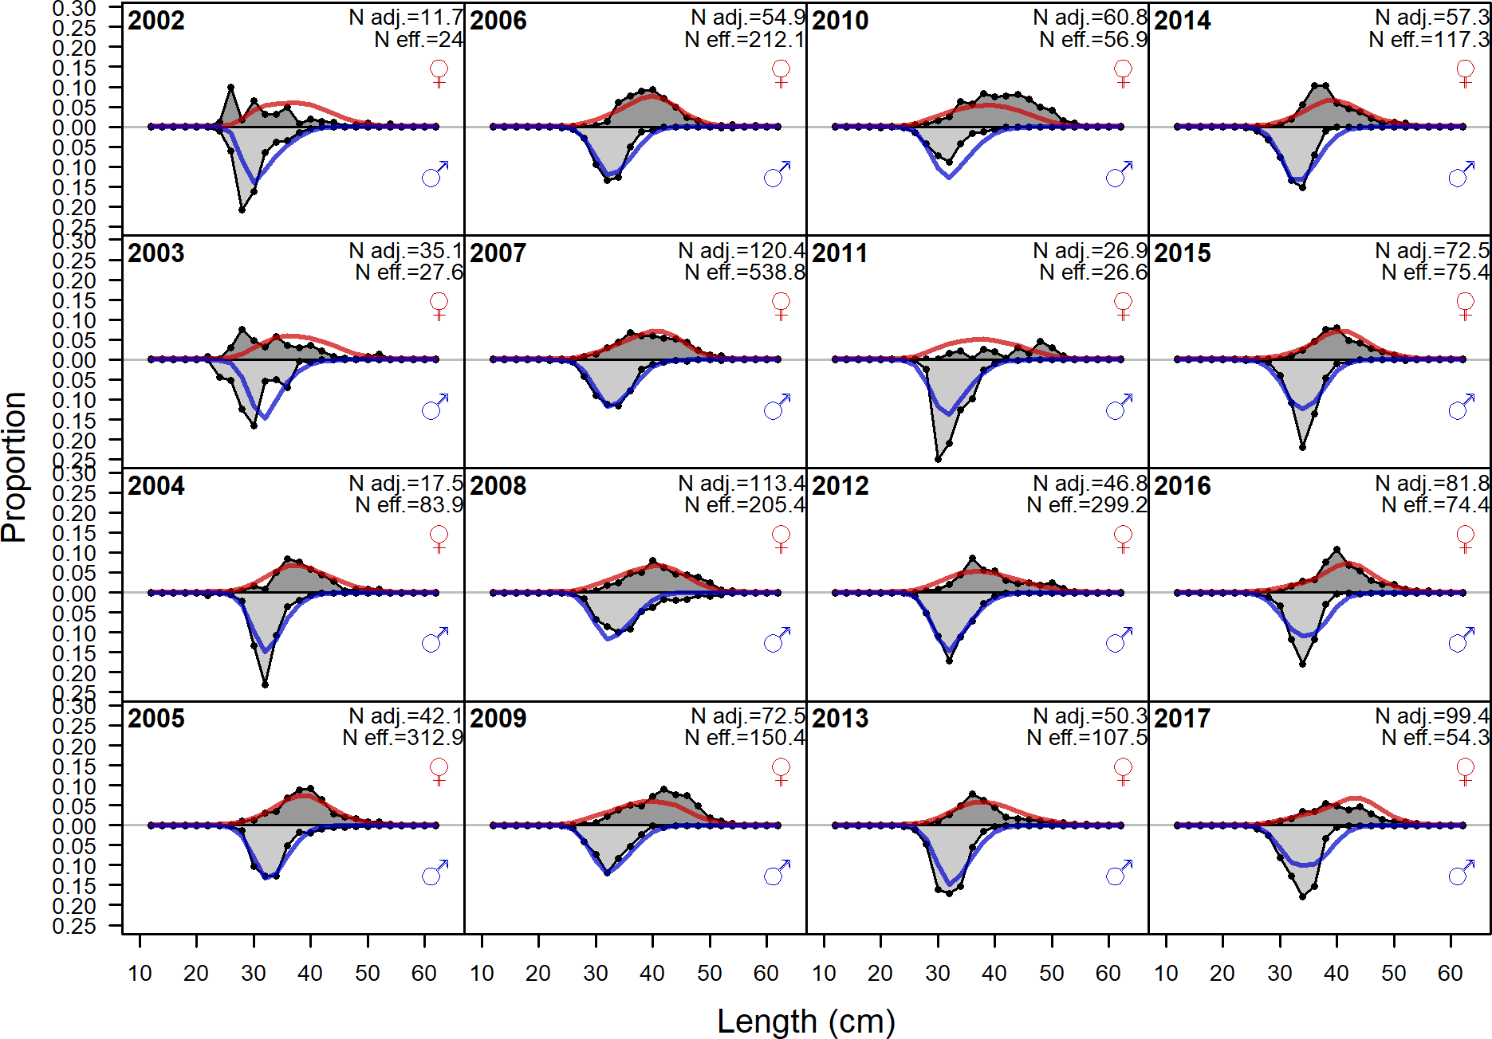

Figure 132: Length comps, retained, Summer (S) (plot 3 of 4)

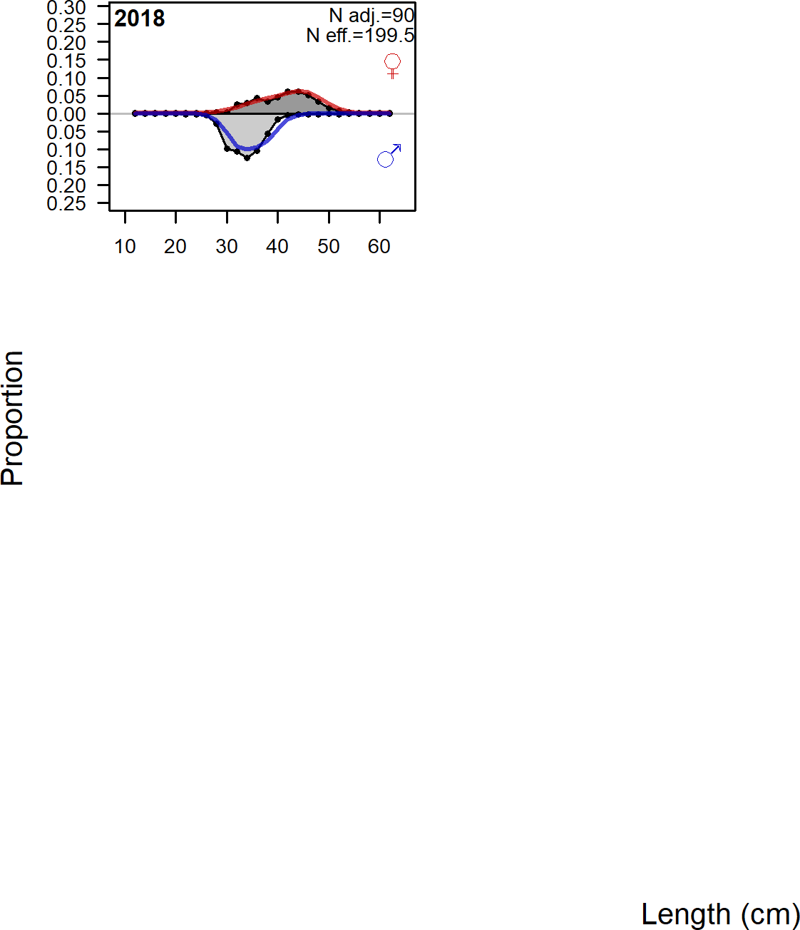

Figure 133: Length comps, retained, Summer (S) (plot 4 of 4)

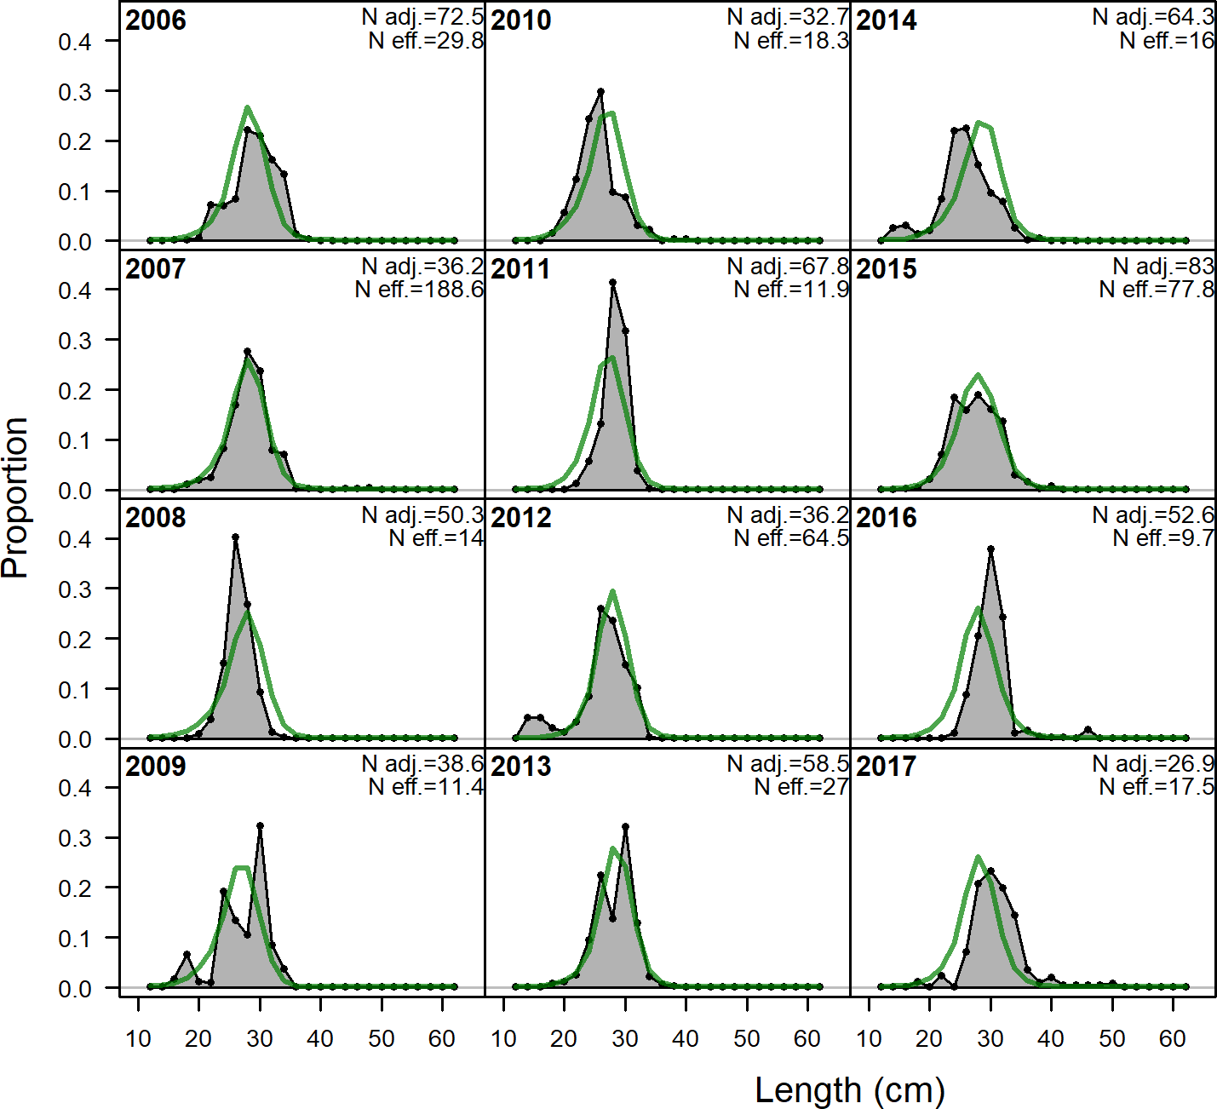

Figure 134: Length comps, discard, Summer (S). ‘N adj.’ is the input sample size af- ter data weighting adjustment. N eff. is the calculated effective sample size used in the

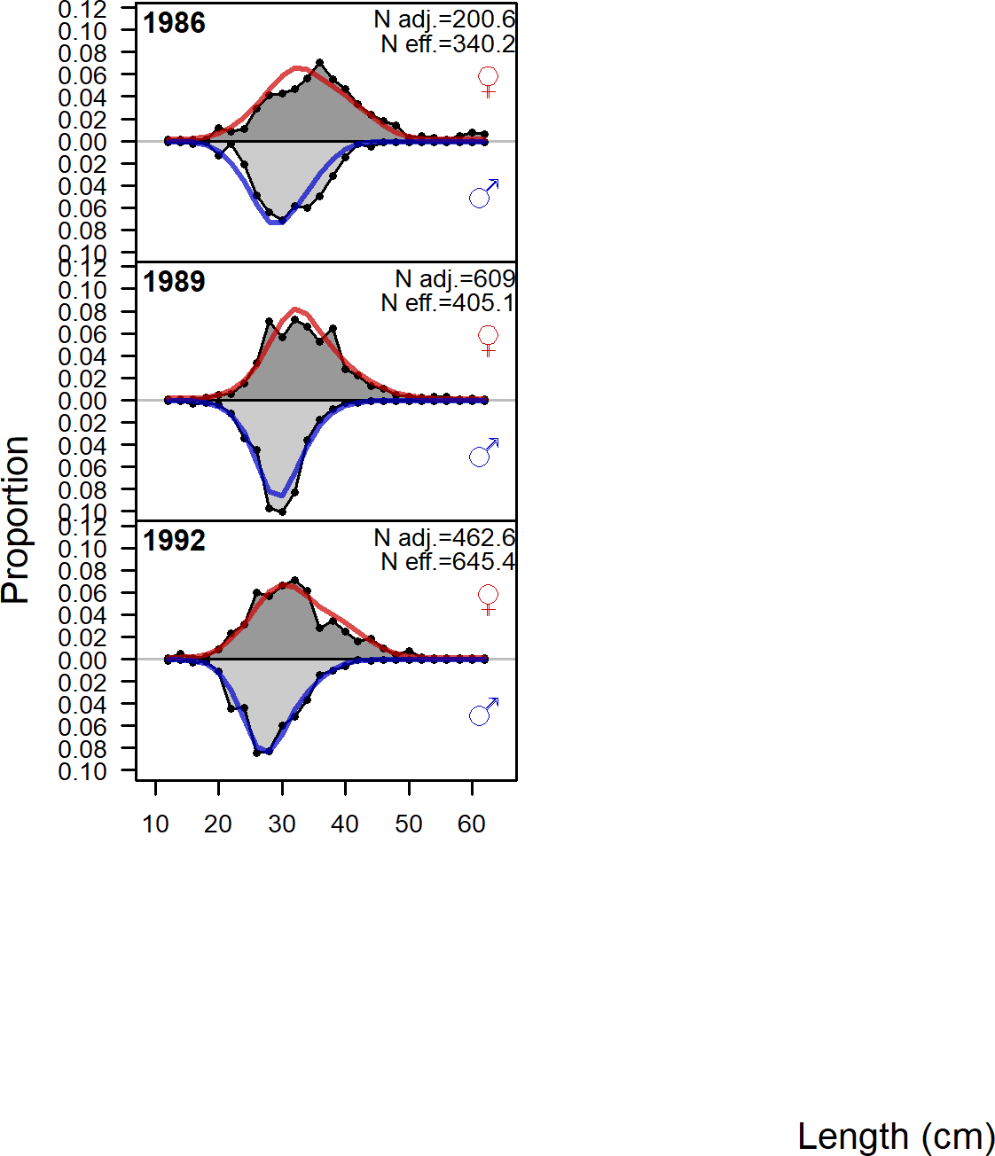

Figure 135: Length comps, whole catch, Triennial Early. ‘N adj.’ is the input sample size

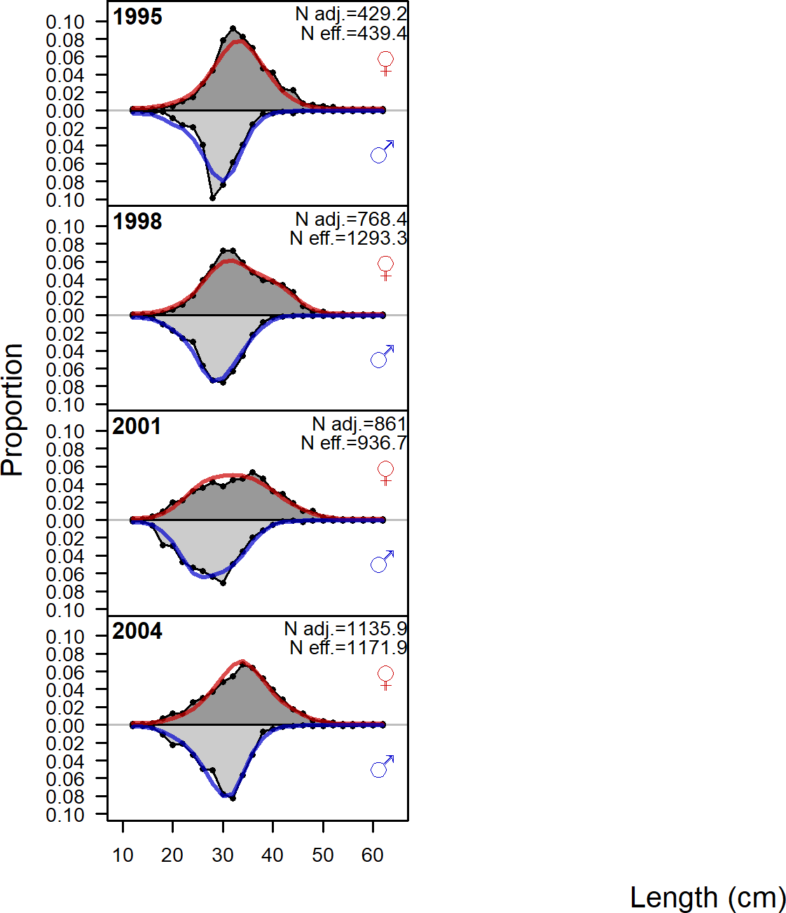

Figure 136: Length comps, whole catch, Triennial Late. ‘N adj.’ is the input sample size

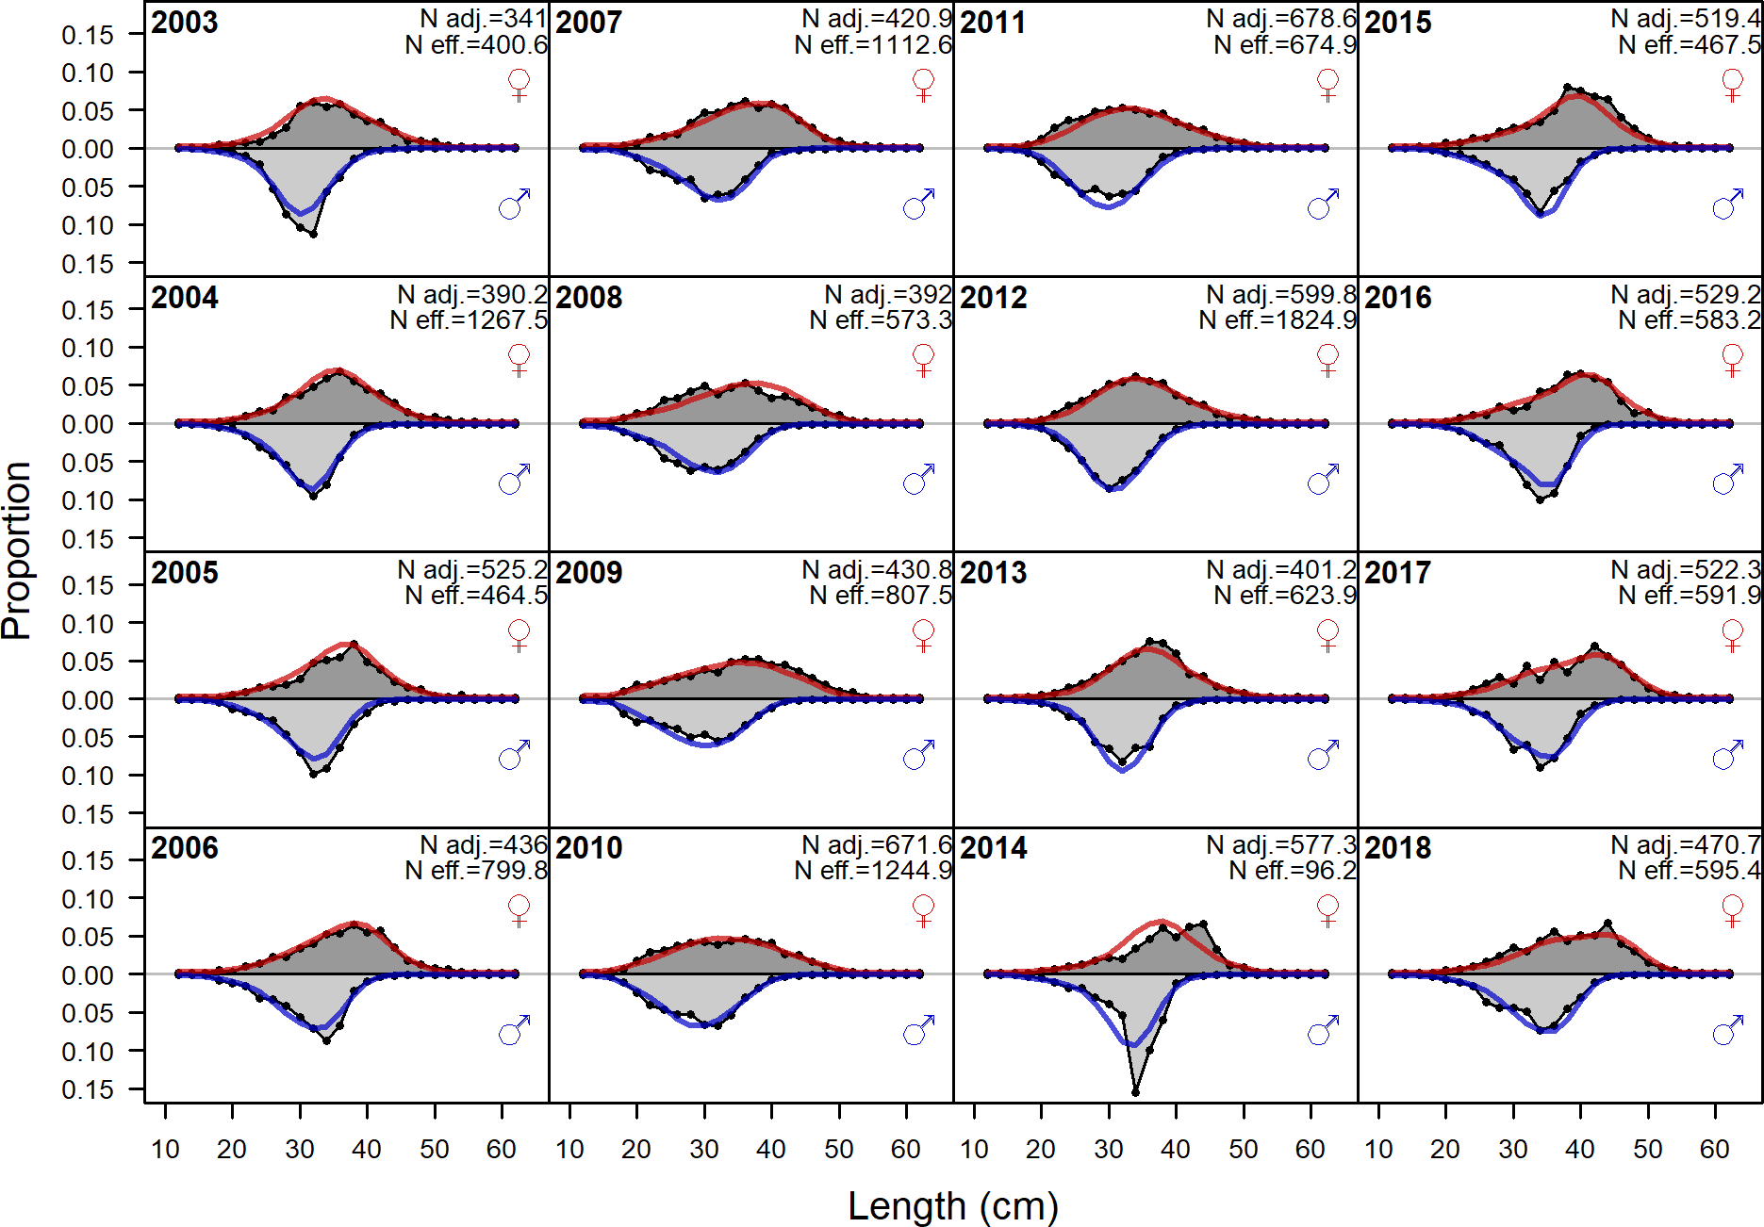

Figure 137: Length comps, whole catch, NWFSC West Coast Groundfish Bottom Trawl Survey. ‘N adj.’ is the input sample size after data weighting adjustment. N eff. is the calculated effective sample size used in the McAllister Iannelli tuning method.

1. **Appendix B. Detailed Fit to Age Composition Data**

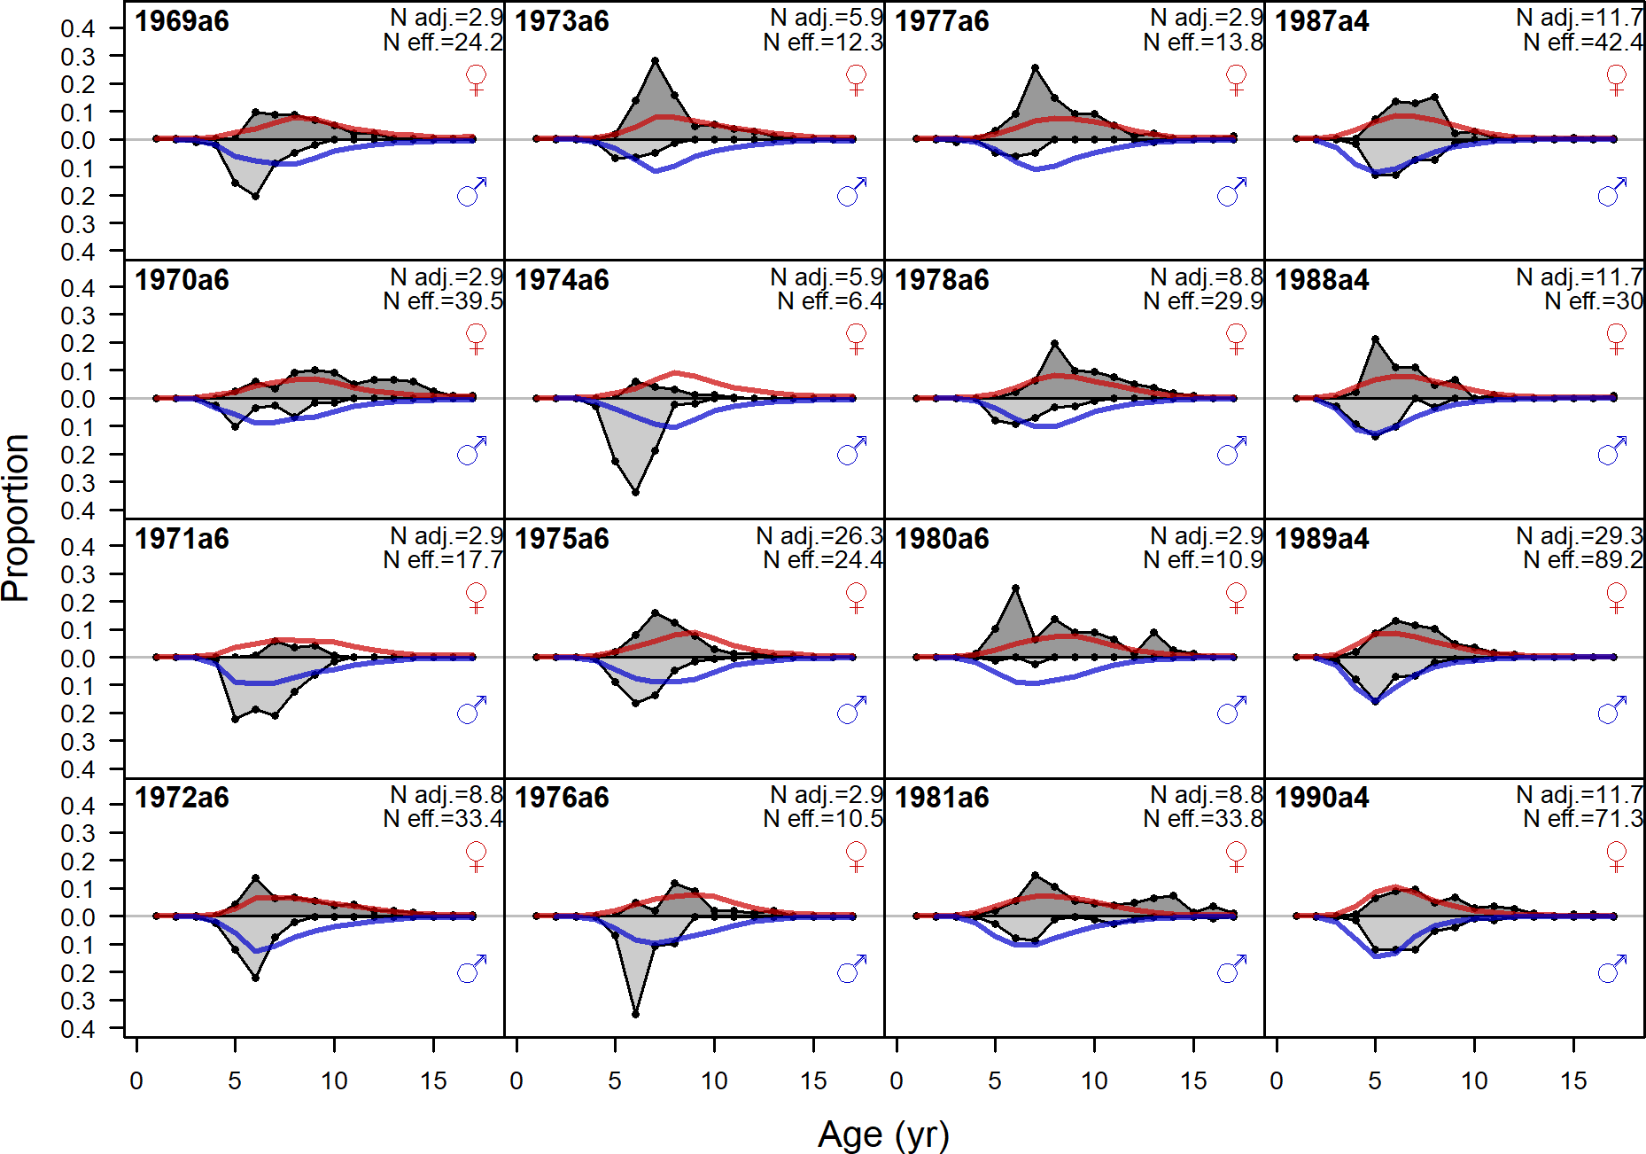

Figure 138: Age comps, retained, Winter (N) (plot 1 of 4). ‘N adj.’ is the input sample size after data weighting adjustment. N eff. is the calculated effective sample size used in the McAllister Iannelli tuning method.

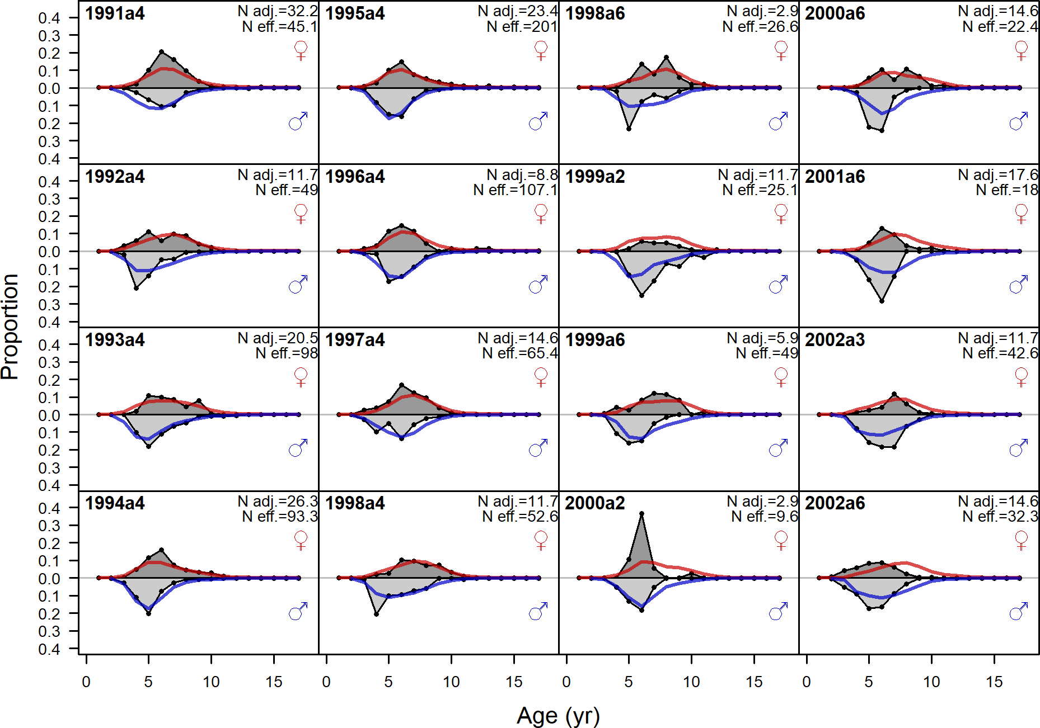

Figure 139: Age comps, retained, Winter (N) (plot 2 of 4)

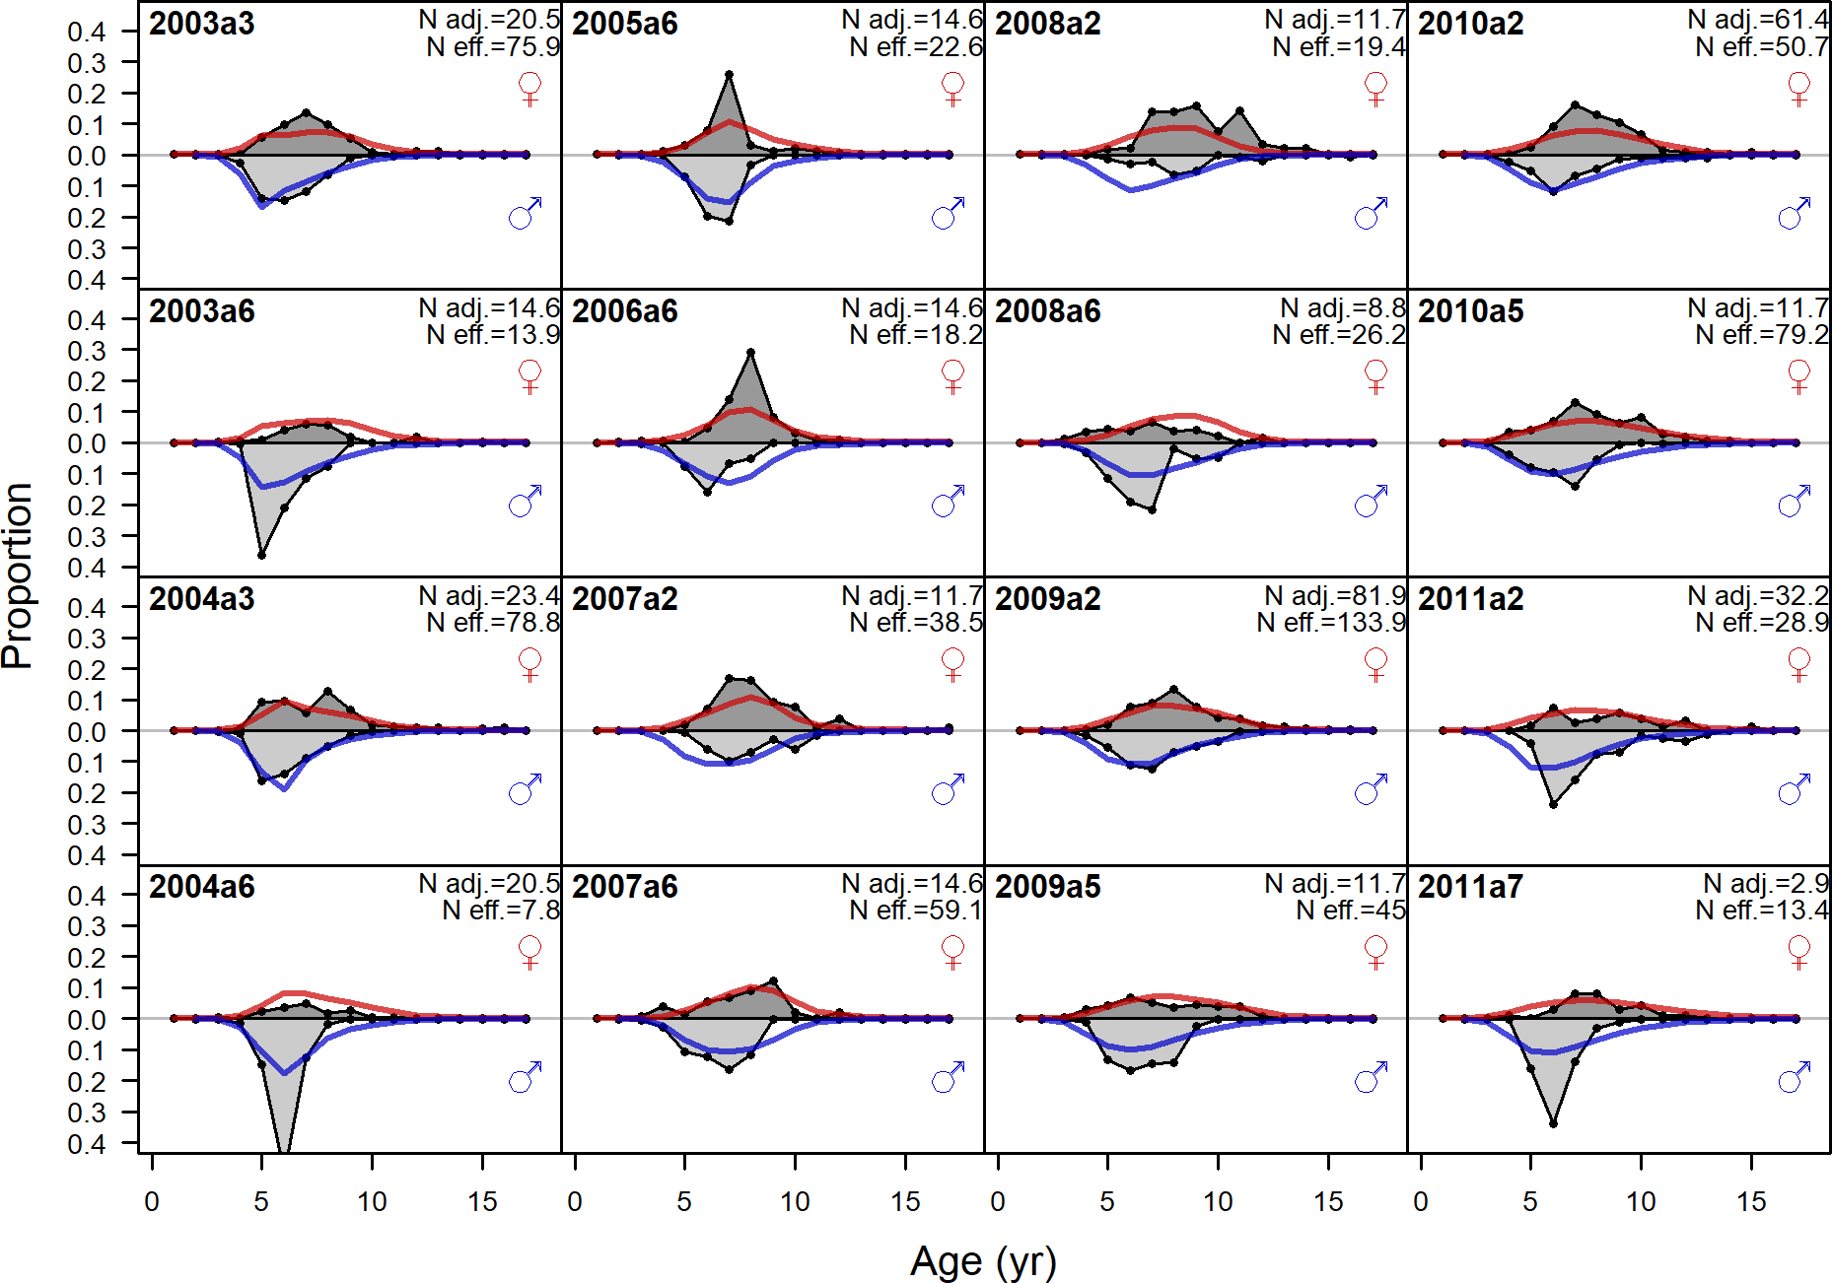

Figure 140: Age comps, retained, Winter (N) (plot 3 of 4)

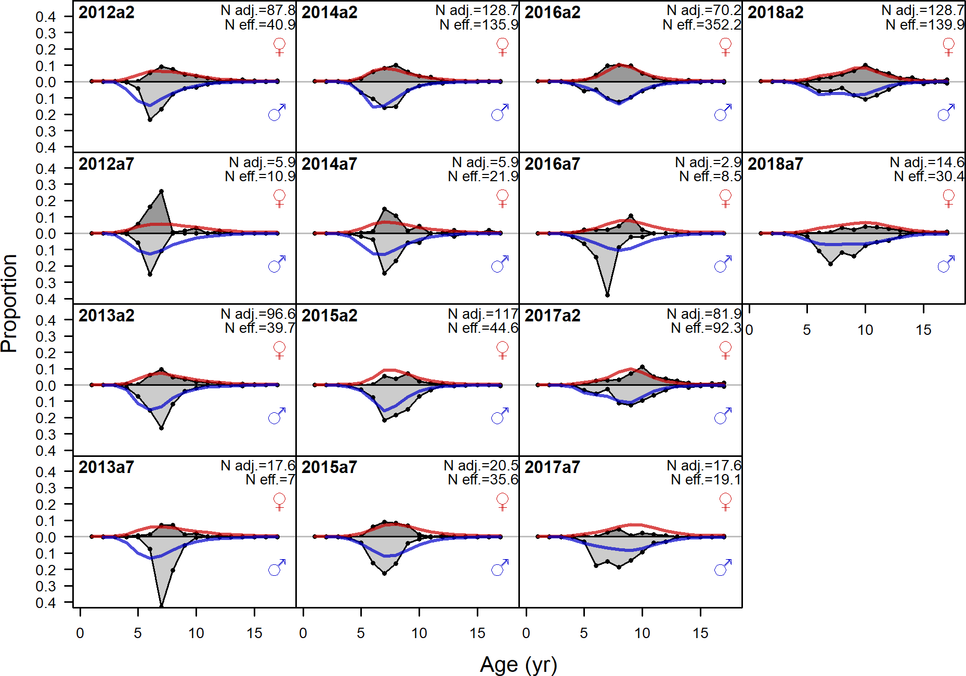

Figure 141: Age comps, retained, Winter (N) (plot 4 of 4)

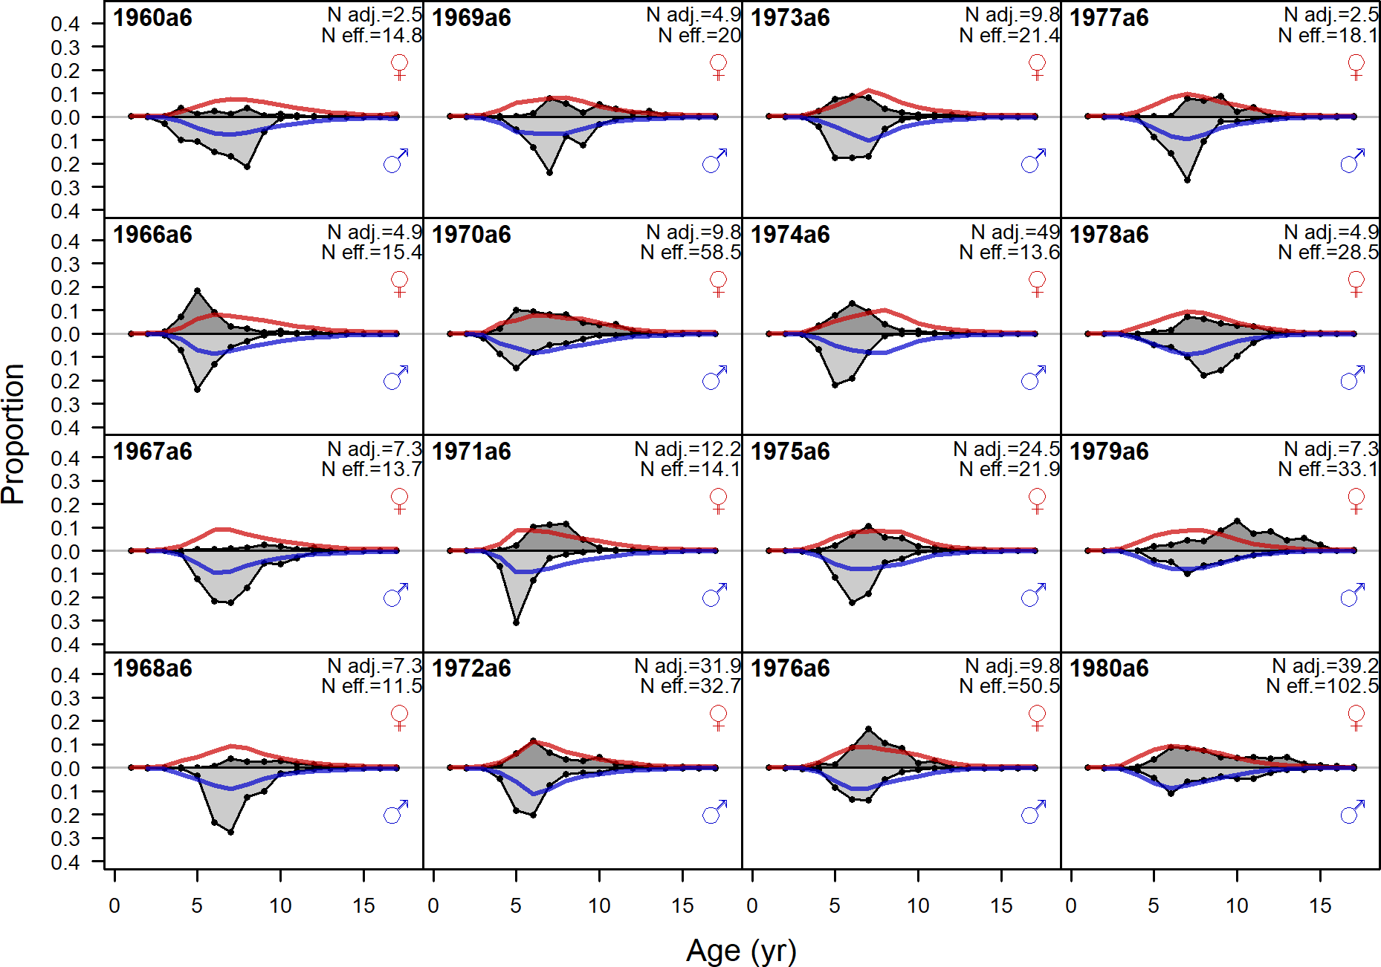

Figure 142: Age comps, retained, Summer (N) (plot 1 of 5). ‘N adj.’ is the input sample size after data weighting adjustment. N eff. is the calculated effective sample size used in the McAllister Iannelli tuning method.

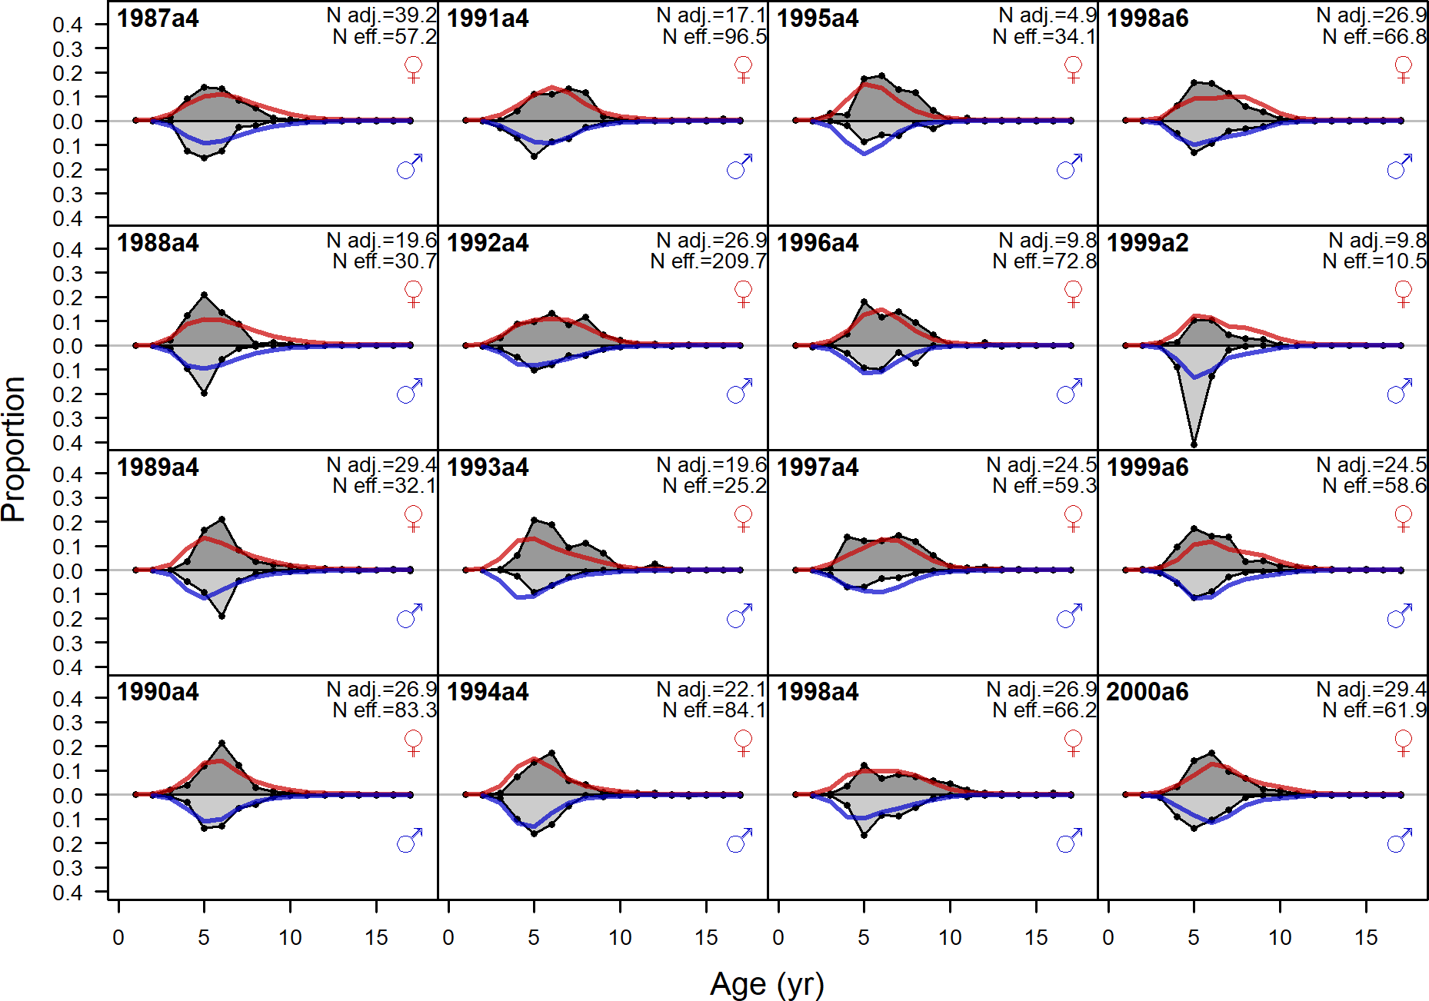

Figure 143: Age comps, retained, Summer (N) (plot 2 of 5)

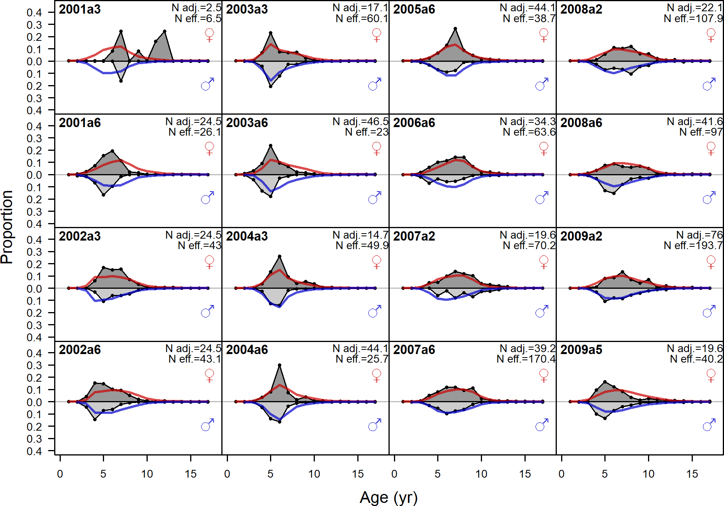

Figure 144: Age comps, retained, Summer (N) (plot 3 of 5)

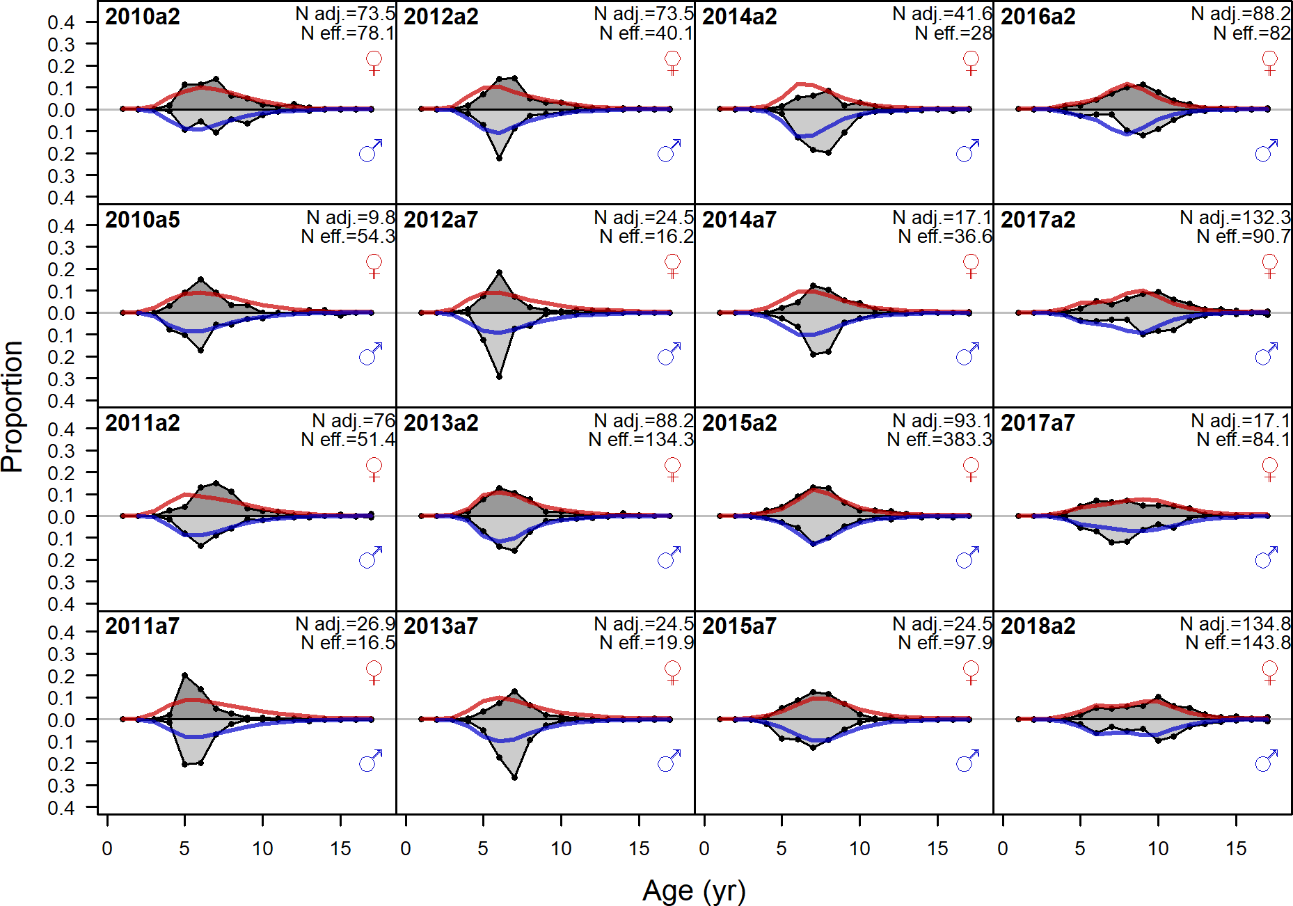

Figure 145: Age comps, retained, Summer (N) (plot 4 of 5)

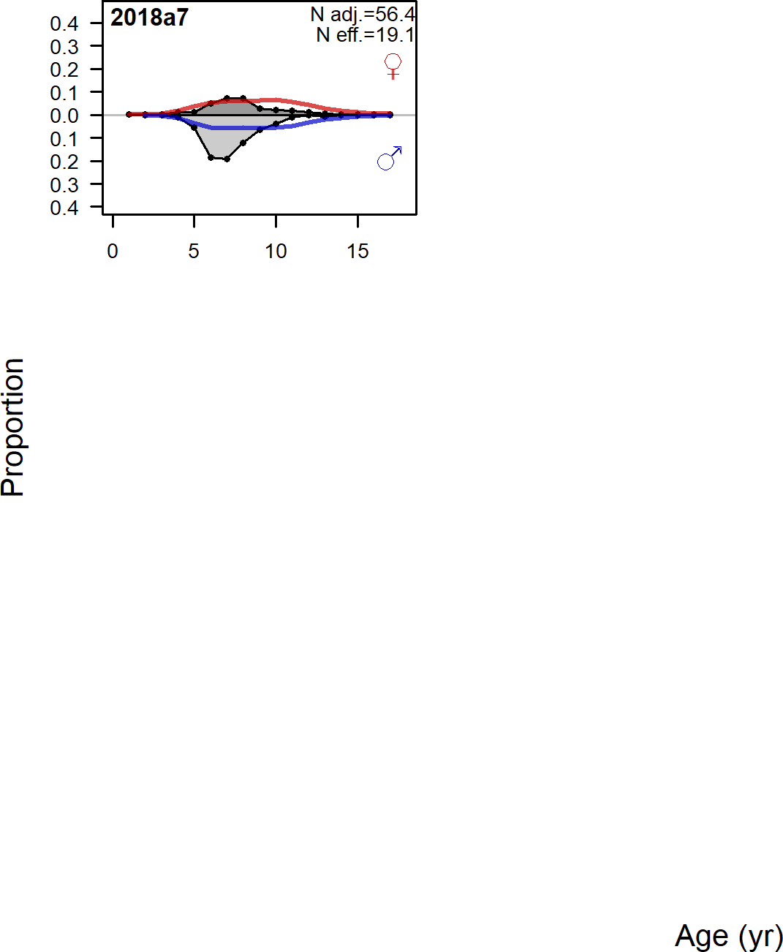

Figure 146: Age comps, retained, Summer (N) (plot 5 of 5)

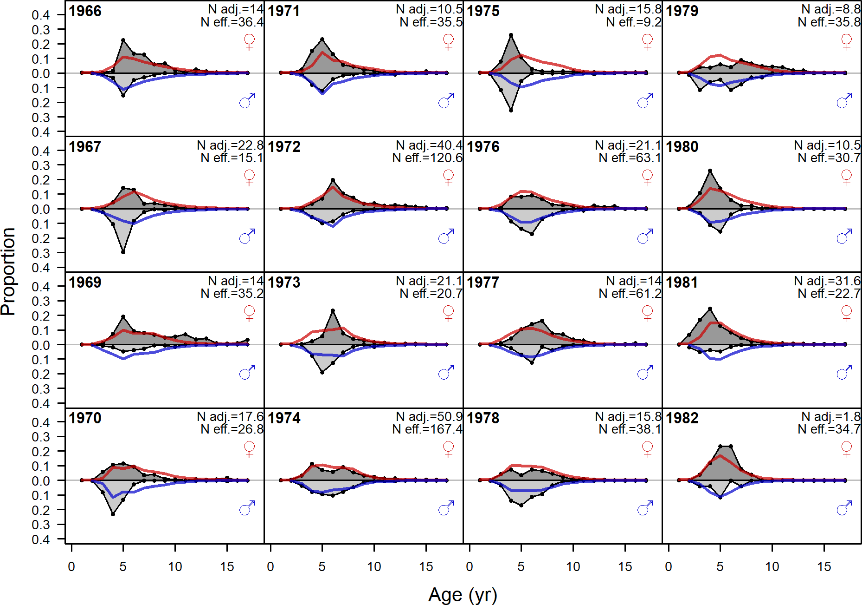

Figure 147: Age comps, retained, Winter (S) (plot 1 of 3). ‘N adj.’ is the input sample size after data weighting adjustment. N eff. is the calculated effective sample size used in the McAllister Iannelli tuning method.

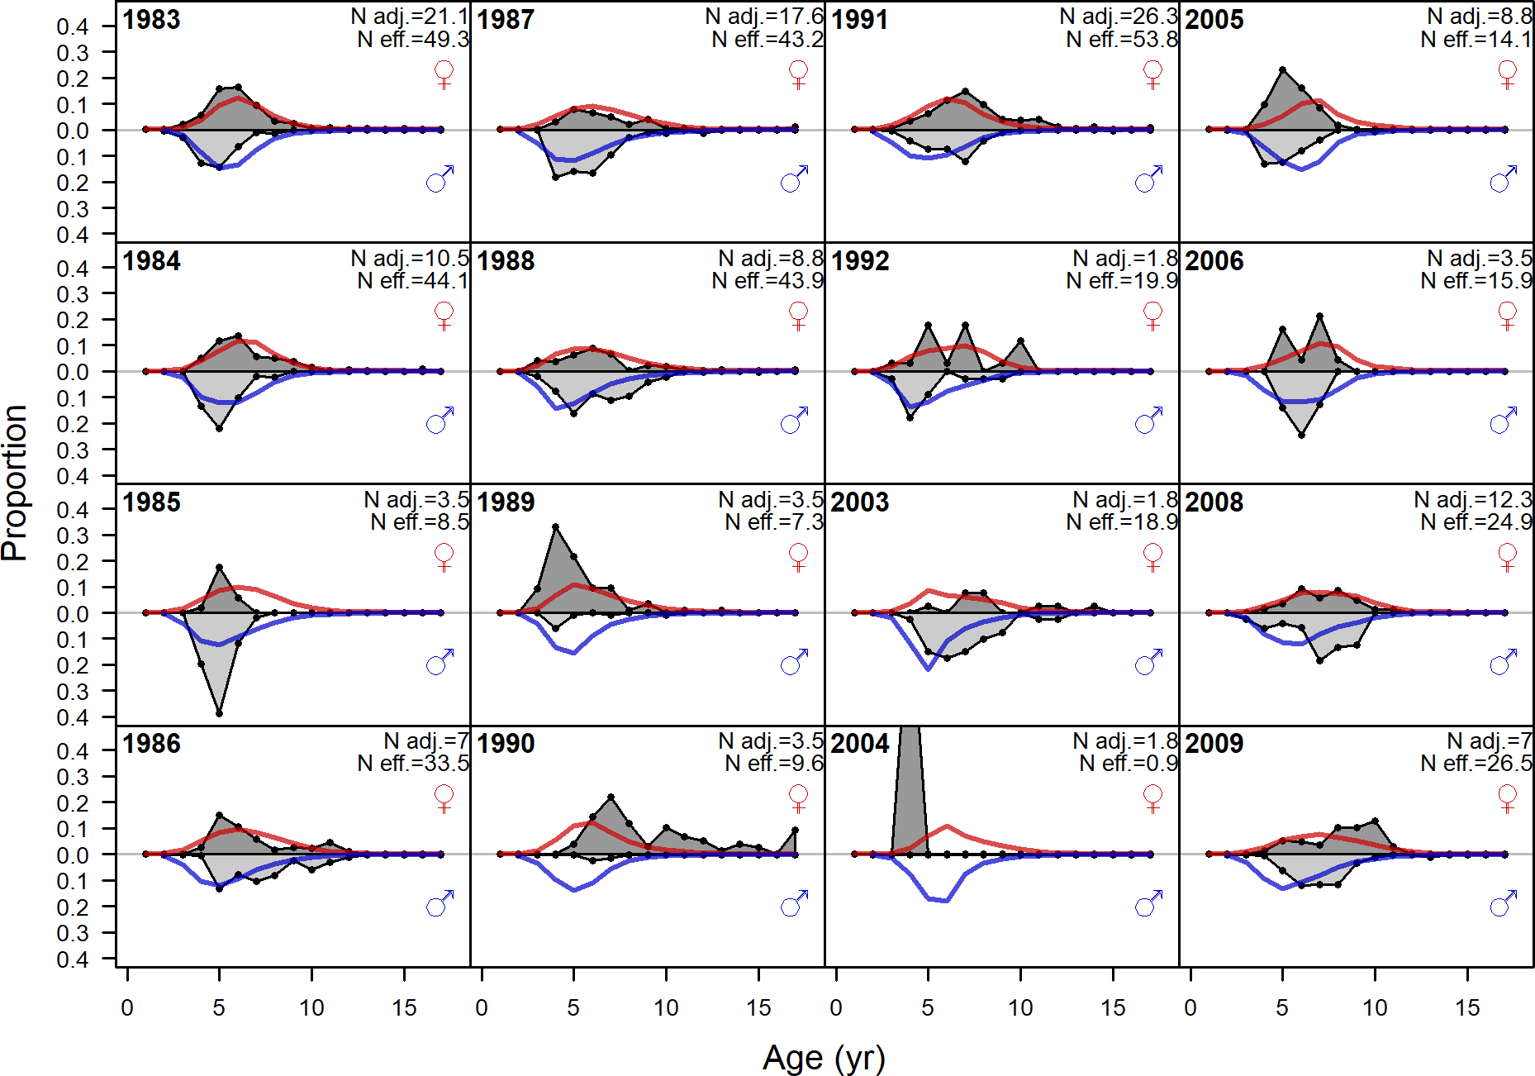

Figure 148: Age comps, retained, Winter (S) (plot 2 of 3)

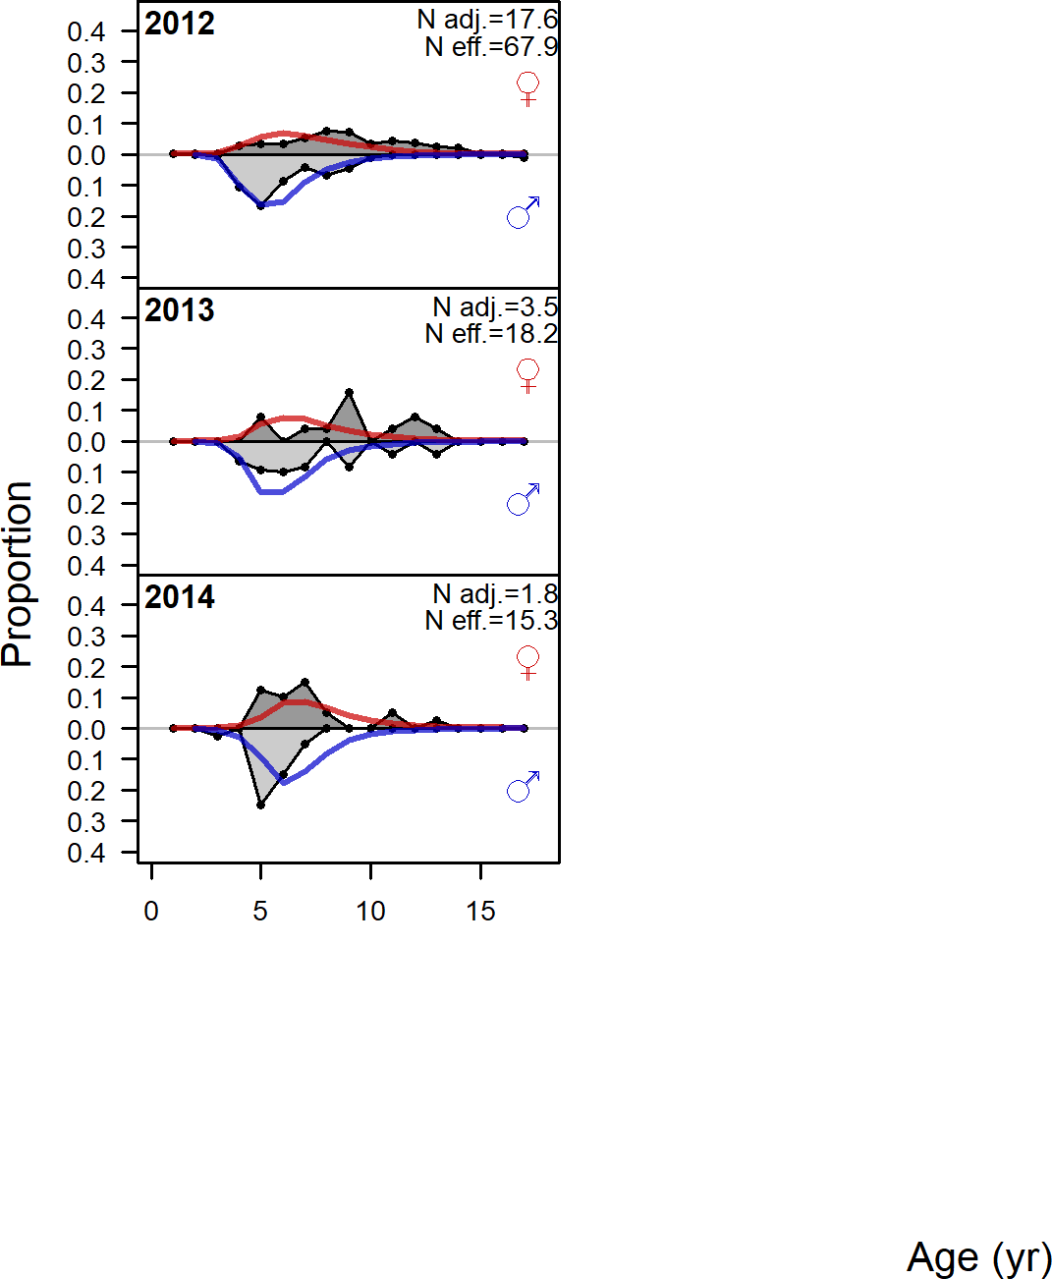

Figure 149: Age comps, retained, Winter (S) (plot 3 of 3)

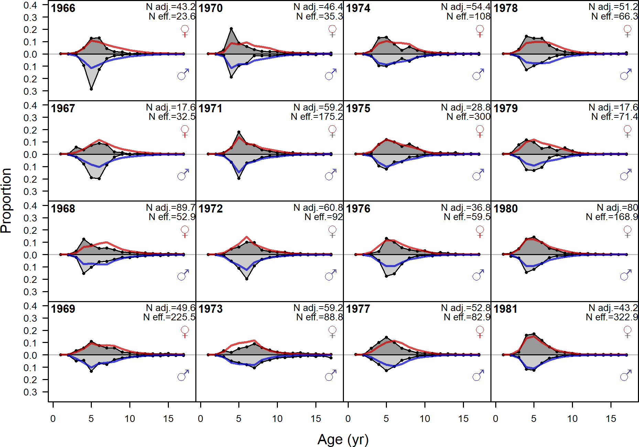

Figure 150: Age comps, retained, Summer (S) (plot 1 of 3). ‘N adj.’ is the input sample size after data weighting adjustment. N eff. is the calculated effective sample size used in the McAllister Iannelli tuning method.

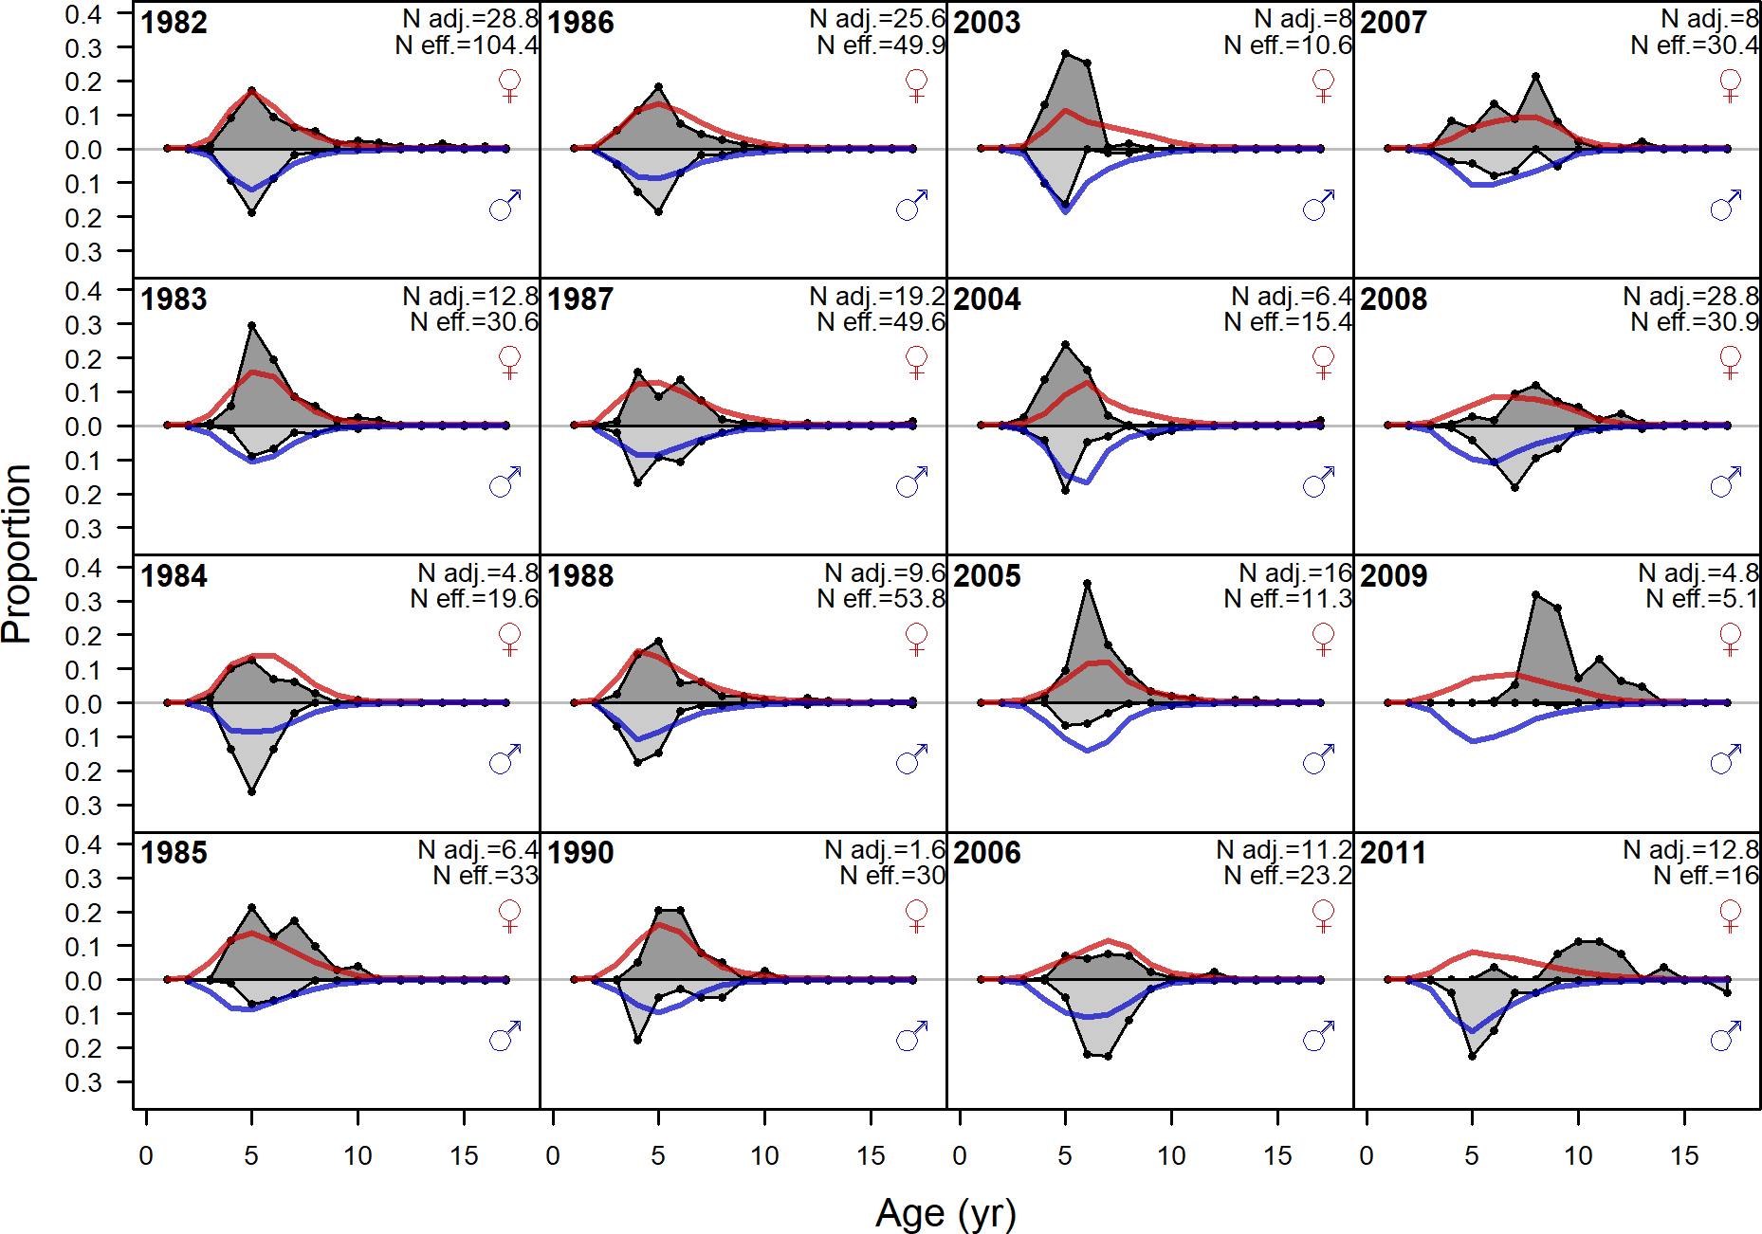

Figure 151: Age comps, retained, Summer (S) (plot 2 of 3)

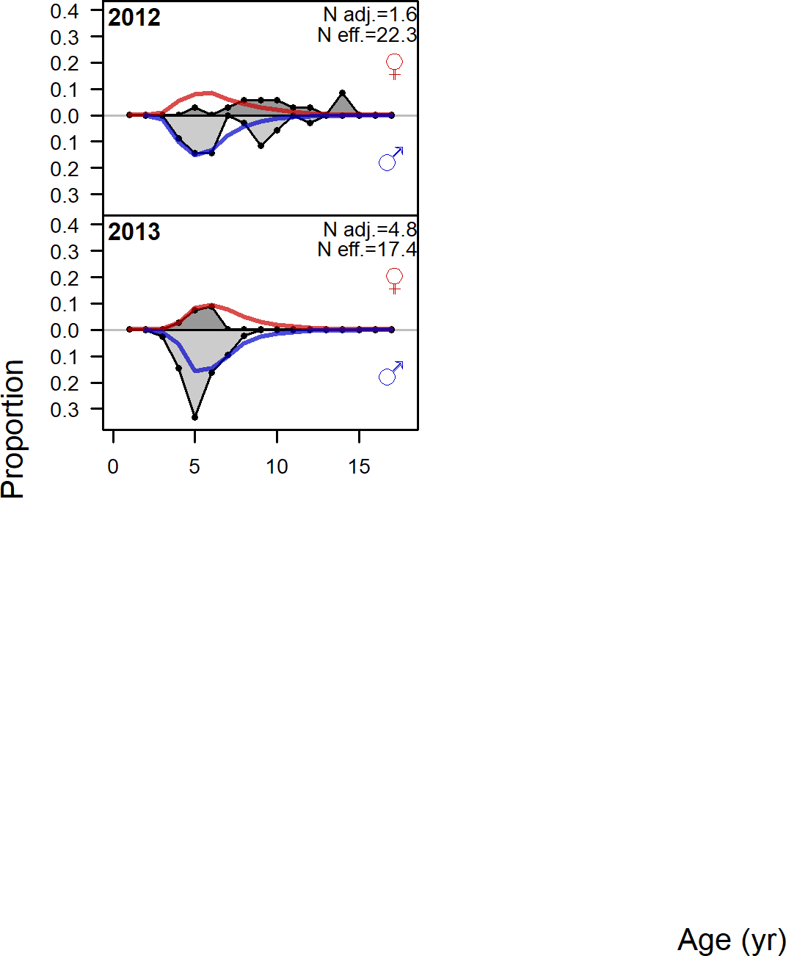

Figure 152: Age comps, retained, Summer (S) (plot 3 of 3)

1. **Appendix C. List of Auxiliary Files Available**

The listed files are also available as auxiliary files to accompany the assessment document:

1. Numbers at age for female and male petrale sole (Petrale natagef.csv and Petrale natagem.csv)
2. The petrale sole Stock Synthesis 3.30.13 model files
   1. 2019petrale.dat
   2. 2019petrale.ctl
   3. forecast.ss
   4. starter.ss